HSIE – History – Stage 2 learning sequence

Resource considerations
This lesson sequence allows for continuity of student learning and could be adapted to fit in with your existing teaching and learning program. Students will be supported to meet outcomes from a Key Learning Area. Each task has a duration of 30 minutes and could be used in conjunction with your framework, designed using the K-6 template. This lesson sequence uses a balance of synchronous and asynchronous learning strategies. The tasks provide options for students with and without technology. They can be used with any online platform. Suggestions about how your school will plan students’ learning from home and ways to communicate with students can be found through the Learning at home, school planning page. Assessment strategies are included to ensure evidence of learning is monitored and collected.

Stage 2 learning sequence – Community and Remembrance 3
Outcomes
HT2-1 identifies celebrations and commemorations of significance in Australia and the world
HT2-5 applies skills of historical inquiry and communication
Learning sequence overview – Students investigate important days and weeks that are celebrated or commemorated in Australia. They identify and describe local, state and national symbols and discuss their origins, symbolism and significance. They record and communicate their information through an infographic or poster.
Key concepts
- Significance: importance of an event, development or individual/group, eg the significance/importance of national days/holidays; the significance of the contributions of early settlers.
- Empathetic understanding: developing an understanding of another's views, life and decisions made, eg developing an understanding of the life and attitudes of an early colonist or convict.
Key language
- Community – Aboriginal, Torres Strait Islander, Country, Place, Land, local, regional, identity, relationship, stories, language, longevity, continuity, traditional, custodian, resource, change, similar, different, diversity, impact, cause, affect, effect, consequence, contribution
- Remembrance – celebrate, commemorate, local, community, state, national, global, international, symbol, emblem, logo, flag, coat of arm, origin, significance, cause, effect, symbolism, respect, ceremony, ceremonial, religion, belief, tradition, similar, different
Key inquiry question – How and why do people choose to remember significant events of the past?

Aim of lesson sequence
- Students investigate important days and weeks that are celebrated or commemorated in Australia. They identify and describe local, state and national symbols and discuss their origins, symbolism and significance. They record and communicate their information through an infographic or poster.

Teacher notes
- This learning sequence looks at significant Australian events and provides a study of local, state and national symbols and emblems of significance, and celebrations and commemorations, both locally and in other places around the world. Students investigate important days and weeks that are celebrated or commemorated in Australia. They identify and describe local, state and national symbols and discuss their origins, symbolism and significance. They record and communicate their information through an infographic or poster.
- It is important to consider the diversity of the students in your class during this unit. If possible, you could incorporate this diversity when discussing significant events that are celebrated and commemorated in Australia.

Activities
- Significant Australian events
  - Digital
  - Provide students with photographs of events that are celebrated or commemorated in Australia or use the photographs in the student resource pack (Harmony Day, ANZAC Day, NAIDOC Week)
  - Answer questions:
    - What do they see, think and wonder about the photos?
    - What symbols do they recognise in the photographs that give them a clue to what event is being celebrated or commemorated?

  - Non-digital
  - Provide students with photographs of events that are celebrated or commemorated in Australia or use the photographs in the student resource pack (Harmony Day, ANZAC Day, NAIDOC Week)
  - Answer questions:
    - What do they see, think and wonder about the photos?
    - What symbols do they recognise in the photographs that give them a clue to what event is being celebrated or commemorated?
Source 1 – Harmony Day, 21 March 2010
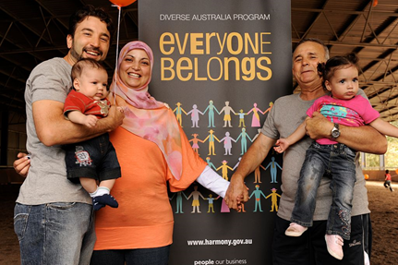
Wikimedia Commons. CC BY 2.0

Source 2 – Navy officers and sailors from HMAS Watson march past the Martin Place Cenotaph in Sydney on Anzac Day, 25 April 2013
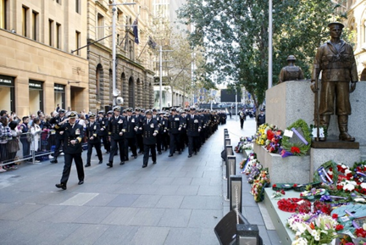
Australian Navy. © Commonwealth of Australia 2018
Source 3 – NAIDOC Week celebration at Mosman Library, NSW, 2011
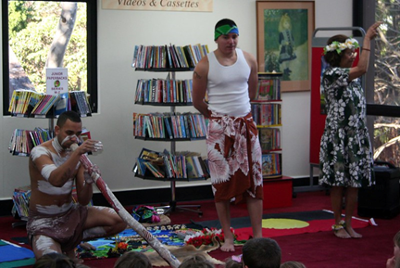
Mosman Library on Flickr. CC BY 2.0

Significant events, commemorations and celebrations for me and my family
  - Digital
  - Using the see, think, wonder, generate a class set of inquiry questions to find out more about the significant days and weeks that are celebrated and commemorated in Australia and the symbols and emblems that are associated with them.
  - Different local, state and national symbols and emblems may include the school logo, Australian and Aboriginal and Torres Strait Islander flags and coats of arms from states and Australia. Ask students if they can identify the symbols and describe the significance of them.
  - Sample questions could include:
    - What are the significant days that are important to us? Why?
    - What is the difference between a celebration and a commemoration?
    - What are Australia’s important symbols and emblems?
  - Design a new celebration or symbol – historical narrative
    - Students create a new celebration or symbol for Australia. Students create a poster to advertise their celebration or symbol. They verbally tell a narrative that outlines what the celebration or symbol is, why it is important, how it is used or celebrated.
  - Reflection
    - Students reflect on the historical inquiry process, reflecting on what they learnt, how they learnt it and what else they would like to find out about significant Australian celebrations, commemorations, symbols or emblems.

  - Non-digital
  - Using the see, think, wonder, generate a set of inquiry questions to find out more about the significant days and weeks that are celebrated and commemorated in Australia and the symbols and emblems that are associated with them.
  - Different local, state and national symbols and emblems may include the school logo, Australian and Aboriginal and Torres Strait Islander flags and coats of arms from states and Australia. Ask students if they can identify the symbols and describe the significance of them.
  - Sample questions could include:
    - What are the significant days that are important to us? Why?
    - What is the difference between a celebration and a commemoration?
    - What are Australia’s important symbols and emblems?
  - Design a new celebration or symbol – historical narrative
    - Students create a new celebration or symbol for Australia. Students create a poster to advertise their celebration or symbol. They verbally tell a narrative that outlines what the celebration or symbol is, why it is important, how it is used or celebrated.
  - Reflection
    - Students reflect on the historical inquiry process, reflecting on what they learnt, how they learnt it and what else they would like to find out about significant Australian celebrations, commemorations, symbols or emblems.

Differentiation
Differentiation is a targeted process recognising that individuals learn at different rates and in different ways. Differentiation refers to deliberate adjustments to meet the specific learning needs of all students.
Here are some questions that you might consider when adapting the learning sequence to meet the needs of your students:
- What adjustments might you put in place for students who require additional support to access the task? For example, how will they get help when needed?
- Do you need to adjust the content to ensure it is adequately challenging and allows students to operate at their own level of thinking, skill and knowledge?
- Will you adapt the instructions so they are provided in a way that EAL/D students can easily interpret them? For example, through the use of visuals, checklists, diagrams or flow charts.
- Could you suggest ways that home language can be used as a tool to support learning? For example, bilingual dictionaries.
- Can you demonstrate that you value the Identity, culture, heritage and language of your Aboriginal students through your teaching practices?

Assessment
Historical inquiry – communicate
Design a new celebration or symbol – historical narrative
Students create a new celebration or symbol for Australia. Students create a poster to advertise their celebration or symbol. They verbally tell a narrative that outlines what the celebration or symbol is, why it is important, how it is used or celebrated.
Reflection
Students reflect on the historical inquiry process, reflecting on what they learnt, how they learnt it and what else they would like to find out about significant Australian celebrations, commemorations, symbols or emblems.

Activity resources
- Online teaching resources:
Source 1 – Wikimedia Commons. CC BY 2.0 Harmony Day, 21 March 2010
Source 2 – Australian Navy. © Commonwealth of Australia 2018 Navy officers and sailors from HMAS Watson march past the Martin Place Cenotaph in Sydney on Anzac Day, 25 April 2013
Source 3 – Mosman Library on Flickr. CC BY 2.0 NAIDOC Week celebration at Mosman Library, NSW, 2011
Source 4 – Milestones in Australian democracy, Museum of Australian Democracy, interactive timeline

- Additional resources looking at primary and secondary sources of information on ANZAC
  - ABC Education: The meaning of ANZAC Day – This video shares the thoughts and feelings of five different people about ANZAC Day.
  - Australian War Memorial – This website provides a variety of resources that explore how and why ANZAC day is commemorated. It also provides information about virtual excursions and memorial boxes for the classroom.
  - Trove, The National Library of Australia – This website brings together content from libraries, museums, archives, repositories and other research. It includes photographs and information from communities around Australia.
  - State Library of NSW on flickr – This website provides photographs of ANZAC Day commemorations.
  - Department of Veterans’ Affairs – This website provides a resource called Here they come – A day to remember. It includes videos that explain the symbols and emblems that are used to commemorate ANZAC Day.

- Student history workbook – for non-digital activities

Parent/carer advice: These activities require students to use a range of primary and secondary information sources. Assistance may be required to interpret and analyse primary and secondary sources of information and some language used in these resources. Parents can talk to their children about their celebrations and commemorations. Students are required to compose written work as part of these activities Parents may need to provide support in drafting, proof-reading and editing.

