Change and continuity, community, people
This learning sequence comprises four inquiries.

Topic – Community and remembrance
10 weeks – 90 minutes per week

Key inquiry questions
- How has our community changed? What features have been lost and what features have been retained?
- What is the nature of the contribution made by different groups and individuals in the community?

Overview
This topic provides a study of identity and diversity in the local and broader context. Moving from the heritage of their local area, students explore the historical features that have been lost and retained. They investigate the diversity of the people in the local community and how they have shaped it. This learning sequence consists of four inquiries – our community, early transport, features of the local community and local cultural groups and how they have shaped the community.
In the first, students investigate the features of their local community. They identify features that have changed or remained the same. They use this information to complete further historical inquiries. In the second, students examine early transport in the local community and New South Wales through a guided inquiry. They use a range of sources to describe and explain how and why transport has changed or remained the same.
In the third inquiry, students work independently, or in groups, to select one feature of the local community to investigate. They use a variety of sources to undertake their investigation. Students outline how and why this feature has changed or remained the same in the local community. In the fourth, students examine the role that people of different cultural backgrounds have played in the development and character of the local community through a guided inquiry. They use a range of sources to determine their contribution to the local community.

Outcomes
A student:
- HT2-2 describes and explains how significant individuals, groups and events contributed to changes in the local community over time
- HT2-5 applies skills of historical inquiry and communication

Content
One important example of change and one important example of continuity over time in the local community, region or state/territory (ACHHK061)
Students:
- using a range of sources, describe and explain how and why ONE area, e.g. transport, work, education, entertainment and daily life, has changed or ONE that has remained the same in the local area, region or state/territory since colonial times
The role that people of diverse backgrounds have played in the development and character of the local community (ACHHK062)
Students:
- identify the various cultural groups that live and work in the local community
- focusing on one group, investigate their diverse backgrounds and outline their contribution to the local community using a range of sources, e.g. photographs, newspapers, oral histories, diaries and letters.

Historical inquiry skills
Comprehension: chronology, terms and concepts
- respond, read and write, to show understanding of historical matters
- sequence familiar people and events (ACHHS065, ACHHS081)
- use historical terms (ACHHS066, ACHHS082)
Analysis and use of sources
- locate relevant information from sources provided (ACHHS068, ACHHS084, ACHHS215, ACHHS216)
- Perspectives and interpretations
- identify different points of view within an historical context (ACHHS069, ACHHS085)
Empathetic understanding
- explain how and why people in the past may have lived and behaved differently from today
Research
- pose a range of questions about the past (ACHHS067, ACHHS083)
- plan an historical inquiry
Explanation and communication
- develop texts, particularly narratives (ACHHS070, ACHHS086)
- use a range of communication forms (oral, graphic, written) and digital technologies (ACHHS071, ACHHS087)

Selected historical concepts
Continuity and change – some things change over time and others remain the same, for example, aspects in the local community that have either changed or remained the same; changes to the lives of Aboriginal peoples with the arrival of the First Fleet.
Cause and effect – events, decisions or developments in the past that produce later actions, results or effects, for example, how conditions and decisions in Britain resulted in the journey of the First Fleet; causes of change in the local area/state.
Syllabus extracts are quoted from History K-10 Syllabus © 2012 NSW Education Standards Authority (NESA) for and on behalf of the Crown in right of the State of New South Wales.

Assessment
All activities require students to demonstrate their learning. All are assessment for learning activities.

Vocabulary
Ask, investigate, observe, locate, collect, explore, examine, identify, record, describe, sequence, compare, explain, discuss, illustrate, write, present
Time, past, present, now, history, importance, significance
Story, oral history, photograph, map, video, library, museum, source, reliable source, primary source, secondary source, historical narrative
Local, community, change, diversity

Teaching and learning activities
This learning sequence comprises four inquiries.

Inquiry 1 – our community
Students investigate the features of their local community. They identify features that have changed or remained the same. They use this information to complete further historical inquiries.
The inquiry questions below should be localised to represent your local community. The local library, historical society or local council may be able to provide or locate local historical sources.

Stimulus
Read source 1 – My place by Nadia Wheatley and Donna Rawlins, Walker Books, 2008. Complete a shared reading of the book focusing on the illustrations. Focus on the changes in the buildings, landscape and maps from the present to the past. The shared reading should demonstrate the historical concept of continuity and change over time. Ask students what they can see on each page. How have things changed or remained the same?
As a class complete a ‘know, want to know, what I learned’ (KWL) chart to find out what students already know about the features of the local community including buildings, landscapes and daily life. Ask students to identify things that they would like to know about how the community has changed and remained the same.

Historical inquiry step 1 – question
Using the KWL Chart and guided by syllabus dot points, generate a class set of inquiry questions to find out more about how the local community has changed or remained the same over time.
Sample questions:
- What did our community look like in the past?
- What does it look like now?
- How has our community changed and remained the same?
Note – inquiry questions may need to be redesigned through the historical inquiry process.

Historical inquiry step 2 – research
Photographs from the past
Collect photographs of your local community from the early 1900s. The photographs could include local features that would be familiar to students including your school, buildings, landscapes or streets. They be found at the local library, local council, local historical society, museum or online. Display the photographs for students to complete a see-think-wonder using the following prompts.
See
- What is in the photograph?
- How is the photograph similar or different to the present?
Think
- Where was the photograph taken? How do you know?
- When was the photograph taken?
- How do you know the photograph is from the past?
Wonder
- What do you wonder when examining the photograph?
Local community walk
Take students for a walk around the local community to find some of the buildings, landscapes and parts of daily life that were identified in the historical photographs. Before you go on the walk brainstorm what sort of features may remain the same and what may have changed. On the search students record the things that have changed and remained the same by writing, drawing or taking photographs.

Historical inquiry step 3 – analyse
Ask students to choose three features that they identified on the walk. In pairs students create a poster or digital display that includes a photo or drawing as well as facts that describe how the features identified have changed or remained the same. Each pair presents and explains their findings to the class.
Create a class display of the information students collected on the walk. This information will assist students in further inquiries.
Using the information collected students complete a table that summarises the features of the community that they think have changed and features that have remained the same.
Update the KWL chart to highlight what students have learnt as a result of the walk and other things that they want to find out about the local community.

Historical inquiry step 4 – evaluate
Discuss the reliability of research conducted. What information might be missing? What other sources could be used in future inquiries? Do the inquiry questions need to be redesigned as a result of evaluating the sources?

Historical inquiry step 5 – communicate
History tour guide – historical narrative
Students use a variety of photographs or drawings from the local community walk. In the role of history tour guide, they verbally tell a historical narrative that outlines what features of the local community have changed or remained the same and explain how they know this.
Reflection
Students reflect on the historical inquiry process, reflecting on what they learnt, how they learnt it and what else they would like to find out the local community.

Inquiry 2 – semi-guided inquiry into early transport
Students examine early transport in the local community and New South Wales through an independent inquiry. They use a range of sources to describe and explain how and why transport has changed or remained the same.
The inquiry questions below can be localised to represent your local community. The local library, historical society or local council may be able to provide or locate local historical sources.

Stimulus
Provide students with photographs of transport in your local community and New South Wales in the early 1900’s or use the examples below.
What do they see, think and wonder about the photos? What is different and what is the same today?
Source 1 – The family in a horse and buggy, Sydney, Australia circa 1880-1923
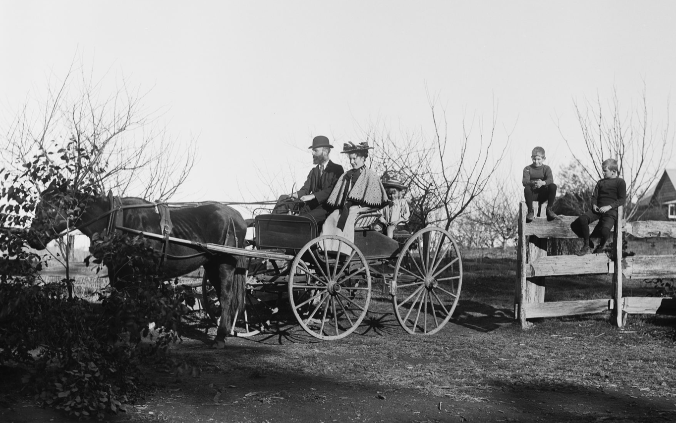
Powerhouse Museum. No known copyright restrictions
Source 2 – Bus, Newcastle, circa 1912
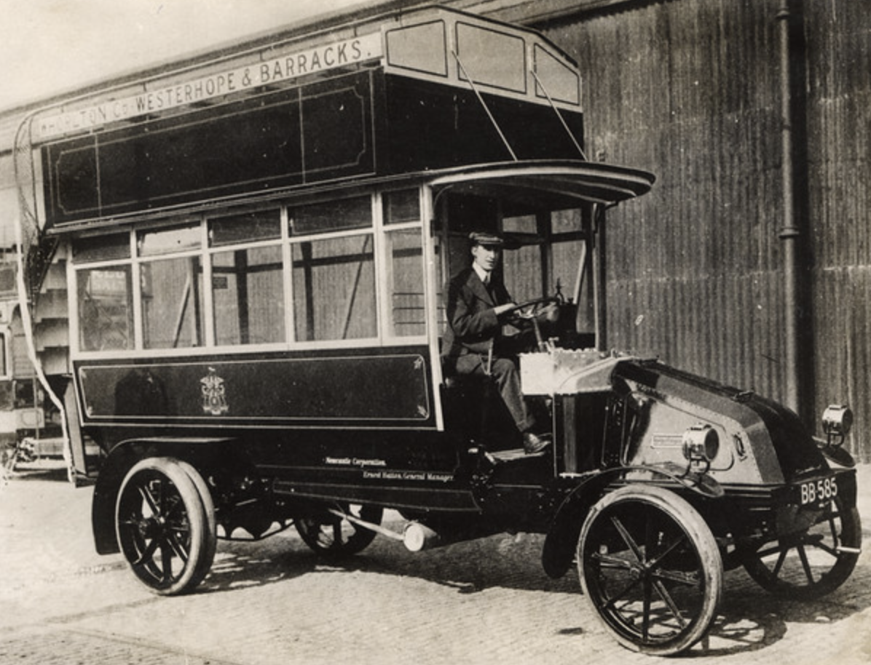
Newcastle Libraries on Flickr. Public domain
Source 3 – Vintage car, a Sir W G Armstrong Whitworth automobile, circa 1904
Newcastle Libraries on Flickr. Public domain

Historical inquiry step 1 – question
Using the see-think-wonder and guided by syllabus dot points, generate a class set of inquiry questions to find out more about transport in the local community and New South Wales. Students will decide if this area has changed or remained the same over time.
Sample questions:
- How did people travel around the local community in the past? How did people travel around New South Wales in the past?
- How do people travel in the local community now? How do people travel around New South Wales now?
- What forms of transport have changed or remained the same in the local community and New South Wales?
Note – inquiry questions may need to be redesigned through the historical inquiry process.

Historical inquiry steps 2 – research
Provide students with at least one primary source and at least one secondary source to support the semi-guided inquiry. Some examples may include information, photographs or videos from the local or State Library of NSW, local council, historical society or National Museum of Australia.
Examples of resources that provide information about transport in New South Wales include:
- Historical photo sets on Flickr, State Library of NSW – This collection of albums on Flickr is from the State Library of NSW. It includes photographs of a variety of early transport including the horse and cart, horse drawn trams, early cars, boats and planes in a variety of places in New South Wales.
- Trove, The National Library of Australia – This website brings together content from libraries, museums, archives, repositories and other research. It includes photographs of early public transport around Australia.
- Historical photo sets on Flickr Newcastle Library – This album on Flickr is from the Newcastle Library. It includes photographs of a variety of early transport including horse and double decker buses, bikes, cars, ferries, trams and early fire trucks in Newcastle NSW.
- Museum of Applied Arts and Sciences – This collection of photographs and negatives provides examples of trains, buses, trams and planes from around Australia and the world.
- ABC Education This video highlights the variety of transport in Australia today.
- State Library of NSW – This website provides photographs of modern transport.
Take students for a walk around the local community to observe the transport used. Before you go on the walk brainstorm what sort of transport they might see. On the walk students record the transport they observe by writing, drawing or taking photographs.
Guide students in extracting information from the sources to answer the inquiry questions. As most of the sources are visual students could create a mind map to record as many observations as they can about transport in the past and present.
As a class create a mind map or display of the information students have collected.
Students use a Venn diagram to compare and contrast early transport to modern transport. What has changed and what has remained the same?

Historical inquiry step 3 – analyse
From the information obtained, collectively identify the information that will be useful to assist in answering the inquiry questions. Assist students to determine which source/s to include or exclude and start to develop an historical opinion about whether transport in the local community and in New South Wales has changed or remained the same.
Collectively sequence photographs and information to identify how transport has changed or remained the same.

Historical inquiry step 4 – evaluate
Guide the students in evaluating the reliability of the sources. Are the sources believable? Are there inconsistencies or contradictions between the sources? Do the inquiry questions need to be redesigned as a result of analysing and evaluating sources?

Historical inquiry step 5 – communicate
Transport expert
Students write a text that describes what has changed or what has remained the same in regards to transport in the local community. They use the information that they have collected from the variety of sources provided. Encourage students to use a range of communication methods to create and present their text including written, graphic and oral. Provide students with the option of using digital technology to create the text.
Reflection
Students reflect on the historical inquiry process, reflecting on what they learnt, how they learnt it and what else they would like to find out.

Inquiry 3 – student-led inquiry on features of the local community
Working independently, or in groups, students select one feature of the local community to investigate. Students may choose a feature such as education, entertainment, work, daily life or another feature they have identified. They use a variety of sources to undertake their investigation. Students outline how and why this feature has changed or remained the same in the local community. They demonstrate the historical inquiry process throughout their inquiry.

Historical inquiry step 1 – question
Students formulate a set of inquiry questions they can answer through their research.
Sample questions:
- How has (insert name of feature) in our community changed or remained the same over time?
- Why has (insert name of feature) changed or remained the same?
- What are some interesting facts about (insert name of feature)?
Note – inquiry questions may need to be redesigned through the historical inquiry process.

Historical inquiry steps 2 and 3 – research and analyse
Students locate, summarise and analyse information from three sources. Sources could include historic newspapers, maps, street directories, photographs, letters, diaries and oral histories. They summarise and record key information in table 1.
Table 1 – source analysis table
Source number | Title and date | Who created it? | Why was it created? | Whose view is it? | Key information | Questions raised

Historical inquiry step 4 – evaluate
Students evaluate the reliability of their sources. Are there inconsistencies or contradictions between the sources? Do the inquiry questions need to be redesigned as a result of analysing and evaluating sources?

Historical inquiry step 5 – communicate
History detective
In the role of History Detective, students create an information text to present their findings about the feature they investigated in the local community. The text should describe and explain how and why the feature has changed or remained the same. Encourage students to use a range of communication forms to present their findings.
Reflection
Students reflect on their historical inquiry process and information communicated in their information text, by answering the questions:
- What did I do well in the historical inquiry process?
- What did I find challenging in the process?
- How do I know the information I communicated?
- What else do I want to find out?

Inquiry 4 – guided inquiry into local cultural groups and how they have shaped the community
Students examine the role that people of different cultural backgrounds have played in the development and character of the local community through a guided inquiry. They use a range of sources to determine their contribution to the local community.
The inquiry questions below should be localised to represent your local community. The local library, historical society or local council may be able to provide or locate local historical sources.

Stimulus
Re-read source 1 – My place by Nadia Wheatley and Donna Rawlins, Walker Books, 2008. Complete a shared reading of the book focusing on the illustrations and the different cultural groups who lived in the same place over time. The shared reading should demonstrate the historical concept of continuity and change over time with a focus on the characters telling the story. Ask students what they can see on each page. How have the people changed or remained the same? How have they played a role in the development of the community?
As a class complete a ‘know, want to know, what I learned’ (KWL) chart to find out what students already know about the different cultural groups represented in the local community. Ask students to identify things that they would like to know about how different cultural groups have helped to shape the local community.

Historical inquiry step 1 – question
Using the KWL chart and guided by syllabus dot points, generate a class set of inquiry questions to find out more about how the local community has been shaped by people from various cultural groups.
Sample questions:
- What different cultural groups live and work in our local community?
- How have they helped to develop and build the character of our local community?
Note – inquiry questions may need to be redesigned through the historical inquiry process.

Historical inquiry step 2 – research
Brainstorm the different cultural groups in the local area. Start with identifying the family backgrounds of students.
Using this information and additional research into cultural groups in the area provide students with at least one primary source and at least one secondary source to support the guided inquiry. Some examples may include data and statistics, photographs, newspapers, diaries, letters, videos or oral histories from the local library, local council, historical society, local museum, local newspaper or from the sources below.
Examples of resources that could provide additional information include:
- Australian Bureau of Statistics – The QuickStats section of the website provides summary data about all people, families and dwellings in a particular area, compared with state and national data.
- Multicultural NSW – This website provides a variety of information about cultural diversity in each Local Government Area in New South Wales.
- Trove, The National Library of Australia – This website brings together content from libraries, museums, archives, repositories and other research. It includes photographs and information from communities around Australia.
- State Library of NSW – This website provides examples of how people from various cultural groups have contributed to the development and character of the community.
- Google Maps – This website allows you to identify buildings in the local community that highlight different cultural groups in the area.
Guide students in extracting information from the sources to answer the inquiry questions. Model the use of a source analysis table.
Table 1 – source analysis table
Source number | Title and date | Who created it? | Why was it created? | Whose view is it? | Key information | Questions raised
As a class create a mind map or display of the information students have collected.
Create a graph to represent the different cultural groups in your area. As a class identify what cultural groups are prominent. What is the largest cultural group in your local area?
Choose a cultural group to investigate further by doing a class case study. Identify the diverse backgrounds of the group and outline their contribution to the local community.
Collect a range of different sources that demonstrate the contribution the group has made in shaping the local community.
Identify local identities from the cultural group and investigate how they have contributed to the character and development of the local community.
Invite a guest speaker to the school who is a representative of the local cultural group being studied. Ask them to explain the significant contribution their community has made in developing and building the character of the local community.
Take students on a walk through the local community. Allow them to visit significant sites or buildings in the local area that represent the group being studied.

Historical inquiry step 3 – analyse
From the information obtained, collectively identify the information that will be useful to assist in answering the inquiry questions. Assist students to determine which source/s to include or exclude and start to develop an historical opinion about the different cultural groups that live and work in the area and how they have helped to shape the local community.
Update the KWL chart to highlight what students have learnt as a result of the walk and other things that they want to find out about the local community.

Historical inquiry step 4 – evaluate
Guide the students in evaluating the reliability of the sources. Are the sources believable? Are there inconsistencies or contradictions between the sources? Do the inquiry questions need to be redesigned as a result of analysing and evaluating sources?

Historical inquiry step 5 – communicate
Newspaper report
Students write a report for the local newspaper that profiles the local cultural group studied and highlights the contribution they have made to the development and character of the local community. They use the information that they have collected from the variety of sources provided. Encourage students to use a range of communication methods to create and present their text. Provide students with the option of using digital technology.
Reflection
Students reflect on the historical inquiry process, reflecting on what they learnt, how they learnt it and what else they would like to find out.

Resources
Picture books
My place by Nadia Wheatley and Donna Rawlins, Walker Books, 2008
Websites
Trove, The National Library of Australia
Historical photo sets on Flickr, State Library of NSW
Historical photo sets on Flickr Newcastle Library
Museum of Applied Arts and Sciences
State Library of NSW
Australian Bureau of Statistics
Multicultural NSW
Google Maps

