HSIE: History S1 workbook
Name:
Class:

Overview
Stage 1 – The past in the present
This learning sequence provides a study of local history. Students explore, recognise and appreciate the history of their local area by examining aspects of the past and considering what they tell us. This learning sequence comprises two inquiries – our school history and the local school in the past and the present. Students use a variety of sources to identify and describe the aspects of the past that they can see around the local school environment. Students investigate information about the local school in the past and present. They draw on their own investigations and that of the local older generations such as their parents and grandparents, as well as other sources.
Key inquiry questions:
- What aspects of the past can you see today?
- What do they tell us?

Resources
- pens, pencils
- paper
- this workbook
- help from an adult

Activity 1
During this activity you will
- identify a significant building, site or part of the natural environment in the local community and what it reveals about the past
- use a variety of sources to identify and describe the aspects of the past that they can see around the local school environment.
- examine what the sources tell them about the past.

Observe Reflect Write

Source 1 – Belmont High School opening, 27 January 1953
Sam Hood, State Library of NSW. CC BY 4.0 (cropped)
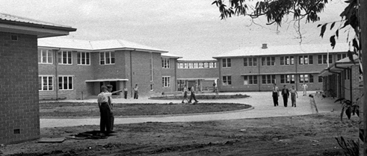
Source 2 – Tumut Public School plaque to commemorate its opening
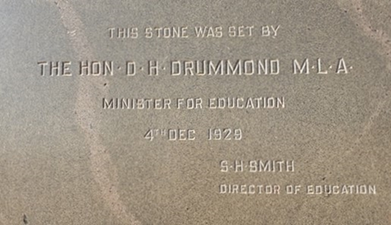
Examine the photograph of the school building in source 1.
- Discuss what can you see in the photograph?
- Is this an example of a primary or secondary source?
________________________________________________________________________________________________________________________________________________________________________________________________________________________________________________________________________________________________
Examine the photograph of a plaque in source 2.
- Discuss what information can be found on the plaque.
- What different information can this source tell us compared to source 1?
- Is this an example of a primary or secondary source?
________________________________________________________________________________________________________________________________________________________________________________________________________________________________________________________________________________________________
Brainstorm/think Write
Following examination and comparison of sources 1 and 2, think about the past and answer these questions:
• What can we use to help us to learn about the past?
________________________________________________________________________________________________________________________________________________________________________________________________________________________________________________________________________________________________
- What aspects of the past can be seen in our school? What do they tell us?
________________________________________________________________________________________________________________________________________________________________________________________________________________________________________________________________________________________________
Read Write
Discuss the terms ‘primary source’ and ‘secondary source’.
A primary source is something that has been created or written during the time being investigated, for example, photographs, letters, objects, personal stories.
A secondary source is an account that has been created after the time being investigated, for example, informative texts and picture books.
Give 3 examples of a primary source and 3 examples of a secondary source.
Primary sources | Secondary sources
Brainstorm Read
Artefacts as sources of information
Brainstorm the meaning of the word artefact.
An artefact is an example of a primary source. They help us to learn about things from the past. Artefacts are things made by humans in the past. An example of an artefact could be a building, object or place.

Create Write
School of the future
Create an artwork of an imagined school of the future, whilst keeping some of the aspects of the past. You will need to explain what aspects of the past you would keep in your school and why you would do this. Reflect on and discuss your school of the future.
What to look for
- detailed drawing of school of the future
- explanation of what aspects of the past you would keep and why
My school of the future

Activity 2
During this activity you will
- identify a significant building, site or part of the natural environment in the local community and what it reveals about the past
- use a variety of sources to identify and describe the aspects of the past that they can see around the local school environment
- examine what the sources tell them about the past
Resources – pens, pencils, paper, student workbook
Source 3 – Drummoyne Public School 1908 souvenir to commemorate opening of northern wing and assembly hall
NSW State Archives and Records. CC BY 4.0
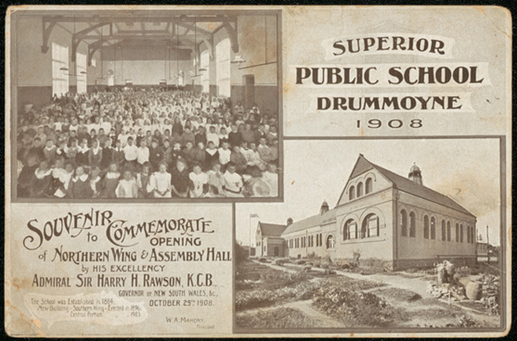
Students to examine Source 3 – Drummoyne Public School 1908 souvenir to commemorate opening of northern wing and assembly hall
Students complete a see-think-wonder using the questions below to guide their examination of source 3.
See-think-wonder prompts
See
- Who is in the photograph?
- What is in the photograph?
________________________________________________________________________________________________________________________________________________________________________________________________________________________________________________________________________________________________
Think
- Why was the photograph taken?
- Where was the photograph taken? How do you know?
- When was the photograph taken?
________________________________________________________________________________________________________________________________________________________________________________________________________________________________________________________________________________________________
Wonder
- What do you wonder about when examining the photograph?
________________________________________________________________________________________________________________________________________________________________________________________________________________________
Read Write
With reference to source 3, discuss these inquiry questions.
• How can we find out about the past at the school?
• Who can tell us about the past? What can they tell us?
• Why are there similarities and differences between the past and the present?
________________________________________________________________________________________________________________________________________________________________________________________________________________________________________________________________________________________________________________________________________________________________________________________________________________________________________________
Reflect/think Discuss
With an adult discuss ways of finding answers to the inquiry questions, for example, primary sources such as photographs, objects and personal stories of parents or other community members (oral histories).
Discuss Write
Past and present photo sorting
Find historic photographs of your school site. The NSW Department of Education photographic collection may help you find images of your school. Discuss what the photographs tell us about the past.
Comparing the past and the present
Using photographs from the previous activity compare one contemporary school photograph to one showing the same image of the school from a past generation. Discuss the similarities and differences. You can then create a Venn diagram to explore the similarities and differences of the school from the past and present.

Write
Schools of the past
Students imagine their first day at school in the past. They write a narrative that describes the buildings, playgrounds and classrooms. Students can use historic photographs of a school as stimulus to write their narrative.
_______________________________________________________________________________________________________________________________________________________________________________________________________________________________________________________________________________________________________________________________________________________________________________________________________________________________________________________________________________________________________________________________________________________________________________________________________________________________________________________________________________________________________________________________________________________________________________________________________________________________________________________________________________________________________________________________________________________________________________________________________________________________________________________________________________________________________________________________________________________________________________________________________

Reflection
Think about what you have learnt in this activity. Use the two stars and a wish structure to guide your reflection.
Star  Something that went well! | Star  Something that went well! | Wish  A goal for next time…

