HSIE: History S1 workbook
Name:
Class:

Overview
Stage 1 – The past in the present 2
This learning sequence provides a study of the impact of changing technology on people’s lives. Students investigate how technology has changed in their home and community and the impacts of changing technology. They discuss the similarities and differences of technology from the past and sequence them over time. Students explore the way technology has changed the way they communicate. They use a range of communication forms to explain the impact of changing technology on people’s lives. They draw on their own investigations and that of the local older generations such as their parents and grandparents, as well as other sources.
Key inquiry questions:
- How have changes in technology shaped our daily life?

Resources
- pens, pencils, paper
- this workbook
- help from an adult

Activity 1
During this activity you will:
- identify examples of changing technologies in your home or community
- discuss the similarities and differences of technology from the past through a range of sources and sequence them over time
- use a range of communication forms to explain how one example of changing technology affected people's lives
- examine what the sources tell them about the past.

Observe Reflect Write
Look and identify the photographs of different communication objects (see Sources 1-6 as examples) old phone, mobile phone, computers old and new, a letter, mailbox, or examples of a mail delivery service by horse, car, van or bike).
Identify each object and decide if it is from the past or the present. Discuss the similarities and differences between the different types of communication technology and sequence them from oldest to newest.
Source 1: Envelope carried on first official airmail flight between Australia and New Zealand, 1934. National Museum of Australia
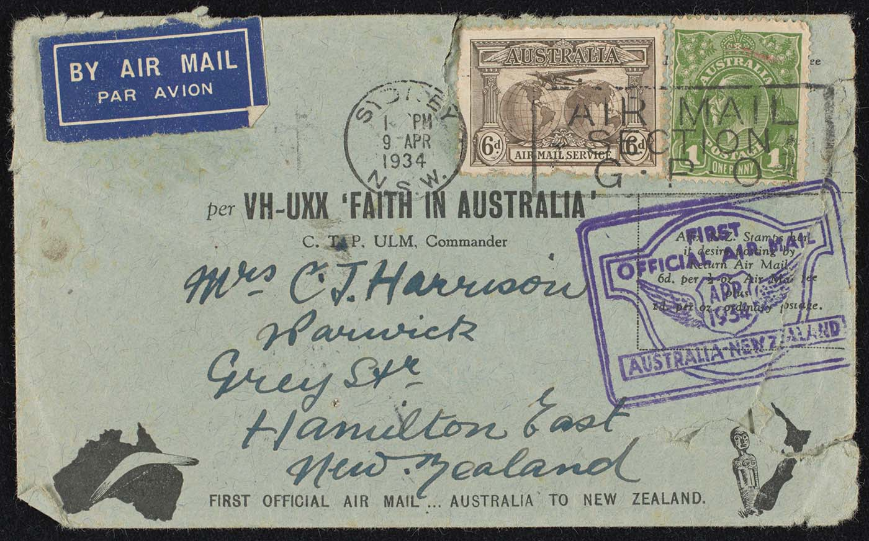
Letter carried on Australian first official airmail flight 1934

Source 2 – Meeting the mailman, circa 1884-1917
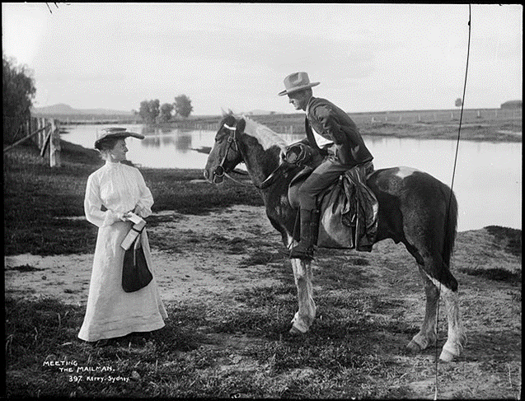
Powerhouse Museum on Flickr No known copyright restrictions
Source 3: Stamped envelope – Royal Visit by Queen Elizabeth and Duke of Edinburgh. Museums Victoria Collections
Licensed under Creative Commons Attribution 4.0 International licence
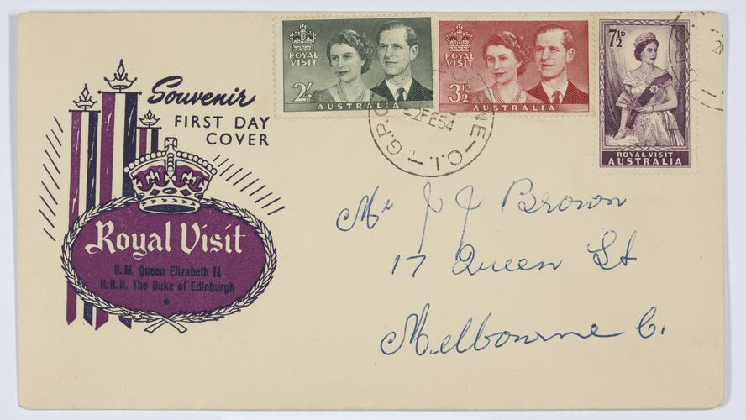
Stamped envelope - Royal visit
Source 4: A man talks on his mobile phone while standing near a conventional telephone box, which stands empty. By 2011, it was estimated that more calls were made using mobile phones than wired devices.
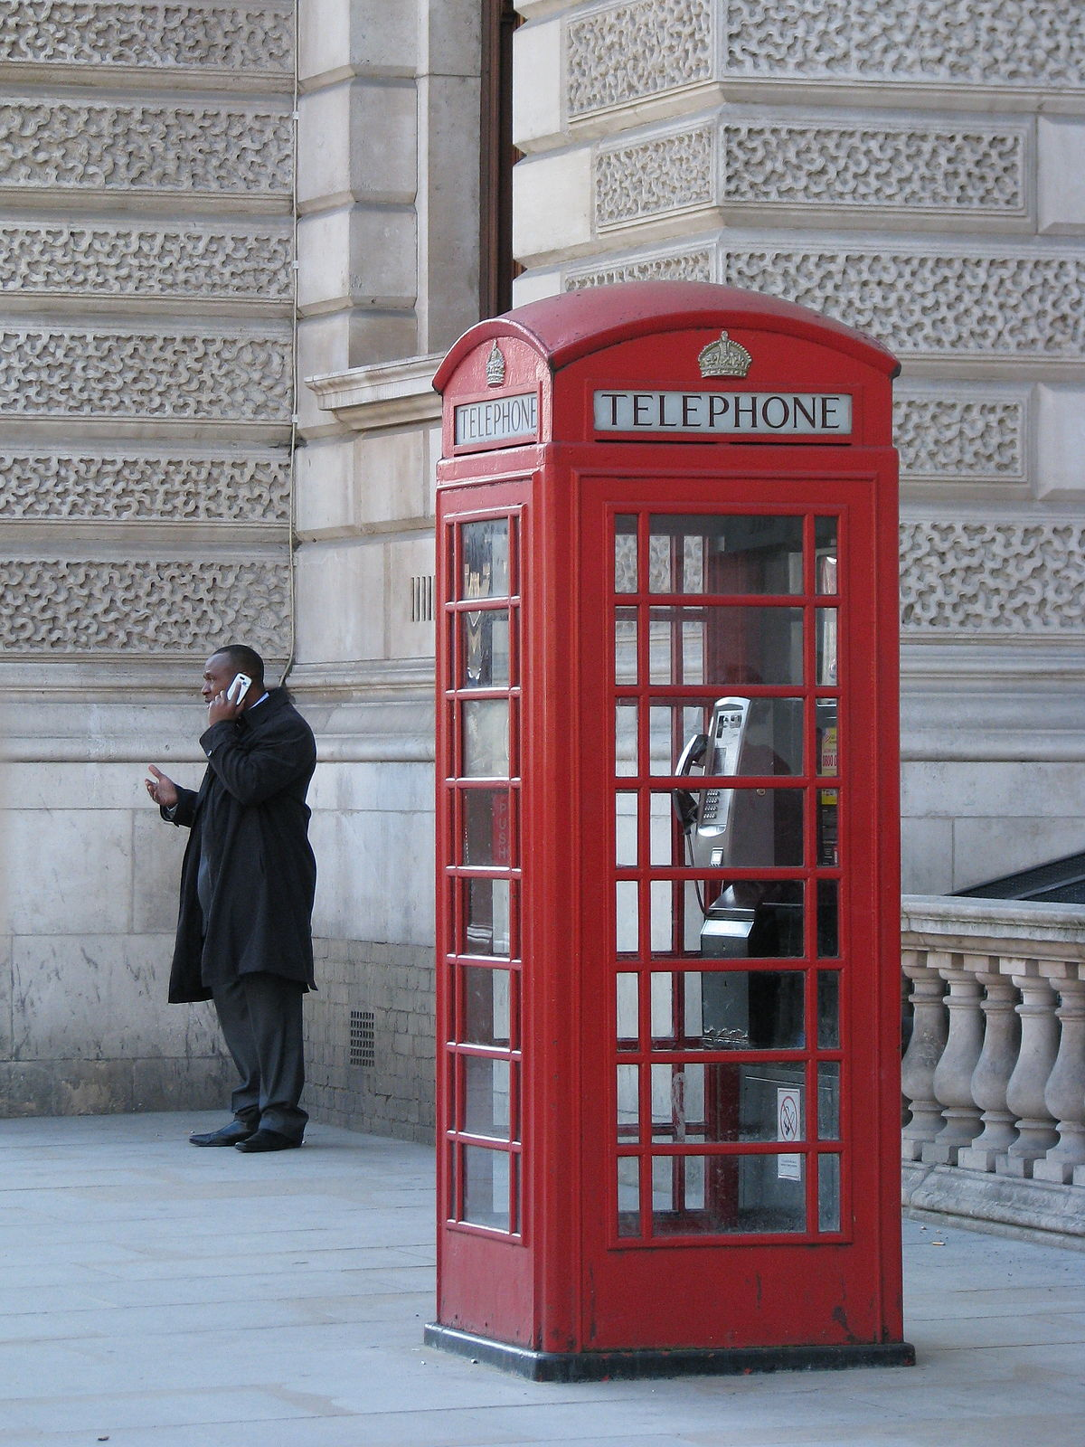
CC BY 2.0 Created 9 October 2008. Phones old and new Wikipedia commons
Source 5: Mobiles and modems, 1997–2003
Created 26 January 2007 Public Domain
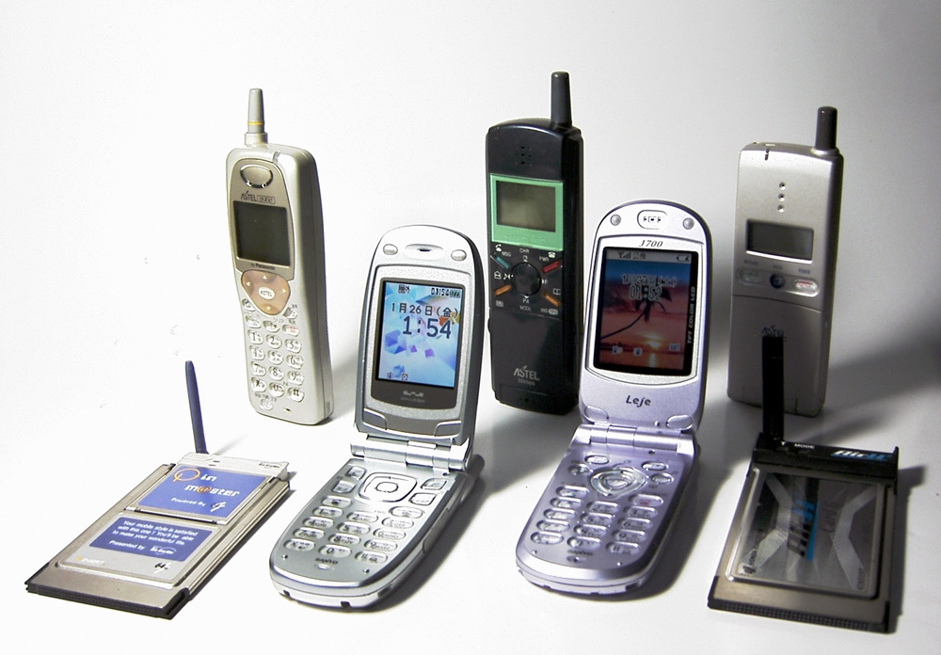
Mobile phones 1997-2003
Source 6: Old telephone landline Western Electric D1 telephone made in 1931
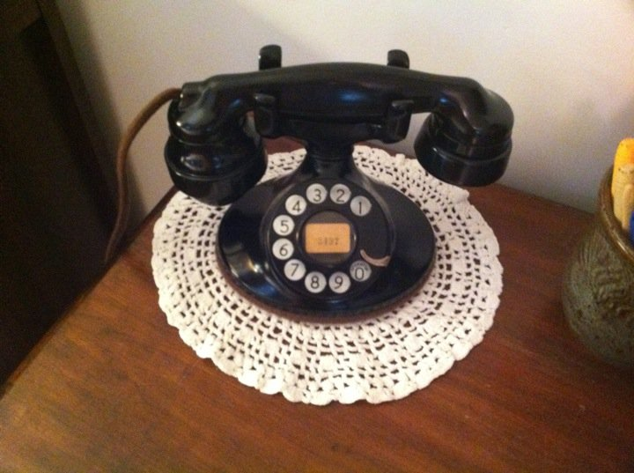
Old Telephone Line - Western Electric 202 made in 1931 CC BY-SA 3.0

Brainstorm Write
Sequence sources 1-6 from oldest to newest
Item - source | Oldest to newest
1.
2.
3.
4.
5.
6.

Brainstorm Write
After exploring the sources 1-6, think and write or draw your answer to the questions:

            - What is technology?

            - How has it changed?

            - What are the similarities and differences of technology from the past to present?

Discuss Write
Talk to your parents or grandparents to find out how technology has changed since they were children. Provide a recount of the information. Possible questions to ask in the interview:
- How has technology changed over time?
- What are the similarities and differences of technology from the past to present?
- How has changing technology affected your lives?

Interview with parents or grandparents

Activity 2
During this activity you will
- identify examples of changing technologies in your home or community
- discuss the similarities and differences of technology from the past through a range of sources and sequence them over time
- use a range of communication forms to explain how one example of changing technology affected people's lives
- examine what the sources tell you about the past.
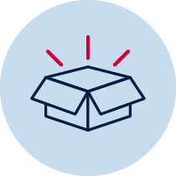 Resources – pens, pencils, paper, student workbook
Read
Stimulus – Source 7: Read the book ‘The Fabulous Friend Machine’ by Nick Bland
Watch The Fabulous Friend Machine

What are the impacts of changing phone technologies on people’s lives?
“...she was so busy sending messages, she didn’t even look up to say hello.”

The Fabulous Friend Machine by Nick Bland, Scholastic Australia, 2016

Discuss Write
Answer questions:
1. How was Popcorn a friend to the other farm animals?

2. What was the impact of Popcorn’s use of the ‘fabulous friend machine’ (mobile phone) on her friends and on herself?

3. How do we know how Popcorn’s friends felt about the mobile phone?

Brainstorm/think Discuss Write
Discuss the similarities and differences between a phone of the past and a mobile phone today. Re-examine sources 4-6.
Ask students:
- What do the phones look like?
- How are they used?
- What are the differences and similarities in their function?
- How has the use of the phone advanced?
- What form of communication did people use before phones were invented?

Discuss Brainstorm Write

Students discuss the type of phone communication they have at their home and then share their own experience with phones in their household growing up, explaining how the phone has changed.
Brainstorm, write and draw what a phone can be used for in the present compared to the past eg text messaging, internet, music.

Discuss Write
Scan through the icons on a mobile device, either projected or personally.
Identify the features of the device and discuss their benefits, e.g. taking and sending photographs and videos, Internet access, emailing.
Construct a cause and effect table showing the positive and negative impacts of present-day mobile phones and devices.
Impacts of phone technologies
Features of device | Positive benefit | Negative impact

How has technology changed the way we communicate?

ReflectDiscussWrite
The impacts of changing technology – comparing the past and the present
Students write a letter to their family that outlines changes in mail technologies. They address an envelope and insert their letter.
Letter:

Envelope:

Reflection
Think about what you have learnt in this activity. Use the two stars and a wish structure to guide your reflection.
Star  Something that went well! | Star  Something that went well! | Wish  A goal for next time…

