HSIE: History workbook S1
Name:
Class:

Overview
Stage 1 – Present and past family life
Students explore differences in family structures and roles of family members today, and how these have changed or remained the same over time.

Resources

Activity 1
- Lead pencils, coloured pencils
- paper

Activity 2
- help from an adult
- Lead pencils, coloured pencils
- paper

Activity 1
My family structure
During this activity you will construct a concept map, diagram or illustration that graphically represents the structure of your own family. Label it.
Resources – lead pencils, colour pencils, paper
Draw

The structure of my family

Read and answer these questions.
Write
- Who is in my immediate family?
____________________________________________________________________________________________________________________________________________________________________________________________________________________________________________________________________________________
- What roles do each of my family members have?
______________________________________________________________________________________________________________________________________________________________________________________________________________________________________________________________________________________________________________________________________________________________________________________________________________________________

Activity 2
Families past and present – similarities and differences. Compare and contrast the structure and roles of your immediate family and earlier families.
Resources – lead pencils, colour pencils, paper
Brainstorm/think
Discuss
Write
Draw
Questions – look at the two sources and answer these questions
- Examine the photograph of a family in source 1.
  - What relationships do you think exist between the family members?
________________________________________________________________________________________________________________________________________________________________________________________________________________________________________________________________________________________________________________________________________________________________________
- Examine the photograph in source 2 and make comparisons to source 1.
  - How have family structures from the past changed or remained the same?
________________________________________________________________________________________________________________________________________________________________________________________________________________________________________________________________________________________________________________________________________________________________________________________________________________________________________________
  - How are these two family structures the same or different to my family structure?
________________________________________________________________________________________________________________________________________________________________________________________________________________________________________________________________________________________________________________________________________________________________________________________________________________________________________________________________________________________________________________________
Source 1 – Three generations of a family
Public domain pictures. Public domain.
Source 2 – Couple with seven children in front of their cottage with bark roof, Hill End, 1871-1875
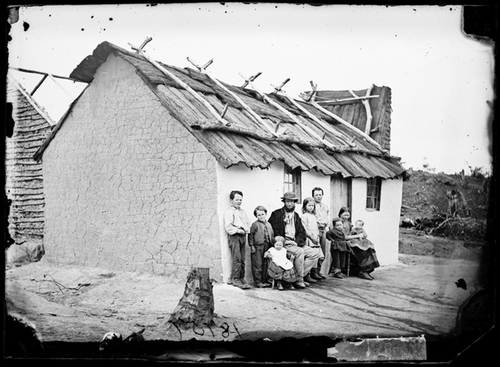
American and Australasian Photographic Company. NSW State Archives on Flickr. No known copyright restrictions.

Reflection
Think about what you have learnt in this activity. Use the two stars and a wish structure to guide your reflection.
Star  Something that went well! | Star  Something that went well! | Wish  A goal for next time…

Parent/carer advice
- These activities require students to use a range of primary and secondary information sources. Assistance may be required to interpret and analyse primary and secondary sources of information and some language used in these resources. Parents can talk to their children about their roles as family members and how family structures have changed or remained the same. Students are required to compose written work as part of these activities. Parents may need to provide support in drafting, proof-reading and editing.

