HSIE – History – S1 learning sequence

Resource considerations
This lesson sequence allows for continuity of student learning and could be adapted to fit in with your existing teaching and learning program. Students will be supported to meet outcomes from a Key Learning Area. Each task has a duration of 30 minutes and could be used in conjunction with your framework, designed using the K-6 template. This lesson sequence uses a balance of synchronous and asynchronous learning strategies. The tasks provide options for students with and without technology. They can be used with any online platform. Suggestions about how your school will plan students’ learning from home and ways to communicate with students can be found through the Learning at home, school planning page. Assessment strategies are included to ensure evidence of learning is monitored and collected.

Stage 1 learning sequence – Present and past family life
Outcomes
HT1-1 – communicates an understanding of change and continuity in family life using appropriate historical terms
Ht1-4 – demonstrates skills of historical inquiry and communication
Learning sequence overview – students explore differences in family structures and roles today, and how these have changed or remained the same over time.
Key concepts
- Continuity and change – some things change over time and others remain the same, e.g. changes and similarities in family life over time; aspects in the local community that have changed or remained the same.
- Perspectives – people from the past will have different views shaped by their experiences, e.g. different points of view about a significant person or site in the local area.
- Empathetic understanding – developing an understanding of another's views, life and decisions made, e.g. how people lived in the past in the local community and decisions they made.
Key language
- Daily lives past and present – family, family structure, family life, role, childhood, generation, parents, grandparents, immediate family, extended family, daily life, leisure, traditions, celebrations, technology, communication, similarities, differences, change, continue, causes, effects
Key inquiry question
- How has family life changed or remained the same over time?
- How can we show that the present is different from or similar to the past?

Aim of lesson sequence
- Investigate the structures of families and roles of family members in the past and the present.

Teacher notes
- Students use a variety of sources, including personal family photographs and oral histories, to investigate the structures of families and roles of family members in the past and the present.
- They also use a range of sources to investigate the similarities and differences in the daily life of children in the past and the present, with a focus on school days and leisure time.
- Note – The definition of ‘immediate family’ varies with the circumstances. Be sensitive to the social and cultural backgrounds of the students and their concept of their immediate family. In particular, be aware of the family structures and kinship system in Aboriginal and Torres Strait Islander families.

Activities
- Represent graphically the structure of their immediate family
  - Digital:
- construct a concept map, diagram or illustration that graphically represents the structure of their own family. (Note ­– As there is great diversity in family structures, enable students freedom in their representations rather than scaffolding this activity).
  - Non-digital:
- construct a concept map, diagram or illustration that graphically represents the structure of their own family. (Note ­– As there is great diversity in family structures, enable students freedom in their representations rather than scaffolding this activity).

- Compare and contrast the structure of their immediate family and earlier families
  - Digital:
- compare and contrast their immediate family with earlier families through photographs and other sources, discussing similarities and differences
- investigate the roles of present family members and compare with the roles of earlier generations using a range of sources.

  - b. Non-digital:
- compare and contrast their immediate family with earlier families through photographs and other sources, discussing similarities and differences
- investigate the roles of present family members and compare with the roles of earlier generations using a range of sources.
Questions – look at the two sources and answer these questions
- Examine the photograph of a family in source 1. Make inferences about the potential relationships between the family members.
- Examine the photograph in source 2 and make comparisons to source 1. How family structures from the past changed or remained the same? How can we illustrate the structure of our immediate family?
Source 1 – Three generations of a family
Public domain pictures. Public domain.
Source 2 – Couple with seven children in front of their cottage with bark roof, Hill End, 1871-1875
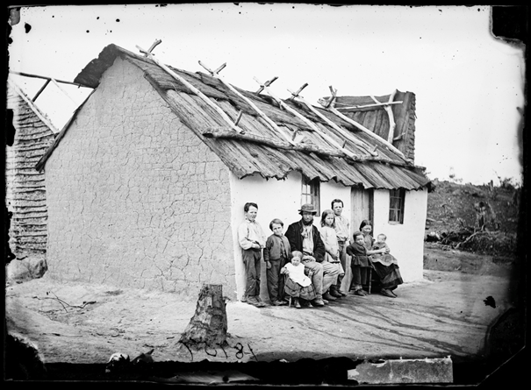
American and Australasian Photographic Company. NSW State Archives on Flickr. No known copyright restrictions.

Differentiation
Differentiation is a targeted process recognising that individuals learn at different rates and in different ways. Differentiation refers to deliberate adjustments to meet the specific learning needs of all students.
Here are some questions that you might consider when adapting the learning sequence to meet the needs of your students:
- What adjustments might you put in place for students who require additional support to access the task? For example, how will they get help when needed?
- Do you need to adjust the content to ensure it is adequately challenging and allows students to operate at their own level of thinking, skill and knowledge?
- Will you adapt the instructions so they are provided in a way that EAL/D students can easily interpret them? For example, through the use of visuals, checklists, diagrams or flow charts.
- Could you suggest ways that home language can be used as a tool to support learning? For example, bilingual dictionaries.
- Can you demonstrate that you value the Identity, culture, heritage and language of your Aboriginal students through your teaching practices?

Assessment
Some assessment opportunities could be embedded into the lesson sequence. All activities require students to demonstrate their learning. All are assessment for learning activities.

Activity resources
- Online teaching resource
Source 1: Three generations of a family Public domain pictures. Public domain.
Source 2: Couple with seven children in front of their cottage with bark roof, Hill End, 1871-1875 American and Australasian Photographic Company. NSW State Archives on Flickr.
- Student printed workbooks
- Parent/carer advice: These activities require students to use a range of primary and secondary information sources. Assistance may be required to interpret and analyse primary and secondary sources of information and some language used in these resources. Parents can talk to their children about their roles as family members and how family structures have changed or remained the same. Students are required to compose written work as part of these activities. Parents may need to provide support in drafting, proof-reading and editing.

