Personal and family histories
HSIE – history – ES1 learning sequence

Resource considerations
This lesson sequence allows for continuity of student learning and could be adapted to fit in with your existing teaching and learning program. Students will be supported to meet outcomes from a key learning area. Each task has a duration of 30 minutes and could be used in conjunction with your framework, designed using the K-6 template. This lesson sequence uses a balance of synchronous and asynchronous learning strategies. The tasks provide options for students with and without technology. They can be used with any online platform. Suggestions about how your school will plan students’ learning from home and ways to communicate with students can be found through the Learning at home, school planning page. Assessment strategies are included to ensure evidence of learning is monitored and collected.

Early Stage 1 learning sequence
Outcomes
HTe-1 – communicates stories of their own family heritage and the heritage of others
HTe-2 – demonstrates developing skills of historical inquiry and communication
Learning sequence overview – This learning sequence comprises two inquiries – sharing stories of past celebrations and celebrating special events. Students use a variety of sources including stories, photographs and personal artefacts to investigate how stories can be communicated, how stories can differ depending on who is telling them and to identify and record information about significant events.
Key concepts –
- Cause and effect – events, decisions or developments in the past that produce later actions, results or effects, for example, simple cause and effect in stories.
- Perspectives – people from the past will have different views shaped by their experiences, for example, exploration of a point of view and understanding that stories may vary depending on who is the narrator.
- Empathetic understanding – developing an understanding of another's views, life and decisions made, for example, development of an understanding of difference and similarities between families.
- Significance – importance of an event, development or individual/group, for example, the personal importance of a treasured object; significant events in students' lives and the importance and meaning of special days and holidays.
Key language – history, time, then, now, past, present, personal, family, relationships, family history, generation, lifetime, stages, treasured, similar, different, daily life, holidays, events, celebrate, commemorate, important, significant, special, point of view, respect, Aboriginal, Torres Strait Islander, Acknowledgement of Country, story, oral history, photograph, object, artefact, site, book, video, event, online, collection, library, museum
Key inquiry questions –
- What stories do other people tell me about the past?
- How can stories be told and shared?

Aim of lesson sequence
- Personal and family histories provides students with the opportunity to learn about their own history and that of their family; this may include stories from a range of other cultures and other parts of the world. As participants in their own history, students build on their knowledge and understanding of how the past is different to the present.

Teacher notes
- This learning sequence comprises two inquiries – sharing stories of past celebrations and celebrating special events. Students use a variety of sources including stories, photographs and personal artefacts to investigate how stories can be communicated, how stories can differ depending on who is telling them and to identify and record information about significant events.
- This inquiry will require input and support from a parent or carer.

Activities
- Sharing stories of past celebrations
Digital and non-digital - Look at stimulus – Source 1:
People use photographs to remember events that happened in the past. Not all stories are written down. Some are remembered by passing on stories using photographs, artefacts, oral histories, digital media and museums.
- Observe the photograph of the birthday party. Ask students
  - What do you think is happening in the photograph?
  - How many people can you see?
  - Who do you think is in the photograph?
  - Where do you think they are?
  - When do you think this photograph was taken?
  - How is this birthday celebration of the past different to a birthday celebration today?
- Students will have varying ideas about what is happening in the photograph. With a parent or carer discuss how stories can change as they are passed on from person to person as they might have a different memory or point of view of the celebration.
  - Students draw a picture of a birthday celebration they went to (it could be their own) and discuss the similarities and differences to the birthday celebration in the photo.
Source 1 – Children’s birthday party, Sam Hood, circa 1930. This is a photograph from the early 1900s of a children’s birthday party.
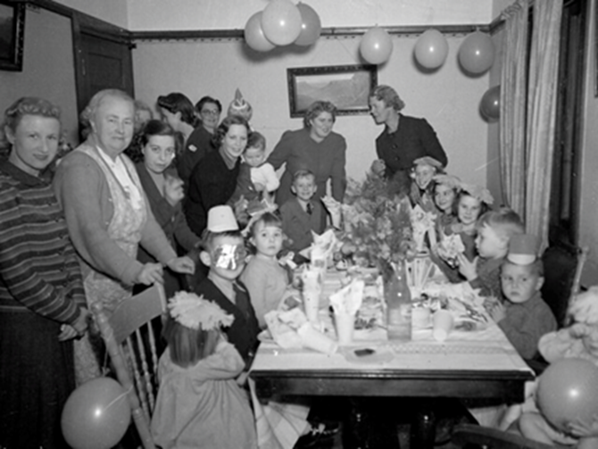
Children’s birthday party at home of Mrs Lucy Jane Moran 1930s State Library of New South Wales on Flickr. Out of copyright created before 1955
- Celebrating special events
Digital and non-digital - Discuss the questions:
- What special events do my family celebrate?
- How does my family celebrate special events?
- How do other families celebrate special events?
- What are some special events that are celebrated in Australia and other countries?
- Why are these events considered significant?
- Draw and label at least 5 special events that you share with your family. Include a family, school and local event.

Differentiation
Differentiation is a targeted process recognising that individuals learn at different rates and in different ways. Differentiation refers to deliberate adjustments to meet the specific learning needs of all students.
Here are some questions that you might consider when adapting the learning sequence to meet the needs of your students:
- What adjustments might you put in place for students who require additional support to access the task? For example, how will they get help when needed?
- Do you need to adjust the content to ensure it is adequately challenging and allows students to operate at their own level of thinking, skill and knowledge?
- Will you adapt the instructions so they are provided in a way that EAL/D students can easily interpret them? For example, through the use of visuals, checklists, diagrams or flow charts.
- Could you suggest ways that home language can be used as a tool to support learning? For example, bilingual dictionaries.
- Can you demonstrate that you value the Identity, culture, heritage and language of your Aboriginal students through your teaching practices?

Assessment
Some assessment opportunities could be embedded into the lesson sequence. All activities require students to demonstrate their learning. All are assessment for learning activities. The ‘two stars and a wish’ reflection strategy has been included in the student workbook.

Activity resources
- Online teaching resource
  - Source 1 – Children’s birthday party, Sam Hood, circa 1930. Children’s birthday party at home of Mrs Lucy Jane Moran 1930s. This is a photograph from the early 1900s of a children’s birthday party. State Library of New South Wales on Flickr. No known copyright restrictions
- Student printed workbooks
- Parent/carer advice: These activities require students to use a range of primary and secondary information sources. Assistance may be required to interpret and analyse primary and secondary sources of information and some language used in these resources. Parents can talk to their children about how they commemorate past events that are important to them. They can discuss how the stories of families and the past can be communicated, for example, through photographs, artefacts, books, oral histories, digital media and museums. Students are required to compose written work as part of these activities. Parents may need to provide support in drafting, proof-reading and editing.

