My family and other families
This learning sequence comprises two inquiries.

Topic – Personal and family histories
5 weeks – 90 minutes per week

Key inquiry questions
- What is my history and how do I know?
- What stories do other people tell me about the past?

Overview
Personal and family histories provides students with the opportunity to learn about their own history and that of their family; this may include stories from a range of other cultures and other parts of the world. As participants in their own history, students build on their knowledge and understanding of how the past is different to the present.
This learning sequence includes two inquiries – my family and other families. Students use a variety of sources, including personal family photographs and written and oral stories, to investigate their family history and the different structures of families in their class.

Outcomes
A student:
HTe-1 communicates stories of their own family heritage and the heritage of others
HTe-2 demonstrates developing skills of historical inquiry and communication

Content
Who the people in their family are, where they were born and raised and how they are related to each other (ACHHK001)
How the stories of families and the past can be communicated, for example through photographs, artefacts, books, oral histories, digital media and museums (ACHHK004)
Students:
- identify people in their immediate families and show relationships between family members
- discuss where members of their families were born and locate countries of origin of students' families in the class
- use a variety of sources including photographs or a treasured object from their homes, to recount stories about their families and discuss how sources are used to answer the question 'How do we know?'
- discuss then and now; past and present.
The different structures of families and family groups today, and what they have in common (ACHHK002)
Students:
- identify and record similarities and differences between families, eg the number of children in the family, family languages spoken at home, number of adults in the immediate family
- compare and contrast various family groups through photographs and stories and identify differences between past and present.

Historical inquiry skills

Comprehension: chronology, terms and concepts
- respond by demonstrating active listening behaviour, through discussion and by recalling and retelling stories
- sequence familiar objects and events (ACHHS015)
- distinguish between the past, present and future (ACHHS016)

Use of sources
- explore and use a range of sources about the past (ACHHS018)
- identify and compare features of objects from the past and present (ACHHS019)

Perspectives
- explore a point of view (ACHHS020)

Empathetic understanding
- recognise differences and similarities between individuals and families in the past and present

Research
- pose questions about the past using sources provided (ACHHS017)

Explanation and communication
- develop a narrative about the past (ACHHS021)
- use a range of communication forms (oral, graphic, written, role play) and digital technologies. (ACHHS022)

Selected historical concepts
Continuity and change – some things change over time and others remain the same, for example, changes and continuities in students' own lifetimes and that of their families.
Empathetic understanding – developing an understanding of another's views, life and decisions made, for example, development of an understanding of difference and similarities between families.
Syllabus extracts are quoted from History K-10 Syllabus © 2012 NSW Education Standards Authority (NESA) for and on behalf of the Crown in right of the State of New South Wales.

Assessment
All activities require students to demonstrate their learning. All are assessment for learning activities.

Vocabulary
Listen, observe, explore, examine, identify, record, describe, sequence, compare, explain, discuss, illustrate, write, present, reflect
Story, photograph, object, artefact, book, video, event, source, point of view
Holidays, events, celebrate, significant, special, family

Teaching and learning activities
This learning sequence comprises two inquiries.

Inquiry 1 – my family
Students explore who the people in their family are, where they were born or raised and how they are related to each other. They use a variety of sources to recount information about their families and discuss how sources are used to answer questions. Students identify differences between their family in the past and present.

Stimulus
Discuss the term ‘family’. Note – the definition of ‘family’ varies for each student. Be sensitive to the social and cultural backgrounds of the students and their concept of their family. In particular, be aware of the family structures and kinship system in Aboriginal and Torres Strait Islander families.
This is a photograph from the early 1900s of a family of eleven. Observe the photograph of the family. How many people can you see? Who is in the photograph and what role do you think they play? What is different and similar about this family in the past to families now? Identify the key ideas about what makes a family.
Source 1 – Portrait of a family group of eleven people, Albert Jones, 1910-1918
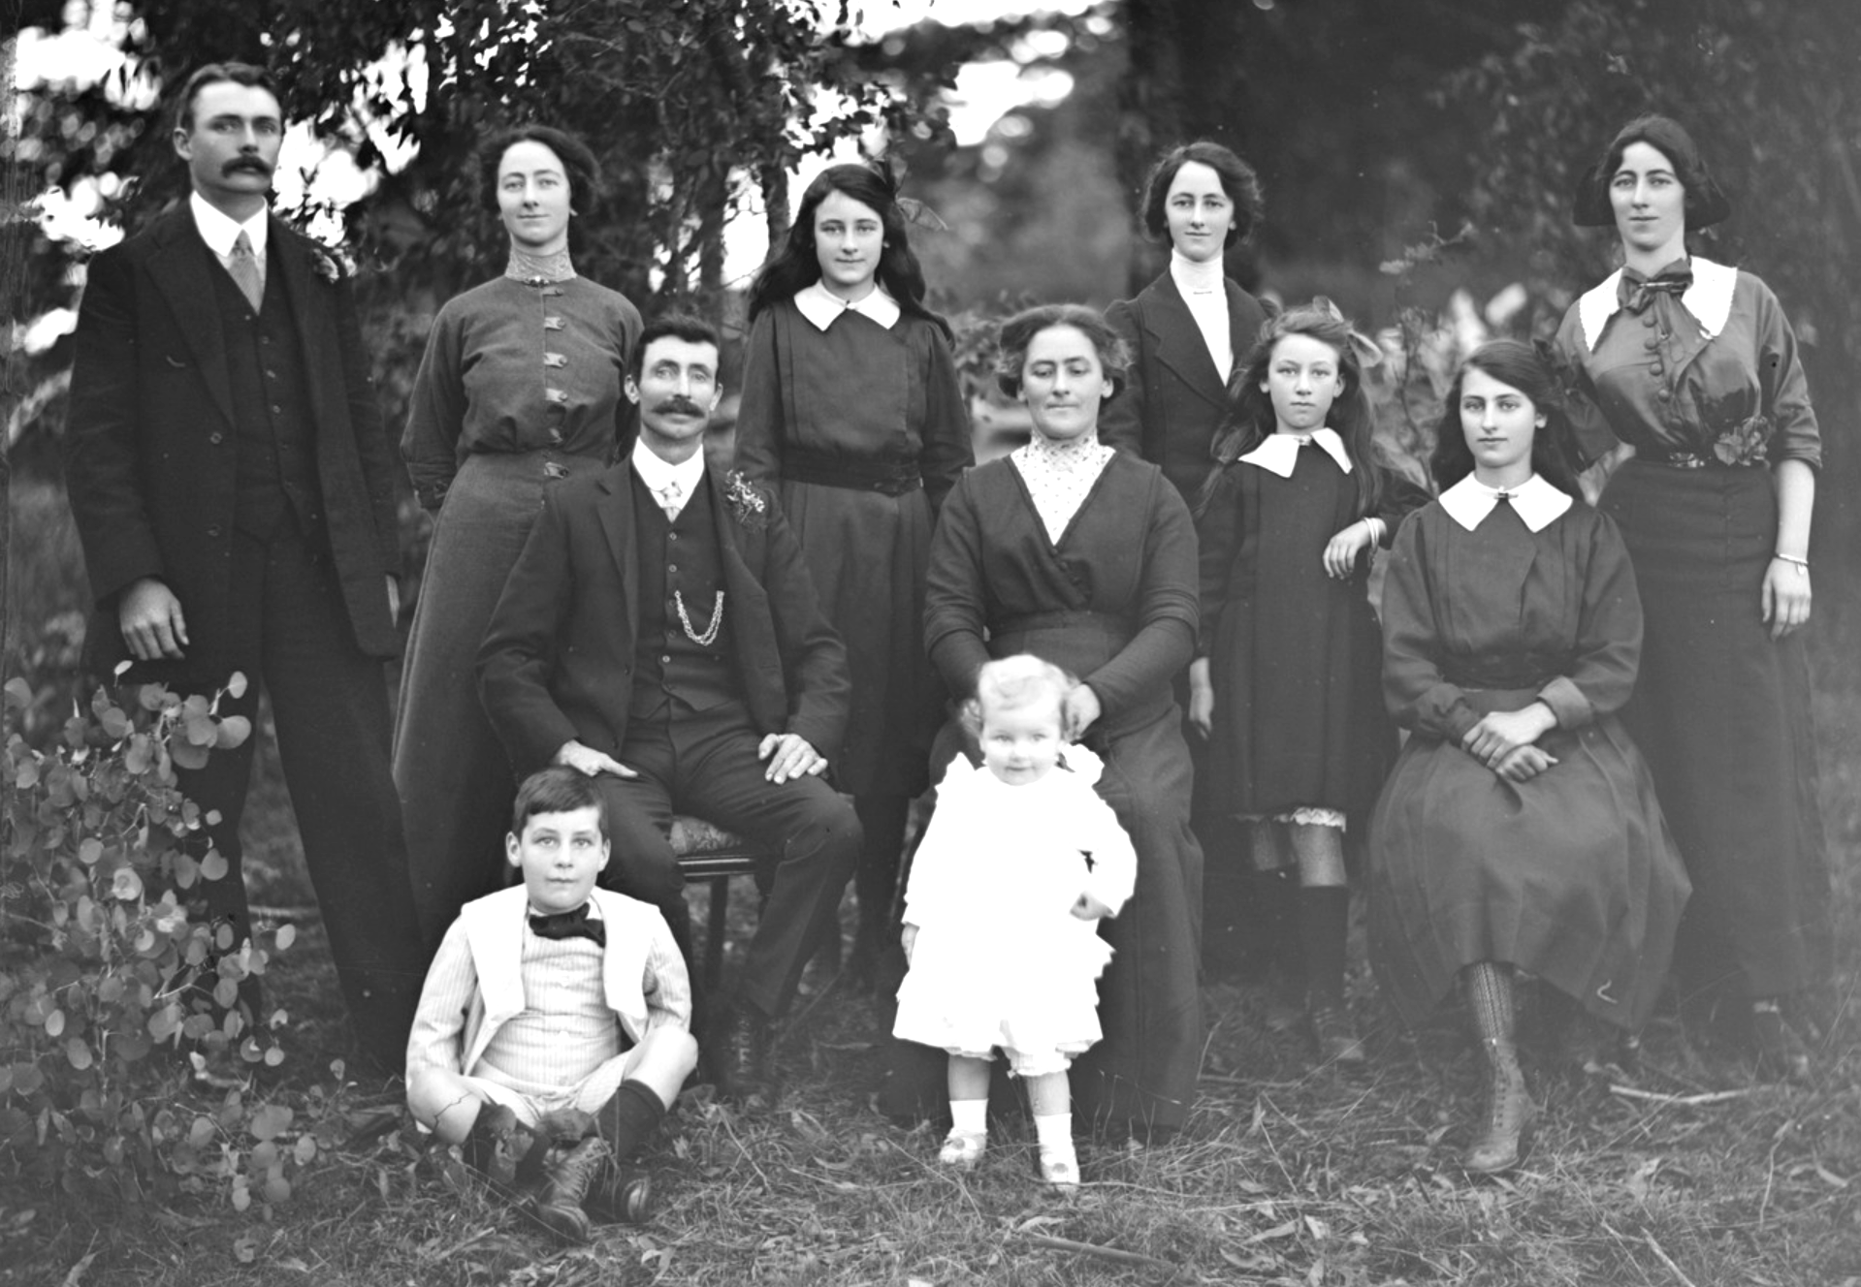
Albert Jones views of the Diamond Creek and Hurstbridge areas
State Library of Victoria. Out of copyright

Historical inquiry step 1 – question
After observing the photograph, and guided by the syllabus dot points, generate a class set of inquiry questions, for example:
- Who are the members of my family and how are we related?
- How can I find out about where members of my family were born?
- Where does my family come from?
- How can I learn more about my past?
Note – Inquiry questions may need to be redesigned through the historical inquiry process.

Historical inquiry steps 2 and 3 – research and analyse
Members of my family
Read a story about a family. List the members of the family and discuss the family relationships in the story. Choose three members of the family and put them in order from youngest to oldest. An example of a story that could be used is Source 2 – Tom Tom by Rosemary Sullivan and Dee Huxley, Working Title Press, 2010.
Students create a drawing of their family and label each member. They explain who the members of their family are and how they are related to each other.
Students choose four members of their family and draw them in sequential order from youngest to oldest.
Note – refer to the Guide to using picture books in history K–10 (Department of Education 2017) for learning activities relating to source 2.
My family and where we come from
Read a story that includes families that are Australian but come from different places. An example of a story that could be used is Source 3 – I’m Australian Too by Mem Fox, Scholastic Australia, 2017.
Explain to students that Australian families come from all different places and have all different pasts. Some families have members that are all born in Australia and other families have members that were born overseas and moved to Australia.
Identify different ways that families can share their stories about the past and pass on information. These include writing, talking and sharing photographs. Ask students to talk to their family about their family past and bring to school photographs, drawings, artefacts or written information about their family. On a map locate and label the different countries that families come from and display the information students have gathered.
Discuss the difference between the terms then, now, past, present and future. Highlight to students that the information that they found out about their family was from the past or then and that we are living in the present or now and that the future is still to come. Ask students to create three images of their family in the past, the present and the future. Students could use digital, graphic or written communication to portray this information.

Historical inquiry step 4 – evaluate
Ask the students to recall some of the sources used to collect information about family celebrations of the past. Discuss the reliability of the sources. Whose view is presented? What might be missing or forgotten?

Historical inquiry step 5 – communicate
Family photograph narratives
Using a family photograph from the past, students create either a written or oral story. The story takes the viewpoint of one person in the portrait to describe to the class what is happening in the photograph, who the members of their family are and how they are related.
Reflection
Students reflect on the historical inquiry process, reflecting on what they learnt, how they learnt it and what else they would like to find out.

Inquiry 2 – other families
Students investigate, identify and record similarities and differences between families and compare and contrast various family groups. They compare and contrast various family groups through various sources such as photographs and stories.

Stimulus
Discuss the terms ‘similar’ and ‘different’.
Examine the photograph of a family in source 1. Discuss the possible relationships between the family members.
Examine the photograph in source 2 and make comparisons to source 1. How are the families different? How are the families similar? For example, the number of adults or children or the members of the family.
Source 1 – Family photograph taken on 1 January 1940
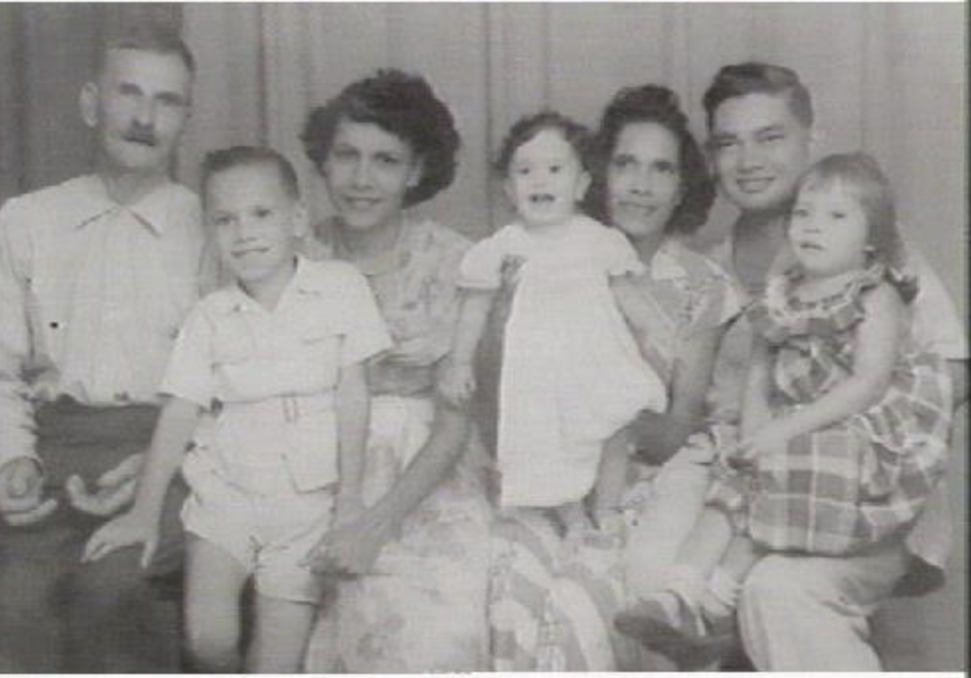
Northern Territory Library. Public domain
Source 2 – Family Christmas party, 2015
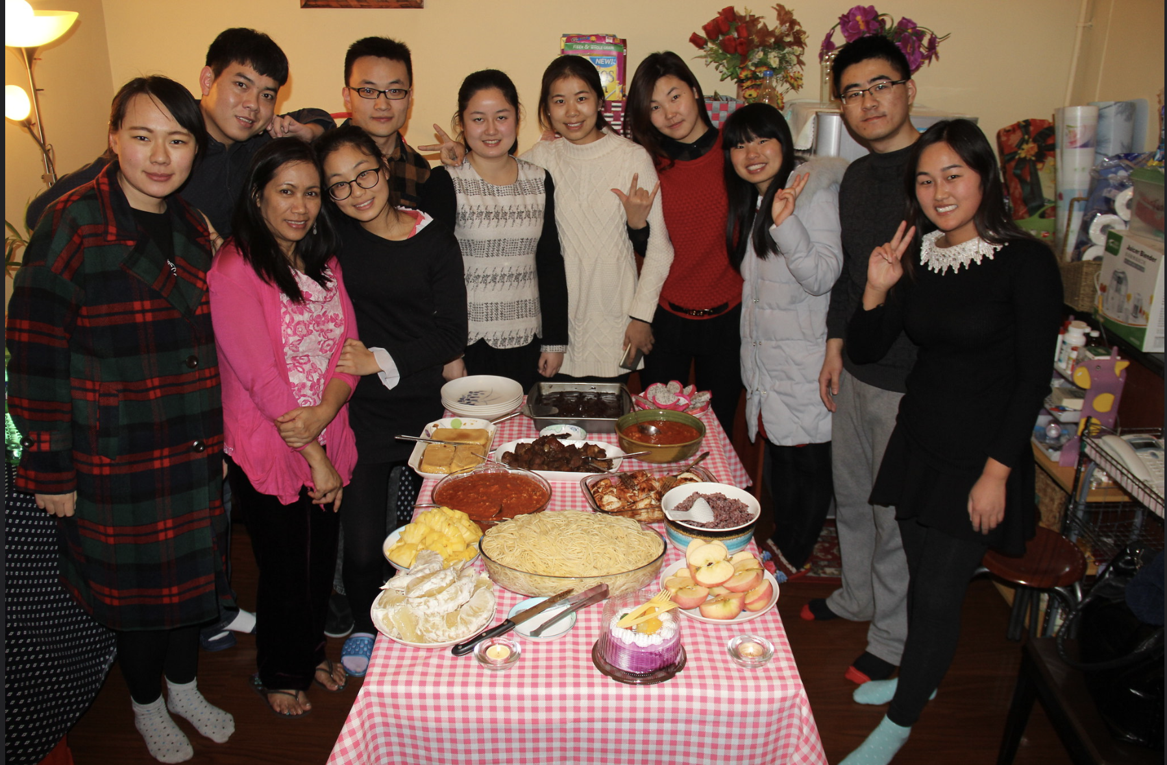
Flickr. Public domain

Historical inquiry step 1 – question

After observing the photographs, and guided by the syllabus dot points, generate a class set of inquiry questions, for example:
- What can make families similar or different?
- How is my family similar to my classmates?
- How is my family different to my classmates?
- What would I like to learn about a family that is different to mine?
Note – inquiry questions may need to be redesigned through the historical inquiry process.

Historical inquiry steps 2 and 3 – research and analyse
Different types of families
Read a collection of stories that include a variety of different family structures. Examples of stories that could be used are Source 3 – The family book by Todd Parr, Little, Brown and Company, 2016, or Source 4 – My mob going to the beach by Silvia Emmerton, Black Ink Press, 2004.
Explain to students that all families come in different forms. Some are similar to the family we live with at home and some are different. Ask students to identify two ways that their family is similar to the families in the stories and two ways their family is different to the families in the stories.
The families in our class
Ask students to illustrate a picture that represents their family. Students could create their family picture using digital technology, make a collage or draw a picture to portray this information.
Display the family illustrations that students have created in a space in the classroom. Ask students to observe all the different families that exist in their class.
Students choose one family of a classmate to use a see-think-wonder strategy to identify the similarities and difference between the two families. Use the See, Think, Wonder prompts to guide their examination.
See-think-wonder prompts
See
- Who is in the picture?
- How many people are in the picture?
- What is something that is similar to your family?
- What is something that is different to your family?
Think
- What are the ages of the people in the picture?
- What are the relationships of the people to each other?
Wonder
- What do you wonder about the family in the picture? Come up with a question that you would like to ask your classmate to learn something about their family.
Provide students with time to discuss their questions with their classmate and share the answer with the rest of the class.

Historical inquiry step 4 – evaluate
Discuss the reliability of photographs and stories of different family structures. Do they provide a true representation of different types of families and how they can be similar or different? Do the inquiry questions need to be redesigned as a result of analysing and evaluating sources?

Historical inquiry step 5 – communicate
Design a family
Students create an artwork that includes their family and a family that has similarities and differences to their family. Students share their artwork with the class and explain the similarities and differences.
Reflection
Students reflect on the historical inquiry process, reflecting on what they learnt, how they learnt it and what else they would like to find out.

Resources
Picture books
Tom Tom by Rosemary Sullivan and Dee Huxley, Working Title Press, 2010
I’m Australian Too by Mem Fox, Scholastic Australia, 2017
The family book by Todd Parr, Little, Brown and Company, 2016
My mob going to the beach by Silvia Emmerton, Black Ink Press, 2004
Digital collections
Historical photograph sets on Flickr, State Library of NSW
Trove, National Library of Australia

