Geography - stage 5 - environmental change and management
Note for teachers:
Students are guided in completing an investigation into different marine environments and environmental change through the use of plastics in the environment. This sample virtual program is intended for 3 weeks of learning and includes several lessons and online resources.
Worksheets and resources are found at the end of the learning sequence.

This document references the Geography K-10 Syllabus © 2015 Copyright NSW Education Standards Authority for and on behalf of the Crown in right of the State of New South Wales.

1.0 Environments, environmental change
Students:
- investigate the role and importance of natural environments
- investigate human-induced environmental changes across a range of scales

1.1 Natural environments across a range of scales and human-induced environmental changes
Teachers note - an understanding of marine environments and biomes is essential for student learning. Students will need access to ICT throughout most of the activities, but alternatives have been suggested. Students will need prior knowledge and definitions of:
Environment - The living and non-living elements of the Earth’s surface and atmosphere. Where unqualified, it includes human changes to the Earth’s surface for example oceans, seas, rivers.
Environmental process - processes of an ecosystem that supports human life and economy.

Activities:
- Brainstorm the different biomes/ecosystems that are present in the natural environment.
- Using a blank world map, label the distribution of ecosystems and using a choropleth mapping technique to show global biome distribution.
- Research and rank ‘which ecosystems are at a greater risk?’ Use the ‘Quick, write’ strategy to answer the following:
  - Which factors are contributing to environmental change?
  - Why is this important?
- Use the Plastinography online learning website and complete all six lessons. Click on the circles in each lesson to reveal further information. Use the navigation button in the top left to move through all the lessons. Complete each of the following steps:
- identify the plastic and the natural environment in each image
- identify the sources in each section (circle) of the lessons
- watch each video and complete a summary of each video
- read all the provided external links.
- complete the questions in the Plastinography worksheet (appendix 1).
- Use Plastic adrift to map plastic movement from five locations from around the world. Examine and describe the movement in the different marine environments.
- Examine the Plastic adrift and the Earth nullschool websites to predict future movement of plastics.
  - The Plastic adrift website shows movement of plastics over a 10 year period; placing the duck over a particular place shows projected plastic movements over a period time.
  - The Earth nullschool website, select the earth menu bar at the bottom left corner then mode – ocean, animate – current, overlay – ocean; this shows the movement of ocean currents.
  - Using both maps, make predictions on a blank world map of where the plastics will potential move to beyond a 10 year period. Justify the predictions in an extended response that uses data and geographical information.
- View the map below, student’s research and complete the following questions about marine environments -
- What are marine environments? What are the types? How do ocean’s support life?
- What are ocean currents? What determines direction of the ocean current?
- What are gyres? What is the role of Coriolis effect in the movement of plastics?
- How does the pathway of marine plastics shown on the website relate to Australia? And your use of plastics?
- What is the likely effect of the plastics in the ocean on wildlife?
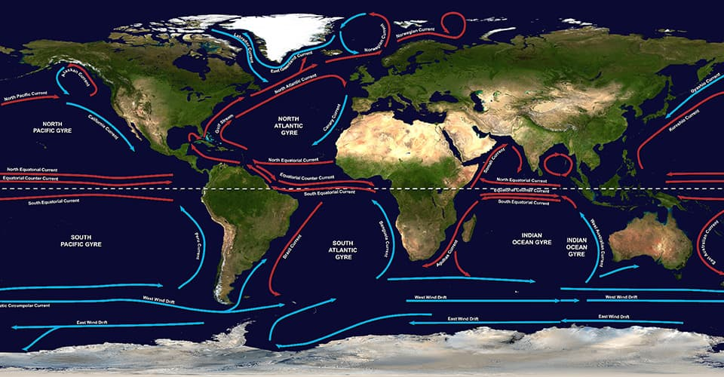
Image of worldwide gyres from National Ocean Services.
- Using the Great Pacific Garbage Patch (GPGP) website and further research, complete the following questions and produce a report for the government. Read the information, interpret the diagrams and watch the GPGP videos from the GPGP website and Parks Australia. Complete the following questions:
- What is the GPGP? How have humans changed the environment?
- How much plastics floats in the GPGP?
- What types of plastic float in the GPGP?
- What are the effects on marine life and humans?
- How did the ocean clean-up conduct its research?
- What is the government’s role in managing the GPGP?
Include a bibliography in the report.
Further information and resources to help students answer the research questions can be found at:
  - Geoscience Ocean Energy
  - Mapping Microplastics
  - BOM
  - CSIRO
  - National Ocean Service.

2.0 Investigative study
Students:
- investigate the biophysical processes essential to the functioning of the selected
- environment
- investigate the causes, extent and consequences of the environmental change
- investigate the management of the environmental change

2.1 Marine environments in Australia and a comparative study with at least one other country
Teachers’ note – if producing the factsheet through Venngage a free account will need to be established prior to starting the activity. Alternatively, the task can be completed offline. Access to the internet for research and development of the fact sheet is required or teachers may choose to provide hard copy sources of information.
Activities:
- Using a Frayer diagram and further research, answer the following questions -
- What is currently happening to marine environments in Australia and one other country of your choosing?
- Why is it a problem in both countries?
- What alternatives/solutions do we have?
- Investigate your own ecological footprint by using the ecological footprint calculator. Explain how you might reduce your impact on marine environments. Produce a structured response with the inclusion of geographical information and data.
- The United Nations Environment Programme (UNEP) wishes to promote the protection and sustainable management of the world’s marine environments. You have been commission by UNEP to create an environment fact sheet for both Australia and another country of your choice. The fact sheet must focus on a marine environment (for example - salt marshes, intertidal zones, estuaries, lagoons, mangroves, coral reef).
Your fact sheet must address these three areas:
- How does the biophysical processes operating in the marine environment maintain its functioning?
- What are the causes, extent and consequences of change in the marine environment?
- How effective is the management responses in achieving environmental sustainability for the marine environment?
Your fact sheet must include diagrams, statistics and a map.
For more information students could use How to create a fact sheet or Environmental Data Explorer Posters.

Appendix 1 - plastinography worksheet
Use the Plastinography online learning website and complete all six lessons. Complete the related questions after each lesson

Lesson 1
How does plastic reach the ocean? Identify a variety of plastic examples in your response.

Lesson 2
What does plastic do in the ocean? Provide primary and secondary sources in your response.

Lesson 3
How does the ocean work? Why do the oceans matter? Use information from the videos.

Lesson 4
Where does my plastic go? What is the great Pacific Garbage Patch? Use specific examples of the natural environment.

Lesson 5
How does plastic impact marine life? Use data in your response.

Lesson 6
What can you do about plastics? Relate to your own plastic use and the impact on the natural environment.

Extension Question: Why can't I see any plastic on my beach? - Why can't we just clean it up? - What can you do to help?

Resources
- Printable free world maps free-world-maps.com/printable-blank-world-maps
- Quick write prompts app.education.nsw.gov.au/digital-learning-selector/LearningActivity/Card
- Choropleth maps by ARCGIS www.arcgis.com/apps/MapJournal/index
- International union for the conservation of nature iucn.org/theme/ecosystem-management/our-work/red-list-ecosystems
- Plastinography by UNSW plastinography.org/lesson1/how-does-plastic-reach-the-ocean
- Plastic Adrift plasticadrift.org/
- Earth Nullschool model earth.nullschool.net/about
- US National Ocean Service oceanservice.noaa.gov/facts/gyre
- The Ocean Cleanup, Great Pacific Garbage Patch theoceancleanup.com/great-pacific-garbage-patch
- Parks Australia - Australian Marine Parks parksaustralia.gov.au/marine
- Geoscience Australia Ocean Energy ga.gov.au/scientific-topics/energy/resources/other-renewable-energy-resources/ocean-energy
- GIS lounge, Mapping Microplastics gislounge.com/monitoring-mapping-microplastics-marine-ecosystems
- Bureau of Meterology bom.gov.au/oceanography/forecasts
- Commonwealth Scientific and Industrial Research Organisation (CSIRO) csiro.au/en/Research/Environment/Oceans-and-coasts/Australasian-ocean-currents
- United Nations Environment Programme unenvironment.org/explore-topics/oceans-seas/what-we-do/working-regional-seas
- Venngage venngage.com/blog/how-to-create-a-fact-sheet
- Ecological Footprint Calculator wwf.org.au/get-involved/change-the-way-you-live/ecological-footprint-calculator
- Frayer Diagram app.education.nsw.gov.au/digital-learning-selector/LearningActivity

