Stage 4 Geography: Landscapes and Landforms
This resource has been designed to support teachers by providing a range of tasks based on syllabus content. Tasks can be incorporated into context driven teaching and learning programs in full or can be used to supplement existing programs. All content is textbook non-specific to ensure equity.
Contents
Overview 2
Key inquiry questions 2
Outcomes 2
Capacity matrix 4
Learning sequence 1: Introducing landscapes and landforms 5
Defining and identifying landscapes and landforms 5
Geomorphic processes that create landforms 10
Examination of one landscape and its distinctive landforms 12
Learning sequence 2: The value of landscapes and landforms 17
The value of Uluru 17
The value of Mt Fuji 20
Learning sequence 3: Changing landscapes 22
The ways people utilise, change, and impact landscapes 22
Examination of gully erosion in Northern Queensland 24
Learning sequence 4: Landscape management and protection 26
Ways people manage and protect landscapes 26
Aboriginal and Torres Strait Islander peoples’ knowledge and protection of Australia’s landscapes and landforms 27
Management and protection strategies for coastal landscapes 30
Learning sequence 5: Geomorphic hazards 31
Geomorphic hazard: White Island New Zealand Volcano 31
Assessment task 36
Outcomes 36
Syllabus content 36
Task: Landscapes or landforms at risk 36
Marking criteria 38
Appendix: Capacity matrix 40
References 43

Overview
Students explore landscapes and landforms using examples from Australia and throughout the world. They explain processes that create landscapes and shape individual landforms and describe the value of landscapes and landforms to different people. Students examine issues of land degradation and ways to manage and protect landscapes and landforms. Students also investigate natural hazards associated with landscapes and people’s responses to that hazard.

Key inquiry questions
- Why is there a diversity of landscapes and landforms on Earth?
- What environmental and human processes form and transform landscapes and landforms?
- Why do people value landscapes and landforms?
- To what extent are landscapes and landforms sustainably managed and protected?

Outcomes
A student:
- GE4-1 locates and describes the diverse features and characteristics of a range of places and environments
- GE4-2 describes processes and influences that form and transform places and environments
- GE4-4 examines perspectives of people and organisations on a range of geographical issues
- GE4-5 discusses management of places and environments for their sustainability
- GE4-7 acquires and processes geographical information by selecting and using geographical tools for inquiry
- GE4-8 communicates geographical information using a variety of strategies.
Outcomes and key terms referred to in this document are from Geography K-10 Syllabus © 2015 NSW Education Standards Authority (NESA) for and on behalf of the Crown in right of the State of New South Wales.

Capacity matrix
Note: Prior to this activity, students should be explicitly taught definitions for the key terms ‘landscapes’ and ‘landforms’.
Explain to the class how to use the Capacity matrix (Appendix). Ensure students understand and can distinguish between information, knowledge, know-how, and wisdom categories in the matrix.
The Capacity matrix can be used as a formative assessment tool that clarifies student understanding of course concepts for the duration of the learning sequence. For more information, see Quality Learning Australasia’s The Capacity Matrix. Please note that teachers need to register to access the free resources on this site.
Review the Capacity matrix for geographical concepts and terms relating to the topic ‘Landscapes and Landforms’. Using different colours for the matrix criteria, shade or tick where you think you are according to the matrix categories for each geographical concept. The criteria for the matrix include:
- information – at this level, you have heard of the term and/or you can recall basic facts about it
- knowledge – at this level, you can explain and know what the term or concept means
- know-how – at this level, you can draw connections between this geographical term or concept and relate them to other concepts or situations
- wisdom – at this level, you can use the term or concept in new contexts or teach others.
You will revisit this matrix throughout the learning sequence.

Learning sequence 1: Introducing landscapes and landforms
Students:
- investigate different landscapes and the geomorphic processes that create distinctive landforms, for example: (ACHGK048, ACHGK050)
- identification of a variety of landscapes and landforms
- explanation of geomorphic processes that create landforms for example weathering, erosion, deposition, tectonic activity
- examination of ONE landscape and its distinctive landforms.

Defining and identifying landscapes and landforms
Make notes for each of the geographical terms, ‘landscapes’ and ‘landforms’.
With a partner, scroll down to Australia on Google Earth. On a blackline map of Australia from d-maps, shade Australia’s major landscapes. Ensure you include:
- deserts
- mountains
- coastal plains.
Note: Explicitly teach the geographical skills of Latitude and longitude (4:24). Ensure you adequately explain The Four Hemispheres of the Earth (2:11) and basic rules associated with the skill, for example, that latitude is always written before longitude. A little tip for students to remember is to follow alphabetical order.
The class will require access to the internet to complete the Where on Google Earth is Carmen Sandiego game.
In pairs, play the Where on Google Earth is Carmen Sandiego game to learn about latitude and longitude. Click ‘Begin the chase’ to launch the game.
Using ICT and sites such as Grand Canyon, Glaciers: Ice on the Move, Great Ocean Walk, and 16 Most Famous Volcanoes In The World, conduct a scavenger hunt to locate each of the landscapes in the table below. Prepare a Google Slides show of the images and present this to the class or share on the class site. Remember to reference where images were found using Table 1.
Table 1 – Landscape scavenger hunt template
Landscape | Examples of landforms | Image source record
Coastline | bay  cliff  headland
Desert | dunes  mesa  buttes  canyons  oasis
Glacial | glacier  u-shaped valley
Mountain | waterfall  valley
Volcanic | volcano  hot springs
Note: The ability to construct photo sketches is a valuable geographical skill. You will need to explain and teach this skill explicitly. It allows students to make a quick summary of the information shown in a photographic image and enables them to highlight and annotate the key elements of the landscape or place photographed. Visit GeogSpace: Photo Sketching: Teacher notes [PDF 335.78KB] and Photo sketch video (2:06) for more information and an example of this skill.
Construct a photo sketch of the photograph of your choice from the scavenger hunt completed in the previous exercise or use the image below in Figure 1. Photo sketch video (2:06) outlines how to draw a photo sketch in geography.
Figure 1 – Mountain
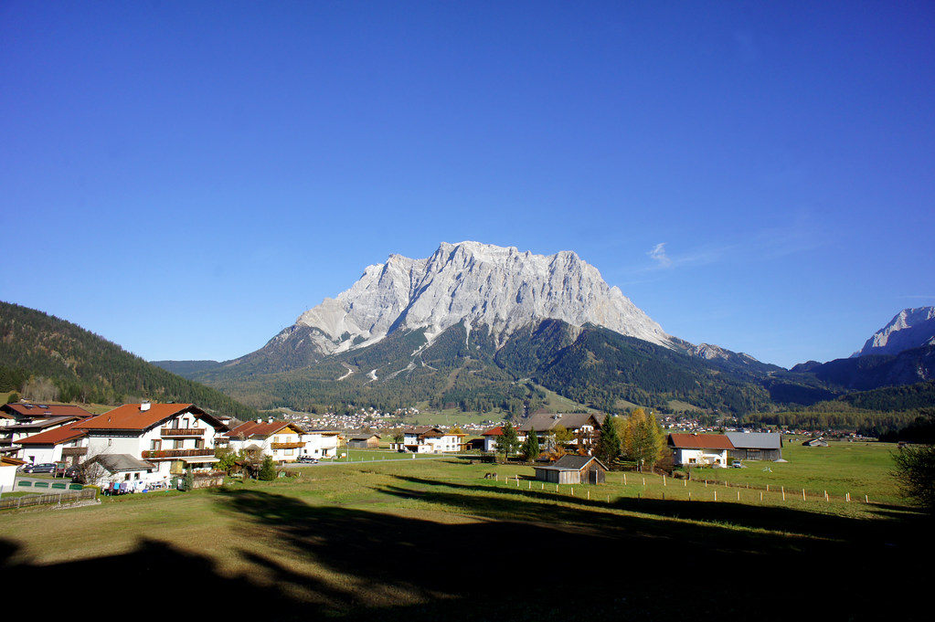
"mountain" by barnyz is licensed under CC BY-NC-ND 2.0.
Respond to the following about the photo sketch:
- What type of landscape does your photo sketch illustrate?
- Identify any landforms illustrated in your photo sketch.
- Describe the landscape drawn in your photo sketch.
- Describe any human aspects illustrated in your photo sketch.
Think about your local environment and answer the following questions:
- What type of landscapes do you see in and around your home or school?
- Are there any distinguishing features that help identify the landscape in and around your home or school?
- Are there any unique landforms you can identify in your local area?
Note: Explicitly teach sketch mapping. A sketch map is a labelled drawing outlining the main geographical features of a place. Use REVISE: How to draw a sketch map – Geography (11:26) to revisit steps in drawing a sketch map.
You could use this point in the learning sequence as an opportunity to walk around the school grounds and make observations as a class. Identify things required for a sketch map and have students identify what things should or could be excluded.
Identify and critically observe an area in your local environment. Take note of physical and human features in the landscape. Draw a sketch map of your local area. View BOLTSS and scale (4:06) prior to completing your sketch map and ensure you include:
- border
- orientation
- legend or key
- title
- physical landforms
- human features.
Note: Use Field sketches video (4:50) to explicitly teach the field sketch geographical skill.
The ability to construct field sketches is a valuable geographical skill. It allows your students to make a quick summary of the information available in the field. It enables them to highlight and annotate the key elements of the landscape or landform observed. Introduction to fieldwork contains more information and an example of this skill.
Construct a field sketch of an area in your local environment of your choice. Complete the following from your field sketch:
- Identify the type of landscape your field sketch illustrates.
- Describe the landscape drawn in your field sketch.
- Identify and list any landforms illustrated in your field sketch.
- Describe any human aspects illustrated in your field sketch.
Note: The following learning task will be easier for students if provided with an A3 copy of a blackline map of Australia, such as one from d-maps. This will provide more room to write summary information and illustrate if required. Remind students that a summary consists of key points of information from the source provided.
On a blackline map of Australia, create a summary of Australia’s landscapes. Choose 5 landscapes from the list provided below:
- Grampians National Park
- Blue Mountains National Park
- Kosciuszko National Park
- Springbrook National Park
- Great Otway National Park
- Tamborine National Park
- Daintree National Park
- Davies Creek National Park
- Mount Field National Park
- Dorrigo National Park
- Girraween National Park
- Glass House Mountains National Park
- New England National Park
- Oxley Wild Rivers National Park
- Barron Gorge National Park
- Rural Australia landscape
- Australian outback.
Note: Provide students with an A3 copy of a blackline map of Asia. This will allow more room to write summary information and illustrate if required. Remind students that a summary consists of key points of information from the source provided.
Using Asia: Physical Geography and further research, create a summary of Asia’s landscapes on a blackline map of Asia. Choose 3 landscapes from the following list:
- Mount Everest and the Himalayas
- Yangtze River
- Mount Fuji
- Lake Baikal
- The Dead Sea.

Geomorphic processes that create landforms
Watch Ice Age: Continental Drift | Ice Age 4: Scrat Continental Crack Up (2:40) and write a paragraph predicting what we will be learning about in the next section of our learning sequence.
Note: Write the definition for ‘geomorphic processes’ from the Geography K-10 Syllabus the on the board.
Using the definition of ‘geomorphic processes’, work with a partner to highlight and discuss the following geographical terms used in the definition:
- lithosphere
- erosion
- weathering
- tectonic activity.
Complete a KWLH chart for geomorphic processes that create landforms.
Watch Landforms, Hey!: Crash Course Kids #17.1 (3:57) to respond to the following:
- Identify the geographical process that shape and change our landforms and landscapes.
- Outline the 4 spheres that make up our Earth system.
- Identify the geomorphic processes outlined.
Note: Explicitly teach the theory of plate tectonics. You could use Plate Tectonics from the Australian Museum to help you.
Access National Geographic’s Plate Tectonics and use this to work with a partner to construct 3 questions to share with your class. Ensure you know how to answer the questions yourself. As a class, swap questions and answer your peer’s questions. At the conclusion of the exercise, check answers with your peers.
Watch Plate Boundaries-Divergent-Convergent-Transform (2:52) and draw sketches illustrating the convergent, divergent, and transformative plate boundaries. Convergent plate boundaries consist of 3 different types. You will need to draw 3 diagrams for convergent plate boundaries including:
- continental to continental
- continental to oceanic
- oceanic to oceanic.
Note: Access Geoscience Australia Classroom Resources for a printable poster of the rock cycle you may wish to display in the classroom.
Watch Gillespie Museum Short Takes – The Rock Cycle (2020) (6:09) and review the diagram The Rock Cycle. Use this to respond to the following:
- Identify the 3 main forms rocks take in our environment.
- Explain why the change in rock formation is called the rock cycle.
- Where are you most likely to find sedimentary rocks?
- Where are you most likely to find metamorphic rocks?
- Where are you most likely to find igneous rocks?
- Explain why the rock cycle is relevant to our study of geography.
Note: The following learning exercise requires fieldwork. Your school will require relevant documentation to take students into the field. Follow school policy regarding fieldwork. You may like to use Geographical inquiry (2:59) to outline the steps involved in a geographical inquiry at this stage in the sequence.
If you are unable to take students into the field, Rivers – Weathering, Erosion, and Deposition (21:27) can supplement the field experience.
Watch Difference between Weathering and Erosion (4:44) and write a definition for weathering, erosion, and deposition.
Take the following table into the field and identify where you can observe examples of weathering, erosion, and deposition. Share your findings with your class.
Table 2 – Field description chart
Classification | Location description | Sketch and justification for classification
Weathering
Erosion
Deposition
Extension: Choose an important landform on the continent of Asia, for example, Mount Everest, and write a one-page report describing the geomorphic processes responsible for the formation of your chosen landform. Where appropriate, ensure you explore and include:
- plate boundaries
- the rock cycle
- weathering, erosion, and deposition.

Examination of one landscape and its distinctive landforms
Note: The next series of lessons will include the Lake Mungo Virtual Excursion, a series of videos developed by Southern Cross School of Distance Education.
Aboriginal and Torres Strait Islander viewers are warned that the series of videos may contain images and voices of deceased persons. Please advise all participants of this prior to viewing the series. Your school may require you to seek permission from parents. Please follow school policy regarding this expectation.
Access Episode 1 Acknowledgement of Country (1:14) and discuss the following as a class:
- What is an Acknowledgement of Country?
- Outline how an Acknowledgement of Country is different to a Welcome to Country.
- Identify the type of landscape you will be learning about.
- Identify what you already know about this type of landscape.
- Before European settlers arrived, Australia was divided into many different Indigenous nations. Identify the 3 traditional lands where these 3 films were made.
Access Episode 4 Geographical location (0:58) and on a blackline map of Australia, identify and label the following:
- the Great Dividing Range
- Willandra Lakes Region
- Murray Darling Basin
- major rivers of the Murray Darling Basin: Murray, Darling, and Murrumbidgee rivers.
Note: The 360 Aboriginal Storytelling – Lake Mungo National Park (5:01) video may require some set up before using in your classroom. Your class can view the video on desktop or with 360 goggles for full immersion in the film.
Access 360 Aboriginal Storytelling – Lake Mungo National Park (5:01) and list 3 interesting facts Aunty Tanya shares in her story.
Note: Explicitly teach students about the geological formation, lunette landforms. Use Australia: The Land Where Time Began to support your understanding of this landform. The following task may require stimulus support from Ancient Mungo Environments.
Access Episode 5 Landscape formation (2:03) and Episode 12 Lake Mungo Today (4:06) and respond to the following:
- Identify 3 features that make Willandra Lakes and Lake Mungo unique.
- Outline how Willandra Lakes region and Lake Mungo are a forever-changing landscape.
- Describe how the unique landscape at Lake Mungo formed. The following table, The Landscape in Action, and Mungo National Park and Lunette will scaffold and support your response.
Table 3 – Formation of Lake Mungo landscape summary
Historical period and dating | Landscape and climate description | Sketch lunette changes (where relevant)
150,000 years ago
70,000 years ago
60,000 years ago
Between 40,000 and 18,000 years ago
20,000 years ago
10,000 years ago
160 years ago
Access Episode 6 Ancient People (6:48) and Episode 7 Ancient Fauna (1:59) and respond to the following:
- Describe in 1-2 paragraphs why the Aboriginal and Torres Strait Islander peoples value Lake Mungo.
- Identify the different foods consumed by the ancestors at Lake Mungo.
- Define the term ‘biodiversity’.
- With a partner, discuss how 40,000 years ago, Lake Mungo could be described as biodiverse.
Access Episode 11 Lake Mungo and European Occupation (3:49) and answer the following questions:
- Identify the major forces of soil degradation in the Lake Mungo region.
- Discuss with a partner the different ways pastoralists, traditional landowners, and world heritage are working to protect the landscape at Lake Mungo.
Revisit your Capacity matrix. Identify any new concepts and understanding for concepts you may now have.
Note: Outline that students will be working in groups to complete a management plan and conduct a peer assessment of management plans.
Access Episode 14 Land Management (13:04). In small groups, develop a management plan for Lake Mungo. Your group will need to consider how to best protect the landscape while keeping all key stakeholders happy. Use the template provided to complete the plan and illustrate where appropriate. Remember to reference sources of information.
Table 4 – Management plan scaffold
Lake Mungo | Notes
Location description
Value of the area
Aboriginal heritage
Threats and hazards
Park protection
Key stakeholders
In groups, complete a SWOT analysis of your plan. Consider if you have been effective in developing your plan of management. Add anything else you may have missed.
Conduct a peer assessment of another group’s management plan for Lake Mungo using TAG. Swap group work between class groups. Read and assess your allocated peer group work against the TAG criteria.
Note: Episode 8 The Megafauna Mystery (5:36) is not directly linked to the topic. However, the episode is an interesting discussion topic that aligns well with the Stage 4 History syllabus and might also be useful to engage disengaged students in the topic or as an extension task for HPGE students.

Learning sequence 2: The value of landscapes and landforms
Students:
- investigate the aesthetic, cultural, spiritual and economic value of landscapes and landforms for people, including Aboriginal and Torres Strait Islander Peoples, for example: (ACHGK049)
- explanation of the aesthetic value of landscapes and landforms to culture and identity
- description of the cultural and spiritual value of landscapes or landforms in different places
- identification of how a landscape can have economic value for different people.

The value of Uluru
Note: Use Study Guide: Landscapes and Landforms: Valuing Landscapes and Landforms to explicitly teach the meaning and classification for aesthetic, cultural, spiritual, and economic values of landscapes and landforms. You may like to use Types of photos video (3:21) at this stage in the learning sequence to address the geographical skill of photograph interpretation.
Access the following photographs (Figures 2-4) of the unique landform Uluru on traditional Anangu land and outline in one paragraph how the landscape is of aesthetic value.
Figure 2 – Uluru Pink Sunset
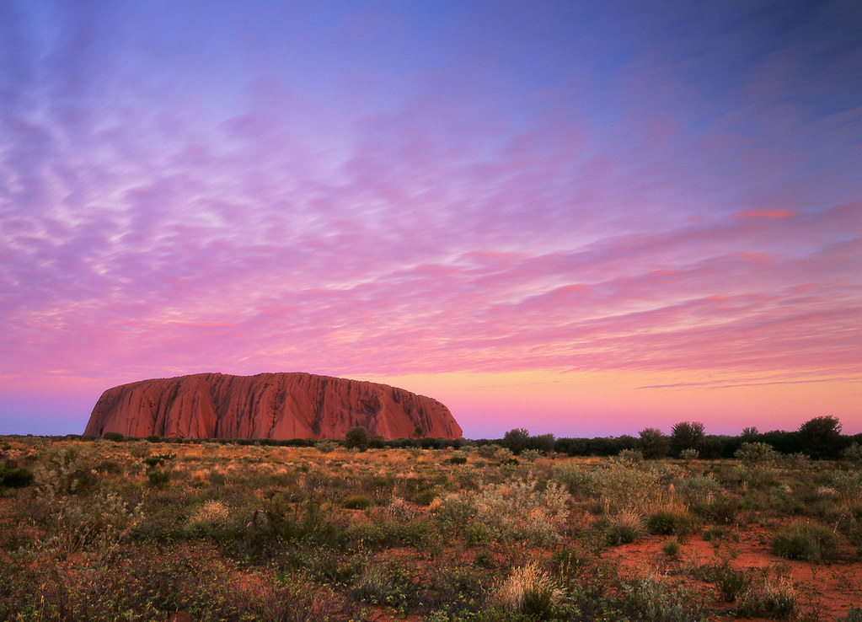
"Uluru Pink Sunset" by Mark Wassell is licensed under CC BY-NC-ND 2.0.
Figure 3 – Aboriginal Art Work – Ayers Rock (Uluru)
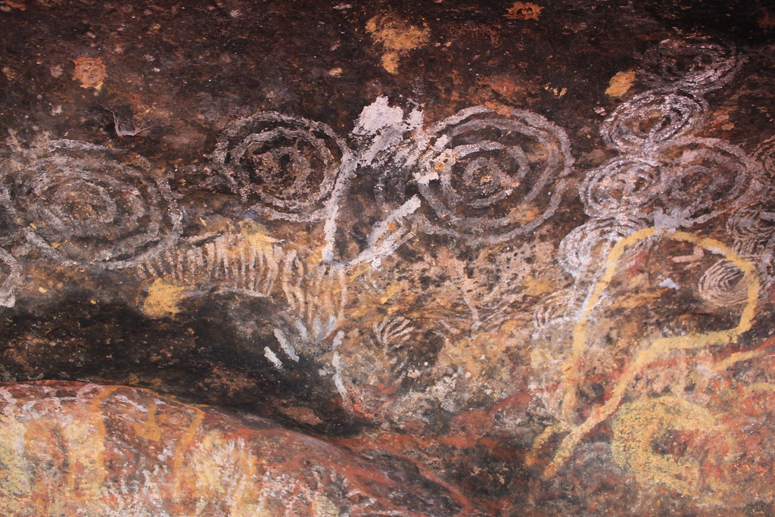
"Aboriginal Art Work – Ayers Rock (Uluru)" by rileyroxx is licensed under CC BY 2.0.

Figure 4 – Uluru
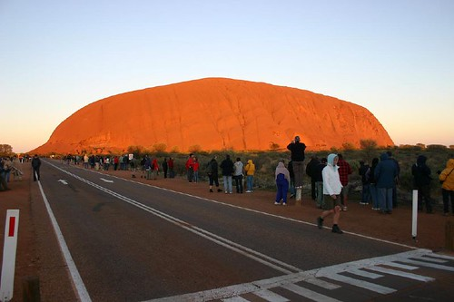
"Uluru (Ayers Rock)" by Allessandro is licensed under CC BY 2.0.
Access Welcome from Anangu, Northern Territory (2:16) and outline how the place has cultural and spiritual value for the Aboriginal and Torres Strait Islander people.
With a partner, complete the following summary table by defining each geographical value in your own words and identify one example of that value in relation to Uluru.
Table 5 – Geographical value of landscapes and landforms
Geographical value | Definition | Explanation for how Uluru is valued accordingly
Aesthetic value
Cultural value
Spiritual value
Economic value
Access Storyspheres for a 3D view of Uluru. While viewing, take note of the shape and size of the unique landform. There are many stories told by the traditional owners. Choose one and listen carefully. When finished, discuss the following with a partner:
- Outline what the story was about.
- Identify how the story illustrates either cultural or spiritual value of Uluru to the traditional owners.
- Write 2-3 sentences summarising your discussion.
Note: The following learning exercise will require students to construct a topographic cross-section for the landform Uluru. Use Cross sections and transects (2:53) to explicitly teach topographic map cross-sections.
Watch Making Topographic Map Profiles (1:40) for a tutorial on this geographical skill. Please note that in Google Maps, topographic maps are sometimes also referred to as terrain maps.
Using a printed topographic map of Uluru from Google Maps, graph paper, and a ruler, complete a topographic cross-section of Uluru.

The value of Mt Fuji
Note: Use Latitude and longitude (4:24) to explicitly teach or revise the geographical skill. Ensure you adequately explain all 4 hemispheres and basic rules associated with the skill, for example, that latitude is always written before longitude. A tip for students to remember is follow alphabetical order.
Conduct a class concept mapping exercise and discuss prior knowledge of Mt Fuji.
Using Google Earth: Mt Fuji, explore the map and identify 5 key facts about Mt Fuji, and identify the latitude and longitude for Mt Fuji.
Using Google Earth Mt Fuji, alternate to the 2D Map and identify the latitude and longitude for Mt Fuji.
In one paragraph, describe the location of Mt Fuji using latitude and longitude. Using a printed terrain map of Mt Fuji from Google Maps, graph paper, and a ruler, complete a topographic cross-section of Mt Fuji. Cross sections and transects (2:53) provide an example for this task.
Note: The Top of Mount Fuji 360 video (2:39) is a 360 video. Your class can view the video on desktop or with 360 goggles for full immersion in the film.
Watch Top of Mount Fuji 360 video (2:39) and discuss what you observed.
With a partner, copy and complete the following table. Use the suggested resources and further research to support your response:
- Mt Fuji More than a mountain
- Fujisan World Cultural Heritage Council
- Sacred Land Film Project
Table 6 – How Mt Fuji is valued
Geographical value | Explanation for how Mt Fuji is valued accordingly
Aesthetic value
Cultural value
Spiritual value
Economic value

Learning sequence 3: Changing landscapes
Students:
- investigate the human causes and effects of land degradation, for example: (ACHGK051)
- identification of the ways people utilise and change landscapes
- description of the impact of a range of human activities on landscapes
- examination of ONE type of land degradation including spatial distribution, causes and impact.

The ways people utilise, change, and impact landscapes
Note: Google Jamboard allows for online contribution to brainstorming. When setting up the Google Jamboard, design some headings that will assist students in discussion and encourage contribution. Access How to use Google Jamboard (6:58) for a tutorial on the teaching tool.
Complete a group or class Google Jamboard that outlines the following:
- examples of ways people utilise and change landscapes
- the impact of human activities on the landscape.
Watch The Value of Soil (4:45) and add further information learnt to your Google Jamboard.
Note: Explicitly teach interpreting and drawing pie graphs. Access Drawing Pie Charts (6:48) and Common graphs (2:58) for information on pie charts.
For further information on the statistics provided in next learning exercise, visit Climate Works Australia.
Copy and complete the following table. Using the data already provided in Table 7, convert percentages to degrees by multiplying the percentage by 3.6. We convert the percentages to degrees because we need to illustrate data as degrees of a circle. There are a total of 360 degrees in a circle. Whenever you have percentages, always check they add up to 100, then multiply by 3.6 to find the degrees to draw your pie chart.
Table 7 – Land use in Australia
Land use | Percentage | Degrees
Grazing native vegetation | 45%
Conservation | 23%
Cropland and horticulture | 4%
Forestry | 2%
Urban | 0.2%
Grazing modified pasture | 9%
Other | 18.8%
Total | 100%
Note: The information used in this table illustrates the different types and percentage of land use in Australia, 2019. Information was acquired from Climate Works Australia
Using the degrees column in the previous table, construct a pie graph.
Conduct a peer assessment by swapping and checking your peers’ pie graphs against the following marking criteria. Where relevant, make suggestions for improvement.
Table 8 – Peer assessment pie chart
Criteria | Yes | No | Comments
Title clear and concise | ☐ | ☐
Degrees calculated accurately | ☐ | ☐
Pie graph presented | ☐ | ☐
Degrees measured accurately for all land use categories | ☐ | ☐
Spelling correct | ☐ | ☐
Graph illustrated neatly | ☐ | ☐
Answer the following questions based on the pie graph you completed:
- Identify the most prominent land use in Australia.
- What percentage of land use is dedicated to conservation in Australia?
- Why is it important to know the percentages associated with land use?
- Explain how knowing the different percentages of land use in Australia inform our understanding of causes of land degradation.
Choose one of the following land degradation issues in Australia and complete an infographic outlining the type of degradation, spatial distribution, causes, and impact:
- wind erosion
- water erosion
- soil fertility decline
- soil acidity
- soil salinity.

Examination of gully erosion in Northern Queensland
Note: A case study aims to address the following questions:
- What happened?
- When did it happen?
- Where did it happen?
- Why did it happen?
- Who was affected by it happening?
For the purpose of the topic ‘Landscapes and Landforms’, a further question should be included: What is being done to mitigate the land degradation and environmental impact?
Encourage students to provide as much detail as possible in their response. You may wish to provide a template similar to the following for students who require structure and guidance on open research, such as Internet Geography’s Geography Case Study Template.
Use the following questions as headings and Greening Australia’s Reef Aid to complete a case study on land degradation in the Great Barrier Reef catchment areas. Your case study must address the following questions:
- What happened?
- When did it happen?
- Where did it happen?
- Why did it happen?
- Who was affected by it happening?
- What is being done to mitigate the land degradation and environmental impact?
- How important is mitigating this land degradation issue to sustainability of the catchment?

Learning sequence 4: Landscape management and protection
Students:
- investigate ways people, including Aboriginal and Torres Strait Islander Peoples, manage and protect landscapes, for example: (ACHGK052)
- description of the nature and extent of landscape protection across a range of scales for example locally protected places, national parks, world heritage listing
- examination of management and protection strategies for ONE landscape
- assessment of the contribution of Aboriginal and Torres Strait Islander Peoples’ knowledge to the use and management of an Australian landscape or landform.

Ways people manage and protect landscapes
Note: As a class, discuss key points and ideas raised in the brainstorming exercise below. Identify ways people manage and protect landscapes. Ensure your class has included:
- National Parks and Wildlife
- World Heritage areas
- Indigenous Protected Areas
- non-government organisations.
With a partner, identify and record the ways we protect landscapes. When you have exhausted your ideas, turn to a pair near you and share your brainstorm. Add any more suggestions to your list.
Think about ways your local suburb or town is protecting the environment. Draw a sketch map (11:26) of your local suburb or town. Ensure you use a legend to identify places that are protected.
Visit Defining Moments: First National Park and identify 5 interesting facts from the information presented.
Reflect on when you personally have visited a national park. If you haven’t visited a national park, use Storyspheres for a 3D view of Uluru and answer the following questions:
- What was the name of the national park you visited?
- When was the park established?
- What characteristics or features made the location important enough to be managed and protected by national parks?
- What observations did you make about ways the park is managing visitors?
- Were there any import landforms located in the park?
Note: Students should visit a site of protection at this stage in the learning sequence. Consider a local protected area and present students with an appropriate fieldwork exercise. Suggestions include a landscape protection scavenger hunt to encourage observation, a field sketch of unique landform, a topographic mapping exercise, or guest speaker. If visiting a protected area such as a national park is unavailable to your class, consider other options, such as a virtual visit with one of the Environmental education centres, incursion with special guest speakers, viewing a documentary about one significant national park in Australia, or a visit to local recreational park space.
Visit The Department of Planning, Industry and Environment and read about careers in the field of conservation. With a partner, discuss how geography relates to a career in this field. Write a one paragraph summary of your discussion and share with the class.

Aboriginal and Torres Strait Islander peoples’ knowledge and protection of Australia’s landscapes and landforms
Note: Explicitly teach the nature and significance of Country in Aboriginal Torres Strait Islander peoples’ perspective of ‘worldview’. The resources provided at Working with Indigenous Australians might be helpful for this topic. Please advise students that the following learning exercise contains a video of a deceased Elder. Provide each group with a printed A3 Y-chart to scaffold a discussion and written response.
Access The Land Owns Us (6:14). In small groups, discuss Bob Randall’s view of Country and belonging. In your groups, complete a Y-chart for the description of land, including what the land looks, feels, and sounds like. You should use 2 different colours to identify between the different views you and Bob Randall have. After you have completed the discussion and notes on the Y-chart, answer the following questions:
- Explain the meaning of land and Country to Aboriginal and Torres Strait Islander peoples.
- Considering the strong connection Aboriginal and Torres Strait Islander peoples have to Country, why is it important to consult with traditional owners when making decisions about landscape management?
Note: Explicitly teach the definitions for Traditional Ecological Knowledge (TEK) and Traditional Knowledge (TK). Explain what constitutes an Indigenous Protected Area (IPA) and how these differ from other conservation sites in Australia.
Access Savanna Burning (7:33) and discuss as a class why savanna burning is a good example of a traditional knowledge. Consider if your class has any other examples of traditional knowledge relevant to your local area.
Read Indigenous Protected Areas and view the map of Australia’s Indigenous Protected Areas. Answer the following questions:
- What is an Indigenous Protected Area?
- What role do Aboriginal and Torres Strait Islander peoples have in Indigenous Protected Areas?
- How many Indigenous Protected Areas are there across Australia? Can you identify any local to your school or home?
Access Marine Turtle and Dugong monitoring on Wunambul Gaambera country (5:00) and answer the following questions:
- In the video, the ranger talks about how he learnt about sacred sites. How is this different to how you are learning today?
- What is the ‘Healthy Country Plan’ and what does it provide the rangers?
- How do boat-based surveys work? Suggest why they are better than other forms of surveying turtles and dugongs.
Visit The Spark Of Life: How Fire Defines A Desert Country and Burning For Biodiversity – The Benefits Of Indigenous Fire Management from Country Needs People. Working in pairs, assess the contribution of Aboriginal and Torres Strait Islander peoples’ knowledge and management to the protection and sustainability of Australia’s unique desert landscape. Copy and complete the following table.
Table 9 – Contribution of Aboriginal and Torres Strait Islander peoples to management of land
Contribution | Comments and notes
The value of traditional knowledge to desert management and protection
The quality of Aboriginal and Torres Strait Islander peoples’ desert management and protection strategies
Outcomes of Aboriginal and Torres Strait Islander peoples’ participation in desert management and protection
Results of Aboriginal and Torres Strait Islander peoples’ participation in desert management and protection
Conduct a peer feedback exercise. Using Ladder of Feedback with your partner, move to work with another pair. You and your partner will follow these steps:
- Read/listen/ask clarifying questions.
- Identify the strengths.
- Identify areas for improvement.
- Suggest ways to improve.
Return to your desk with your partner. Discuss suggested ways to improve. Decide on and include any new changes required.

Management and protection strategies for coastal landscapes
Note: Using Jigsaw expert groups, have students examine the management and protection strategies for coastal landscapes.
CoastAdapt provides multiple case studies for students to choose from. Note that some of the case studies do not directly align to landscapes and it will be important to discourage groups from choosing irrelevant options.
The task involves a presentation and pitch to the class. Teachers may choose to provide the class with a structured marking rubric for peer-assessment or invite a small guest panel into the class to assess the best pitch.
Using Jigsaw, choose a case study from CoastAdapt and become experts. Your task is to present a pitch to the class for funding the management and protection of you chosen case study. The aim of the pitch is to inform the audience about the coastal issue and strategies for management; that is, why your coastal landscape should receive funding for management and protection.

Learning sequence 5: Geomorphic hazards
Students:
- investigate ONE contemporary geomorphic hazard including causes, impacts and responses, for example: (ACHGK053)
- description of the spatial distribution of the disaster
- explanation of geomorphic processes causing the disaster and its impacts
- examination of responses of individuals, groups and governments to the impact of the disaster
- discussion of management strategies to reduce the future impact of similar hazard events including the role of technology in monitoring and predicting geomorphic hazards.

Geomorphic hazard: White Island New Zealand Volcano
This section of the learning sequence refers to the 2019 White Island disaster in New Zealand. Please be aware this may be upsetting for some students and refer to the Controversial Issues in Schools Policy before proceeding.
Note: 360° Kamchatka Volcano Eruption | National Geographic (2:16) is a 360 video. Your class can view this on a desktop or with 360 goggles for full immersion in the film.
Using 360 headsets or your desktop computer, access 360° Kamchatka Volcano Eruption | National Geographic (2:16) and identify 3 key points of interest.
Using a KWHL chart, identify what you already know about volcanoes, what you would like to learn, and how you like to learn. Watch Volcanoes 101 | National Geographic (4:58) and use this add any new information to your KWHL chart.
Think carefully about what you know about the structure of volcanoes. Draw a sketch of a volcano. Do not look up parts of a volcano online or in a text. Instead, try to recall all you know about the structure of volcanoes. Share your diagram with a partner and add any other parts of a volcano you missed.
Visit The Science Behind the Volcano and revisit your diagram. Add any details you may have missed.
On a blackline world map, illustrate the location of Earth’s Major Volcanoes.
With a partner discuss the following:
- Where are Earth’s major volcanoes are located?
- How do the location of volcanoes align to the plate margins you learnt about previously in Learning sequence 1?
Note: Explicitly teach or revise geographical skills latitude and longitude and field sketch. The videos Latitude and longitude (4:24) and Photo sketch (2:06) may prove helpful here.
Visit Google Maps White Island, New Zealand and explore the information provided to answer the following learning exercises:
- locate and label White Island on a blackline world map.
- Using Google Earth White Island New Zealand grid lines, identify and note the latitude and longitude for White Island, New Zealand. Use these location details to write a one-paragraph description for the location of White Island, New Zealand.
- Choose one image of White Island and draw a photo sketch.
- Describe in one paragraph the landscape you have observed at White Island.
Note: Access How the White Island eruption unfolded and provide students with a copy of the infographic Why White Island Blew, found halfway down the article. It is important to note that this section of the learning sequence addresses the loss of life at White Island. Follow school protocol and department policy regarding the teaching of controversial and sensitive content.
Using the following suggested sites and further research, complete the report scaffold for the White Island volcanic eruption:
- ABC News’ account of the 2019 eruption at White Island
- infographic provided by your teacher Why White Island Blew (accessed via How the White Island eruption unfolded)
- Whakaari/White Island eruption: Update #8
- Whakaari White Island recovery operation
- Kaimoana (seafood and shellfish) around the Whakaari and White Island Area
- Local tourism works to mitigate economic impact following Whakaari eruption
Table 10 – Report scaffold
Report scaffold | Comments and notes
Introduction – what the report will cover (one paragraph)
Overview of the disaster (one paragraph)
Geomorphic processes that resulted in an eruption at White Island (3 paragraphs)
The impact of the disaster, including environmental, social, and economic impacts (3 paragraphs)
The response to the eruption at White Island (2 paragraphs)
Conclusion – summarise what was learnt in the report (one paragraph)
Using your notes in the above scaffold, write a report outlining the cause, impact, and response of White Island volcano.
You are responsible for reviewing a peer’s report on the White Island volcano. Use the following criteria to assess your peer’s report and make relevant suggestions where your peer can improve.
Table 11 – Report marking criteria
Marking Criteria | Didn’t | Tried | Did
Included an introduction that clearly stated what will be included in the report. At least one paragraph. | ☐ | ☐ | ☐
Clearly outlined the White Island volcano event in at least one paragraph. | ☐ | ☐ | ☐
Outlined the major geomorphic processes that resulted in an eruption at White Island in 2 paragraphs. | ☐ | ☐ | ☐
Discussed the impact of the disaster on the environment, people, and economy of New Zealand in 3 paragraphs. | ☐ | ☐ | ☐
Summarised the response to the eruption at White Island in 2 paragraphs. | ☐ | ☐ | ☐
Included a conclusion that summarised what was learnt in the report in one paragraph. | ☐ | ☐ | ☐
Revisit your report after gaining peer feedback. Reflect on the feedback and make improvements to your response.
Note: Read New Zealand’s White Island is likely to erupt violently again, but a new alert system could give hours of warning and save lives to your class. Pose the debate topic: ‘White Island should be allowed to open as a tourist destination again’. Allocate groups for the debate and a panel for judging.
Conduct a class debate on the following topic: ‘White Island should be allowed to open as a tourist destination again’.
Visit Internet Geography and review strategies for Reducing the impacts of earthquakes and volcanoes. Complete the Check your understanding quiz at the end of the information page. Once you have completed the quiz, share traffic light feedback with the class:
- Red: I had many answers incorrect
- Orange: I had some answers incorrect
- Green: I had many answers correct.

Assessment task
Note: When using this assessment task, ensure it is placed on the school template and follows all assessment requirements.
For this task, students will need to be familiar with de Bono’s Six Thinking Hats.

Outcomes
- GE4-4 examines perspectives of people and organisations on a range of geographical issues
- GE4-5 discusses management of places and environments for their sustainability
- GE4-7 acquires and processes geographical information by selecting and using geographical tools for inquiry

Syllabus content
Students explore landscapes and landforms using examples from Australia and throughout the world. Students examine issues of land degradation and ways to manage and protect landscapes and landforms.
Students:
- investigate ways people, including Aboriginal and Torres Strait Islander Peoples, manage and protect landscapes (ACHGK052)

Task: Landscapes or landforms at risk
You are an environmental specialist who has been asked to identify an Australian landscape or landform at risk. You will need to research:
- a landscape or landform at risk
- the reasons the landscape or landform is at risk
- how the landscape or landform is managed.
Write a report on your chosen landscape or landform. When researching and writing your report, use the Six Thinking Hats provided as a tool to gather your information:
- Description of landscape or landform (White hat): When using this hat, provide only information that is known or needed, including
- identification and brief written description of the location of the landscape
- location of the site of investigation on a map
- a field or photo sketch of the landscape of landform with annotations identifying areas at risk
- a brief outline of 2 strategies that are currently used to manage the site for sustainability.
- Benefits (Yellow hat): When using this hat, explore the positives and benefits for each strategy.
- Risks and problems (Black hat): When using this hat, explore the risks, difficulties, and problems for each strategy.
- Stakeholder perspectives (Red hat): When using this hat, consider feelings, emotions, likes, and dislikes. For each strategy, describe 3 key stakeholder perspectives, including Aboriginal and Torres Strait Islander perspectives about how the site should be managed
Recommendation
As an environmental specialist, you need to present your findings to your supervisor in the form of an answer to the following question: To what extent is your chosen landscape or landform sustainably managed? (one paragraph)

Marking criteria
Table 12 – Assessment marking criteria
Criteria | Grade
- Selects and uses appropriate and relevant geographical tools to support the inquiry  - Comprehensively discusses the strategies for managing the chosen landscape or landform  - Comprehensively examines the perspectives of people and organisations about the management of the chosen landscape or landform  - Comprehensively evaluates the suggested strategies | A
- Selects and uses appropriate geographical tools to support the inquiry  - Thoroughly discusses the strategies for managing the chosen landscape or landform  - Thoroughly examines the perspectives of people and organisations about the management of the chosen landscape or landform  - Evaluates the suggested strategies | B
- Selects and uses some geographical tools to support the inquiry  - Completes a sound discussion of the strategies for managing the chosen landscape or landform  - Completes a sound examination of the perspectives of people and organisations about the management of the chosen landscape or landform  - Makes some attempt to evaluate the suggested strategies | C
- Refers to geographical tools to support the inquiry  - Completes a basic discussion of the strategies for managing the chosen landscape or landform  - Completes a basic examination of the perspectives of people and organisations about the management of the chosen landscape or landform  - May provide a conclusion or some attempt to evaluate the suggested strategies | D
- May make some reference to geographical tools  - May make some reference to the strategies for managing the chosen landscape or landform  - May make some reference to the perspectives of people and organisations about the management of the chosen landscape or landform  - May provide a conclusion | E

Appendix: Capacity matrix
Note: A general concept and glossary list has been outlined. However you may wish to add further terminology or skills to the capacity matrix.
Key classification
- information – recall basic facts or heard of this before
- knowledge – can explain and know what it means
- know-how – can draw connections between this geographical term or concept and relate them to other concepts or situations
- wisdom – can use the term or concept in new contexts or teach others
Shade or tick information, knowledge, know-how, and wisdom as you progress with your understanding of the geographical concept or term. At the end of the learning sequence, reflect on your progress and discuss with your teacher if you observe any areas you can improve.
Table 13 – Glossary of concepts and terms
Glossary word | Information | Knowledge | Know-how | Wisdom
biodiversity | ☐ | ☐ | ☐ | ☐
conservation | ☐ | ☐ | ☐ | ☐
convergent boundary | ☐ | ☐ | ☐ | ☐
cross-section | ☐ | ☐ | ☐ | ☐
crust (Earth) | ☐ | ☐ | ☐ | ☐
deposition | ☐ | ☐ | ☐ | ☐
divergent boundary | ☐ | ☐ | ☐ | ☐
erosion | ☐ | ☐ | ☐ | ☐
field sketch | ☐ | ☐ | ☐ | ☐
geomorphic | ☐ | ☐ | ☐ | ☐
Indigenous Protected Area | ☐ | ☐ | ☐ | ☐
landforms | ☐ | ☐ | ☐ | ☐
landscapes | ☐ | ☐ | ☐ | ☐
latitude | ☐ | ☐ | ☐ | ☐
lava | ☐ | ☐ | ☐ | ☐
longitude | ☐ | ☐ | ☐ | ☐
magma | ☐ | ☐ | ☐ | ☐
mantle | ☐ | ☐ | ☐ | ☐
national park | ☐ | ☐ | ☐ | ☐
photo sketch | ☐ | ☐ | ☐ | ☐
plate tectonics | ☐ | ☐ | ☐ | ☐
rock cycle | ☐ | ☐ | ☐ | ☐
sustainability | ☐ | ☐ | ☐ | ☐
topographic mapping | ☐ | ☐ | ☐ | ☐
traditional ecological knowledge | ☐ | ☐ | ☐ | ☐
transformative boundary | ☐ | ☐ | ☐ | ☐
values (aesthetic, cultural, spiritual, and economic) | ☐ | ☐ | ☐ | ☐
volcano | ☐ | ☐ | ☐ | ☐
weathering | ☐ | ☐ | ☐ | ☐
worldview | ☐ | ☐ | ☐ | ☐

References
Links to third-party material and websites
Please note that the provided (reading/viewing material/list/links/texts) are a suggestion only and implies no endorsement, by the New South Wales Department of Education, of any author, publisher, or book title. School principals and teachers are best placed to assess the suitability of resources that would complement the curriculum and reflect the needs and interests of their students.
If you use the links provided in this document to access a third-party's website, you acknowledge that the terms of use, including licence terms set out on the third-party's website apply to the use which may be made of the materials on that third-party website or where permitted by the Copyright Act 1968 (Cth). The department accepts no responsibility for content on third-party websites.
All material © State of New South Wales (Department of Education), 2021 unless otherwise indicated. All other material used by permission or under licence. Except as otherwise noted, this resource is licensed under the Creative Commons Attribution 4.0 International Licence. To view a copy of this licence, visit http://creativecommons.org/licenses/by/4.0/
Geography K-10 Syllabus © 2015 NSW Education Standards Authority (NESA) for and on behalf of the Crown in right of the State of New South Wales.
© 2021 NSW Education Standards Authority. This document contains NSW Curriculum and syllabus content. The NSW Curriculum is developed by the NSW Education Standards Authority. This content is prepared by NESA for and on behalf of the Crown in right of the State of New South Wales. The material is protected by Crown copyright.
Please refer to the NESA Copyright Disclaimer for more information.
NESA holds the only official and up-to-date versions of the NSW Curriculum and syllabus documents. Please visit the NSW Education Standards Authority (NESA) website and the NSW Curriculum website.
12FLY TV (2012) ‘Welcome from Anangu, Northern Territory’ [video], 12FLY TV, YouTube, accessed 15 December 2022.
Australian Museum (2018) ‘Plate Tectonics’, Shaping the Earth, Australian Museum website, accessed 15 December 2022.
Australian National Maritime Museum (8 June 2016) ‘Longitude and Latitude explained’ [video], Australian National Maritime Museum, YouTube, accessed 15 December 2022.
BBC (British Broadcasting Corporation) (2022), ‘Introduction to Fieldwork: Field sketches’, Bitesize, BBC website, accessed 15 December 2022.
Beddows C (30 October 2014), ‘The Science Behind the Volcano’, Elsevier: SciTech Connect blog, accessed 15 December 2022.
Bennett A (2022) Geography Case Study Template, Internet Geography website, accessed 15 December 2022.
Boudreau D, McDaniel M, Sprout E and Turgeon A (2022) ‘Asia: Physical Geography’, Resource Library, National Geographic Society website, accessed 15 December 2022.
CambrianEd (31 October 2015), Making Topographic Map Profiles, CambrianEd, YouTube, accessed 15 December 2022.
Cartoscope Pty Ltd (n.d.), ‘Mungo National Park and Lunette’, Geological sites, Geological sites of NSW website, accessed 15 December 2022.
Clench S (11 December 2019) ‘How White Island eruption unfolded’, news.com.au, accessed 15 December 2022.
Climateworks Centre (2022), Land Use Futures: Australia's Land Use, Climateworks Centre website, accessed 15 December 2022.
Commonwealth of Australia (2020) ‘Indigenous Protected Areas (IPAs)’, Environment, National Indigenous Australians Agency website, accessed 15 December 2022.
Commonwealth of Australia (Geoscience Australia) (2021) ‘Our Changing Earth – The Rock Cycle’, Classroom Resources, Geoscience Australia website, accessed 15 December 2022.
Commonwealth of Australia (Geoscience Australia) (2021) ‘Topographic Maps’, Topographic Information, Geoscience Australia website, accessed 15 December 2022.
Country Needs People (13 April 2016) ‘Burning For Biodiversity – The Benefits Of Indigenous Fire Management’, Country Needs People news, accessed 15 December 2022.
Crash Course Kids (2015),’ Landforms, Hey!: Crash Course Kids #17.1’, Crash Course Kids, YouTube, accessed 15 December 2022.
Dail K (2020) ‘16 Most Famous Volcanoes In The World’, Feri.org, accessed 15 December 2022.
Dempsey D and Cronin S (20 July 2020) ‘New Zealand’s White Island is likely to erupt violently again, but a new alert system could give hours of warning and save lives’, The Conversation, accessed 15 December 2022.
Department of Climate Change, Energy, the Environment and Water (2022) ‘Indigenous Protected Areas’, Land, Australian Government, accessed 15 December 2022.
Department of the Environment and Energy and National Climate Change Adaptation Research Facility (n.d.) Case Studies, CoastAdapt website, accessed 15 December 2022.
D-maps.com (2022), Australia: Commonwealth of Australia, D-maps.com, accessed 15 December 2022.
Education Services Australia Ltd (2013) Photo sketching: Teacher notes [PDF 335.78KB], Australian Geography Teachers Association, Education Services Australia Ltd, accessed 15 December 2022.
ELDinitiative #ELDsolutions (20 June 2013) ‘ELD-Film: The Value of Soil’ [video], ELDinitiative #ELDsolutions, YouTube, accessed 15 December 2022.
Flipped Classroom Tutorials (30 January 2019) ‘How to use Google Jamboard’ [video], Flipped Classroom Tutorials, YouTube, accessed 15 December 2022.
floorvrチャンネル (6 April 2018) ‘Top of Mount Fuji 360 video’ [video], floorvrチャンネル, YouTube, accessed 15 December 2022.
Fox Family Entertainment (8 January 2011) ‘Ice Age: Continental Drift | Ice Age 4: Scrat Continental Crack Up HD’ [video], Fox Family Entertainment, YouTube, accessed 15 December 2022.
Fujisan World Cultural Heritage Council (n.d.) Outstanding Universal Value of Mt. Fuji, Fujisan World Cultural Heritage Council, accessed 15 December 2022.
Gilson E (2020) Drawing a cross section on a topographical map, Ministry for Education and Employment: Teleskola website, accessed 15 December 2022.
Global Oneness Project (27 February 2009) ‘The Land Owns Us’ [video], Global Oneness Project, YouTube, accessed 15 December 2022.
Google Earth (n.d.) Mt Fuji: Mountain in Japan [Google Earth map], accessed 15 December 2022.
Google Earth (n.d.) Where on Google Earth is Carmen Sandiego: The Crown Jewels Caper [Google Earth map], accessed 15 December 2022.
Google Maps (2022) Mount Fuji [Google Map], accessed 15 December 2022.
Google Maps (2022) Uluru [Google Map], accessed 15 December 2022.
Google Maps (2022) White Island New Zealand [Google Map], accessed 15 December 2022.
Greening Australia (2018) Reef Aid, Greening Australia website, accessed 15 December 2022.
Grzelewski D (July to September1993) ‘Glaciers – Ice on the Move’, New Zealand Geographic, Issue 09, accessed 15 December 2022.
Infogram (2022) What is an infographic, Infogram website, accessed 15 December 2022.
Internet Geography (2022) ‘Reducing the impacts of earthquakes and volcanoes’, The Natural Environment: iGCSE Geography, Internet Geography, accessed 15 December 2022.
JNTO (Japan National Tourism Organization) (n.d.) ‘Mt. Fuji: More Than a Mountain’, Mt. Fuji Guide, JNTO website, accessed 15 December 2022.
Keer A (3 October 2016) ‘Drawing Pie Charts’ [video], Adam Keer, YouTube, accessed 15 December 2022.
Lawrence-Taylor M, National Environmental Research Program and Northern Australia Hub (producers) (2014) Marine Turtle and Dugong monitoring on Wunambal Gaambera country [film], Michael Lawrence-Taylor, Trusscott, WA, accessed 15 December 2022.
Leslie T, Byrd J and Hanrahan C (12 December 2019) ‘How New Zealand's White Island volcano eruption unfolded’, ABC News, accessed 15 December 2022.
Miller C (2019) ‘Whakaari/White Island eruption: Update #8’, Volcanic Activity Bulletins, GeoNet website, accessed 15 December 2022.
Monroe MH (2011) Australia: The Land Where Time Began, Aus Thru Time website, accessed 15 December 2022.
MooMoo Math and Science (10 April 2020) ‘The Difference Between Weathering and Erosion’ [video], MooMoo Math and Science, YouTube, accessed 15 December 2022.
MooMooMath and Science (10 January 2020) ‘Plate Boundaries-Divergent-Convergent-Transform’ [video], MooMooMath and Science, YouTube, accessed 15 December 2022.
MooMooMath and Science (20 November 2020) ‘The Four Hemispheres of the Earth’ [video], MooMooMath and Science, YouTube, accessed 15 December 2022.
Morgan S (28 April 2020) ‘REVISE: How to draw a sketch map – Geography’ [video], Stephen Morgan, YouTube, accessed 15 December 2022.
Mungo National Park (2022) Mungo National Park [website], accessed 29 July 2022.
Muswellbrook Shire Council and Walking Together Reconciliation Committee (2020) 'The Dreaming', Culture, Working with Indigenous Australians website, accessed 15 December 2022.
National Geographic (13 November 2016) ‘360° Kamchatka Volcano Eruption | National Geographic’ [video], National Geographic, YouTube, accessed 15 December 2022.
National Geographic (15 January 2020) ‘Volcanoes 101 | National Geographic’ [video], National Geographic, YouTube, accessed 15 December 2022.
National Geographic Society (2022) ‘Earth’s Major Volcanos’, Resource Library, National Geographic Society website, accessed 15 December 2022.
National Geographic Society (2022) ‘Longitude’, Resource Library, National Geographic Society website, accessed 15 December 2022.
National Geographic Society (2022) ‘Plate Tectonics’, Resource Library, National Geographic Society website, accessed 15 December 2022.
National Museum Australia (2022) ‘First national park’, Defining Moments, National Museum Australia website, accessed 15 December 2022.
National Park Service (2020) ‘Overview of TEK’, Traditional Ecological Knowledge, National Park Service website, accessed 15 December 2022.
National Park Service (2022) Grand Canyon: National Park Arizona, National Park Service website, accessed 29 July 2022.
New Zealand Police (12 December 2019) ‘Whakaari / White Island recovery operation’, New Zealand Police Media Centre news, accessed 15 December 2022.
Office of Environment and Heritage (2022) ‘Ancient Mungo Environments’, Understanding Mungo, Mungo National Park website, accessed 15 December 2022.
Office of Environment and Heritage (2022) ‘The Landscape in Action’, Ancient Mungo Environments, Mungo National Park website, accessed 15 December 2022.
Paltridge R and Young A (13 April 2016) ‘The Spark Of Life: How Fire Defines A Desert Country’, Country Needs People news, accessed 15 December 2022.
Parks Australia (Commonwealth of Australia) (2022) ‘Virtual tour’, Discover Uluru-Kata-Tjuta, Parks Australia website accessed 15 December 2022.
Pennay D (producer) (2014) Savanna Burning [film], 3 Hand Studios, Victoria, accessed 15 December 2022.
QLA (Quality Learning Australasia) (n.d.) The Capacity Matrix, QLA website, accessed 15 December 2022.
RAW travel (2018) Great Ocean Walk Geology, Great Ocean Walk website, accessed 15 December 2022.
RCS (Rochester Community Schools) (n.d.) Traffic Light, Think! From the Middle RCS website, accessed 15 December 2022.
Sacred Land Film Project (2004) Mount Fuji, Sacred Land Film Project website, accessed 15 December 2022.
Sammartano M (9 April 2020) ‘Rivers, Weathering, Erosion and Deposition’ [video], Mike Sammartano, YouTube, accessed 15 December 2022.
St Albans Secondary College (2020) ‘Valuing Landscapes and Landforms’, Study Guide: Landscapes and Landforms, St Albans Secondary College Library website, accessed 15 December 2022.
State Government of Victoria (2021) ‘Traditional knowledge’, Taking Care of Culture Discussion Paper, Victorian Aboriginal Heritage Council website, accessed 15 December 2022.
State of New South Wales (Department of Planning and Environment) (2022) Careers: Working with us, Department of Planning and Environment website, accessed 15 December 2022.
Stetson University (2021) ‘Rock Cycle diagram’, Gillespie Museum, Stetson University, accessed 15 December 2022.
Stetson University (29 October 2020) ‘Gillespie Museum Short Takes – The Rock Cycle (2020)’ [video], Stetson University, YouTube, accessed 15 December 2022.
Terborg S (21 October 2018) ‘Ladder of Feedback’, Sonya Terborg blog, accessed 15 December 2022.
Virtual Oceania (2022) ‘Australian Landscape’, Australia Photos, Virtual Oceania website, accessed 15 December 2022.
Whakatāne District Council (20 February 2020) ‘Local tourism industry works to mitigate economic impact following Whakaari eruption’, Whakatāne District Council news, accessed 15 December 2022.
Whakatāne District Council (n.d.) Kaimoana (seafood and shellfish) around the Whakaari / White Island area, Whakatāne District Council website, accessed 15 December 2022.
WilderQuest and NSW National Parks and Wildlife Service 3 September 2017) ‘360 Aboriginal Storytelling – Lake Mungo National Park’ [video], WilderQuest, Vimeo, accessed 15 December 2022.
World Map Blank (2020) Printable Blank Map of Asia – Map of Asia Blank, World Map Blank website, accessed 15 December 2022.
World Map Blank (2021) Printable Blank World Map – World Map Blank, World Map Blank website, accessed 15 December 2022.

