HSIE: Geography workbook S2
Name:
Class:

Overview
You will learn about the geographical skills of mapping and data representation. You will construct tables, graphs and maps, and interpret these to identify distributions and draw a conclusion about climate, natural vegetation and native animals in Australia.

Resources

Activity 1
- colour pencils

Activity 2
- colour pencils

Activity 1
During this activity you will explore tables and graphs using climate data. You will do a survey of Australian animals, record data in a table, create a graph and write a conclusion.
Resources – colour pencils

Weather and seasons
Reflection
What do you remember about the weather and seasons?
There are different types of weather and some of these help us identify the seasons. Draw lines to match the images with seasons. Some images may fit into more than one season.
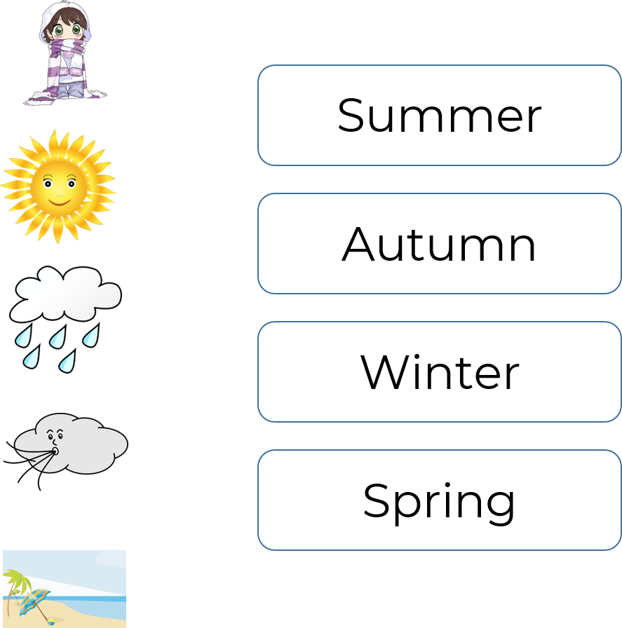

Climate
Did you know that weather and climate are different! Climate is the pattern of weather over time. For example, along the east coast of NSW during the summer, the climate is mild with moderate average temperatures and moderate average rainfall. However, in tropical north Queensland the climate is warm and wet. The temperature is hotter and there is more rainfall on average than coastal NSW.

Purpose and features of tables
A table is a graphical tool used for recording data. Geographers conduct field surveys to collect data, and that they record this in a table. Most data tables have similar features that need to be included when you construct a data table.
Observe/find
Climate data is often recorded as a table or a graph. The table below is an example of monthly climate data for Sydney, NSW. Look at the table and identify some features of a table.
Climate data for Sydney, NSW.
Month | Average temperature high/low (⁰C) | Average rainfall (mm)
January | 26/19 | 101
February | 26/19 | 119
March | 25/18 | 132
April | 23/15 | 127
May | 20/12 | 117
June | 17/9 | 134
July | 16/8 | 96
August | 17/9 | 80
September | 20/11 | 68
October | 22/14 | 77
November | 24/16 | 84
December | 25/18 | 77
Observe/find
Compare the climate data table for Sydney, NSW with a real data table for Broken Hill, NSW by the Bureau of Meteorology. The data table for Broken Hill is similar because it has a title, columns, rows and column titles. It is different because it has row titles. Some of the data is the same as the data in the table for Sydney. It has average monthly high temperature, average monthly low temperature, and average (mean) rainfall for each month.
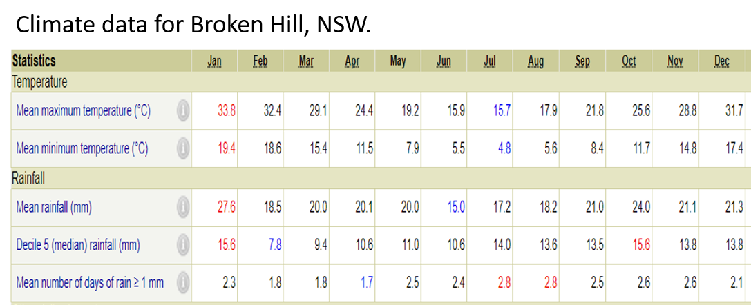
Climate data is reproduced by permission of Bureau of Meteorology, © 2020 Commonwealth of Australia.
Observe/find
Can you see any patterns in the climate data for Sydney or Broken Hill? Choose one of the tables and identify a pattern in the average monthly rainfall. Think about which months the rainfall is highest and which months the rainfall is lowest then write a conclusion in sentence form in the space below.
The pattern in rainfall for Sydney/Broken Hill (circle your choice) is….

Checklist
List some features of data tables.
Feature 1 ___________________________________
Feature 2 ___________________________________
Feature 3 ___________________________________
Feature 4 ___________________________________

Purpose and features of graphs
A graph is a visual representation of data. The image below shows some different types of graphs.
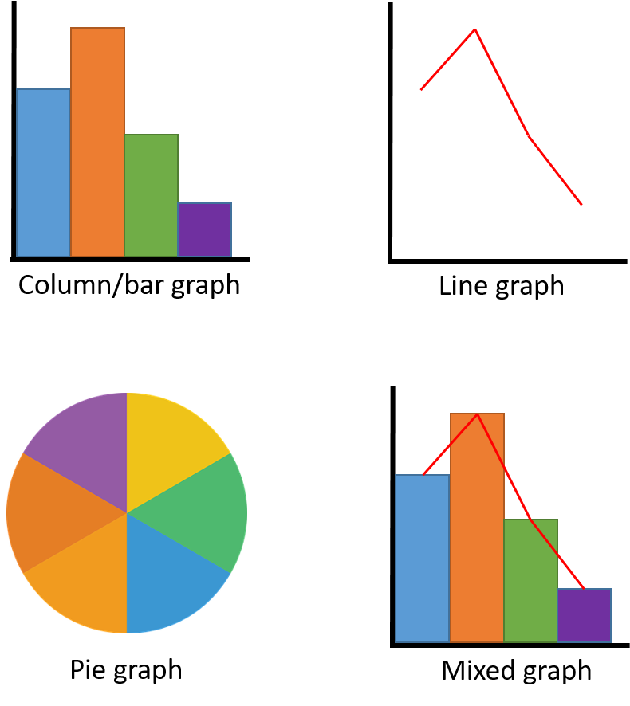

Creating a graph
Climate graphs are a visual representation of data from climate data tables. The climate graph below shows the data for rainfall in Broken Hill. This graph has been created using Microsoft Excel.

The same data has been used to create a hand-drawn graph on grid paper on the next page. Compare the two graphs and observe the similarities between them.
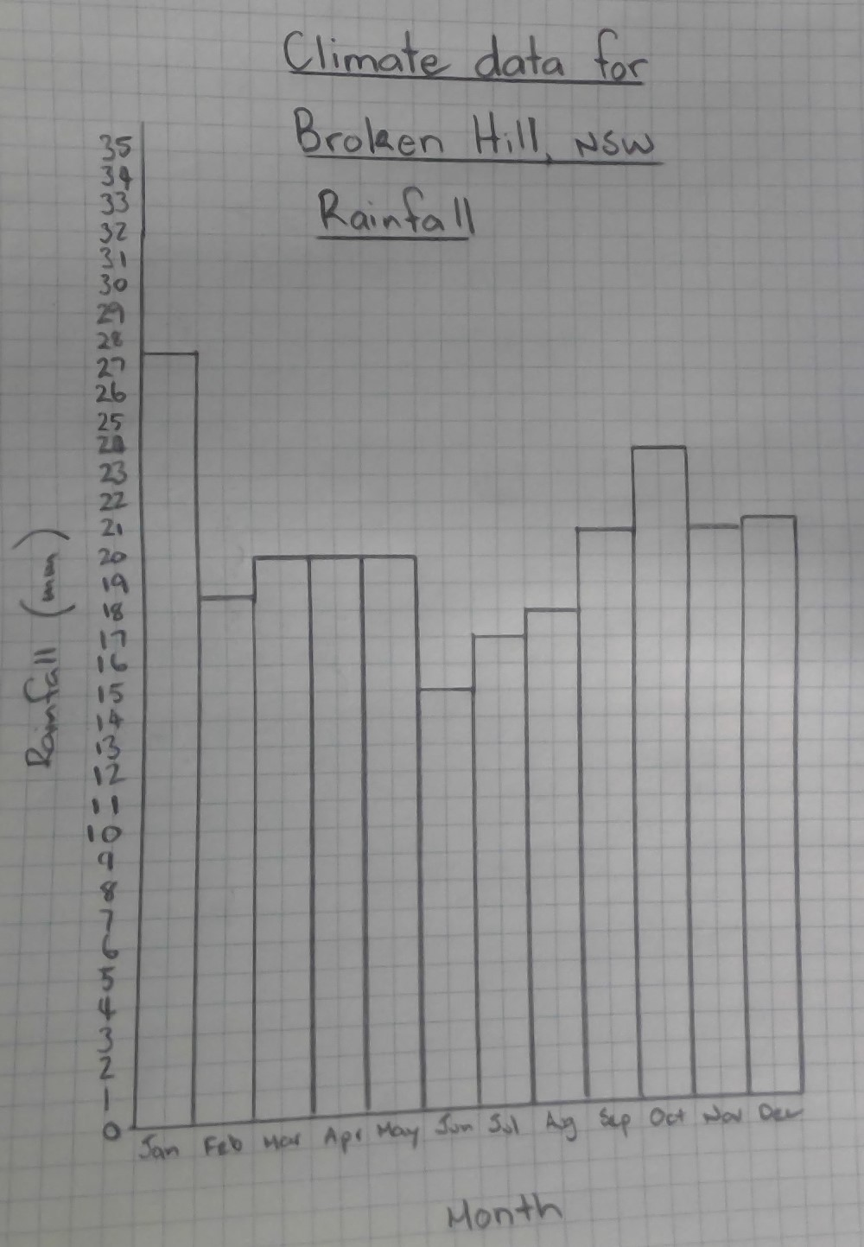Do you think it’s easier to see patterns or trends in a data table or a graph? (Circle your choice).
Tally table
A tally table is a type of data table that is used to record the number of things observed during a survey.
Observe/find
Look closely at the tally table below, which shows the survey results for the number of cars that drive down a road in 1 hour.
Car colour | Tally | Total
Red |  | 5
Green |  | 1
Blue |  | 3
White |  | 15
Black |  | 10
Hands on
Conduct a survey of Australian animals at school or at home. To do the survey, you will need to identify and count all the Australian animals that you can see at school or from home in the space of 20 minutes. If there are no Australian animals, think of something else that you can count to include in your survey, like birds, plants, insects or cars.
If you have more time, make a 1-hour survey and see if there is any difference in numbers observed.

Record your observations using the tally table below. If you need more space, draw a tally table on a piece of paper and staple it to this page.
Animal | Tally | Total
Create/make
Construct a bar graph using data from the ‘Animal’ column and the ‘Total’ column in your tally table. Use the grid below. Don’t forget to include a title.
Title:
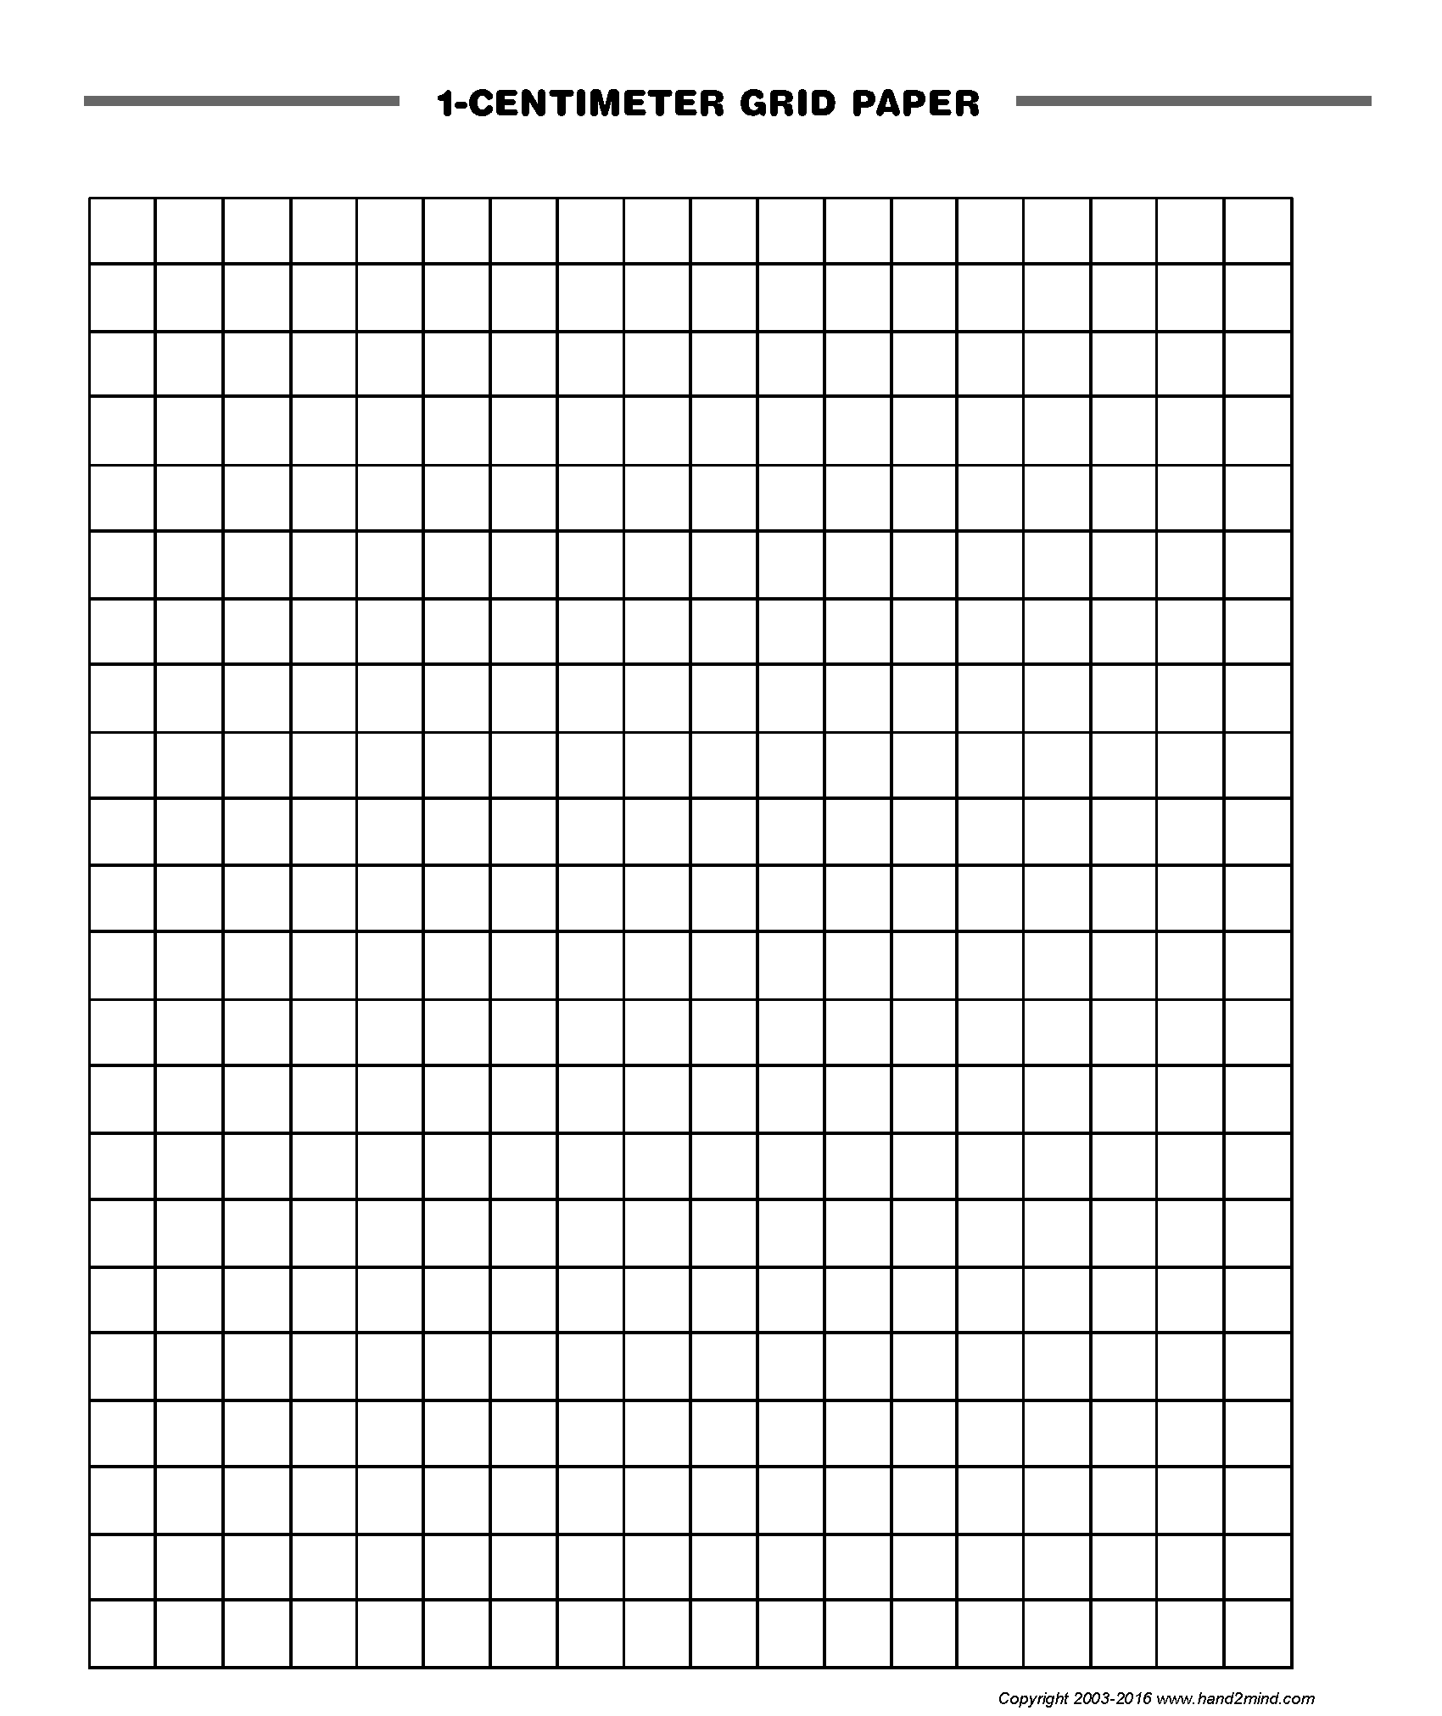
Observe/find
Can you see any patterns in your graph?
Write
Write a 1-sentence conclusion describing the data shown by your graph.

Reflection
Think about what you have learned in this activity. Use the two stars and a wish structure to guide your reflection.
Star  Something that went well! | Star  Something that went well! | Wish  A goal for next time…

Activity 2
During this activity you will conduct a vegetation survey, collect and record data, and create a vegetation map to show the distribution of plants at school or at home.
Resources – colour pencils

Vegetation survey
Geographers use vegetation surveys to identify patterns in the distribution and density of plant growth. This information can be used to help plan new developments like housing estates, parks and other recreation areas.
Hands on
Conduct a vegetation survey at school or at home. Use the tally table below to record your observations. For grass, estimate how much area is covered and record this as a percentage. For example, 100% of the ground which is not gardens. Ask a parent or caregiver to help you identify plant names. If you need more space, use a separate sheet of paper and staple it to this page.
Plant | Tally | Total

Maps
In geography, maps are another way to visually represent data. A map should include the following features:
- title
- legend
- scale
- drawn on a grid.
A legend shows the colours and symbols that are used on the map. Colour shading may be used to represent the density of vegetation from light to heavy. For example, one area may be half-covered in grass where another area is fully covered. You could use shading to indicate how thick the grass cover is.
Some other features that can be shown on maps include:
- road
- building/structure
- pool/pond/dam/lake
- fence
- boundary
- playground/sport field
- tree
- flower
- grass
Scale is the relative size of objects represented on a map. For example, 1 cm on the map equals 1 m in real life (Scale: 1 cm = 1 m).

Vegetation map
A vegetation map shows the distribution and abundance of plants in an area. View and discuss the features of the vegetation map. Alternatively, a range of vegetations maps can be sourced through an online search.
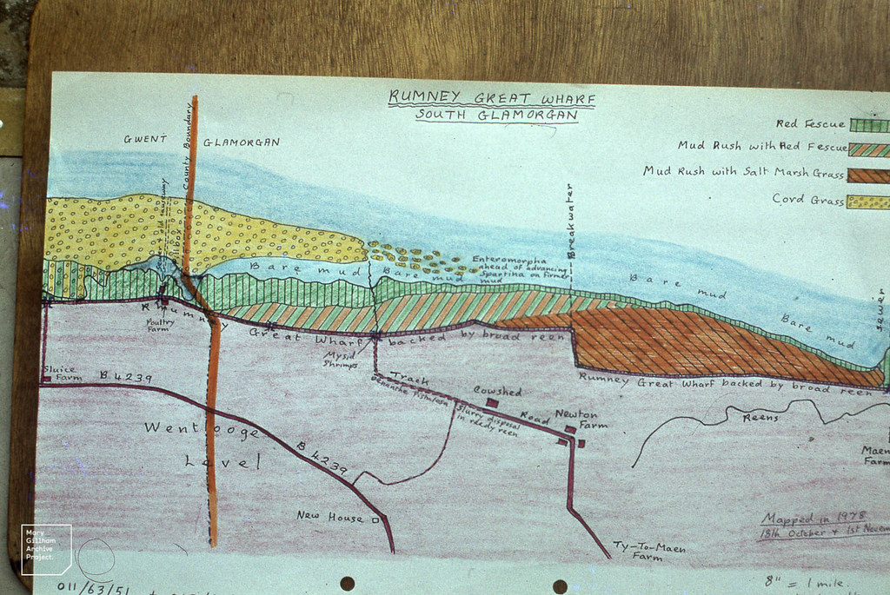
"Vegetation map. Saltmarsh outside Rumney at wharf. November 1978" by Mary Gillham Archive Project is licensed under CC BY 2.0

Hands on
Using data from your survey tally table, and with the help of a parent or carer, construct a vegetation map of your school or home. If you need more space, use a sheet of 1 cm grid paper and staple it to this page.

Reflection
Think about what you have learned in this activity. Use the two stars and a wish structure to guide your reflection.
Star  Something that went well! | Star  Something that went well! | Wish  A goal for next time…

.

