Geography workbook S2 - Places are similar and different
Name:
Class:

Overview
You will learn about the climate, settlement patterns and demographic characteristics and natural vegetation of places in Australia and then use this information to imagine what it would be like to live in those places. You will compare the climate, settlement patterns and the lives of the people of three Australian places, including your own place/town/city. At the end of this project you will create and publish a mini atlas.
Questions to consider during the geographic inquiry:
- What is Australia’s location in the world and region?
- Where are Australia’s states, territories and major cities located?
- How are Aboriginal and Torres Strait Islander People’s Countries and Places identified?
- What are some of the unique natural features of Australia? (e.g. significant landforms, flora and fauna, World Heritage places.)
- What are the similarities and differences in the geographical characteristics of my town/city and two other Australian places? (Including landscapes, climate, demographics, daily lives.)
- What can Australians do to protect our unique environments and features?
Student centred geographical inquiry of three Australian places
- You will be creating a mini atlas that shows geographical characteristics and features of Australia and provides profiles of your place and two other populated Australian places.
- What are the similarities and differences in the geographical characteristics of my place/town/city and two other Australian places?

Resources

Activity 1
- help from an adult to discuss different places in Australia
- lead pencil and rubber
- coloured pencils
- Scissors
- glue

Activity 2
- help from an adult to discuss what features an atlas should have
- lead pencil and rubber
- coloured pencils
- Scissors
- glue

Activity 1
During this activity you will explore several places in Australia and how and why places are similar and different.
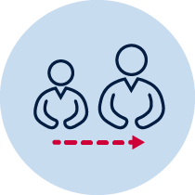 Adult support
Discuss with an adult, places you and they have visited and what you remembered about those places.
Using the map outline of Australia and map outline of the world in this booklet:
Where are we in the world?
Where is my school/home located?
Locate and label the names of Australia's states and territories, capital cities, major cities, major landforms and any main cultural and heritage sites. When you are happy you have enough information, share your map with a family member.
Locate Australia on a world map.
Label Australia and other major countries or continents.
On an outline map of Australia plot and label the states and territories, major cities, major landforms and major cultural and heritage sites.

Read
In each place in Australia there are natural features and characteristics. Certain things in nature help to define a place. Here are some natural features and characteristics. Discuss with an adult.
- deserts
- rivers
- mountains
- weather and temperature
- land and soil
- plant life
- animal life
In each place in Australia there are also human features and cultural characteristics. The people and cultures in a place also help to define a place. Here are some cultural characteristics. Discuss with an adult.
- languages
- religions
- where people settle
- how people get from place to place
- how money is exchanged
- government
Draw
Pick one natural feature and one human feature of your own place/community to draw. Use the spaces provided. Make sure you include as much detail as you can. You may need to add words to add some of this detail. When you are finished, show your drawing to an adult and explain what feature it shows and why you chose that one.
Natural features and characteristic in my place/community

Human features and cultural characteristic in my place/community
Brainstorm/think
View the image of two different places in Australia, Glebe and Gulargambone in sources 1-6.
- Glebe: inner city suburb of Sydney, NSW
- Gulargambone: rural village in the Coonamble Shire, north-western NSW. Coonamble is a rural town

Source 1: The Gulargambone cypress pine sawmill, 2003, photographed by Darren Clark. | Source 2: Unloading tuna, Fish Markets, Glebe, 30/10/2007 photographed by Patricia Baillie.
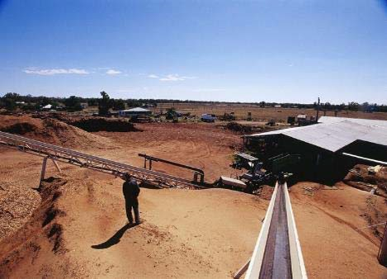http://www.acmssearch.sl.nsw.gov.au/search/itemDetailPaged.cg i?itemID=447439 | 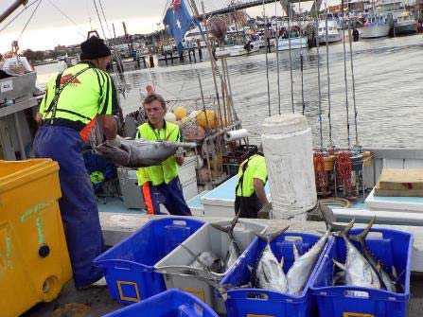http://www.acmssearch.sl.nsw.gov.au/search/itemDetailPaged. cgi?itemID=918295
Source 3: The Wingadee Stock Yards, Coonamble, 2004, photographed by Darren Clark | Source 4: Swimming in the Castlereagh River, Coonamble, 2003, photographed by Darren Clark
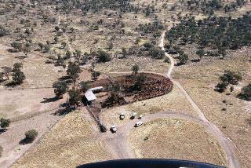http://www.acmssearch.sl.nsw.gov.au/search/itemDetailPaged.cgi?itemID=447439 | 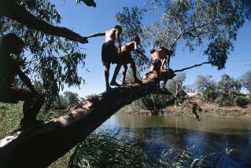http://www.acmssearch.sl.nsw.gov.au/search/itemDetailPaged.cgi?itemID=447439
Source 5: Street in Glebe, 2002, photographed by Patricia Baillie  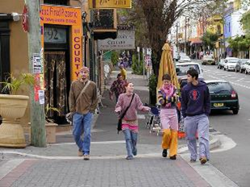http://digital.sl.nsw.gov.au/delivery/DeliveryManagerServlet?dps_pid=FL1499679&embedded=true&toolbar=false | Source 6: Fitness ‘bootcamp’, Blackwattle Bay, Glebe, 24/04/2010, photographed by Patricia Baille  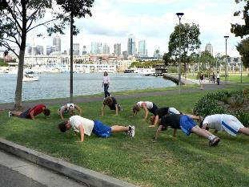https://digital.sl.nsw.gov.au/delivery/DeliveryManagerServlet?embedded=true&toolbar=false&dps_pid=FL4317499
Pictures courtesy State Library of New South Wales: NSW Syllabus for the Australian Curriculum – Geography (Places are similar and different)
Looking at the pictures of Glebe and Gulargambone, answer the following questions:
- What is happening in each photograph?
- Where do you think each photograph was taken from? Provide a possible caption for each photograph.
- What people, buildings, equipment and objects are shown? What is the physical setting in each photograph?
- Who are the people, what do they do and where do they live in Glebe and Gulargambone?
- How is inner city Sydney similar and different to north-western NSW?
- How and why is daily life similar and different in inner city Sydney and rural north-western NSW?

Activity 2
During this activity you will create a mini atlas.
Resources – help from an adult. You may need extra paper, some magazines, scissors, a stapler, colouring pens and pencils.

Creation of a mini atlas
It’s time to demonstrate your learning and create a mini atlas.
The mini atlas should include:
- A map that locates and describes features of Australia. Use your map of Australia that you completed in activity 1.
- Annotated photographs, pictures, or drawings to describe significant landforms and major cultural sites in Australia.
- A profile page of each of the three Australian places investigated.
- Explanations of similarities and differences between features, and daily life, including an explanation about the way the environment affects lifestyle.
- Australia’s position on a world map.

Category | Awesome | Great | Need to develop
Writing - Organisation | Each written section in the atlas has a clear beginning, middle, and end. | Almost all written sections of the atlas have a clear beginning, middle and end. | Less than half of the written sections of the atlas has a clear beginning, middle and end.
Organisation and Format | The atlas has excellent formatting and well-organised information. | The atlas has good formatting and well-organised information. | The atlas's formatting and organisation of material are confusing to the reader.
Spelling & Proofreading | No spelling errors - careful editing. | No more than 1 spelling error remains after careful editing | Several spelling errors in the atlas.
Graphics/Pictures | Graphics go well with the text and there is a good mix of text and graphics. | Graphics go well with the text, but there are so many that they distract from the text. | Graphics do not go with the accompanying text or appear to be randomly chosen.

Map of the world
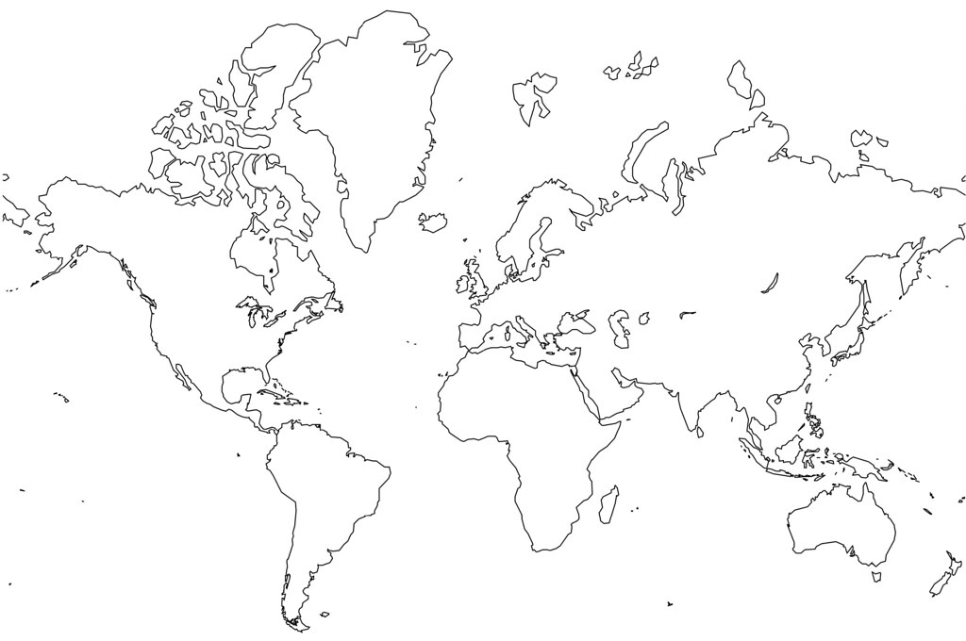

"Blank World Map - no borders" by jrhode is licensed under CC BY-NC-SA 2.0
Map of Australia
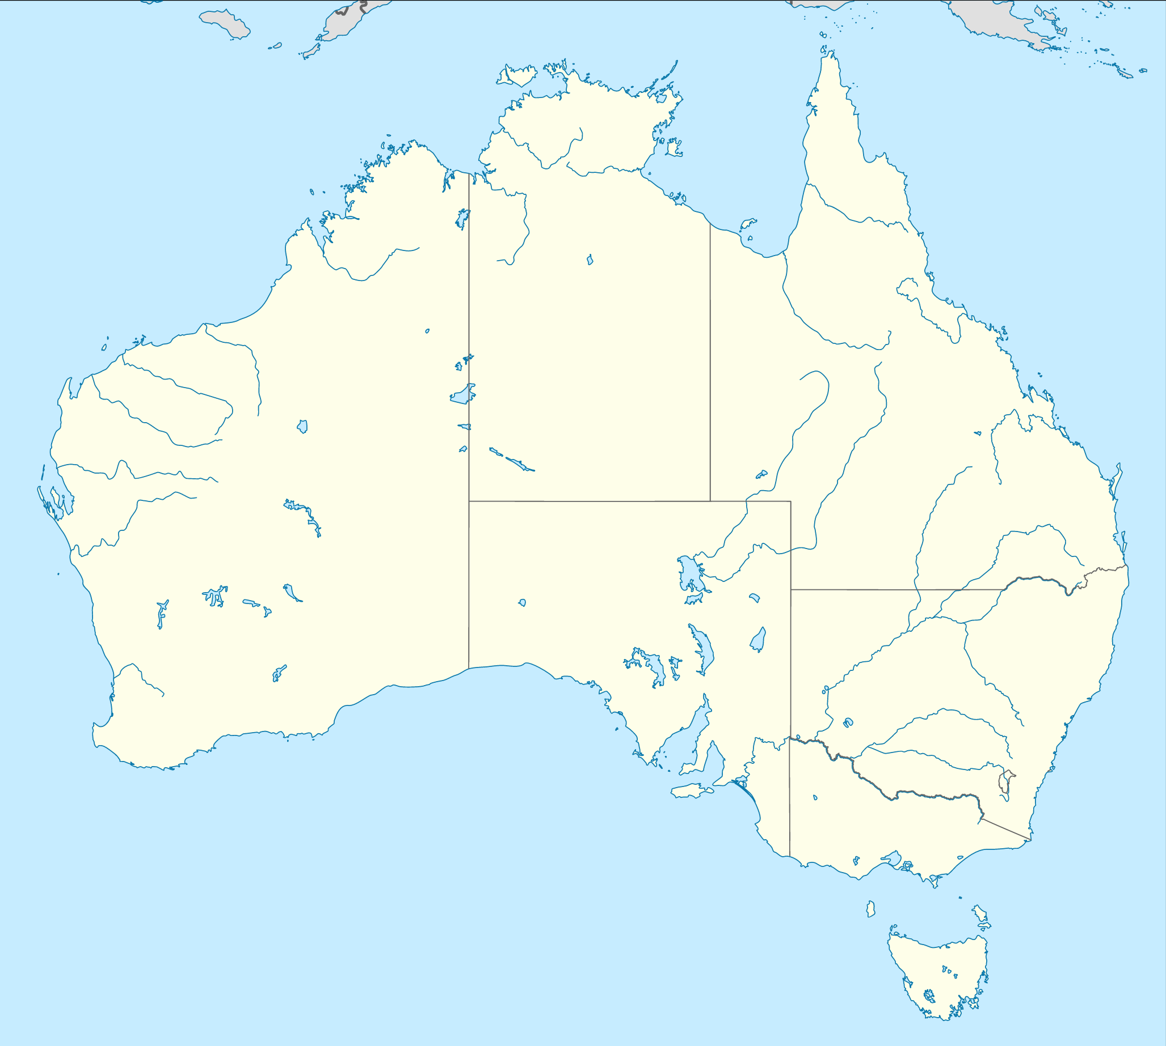
"File:Australia location map.svg" by NordNordWest is licensed under CC BY-SA 3.0

