HSIE: Geography ES1 resources

The following activities correspond to the resource worksheets 1-7 in the learning sequence for ES1 Geography – People live in places.

Please use all worksheets in a booklet form or choose and print the ones you want as you need them.

HSIE: Geography ES1 worksheet 1
Name:
Class:

My home
Here is the google map satellite image of my home where all you can see is the roof.
My home is circled.
Circle the correct answers
When I stand in front of my home I see:
The colour of my home
brown | black | white | grey | blue | Colour this box the colour of your home
The levels of my home
1 | 2 | 3 | More! How many?
The windows in my home
1 | 2 | 3 | 4 | More!  How many?

Here is a drawing of the outside of my home

When I walk into my home I see:
The bedrooms in my home
1 | 2 | 3 | 4 | 5 | More!  How many?

The floors in my home
Wood | Carpet | Tiles | Concrete | Something else?

HSIE: Geography ES1 worksheet 2
Name:
Class:

My favourite place
Draw your favourite place in your home and tell us why in the boxes below.
Give four reasons why this is your favourite place.

4 reasons why this is my favourite place

HSIE: Geography ES1 worksheet 3
Name:
Class:

Other peoples’ favourite places
Everyone has different special places. Circle the reason in the pictures why these children might have these as their favourite places.
Other peoples’ favourite places
I love to read!  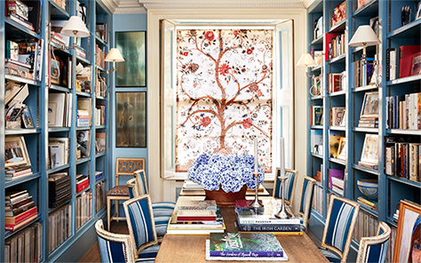  https://cdn.pixabay.com/photo/2014/04/03/11/07/girl-311782_960_720.png  https://3.bp.blogspot.com/-F52yv9ZJPZw/WFxybt1up_I/AAAAAAAAbqk/08S1q1DR-uo47E-fpaQjI8S_AAHRdxejgCEw/s1600/shelves-of-style.jpg | 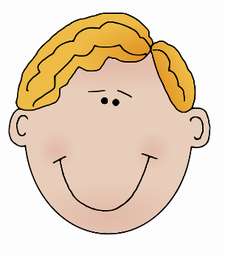  I’m great at swimming  https://cdn.pixabay.com/photo/2012/04/13/00/04/blonde-31103_960_720.png  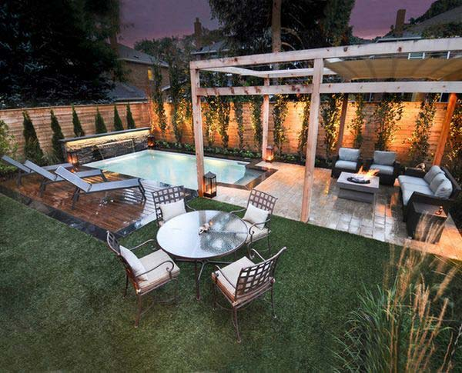  http://www.woohome.com/wp-content/uploads/2015/05/Small-Backyard-Pool-Woohome-3.jpg
https://cdn.pixabay.com/photo/2014/04/02/10/50/head-304719_960_720.png  I love watching old movies!  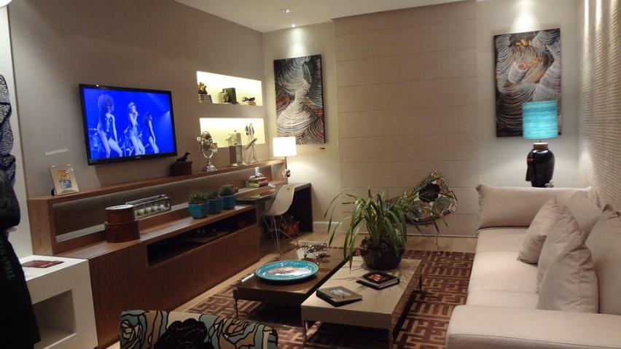  https://cdn.pixabay.com/photo/2015/02/24/02/01/tv-room-647010_960_720.jpg | My feet get cold in winter!  https://cdn.pixabay.com/photo/2014/04/02/11/13/boy-305593_960_720.png  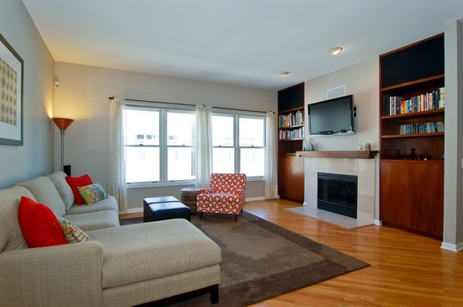  http://3.bp.blogspot.com/-_3LB0Oj8Hnw/TmeOSqTsOTI/AAAAAAAAGFU/IJ_tWLZuAI0/s1600/livingroom3.jpg

HSIE: Geography ES1 worksheet 4
Name:
Class:

Playground spaces
Here is a playground from a primary school.
What playground activities do you like the most? Which activities do you not like at all?
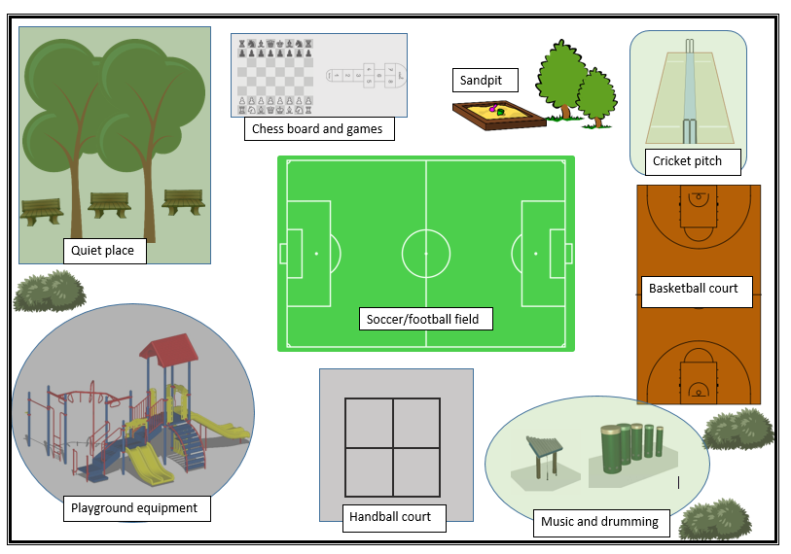

Playground picture attributions:
Quiet place
https://openclipart.org/image/2400px/svg_to_png/161173/Tree-1.png
https://cdn.pixabay.com/photo/2014/04/02/16/21/bench-307001_960_720.png
Chess board and games
https://i.stack.imgur.com/a8DcL.gif
https://upload.wikimedia.org/wikipedia/commons/thumb/c/cb/Image_marelle_2.jpg/100px-Image_marelle_2.jpg
Sandpit
https://cdn.pixabay.com/photo/2012/04/16/11/12/sandpit-35536_960_720.png
https://openclipart.org/image/2400px/svg_to_png/44023/TREES.png
Cricket pitch
https://upload.wikimedia.org/wikipedia/commons/thumb/4/47/Cricket_pitch_perspective.svg/170px-Cricket_pitch_perspective.svg.png
Basketball
https://upload.wikimedia.org/wikipedia/commons/thumb/b/be/Basketball_court_fiba.svg/170px-Basketball_court_fiba.svg.png
Music and drumming
https://dpa730eaqha29.cloudfront.net/myedmondsnews/wp-content/uploads/2018/03/Play-structure-drums-e1521005985387-470x420.jpeg
https://dpa730eaqha29.cloudfront.net/myedmondsnews/wp-content/uploads/2018/03/play-structure-xylophone-e1521006050250.jpeg
https://cdn.pixabay.com/photo/2014/12/21/23/54/bush-576310_960_720.png
Playground equipment
https://static.pexels.com/photos/340098/pexels-photo-340098.jpeg

Cut and paste the activity names under the smiley faces to show which activities you enjoy the most, and which activities you don’t enjoy, in order from most liked to least liked.

Playground activities I like the best
https://www.empillsblog.com/wp-content/uploads/2015/04/Smiley.jpg | https://images.vexels.com/media/users/3/134643/isolated/lists/f967dff67c513d21ebd6375982054b55-laugh-emoji-emoticon.png | https://cdn.pixabay.com/photo/2017/03/05/21/55/emoticon-2120024_640.png | https://upload.wikimedia.org/wikipedia/commons/thumb/d/dc/Oxygen480-emotes-face-smile.svg/1024px-Oxygen480-emotes-face-smile.svg.png | https://upload.wikimedia.org/wikipedia/commons/thumb/c/cb/Twemoji_1f610.svg/200px-Twemoji_1f610.svg.png | https://cdn.pixabay.com/photo/2017/01/13/15/39/boredom-1977519_960_720.png | https://upload.wikimedia.org/wikipedia/commons/thumb/b/b2/Twemoji_1f614.svg/768px-Twemoji_1f614.svg.png | https://upload.wikimedia.org/wikipedia/commons/thumb/4/4c/Face-bad.svg/120px-Face-bad.svg.png | https://upload.wikimedia.org/wikipedia/commons/thumb/8/8f/Emojione_1F620.svg/1024px-Emojione_1F620.svg.png
-----------------------------------------------------------------------------------------------------------------------
Sandpit | Quiet place | Playground equipment | Soccer and football | Basketball | Chess and games | Handball | Music | Cricket
Why did you choose your favourite activity? What do you like about it?
______________________________________________________________________________________________________________________________________________________

HSIE: Geography ES1 worksheet 5
Name:
Class:

Caring for rooms and spaces
Think about the things you and your family need to do to care for your home and keep it clean, organised and a nice place to live.
For each of the pictures, write or draw what you might do to help care for that space.

Space, place or room | How do we care for it?
Bathroom
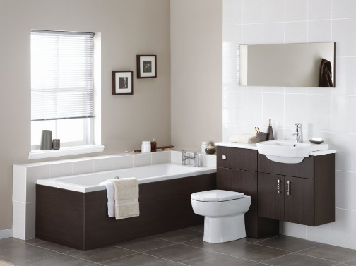

http://www.witteringwest.co.uk/images/bathroom-photos/truffle-brown-wall-hung.jpg
Kitchen
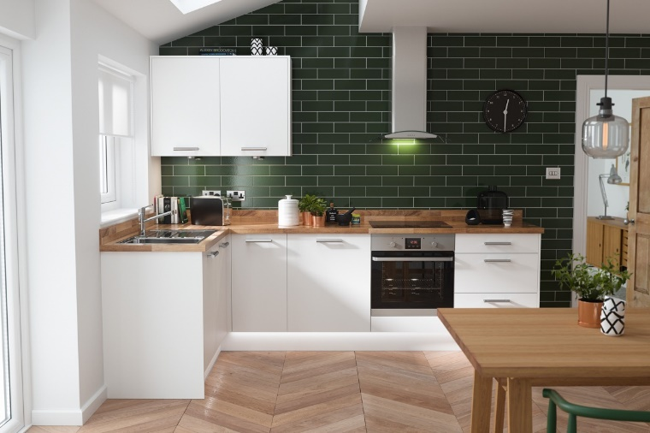

http://cdn.home-designing.com/wp-content/uploads/2018/05/Dark-green-kitchen-tiles.jpg

Bedroom
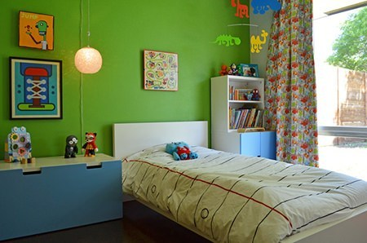

http://i1.wp.com/hisforhomeblog.com/images/home-tones/green-flash/kids-bedroom.jpg?resize=450%2C298
Backyard or garden
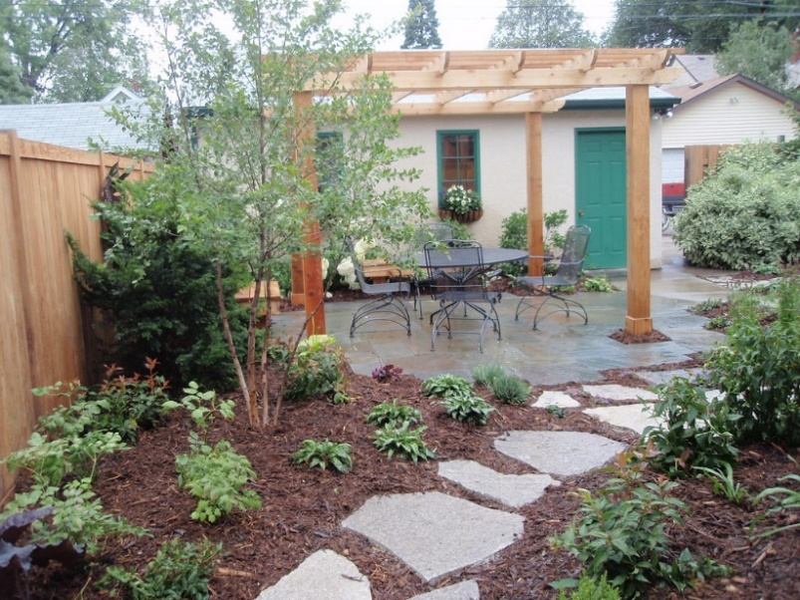

https://c1.staticflickr.com/3/2490/3798519379_eb140b8e60_b.jpg
Lounge room
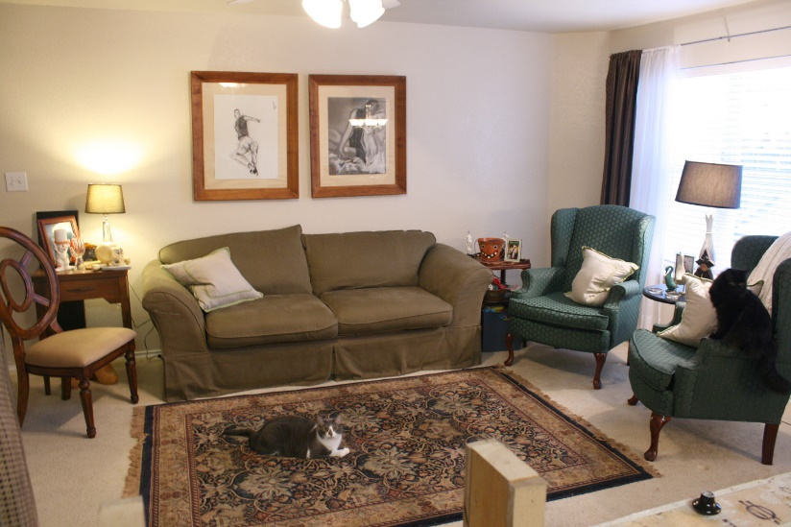

https://4.bp.blogspot.com/_zJZNte9YwyQ/TUeD6K-CO3I/AAAAAAAAN2I/VcK-__pfs7E/s1600/104b.JPG

HSIE: Geography ES1 worksheet 6
Name:
Class:

Steps to clean your classroom
Think about the order that you clean off your desk, pack away your books and pack your bag ready for the bell to ring.
Put these things in order from the first thing to the last thing you do to get your classroom tidy for the next day.
You can write or draw a picture.
Step 1.

Step 2.

Step 3.

Step 4.

HSIE: Geography ES1 worksheet 7
Name:
Class:

Jobs that look after Australian special places
We have many special places in Australia that need people to care for them. Below are 8 jobs that you need to match with the special places they are caring for. More than one job might be needed in some places.
Jobs that care for special places
Park Ranger | Cleaner
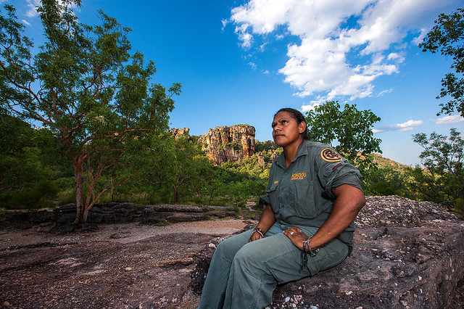  https://farm6.staticflickr.com/5532/9266994222_5f0794ba8b_z.jpg | 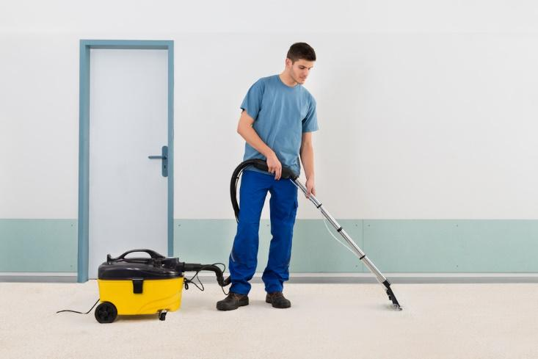  https://technofaq.org/wp-content/uploads/2017/04/image02-1.jpg
Painter | Rubbish collector
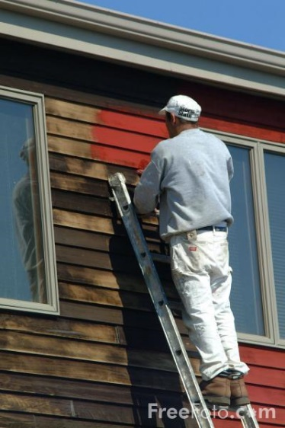  https://s3.freefoto.com/images/13/51/13_51_52_web.jpg | 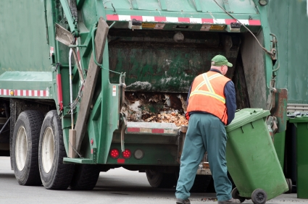  http://4.bp.blogspot.com/-LqVnDEMvVB8/TlsB4BhOKHI/AAAAAAAAAcM/anCdgPTUcCQ/s1600/garbage+truck.jpg
Farmer | Gardener
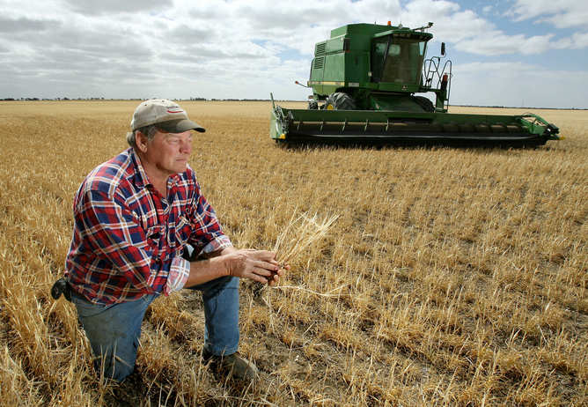  https://62e528761d0685343e1c-f3d1b99a743ffa4142d9d7f1978d9686.ssl.cf2.rackcdn.com/files/15691/width668/7f9zdr44-1348116290.jpg | http://res.freestockphotos.biz/pictures/17/17354-a-woman-working-in-her-garden-pv.jpg
Builder | Marine Park Ranger
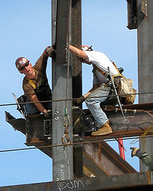  https://upload.wikimedia.org/wikipedia/commons/thumb/4/4a/Construction_Workers.jpg/220px-Construction_Workers.jpg | 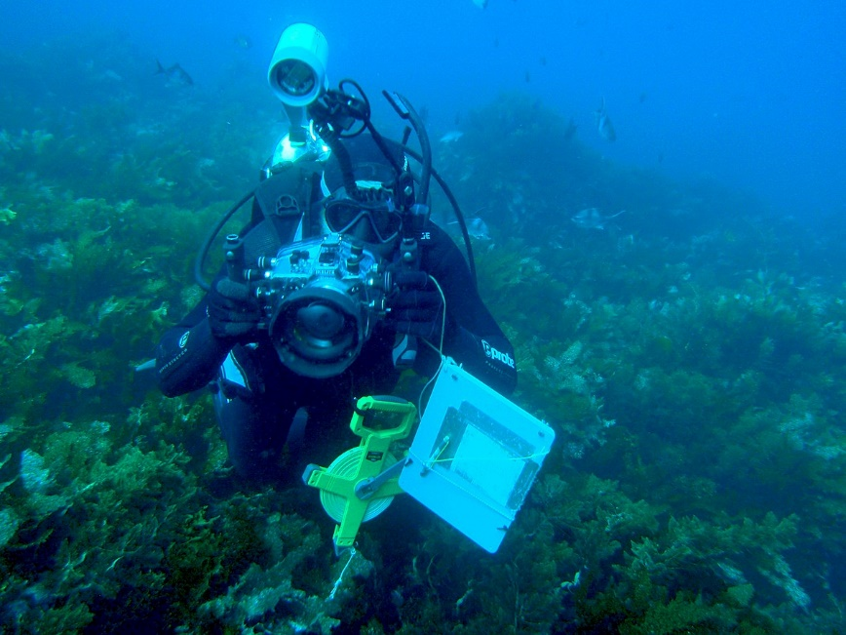  https://upload.wikimedia.org/wikipedia/commons/thumb/5/5d/Graham_Edgar_on_RLS_transect_at_Pearson_Island_P1091644.JPG/1200px-Graham_Edgar_on_RLS_transect_at_Pearson_Island_P1091644.JPG

Match these jobs to the special Australian place they are caring for. Each special place might need more than one job caring for it.
Special Australian places | The jobs that care for this place
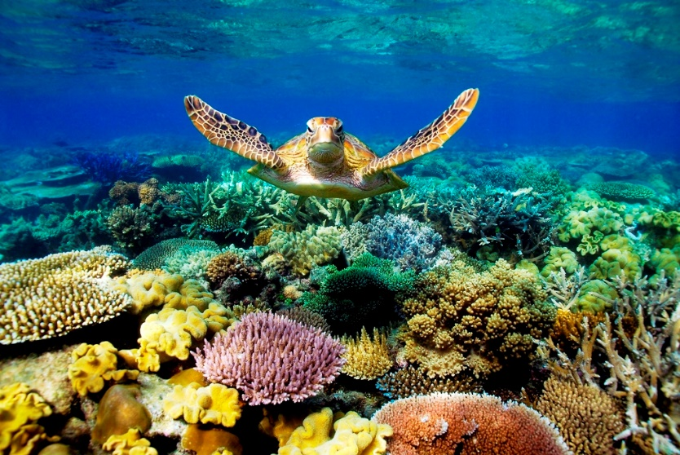
Great Barrier Reef
https://overseasadventuroustravel01.files.wordpress.com/2015/01/barrier-reef.jpg
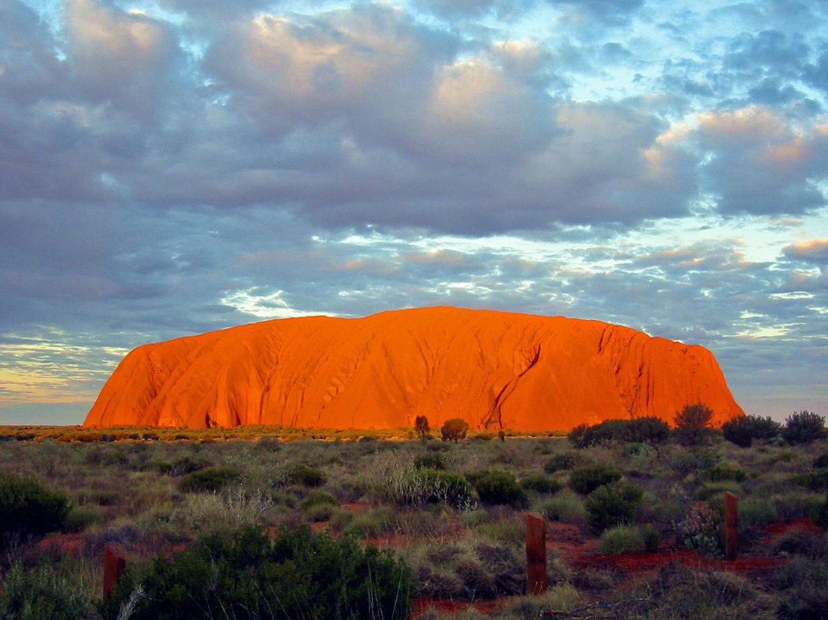
Uluru
https://upload.wikimedia.org/wikipedia/commons/thumb/1/1a/Uluru_Australia%281%29.jpg/1200px-Uluru_Australia%281%29.jpg
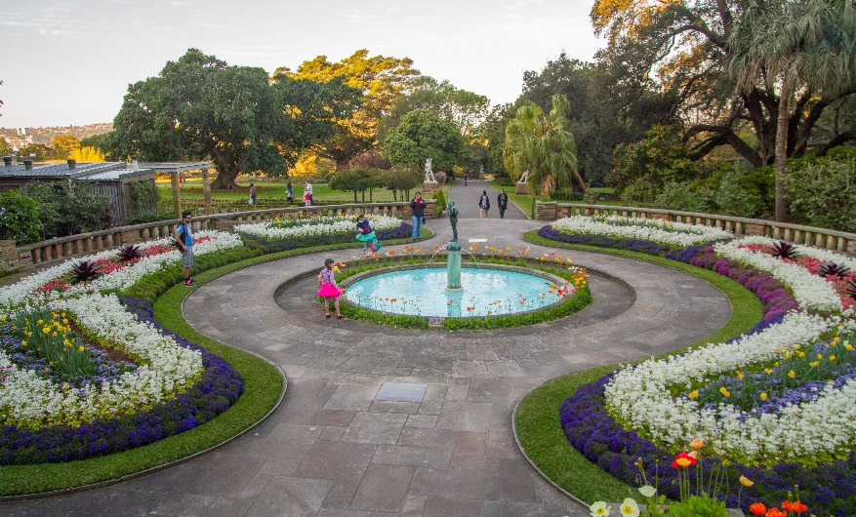
Royal Botanic Gardens
https://upload.wikimedia.org/wikipedia/commons/9/90/2015-09-13_Royal_Botanic_Gardens%2C_Sydney_-_1.jpg
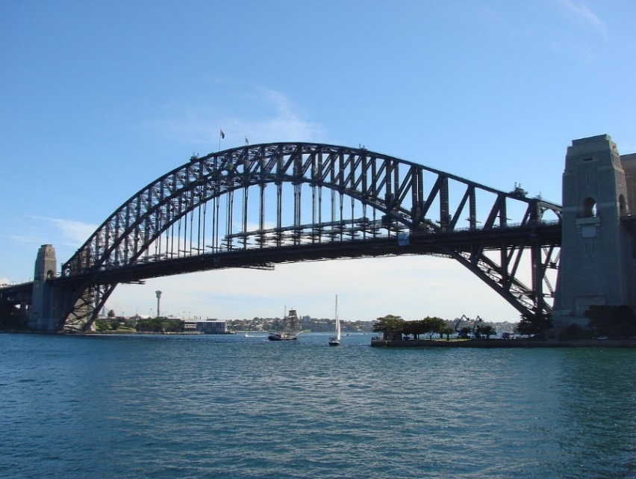
Sydney Harbour Bridge
https://upload.wikimedia.org/wikipedia/commons/thumb/4/47/Harbour_Bridge_-_panoramio.jpg/1200px-Harbour_Bridge_-_panoramio.jpg
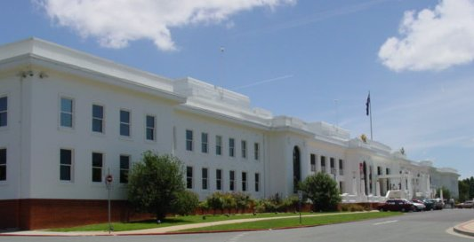
Old Parliament House
https://upload.wikimedia.org/wikipedia/commons/thumb/7/7f/Old_Parliament_House_cropped.jpg/220px-Old_Parliament_House_cropped.jpg
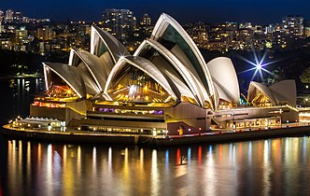
Sydney Opera House
https://upload.wikimedia.org/wikipedia/commons/thumb/c/cd/Sydneyoperahouse_at_night.jpg/332px-Sydneyoperahouse_at_night.jpg
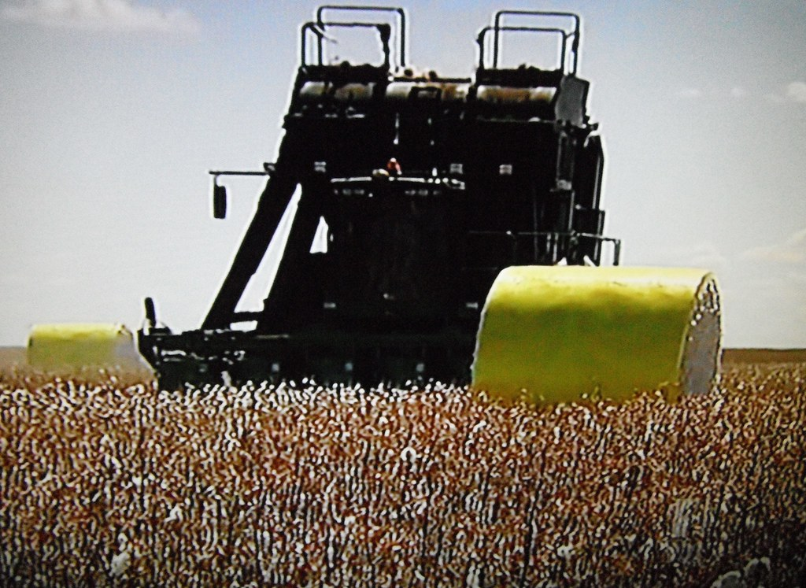

Cubbie Station Cotton Farm
https://live.staticflickr.com/8188/8135087714_93d3a15325_b.jpg

