Significant Australians
This learning sequence comprises two short inquiries.

Topic – Australia as a nation
3 weeks – 90 minutes per week

Key inquiry questions
- What contribution have significant individuals and groups made to the development of Australian society?

Overview
Inquiry 1 is a guided inquiry into Aboriginal inventor, writer, musician, preacher and spokesman, Robert Unaipon, who is remembered on Australia’s fifty-dollar note. Inquiry 2 is an independent inquiry into an individual or group who has made a significant contribution to Australia. If students are competent in the historical inquiry process, Inquiry 1 can be omitted.

Outcomes
A student:
HT3-3 identifies change and continuity and describes the causes and effects of change on Australian society
HT3-5 applies a variety of skills of historical inquiry and communication

Content
The contribution of individuals and groups, including Aboriginal people and/or Torres Strait Islanders and migrants, to the development of Australian society, for example in areas such as the economy, education, sciences, the arts, sport (ACHHK116)
Students:
- using a range of sources, research and describe the contribution of Aboriginal and Torres Strait Islander peoples and other groups to Australian society

Historical inquiry skills
Comprehension: chronology, terms and concepts
- respond, read and write to show understanding of historical matters
- sequence historical people and events (ACHHS098, ACHHS117)
- use historical terms and concepts (ACHHS099, ACHHS118)
Analysis and use of sources
- locate information relevant to inquiry questions in a range of sources (ACHHS102, ACHHS121)
- compare information from a range of sources (ACHHS103, ACHHS122)
Perspectives and interpretations
- identify different points of view in the past and present (ACHHS104, ACHHS123)
Empathetic understanding
- explain why the behaviour and attitudes of people from the past may differ from today
Research
- identify and pose questions to inform an historical inquiry (ACHHS100, ACHHS119)
- identify and locate a range of relevant sources to support an historical inquiry (ACHHS101, ACHHS120)
Explanation and communication
- develop historical texts, particularly narratives and descriptions, which incorporate source material (ACHHS105, ACHHS124)
- use a range of communication forms (oral, written, graphic) and digital technologies. (ACHHS106, ACHHS125)

Selected historical concepts
Continuity and change – some things change over time and others remain the same, eg aspects of both continuity and change in Australian society throughout the twentieth century.
Cause and effect – events, decisions or developments in the past that produce later actions, results or effects, eg events and other reasons that led to migration to Australia; reasons for the struggle for rights and freedoms for various groups in Australia.
Perspectives – people from the past will have different views and experiences, eg differing attitudes of various groups to Federation or to granting rights and freedoms to women and Aboriginal peoples.
Empathetic understanding – an understanding of another's point of view, way of life and decisions made in a different time, eg differing attitudes and experiences of living in an Australian colony; understanding the experiences of Aboriginal and Torres Strait Islanders, women and migrants throughout the twentieth century.
Significance – the importance of an event, development or individual/group, eg determining the importance (significance) of various peoples' contributions to the development of a colony.

Assessment
All activities require students to demonstrate their learning. All are assessment for learning activities.

Vocabulary
Investigate, locate, examine, observe, interview, infer, summarise, record, primary source, secondary source, reliable, evidence, perspective, reproduce, recreate, role play, historical narrative
Role, occupation, contribution, significance, influence, motivation, action, colony, challenge, criticism, success, legacy, remember, commemorate

Teaching and learning activities
This learning sequence comprises two inquiries.

Inquiry 1 – guided inquiry into David Unaipon
Students investigate the contribution of David Unaipon to Australia. They write his biography and explain his contribution to Australia.
Note – If students are competent in the historical inquiry process, inquiry 1 can be omitted, or used for students who need an inquiry scaffold. David Unaipon has been selected as he is remembered on Australia’s fifty-dollar note. An alternative person or group can be investigated.

Stimulus
Collectively examine source 1. Students make inferences about the significance of the diagrams and text associated with the image. They make inferences on the contributions of David Unaipon to Australia.
Source 1 – Image of David Unaipon on the Australian fifty-dollar note

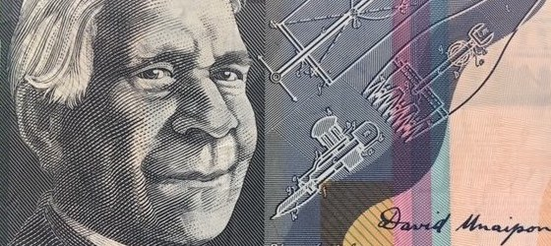
Note: Image meets the Reserve Bank of Australia copying guidelines

Historical inquiry step 1 – question
With reference to the students’ inferences, formulate a set of inquiry questions relating to the significance of David Unaipon to Australia.
Sample questions:
- Who is David Unaipon?
- Where and when was he born and raised?
- What were his occupations and interests?
- How has David Unaipon contributed to Australia?
- Why is David Unaipon a significant person?
- What is his legacy and how is he remembered?
Note – Inquiry questions may need to be redesigned through the historical inquiry process.

Historical inquiry step 2 – research
Biography of David Unaipon
Students use sources 2 to 6 to develop a biography of David Unaipon. They organise their information in the source analysis table in table 1.
Source 2 – Biography of David Unaipon, State Library of South Australia
David Unaipon was born at Raukkan (Point McLeay) Mission in 1872. Educated at the mission school and in Adelaide, Unaipon was particularly interested in scientific studies and began to study mechanics and conduct experiments in perpetual motion and polarised light. Many of Unaipon’s ideas were ahead of his time and he was referred to as ‘Australia’s Leonardo’. In 1909, he developed and patented a modified handpiece for shearing and in following decades submitted patent applications for nine other inventions, including a centrifugal motor. He predicted the invention of the helicopter. Unaipon was also known as a writer, musician, preacher and a spokesman for his people. He retired to Raukkan Mission, where he worked on his inventions, particularly investigating perpetual motion.
State Library of South Australia
Source 3 – Patent specification for mechanical sheep sheers developed by David Unaipon, 1909
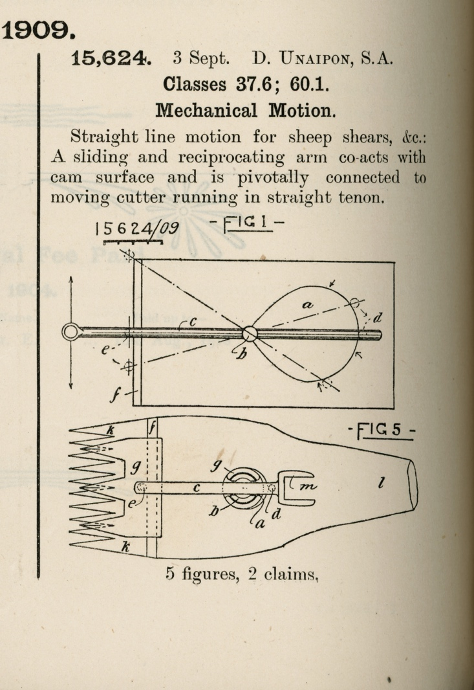
Patent specification for mechanical motion in sheep shears. No.15,624, 1909. David Unaipon, South Australia. Australian Patent Office, Australian official journal of patents, Government Printer, Melbourne, 1905–1931, State Library of South Australia. Out of copyright
Source 4 – Extract from ‘Mr David Unaipon visiting Singleton: Brilliant Aboriginal student and inventor’, Singleton Argus, 4 September 1939
He is a man of wide accomplishments, being recognised as one of Australia's leading anthropologists, having written more than one work on this subject. His opinion is constantly sought by the authorities of Adelaide University on this subject. His attainments, however, are not limited to this study.
David Unaipon is a man of recognised and genuine scientific attainments. It was he who discovered unilateral motion and the method of applying it. It will come as a surprise to the people of this district to know that their shearing machines are dependent upon this discovery. Without Mr Unaipon's work, the modern shearing machine would not be possible.
Nor is that the limit to which he has gone in the field of invention. A discovery of interest is a method he has perfected for causing an aeroplane to rise straight up from the ground, or to remain stationary in the air. Because he fears its possible misuse in war, he will not make this available for use.
Mr Unaipon is a brilliant and charming speaker. Recently, when in Sydney, it became known that he was preaching at St. Andrew's Cathedral, the A.B.C., at the last minute, suspended part of its normal programme especially to broadcast his address.
Singleton Argus, 4 September 1939, p 3. Trove
Source 5 – Transcript from the handwritten preface to David Unaipon’s book, ‘The legendary tales of the Australian Aborigines’, written in 1924 to 1925.
The image from the fifty-dollar note is a reproduction of the last paragraph of the preface, in David Unaipon’s handwriting.
My race - the Aborigines of Australia - has a vast tradition of legends, myths and folk-law stories. These, which they delight in telling to the younger members of the tribe, have been handed down orally for thousands of years. In fact, all tribal law and customs are, first of all, told to the children of the tribe in the form of stories, just as the white Australian mother first instructs her children with nursery stories: Of course the mothers and the old men, in telling these stories, drag them out to a great length, putting in every detail, with much gesture and acting, but in writing them down for our white friends I have used the simplest form of expression, in order that neither the meaning nor the "atmosphere" may be lost.
As a full-blooded member of my race I think I may claim to be the first - but, I hope not the last - to produce an enduring record of our customs, beliefs and imaginings.
David Unaipon
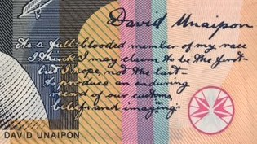
The handwritten preface can be viewed in the original volume of The legendary tales of the Australian Aborigines by David Unaipon, 1924-1925, Mitchell Library, State Library of NSW, Note – Image from fifty-dollar note meets the Reserve Bank of Australia copying guidelines
Source 6 – Additional primary sources in the biography planner: Significant individuals – David Unaipon
Table 1 – Source analysis table
Source number | Title and date | Who created it and why? | Key information | What it provides evidence of | Questions raised

Historical inquiry step 3 – analyse
Students analyse their information in table 1 to answer the inquiry questions and create a biography of David Unaipon. They organise their information in table 2.
Table 2 – Biography of David Unaipon
Category | Key information | Evidence in sources
Name
Date of birth and death
Place of birth and death
Occupation and role
Works and inventions
Contribution to Australia
Significance to Australia
Challenges
Legacy
Commemoration

Historical inquiry step 4 – evaluate
Review the evaluations of the reliability of the sources in tables 2 and 3. Are there inconsistencies or contradictions between the sources? Do the inquiry questions need to be redesigned as a result of analysing and evaluating sources?

Historical inquiry step 5 – communicate
What’s on the fifty-dollar note?
On an enlarged image of a fifty-dollar note, students label and annotate the significance and meaning of the images and text around the portrait of David Unaipon, explaining his contributions to Australia.
Reflection
Students reflect on the historical inquiry process, reflecting on what they learnt, how they learnt it and what else they would like to find out.

Inquiry 2 – student-led inquiry on a significant Australian
Students undertake a student-led inquiry into a significant individual or group who made a notable contribution to Australia. They communicate through designing and annotating a new Australian monetary note that draws on primary sources, presented briefly as a PechaKucha.
Note – The student inquiry is intended to be a short research task. It could be undertaken concurrently with the guided class inquiry, or instead of the guided class inquiry.

Historical inquiry step 1 – question
Students select a notable colonial and formulate a set of inquiry questions.
Sample questions:
- Who is the person or group?
- Where and when was the person born and raised?
- What were the person’s occupation and interests?
- How has the person contributed to Australia?
- Why is the person significant to Australia?
- What is the person’s legacy and how is he or she remembered?

Historical inquiry step 2 – research
Students locate and use secondary and primary sources. They use source analysis skills to interrogate the sources. Students use table 3 to organise their information from the sources. Sources could include newspaper articles sourced through Trove, paintings, photographs and biographies.
Table 3 – Source analysis table
Source number | Title and date | Who created it and why | Key information | What it provides evidence of | Questions raised

Historical inquiry step 3 – analyse
Table 4 – Biography of a significant Australian
Category | Key information | Evidence in sources
Name
Date of birth and death
Place of birth and death
Occupation and role
Works and achievements
Contribution to Australia
Significance to Australia
Challenges
Legacy
Commemoration

Historical inquiry step 4 – evaluate
During research and analysis, students evaluate the reliability of the sources. Are there inconsistencies or contradictions between the sources? Do the inquiry questions need to be redesigned as a result of analysing and evaluating sources?

Historical inquiry step 5 – communicate
Design for a new note
Students create a visual representation of their significant Australian suitable for featuring on a new Australian seventy-five dollar note. The image should show a portrait of the person, and make reference to primary sources that show aspects of the person’s life and achievements. Students label and explain the features of their design and provide justification as to why their person should be the one included on the new note. Designs are presented to the class as a pecha kucha.
Reflection
Students reflect on the historical inquiry process, reflecting on what they learnt, how they learnt it and what else they would like to find out.

Additional resources
Books
Tea and sugar Christmas by Jane Jolly and Robert Ingpen (PRC K-2)
Meet the flying doctors by George Ivanoff and Ben Wood (PRC 3-4)
Teacher resource

A Guide to using picture books in History K-10, Department of Education, 2017
Digital collections
National Archives Australia
Trove
State Archives and Records of NSW

