Colonial immigration
This learning sequence comprises two inquiries.

Topic – The Australian colonies
4 weeks – 90 minutes per week

Key inquiry questions
- What do we know about the lives of people in Australia's colonial past and how do we know?
- How did an Australian colony develop over time and why?

Overview
Inquiry 1 is a guided inquiry into the reasons for colonial immigration to Australia. With reference to paintings, passenger lists and passenger tickets, they identify the main countries from which people migrated, the causes that led to migration and their effects on Australia. Inquiry 2 investigates the experiences of Chinese immigrants and their contributions to Australian society. This can be amended to an investigation into the experiences and contributions of another colonial immigrant group.

Outcomes
A student:
- HT3-1 describes and explains the significance of people, groups, places and events to the development of Australia
- HT3-5 applies a variety of skills of historical inquiry and communication

Content
The reasons people migrated to Australia from Europe and Asia, and the experiences and contributions of a particular migrant group within a colony (ACHHK096)
Students:
- identify the European and Asian countries from which people migrated to Australia during the nineteenth century and reasons for their migration
- investigate the experiences of a particular migrant group and the contributions they made to society

Historical inquiry skills
Comprehension: chronology, terms and concepts
- respond, read and write to show understanding of historical matters
- sequence historical people and events (ACHHS098, ACHHS117)
- use historical terms and concepts (ACHHS099, ACHHS118)
Analysis and use of sources
- locate information relevant to inquiry questions in a range of sources (ACHHS102, ACHHS121)
- compare information from a range of sources (ACHHS103, ACHHS122)
Perspectives and interpretations
- identify different points of view in the past and present (ACHHS104, ACHHS123)
Empathetic understanding
- explain why the behaviour and attitudes of people from the past may differ from today
Research
- identify and pose questions to inform an historical inquiry (ACHHS100, ACHHS119)
- identify and locate a range of relevant sources to support an historical inquiry (ACHHS101, ACHHS120)
Explanation and communication
- develop historical texts, particularly narratives and descriptions, which incorporate source material (ACHHS105, ACHHS124)
- use a range of communication forms (oral, written, graphic) and digital technologies. (ACHHS106, ACHHS125)

Selected historical concepts
Cause and effect – events, decisions or developments in the past that produce later actions, results or effects, eg events and other reasons that led to migration to Australia; reasons for the struggle for rights and freedoms for various groups in Australia.
Perspectives – people from the past will have different views and experiences, eg differing attitudes of various groups to Federation or to granting rights and freedoms to women and Aboriginal peoples.
Empathetic understanding – an understanding of another's point of view, way of life and decisions made in a different time, eg differing attitudes and experiences of living in an Australian colony; understanding the experiences of Aboriginal and Torres Strait Islanders, women and migrants throughout the twentieth century.
Significance – the importance of an event, development or individual/group, eg determining the importance (significance) of various peoples' contributions to the development of a colony.

Assessment
All activities require students to demonstrate their learning. All are assessment for learning activities.

Vocabulary
Cause, effect, significance, perspective, empathy
Observe, examine, summarise, record, sequence, infer, speculate, representation, conclude
Colonial, colony, penal, settlement, establishment, settlement patterns, influence, factors, consequences, impacts
Europe, Asia, migrated, emigrant, immigrant, migrant, passenger, gender, experience, society, colony, contribution, customs, traditions, culture, cause, effect, perspective, opportunity, challenge, endurance

Teaching and learning activities
This learning sequence comprises two sequential inquiries.

Inquiry 1 – reasons for colonial migration
Through a guided inquiry, students use a range of primary sources to identify the European and Asian countries from which people migrated to Australia and the reasons for their migration.

Stimulus
Collectively examine source 1. Discuss first impressions of the painting. Consider the gender and ages of the people and their potential reasons for immigrating to Australia.
Source 1 – Coming south, painted by Tom Roberts, 1886
Tom Roberts was a significant colonial painter who migrated from England to Australia in 1869. The ship in the painting is the SS Lusitania, the first mail steam ship on the Orient Line.
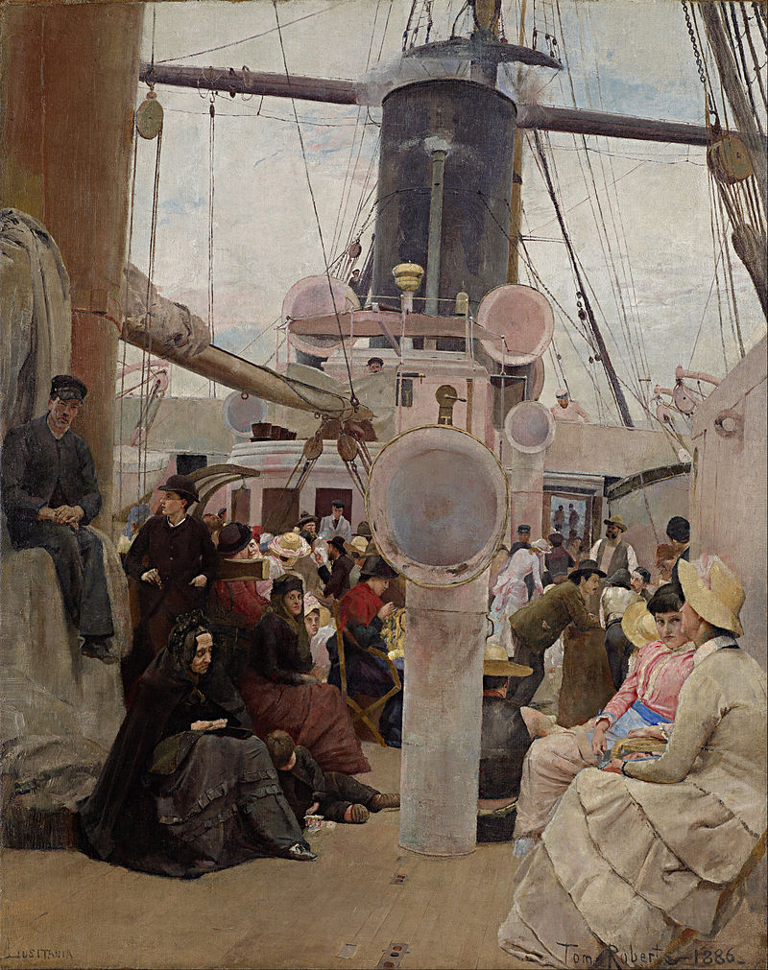
Google Art Project. Public domain
In pairs or individually, using computers or tablets, students use the zoom tools to examine the details of the painting, Coming south, on the Google Arts and Culture website.
Students discuss the people in the painting using See-Think-Wonder prompts to guide their observations and inferences.
See-Think-Wonder prompts
See
- What people are shown? What is the gender mix? What are they doing?
- What objects are shown? How are they being used?
- What details can you see? Is there something unexpected?
Think
- Who are the people and why are they there?
- What are their stories?
- What can you learn from examining this painting?
Wonder
- What else would you like to know?

Historical inquiry step 1 – question
With reference to the students’ See-Think-Wonder discussions, students formulate a set of inquiry questions relating to the syllabus dot point:
Sample questions:
- Who were the people who came to Australia between 1800 and 1890?
- From what countries did they come?
- Why did they come?
Note – Inquiry questions may need to be redesigned through the historical inquiry process.

Historical inquiry steps 2 and 3 – research and analyse
Countries of origin
Students read the information in sources 2, 3 and 4. They identify and write the reasons for migration in table 1.
Source 2 – Shipboard, The 19th century emigrant experience: Emigrating, State Library of NSW

Source 3 – Harvest of endurance: Chinese workers, National Museum Australia
Source 4 – Making a nation: ‘Afghans’ and their camels for Australian inland transport, Museum of Applied Arts and Sciences
Table 1 – Reasons for migration cause and effect table
Country | Cause | Effect | Migration opportunity
United Kingdom
Australia
China
Afghanistan*
Note – The Afghan cameleers came from Afghanistan and other surrounding countries.
British colonial immigrants
Students select a passenger list of one journey to Australia from the gallery of passenger lists in source 2. They use tally marks to record the different types of passengers, per class of travel, as listed in table 2. From the table, students determine the main types of immigrants for that journey.
As an optional activity, students examine the digitised passenger tickets in source 2 to learn the ages and compositions of families migrating to Australia.
Table 2a – Ship details
Name of ship | Year | Travelling from | Travelling to
Table 2b – Types of passengers travelling to Australia, per class of travel
Class | Men on their own: Mr | Married women on own: Mrs | Single women: Miss | Married couples: Mr and Mrs | Families: Mr, Mrs, Miss, Master
First
Second
Third
Students draw conclusions based on the evidence presented in table 2b:
- What type of passenger has the highest representation for each class of passage?
- What type of passenger has the highest representation overall?
- Provide inferences and reasons for the mix of passengers migrating to Australia.
Note – Passengers were separated into spaces on the ship according to their social class, as well as their gender and marital status.

Historical inquiry step 4 – evaluate
Guide the students in evaluating the reliability of the sources: Are paintings, passenger tickets and on-board newspapers reliable sources of information? Why or why not? Do the inquiry questions need to be redesigned as a result of analysing and evaluating sources?

Historical inquiry step 5 – communicate
Journal entry
In role as a passenger on a colonial migrant ship travelling to Australia, students write a journal entry written in the first week of their journey to Australia. They state why they left their country and migrated to Australia. They describe a person or couple they met on the deck. Students include their hopes for their new life in Australia.
Reflection
Students reflect on the historical inquiry process, reflecting on what they learnt, how they learnt it and what else they would like to find out.

Inquiry 2 – experiences of one colonial migrant group
As a semi-guided inquiry, students use secondary sources to investigate the experiences of Chinese immigrants and the contribution they made to Australian society. They locate and use primary sources to verify their information. As an alternative, students could investigate the experiences of a different colonial immigrant group, such as the Afghan cameleers.

Stimulus
Students examine sources 5 and 6, images of Chinese gold miners. They compare the people and the setting in these images to Tom Roberts’ painting, Coming south, viewed in Inquiry 1. Students use See-Think-Wonder prompts to guide their observations and inferences.
Source 5 – Chinese on their way to the gold diggings in Bendigo, Victoria, by Charles Lyall, circa 1854
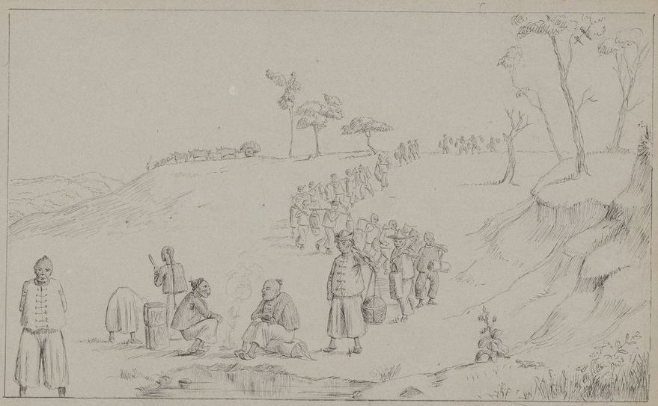
State Library of Victoria. Out of copyright
Source 6 – Australian gold rush, panel from the Harvest of Endurance scroll by Mo Xiangyi, 1988
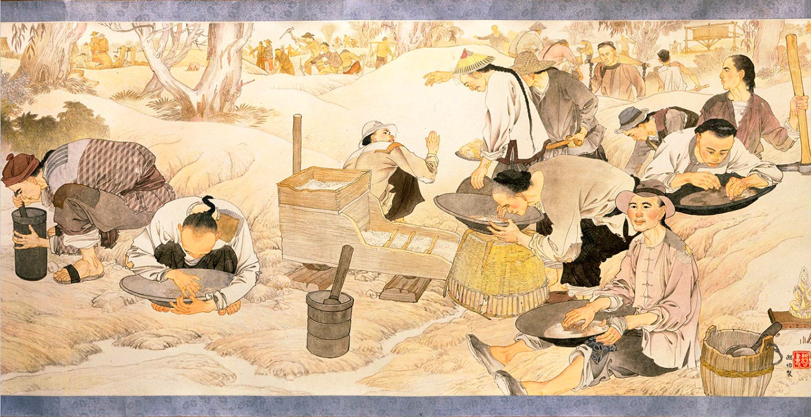
Copyright: Australia-China Friendship Society. Reproduced with permission, National Museum Australia.
See-Think-Wonder prompts
See
- What people are shown? What is their gender and nationality? What are they doing?
- What objects are shown? How are they being used?
- What details can you see? Is there something unexpected?
Think
- Who are the people and why are they there?
- What are their stories?
- What can you learn from examining this sketch?
Wonder
- What else would you like to know?

Historical inquiry step 1 – question
With reference to the students’ See-Think-Wonder discussions, students formulate two or three inquiry questions.
Sample questions:
- What were the experiences of the Chinese gold miners who came to Australia from the 1850s?
- What contribution did they make to Australia?
Note – Inquiry questions may need to be redesigned through the historical inquiry process.

Historical inquiry steps 2 and 3 – research and analysis
Students select one of the two research tasks listed below.
1. Chinese immigrant experience
- Use the video in source 7 to create a summary of the key experiences in the life of one Chinese immigrant who immigrated to Australia in the 1850s.
- State the contribution that the immigrant made to Australia during the colonial years.
- Locate two primary sources that verify the information presented in the video.
- Use table 3 to record information provided by each primary source.
Source 7 – Chinese migration, Behind the News, ABC (video and transcript)
2. Colonial Chinese immigration timeline
- Use the information links in the Harvest of endurance site in source 8, from Australian gold rush to The general store, to create a timeline of key experiences for Chinese immigrants in Australia.
- On the timeline highlight the contributions that Chinese immigrants made to Australia between 1850 and 1890.
- Locate two primary sources that illustrate and verify two of the key events.
- Use table 3 to record information provided by each primary source.
Source 8 – Harvest of endurance: Australian Gold Rush, National Museum of Australia
Table 3 – Chinese immigrants source analysis table

Source number | Title and date | Who created it and why? | Whose view is it? | Key information | Questions raised

Historical inquiry step 4 – evaluate
Guide the students in evaluating the reliability of the sources: Are sketches and paintings reliable sources of information? Why or why not? Do the inquiry questions need to be redesigned as a result of analysing and evaluating sources?

Historical inquiry step 5 – communicate
Chinese immigrant contributions
Using speech bubble sticky notes, or a digital annotation app, students annotate a copy of the Australian gold rush panel in source 5. They select three or four miners and write a speech bubble that states their future contribution to Australia. For example, “After the gold dried up I set up a very successful general store. I stocked it with all sorts of products from foods to tools that people in our community needed. Without my store, people would have had to travel great distances to buy what they needed.”
Reflection
Students reflect on the historical inquiry process, reflecting on what they learnt, how they learnt it and what else they would like to find out.

Additional resources
Books
Bridget: A new Australian by James Maloney (PRC 5-6) – set in 1848
Kerenza: A new Australian by Rosanne Hawke (PRC 5-6) – set in 1911 in South Australia’s Mallee country
My name is Lizzie Flynn: A story of the Rajah Quilt by Claire Saxby and Lizzy Newcomb (PRC 3-4) – based on the true story of the making of the Rajah Quilt by convict women under the instigation and supervision of a free passenger and now housed in the National Gallery of Australia
Mustara by Rosanne Hawke and Robert Ingpen (PRC 3-4)
The big book of Australian History by Peter Macinnis
Websites
Australian migration history timeline, 1840-1900, Migration Heritage Centre, NSW (archived site)
Braidwood’s Chinese pioneers, Braidwood and District Historical Society
Australian migration (1788-1900) – The colonial years: The Chinese experience, YouTube
Gold: Immigration and population, SBS
Digital collections
Trove
State Library of NSW
State Records of NSW

