Colonial development
This learning sequence comprises two inquiries, with two options for the second inquiry.

Topic – The Australian colonies
6 weeks – 90 minutes per week

Key inquiry questions
- What do we know about the lives of people in Australia's colonial past and how do we know?
- How did an Australian colony develop over time and why?
- How did colonial settlement change the environment?
- What were the significant events and who were the significant people that shaped Australian colonies?

Overview
This teaching and learning sequence builds on understandings developed in the framework: Colonial settlement and life.
In inquiry 1, students investigate and generate a timeline of the significant events that shaped Australia’s identity. Inquiry 2 is offered with two options. In inquiry 2a, students undertake a guided inquiry into the impacts of internal exploration. Inquiry 2b provides a list of topics, for the selection of one, for investigation as a guided or semi-guided inquiry.
Note – The teaching and learning sequence, Notable colonials, could follow this framework to create a ten week learning sequence.

Outcomes
A student:
- HT3-1 describes and explains the significance of people, groups, places and events to the development of Australia
- HT3-2 describes and explains different experiences of people living in Australia over time
- HT3-5 applies a variety of skills of historical inquiry and communication

Content
The impact of a significant development or event on a colony; for example, frontier conflict, the gold rushes, the Eureka Stockade, internal exploration, the advent of rail, the expansion of farming, drought (ACHHK095)
Students:
- identify events that have shaped Australia's identity and discuss why they were significant
- use a range of sources to investigate ONE significant development or event and its impact on the chosen colony

Historical inquiry skills
Comprehension: chronology, terms and concepts
- respond, read and write to show understanding of historical matters
- sequence historical people and events (ACHHS098, ACHHS117)
- use historical terms and concepts (ACHHS099, ACHHS118)
Analysis and use of sources
- locate information relevant to inquiry questions in a range of sources (ACHHS102, ACHHS121)
- compare information from a range of sources (ACHHS103, ACHHS122)
Perspectives and interpretations
- identify different points of view in the past and present (ACHHS104, ACHHS123)
Empathetic understanding
- explain why the behaviour and attitudes of people from the past may differ from today
Research
- identify and pose questions to inform an historical inquiry (ACHHS100, ACHHS119)
- identify and locate a range of relevant sources to support an historical inquiry (ACHHS101, ACHHS120)
Explanation and communication
- develop historical texts, particularly narratives and descriptions, which incorporate source material (ACHHS105, ACHHS124)
- use a range of communication forms (oral, written, graphic) and digital technologies. (ACHHS106, ACHHS125)

Selected historical concepts
Continuity and change – some things change over time and others remain the same, eg aspects of both continuity and change in Australian society throughout the twentieth century.
Cause and effect – events, decisions or developments in the past that produce later actions, results or effects, eg events and other reasons that led to migration to Australia; reasons for the struggle for rights and freedoms for various groups in Australia.
Perspectives – people from the past will have different views and experiences, eg differing attitudes of various groups to Federation or to granting rights and freedoms to women and Aboriginal peoples.
Empathetic understanding – an understanding of another's point of view, way of life and decisions made in a different time, eg differing attitudes and experiences of living in an Australian colony; understanding the experiences of Aboriginal and Torres Strait Islanders, women and migrants throughout the twentieth century.
Significance – the importance of an event, development or individual/group, eg determining the importance (significance) of various peoples' contributions to the development of a colony.
Contestability – historical events or issues may be interpreted differently by historians, eg British 'invasion' or 'settlement' of Australia.

Assessment
All activities require students to demonstrate their learning. All are assessment for learning activities.

Vocabulary
Cause, effect, significance, perspective, empathy
Observe, examine, summarise, record, sequence, infer, speculate, representation, conclude
Settlement, colony, government, inhabitants, occupation, patterns, significant, exploration, expedition, discovery, conflict, frontier conflict, struggle, resistance, economic warfare, displacement, expansion, identity, impacts, effects, consequences, economic, social, political, environmental

Teaching and learning activities
This teaching framework comprises two inquiries, with two options for inquiry 2.

Inquiry 1 – guided inquiry on an early sea explorer
As a semi-guided inquiry, students investigate significant events that shaped Australia’s identity for one decade or era within the 1800s. They share their information creatively in chronological order to create a timeline of significant events and their effects for the time period 1800 to 1900.

Stimulus
K-W-L chart
Students examine source 1. In 1813 Gregory Blaxland, William Lawson, William Charles Wentworth, a local guide, three convict servants, four pack horses and five dogs set off on an expedition to cross the Blue Mountains. Whilst they didn’t complete the crossing, their report of the suitability of land west of the mountains for grazing led to rapid inland colonial expansion in New South Wales. The lithograph in source 1 shows an 1880 artist’s impression of the exploration party at the summit of their 1813 expedition. It was published in The Sydney Mail as a double page Christmas supplement on Christmas Day 1880.
Students discuss the significance of the crossing of the Blue Mountains in 1813 and its impacts on the colony. Collectively brainstorm other events or developments that were significant to colonial expansion and helped shape the identity of Australia. Students list these in a personal K-W-L chart. They write their questions in the Want to know and Wonder columns.
As an optional activity, students use speech bubble sticky notes, digital annotation, or role play to express the thoughts and conversations of the people represented in source 1.
Source 1 – Crossing of the Blue Mountains, lithograph created by M Emile Ulm in 1880
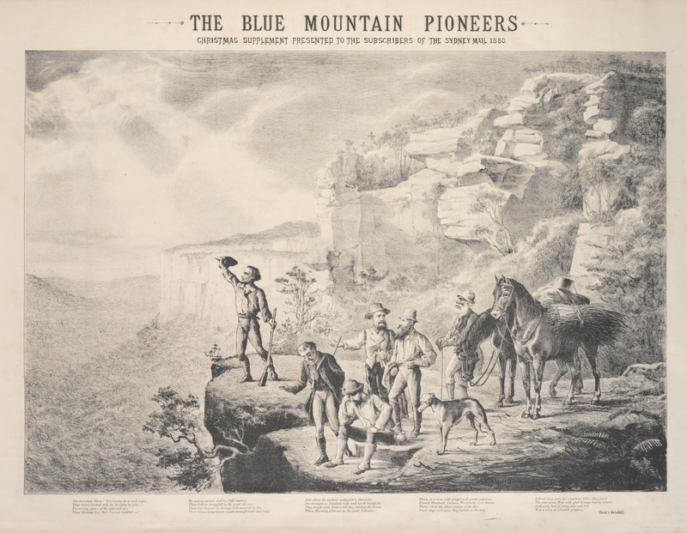
The Blue Mountain pioneers, lithograph by M Emile Ulm, The Sydney Mail, 25 December 1880. State Library of NSW. Public domain

Historical inquiry step 1 – question
With reference to their K-W-L charts, students formulate inquiry questions.
Sample questions:
- What significant events and developments occurred in Australia between 1800 and 1900?
- Where did the significant events occur?
- Who were the key people related to these events?
- Why did the event or development occur?
- How did these events help shape Australia?
Note – Inquiry questions may need to be redesigned through the historical inquiry process.

Historical inquiry steps 2 and 3 – research and analyse
Activate prior knowledge of the patterns of settlement of NSW, and Australia and prior knowledge of the impacts of settlement on Aboriginal people and the environment. Outline the main factors that influenced settlement patterns, that is, development of new grazing and farming lands, gold and mineral rushes and laying of inland railways.
Compile a class list of the events and developments that were significant to shaping Australia, identified by the students in their K-W-L charts. Locate the date for each and sequence the list chronologically into a timeline.
Using a jigsaw approach, and working in pairs to enable discussion, students use source 2 to identify the most significant events in one decade or era of the 1800s. Students undertake further research as necessary to summarise their information into table 1.
Students also select, then save or print, one or two visual primary sources that represent their era. They label each source and write a caption outlining the evidence it provides.
Source 2 – Defining moments in Australian history, National Museum Australia,
Table 1 – Timeline of significant events
Date | Event | Location | Reason | Key people | Effects | Image

Historical inquiry step 4 – evaluate
Guide the students in evaluating the reliability of source 2 and other sources used. Whose views were presented in the sources? Did the secondary sources make reference to primary sources? How reliable were the sources? Do the inquiry questions need to be redesigned as a result of analysing and evaluating sources?

Historical inquiry step 5 – communicate
1800s timeline
For each era, commencing with 1800 to 1810, students devise a creative way to share their key events with the class in a short, sharp and engaging manner. Suggestions: Pecha-kucha presentation, role play, talking statues, walking ‘tour’, audio visual, artworks.
Reflection
Students reflect on the historical inquiry process, reflecting on what they learnt, how they learnt it and what else they would like to find out.

Inquiry 2 – impact of one significant development
Select inquiry 2a or inquiry 2b
The syllabus requires students to use a range of sources to investigate one significant development or event and its impact on the chosen colony. As such, students undertake either inquiry 2a – a guided inquiry on the impacts of internal exploration, or inquiry 2b – guided or independent inquiry on one topic from the following list.
Topic selection
Select one significant development or event for an in-depth inquiry into its impacts and consequences:
- internal exploration
- expansion of farming
- advent of rail
- frontier conflict
- gold rushes
- Eureka Stockade
- Federation drought of 1895 to 1903.

Inquiry 2a – impacts of internal exploration
Inquiry 2a is a guided inquiry into the effects of internal exploration in Australia. Students use a range of sources to understand the extent of inland exploration and its impacts on colonial development, the environment and Aboriginal peoples.

Stimulus
View the lithograph in source 3. Use See-Think-Wonder prompts and visual literacy skills to analyse the creator’s perspective and intent. Briefly discuss the motivations for and potential impacts of inland exploration as an introduction to the inquiry.
Source 3 – The departure of the Burke and Wills exploring expedition, Melbourne, 18 August 1860
The Burke and Wills expedition crossed Australia from south to north: Melbourne to the Gulf of Carpentaria. The expedition party consisted of 19 men, including four Afghan cameleers, 26 camels, 23 horses and 6 wagons. Their departure was farewelled by 15 000 Victorians. Whilst ending in disaster, relief expeditions contributed further to the knowledge of the inland.
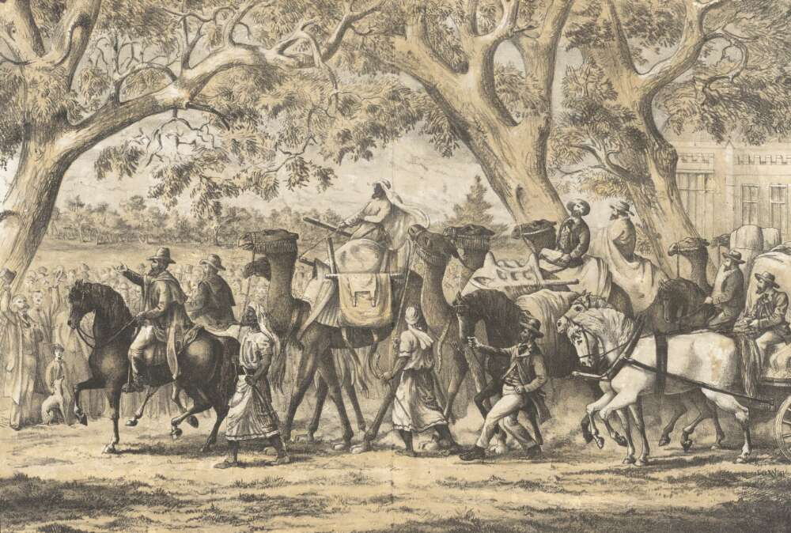
Lithograph by A H Massina and Co. 1860, National Library Australia. Zoomable image available. Out of copyright
See-Think-Wonder
See
- What is happening in the lithograph?
- Who are the people in the image and what are they doing?
- What animals are in the image and what are they doing?
- What objects are the people and animals holding or carrying?
- What is the physical setting?
- What structures and other objects are in the image?
- What other details do you notice?
Think
- Why do you think the various people are in the location?
- Who are the salient people in the image?
- What supplies would they have strapped to the camels and on wagons?
- Why was the lithograph created and what was the point of view of the creator?
- Does the lithograph provide a reliable source? Why or why not?
Wonder
- What do you wonder about when viewing the lithograph?

Historical inquiry step 1 – question
With reference to their analysis of source 3, students formulate inquiry questions relating to the impacts of internal exploration.
Sample questions:
- Why were internal exploration expeditions undertaken?
- When and where did internal expeditions occur?
- How did inland explorers document their discoveries and observations?
- Who were the key people in expedition parties?
- What were the immediate and longer term effects of internal exploration?
- How can we find out about colonial internal exploration and its impacts?
Note – Inquiry questions may need to be redesigned through the historical inquiry process.

Historical inquiry steps 2 and 3 – research and analyse
Inland exploration source analysis
Recall the information on inland exploration shown on the historical maps examined in inquiries into colonial settlement patterns. Activate prior knowledge on internal exploration in Australia.
Working in pairs, and with reference to the inquiry questions, students use source analysis skills to examine sources 4 to 8. They locate on a map each place mentioned in the sources. Students organise their information into the source analysis table in table 2.
Source 4 – Map showing explorers’ routes, 1 January 1891
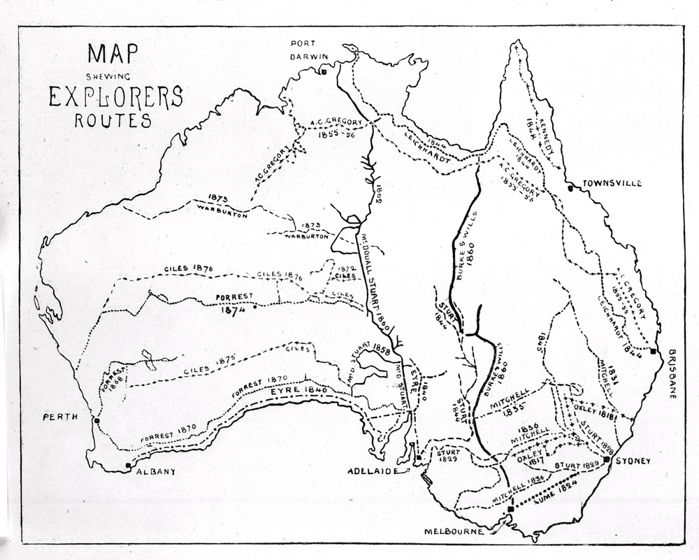
Wood engraving, Melbourne: David Syme and Co, State Library Victoria. Zoomable image available. Out of copyright
Source 5 – The Plains, Bathurst, circa 1815-1816, by J W Lewin
The watercolour is from Henry Antill's journal titled, Journal of an excursion over the Blue or Western Mountains of New South Wales to visit a tract of new discovered Country, 1815. The journal entry for 5 May 1815 (pp 36-37) states:
‘The spot which was chosen for the Governor's large tent was upon a little rising ground about three hundred yards from the men's huts; a small tent was placed on each side with a clear space in front upon which a small flag staff was erected. This was a delightful spot for a town, commanding a view of the surrounding country to a considerable extent....’
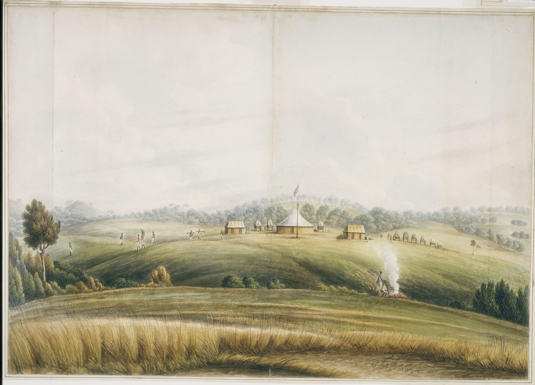
View 19 The Plains, drawn by John Lewin, Mitchell Library, State Library of New South Wales. Zoomable image available. Out of copyright
Source 6 – John Oxley’s journal entry for 20 April 1817 from his first expedition into the interior of NSW
In this entry he is travelling from Bathurst and describes the Bathurst Plains:
Sunday, April 20 — ‘Proceeded on our journey towards the Lachlan River. At two o'clock we arrived at the head of Queen Charlotte's Valley, passing through a fine open grazing country; the soil on the hills and in the vale a light clayey loam, occasionally intermixed with sand and gravel: the late rains had rendered the ground soft and boggy. The trees were small and stunted, and thinly scattered over the hills, which frequently closed in stony points on the valley. The rocks a coarse granite.’
Journals of two expeditions into the interior of New South Wales: Undertaken by order of the British Government in the years 1817-18, Part 1, University of Sydney Library, 2002, reproduced from the print edition published by John Murray, London, 1820.
Source 7 – Arbuthnot's Range viewed from the west, drawn by Major Taylor from a sketch by Mr Evans in 1818.
The original sketch was made during John Oxley’s first expedition into the interior of NSW. It was published in 1820 in the Journals of two expeditions into the interior of New South Wales, undertaken by order of the British government in the years 1817-1818. Now called The Warrumbungles, John Oxley was the first to sight and explore this area in north-western NSW on his 1817 expedition.

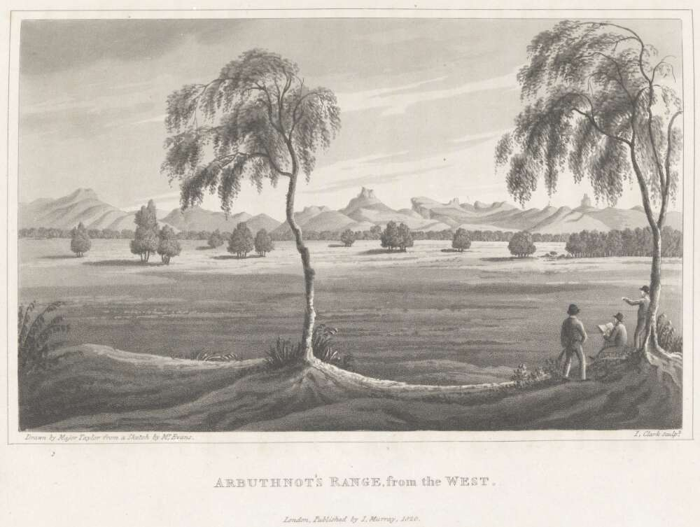
Plate from: Journals of two expeditions into the interior of New South Wales by John Oxley, part of Journals of two expeditions into the interior of New South Wales, undertaken by order of the British government in the years 1817-18, published 1820. Engraver, John Clark. National Library of Australia. Out of copyright
Source 8 – Extract from newspaper article titled, Inland exploration, written by a writer in the South Australian Register.
Reproduced in the Geelong Advertiser, 13 September 1850, the author suggests that a reward should be offered to encourage an expedition to the north-west corner of South Australia.
Our flock-owners and landholders are crying loudly for additional space whereon to de-pasture their flocks and herds. Besides this, the interest that naturally attaches itself to such an expedition should not be the least incentive towards originating and carrying into execution such an important project fraught with commercial and geographical advantages. The starting point should be at Depot Creek, the distance from which to the NW, angle is, in round numbers, 600 miles. The whole journey, we may imagine, could be accomplished in one year; and from the line of route cutting diagonally across the most extensive portion of the province, nothing, or comparatively so, would be left for future expeditions to accomplish…
It would settle at once, and forever, the great question as to the general features of the country –whether a stony desert intervenes, or a series of sandy plains interspersed with extensive salt shallows – the last appearance of the country that poor Horrocks found – or whether another "Cooper's-Creek" or a “Victoria River" fertilizes undulating valleys and grassy plains.
Geelong Advertiser, 13 September 1850, p 2. Trove

Table 2 – Source analysis table
Source number | Title and date | Who created it and why? | Key information | What it provides evidence of | Questions raised
Bathurst – expedition to proclamation
Students locate and use sources to research answers to the following questions in relation to the settlement of Bathurst in central NSW, described by internal explorers in sources 5 and 6. They research answers to the questions raised in table 2.
- When was Bathurst proclaimed a town?
- What is its ‘claim to fame’?
- What was significant about the Bathurst Plains to the expanding colony?
- What were the effects of inland expeditions west to Bathurst?
Impacts of inland exploration in NSW
Compare the NSW map in source 9 with the NSW section of the map of internal exploration in source 4. Students draw, or create an overlay of, the exploration routes in source 4 onto a printed or digital version of source 9. They identify correlations between inland expedition routes, town location and rail lines.
Students use concept maps to brainstorm the impacts of inland settlement on the environment, Aboriginal peoples, European settlers, the colony’s economy and politics. They classify the impacts into the categories of social, environmental, economic and political and list them into table 3.
Source 9 – Map showing location of towns in New South Wales in 1911, modern and disused lines railway lines (2007) and area of the capital city (2006)
Town location resulted from the spread of industry in response to exploration, topography and climate, the impact of the gold rushes and the subsequent development of transport systems.
Note: Rail lines are from MapInfo StreetPro (2007), and include both modern and disused lines. Capital city shaded based on the 2006 Statistical Division.
Source: BITRE analysis of ABS/CBCS 1911 Census and Geoscience Australia Gazetteer.

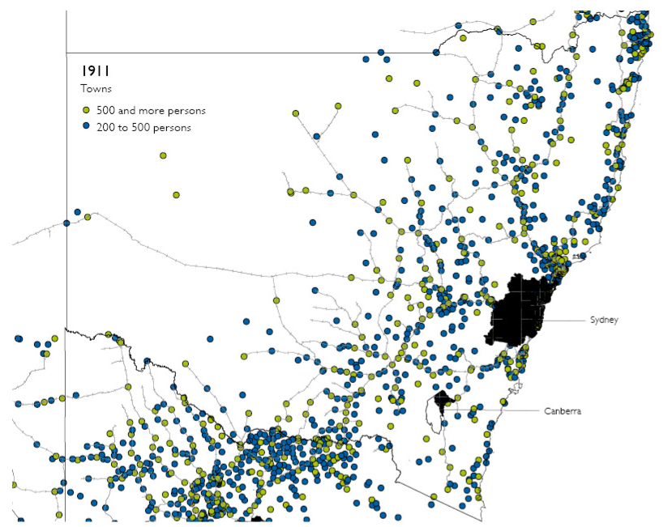
Bureau of Infrastructure, Transport and Regional Economics (BITRE), 2014, The evolution of Australian towns, Report 136, Canberra ACT, Chapter 3, pp 35 and 48. © Commonwealth of Australia 2014, CC BY 3.0 AU

Table 3 – Impacts of inland exploration in NSW
Social consequences | Environmental consequences | Economic consequences | Political consequences
Impacts of internal exploration in Australia
Recall the composition of the Burke and Wills expedition party illustrated in source 3. View the 1:52 minute video in source 11 on the contribution of camels and cameleers to inland exploration and its resulting effects. Analyse the engraving in source 11 as an introduction to the laying of the Overland Telegraph Line.
As a brief case study, students locate and use sources to research the location and construction of the Overland Telegraph Line as an effect of internal exploration. They use at least one secondary source and locate three primary sources, stating the evidence provided in the primary sources.
Sample questions:
- Why was there a need for an Overland Telegraph Line?
- Where was the Overland Telegraph Line laid?
- When was it commenced and completed?
- How did John McDouall Stuart’s return expedition influence the laying of the line?
- What groups of people contributed to its construction?
- What role did camels play in the construction of the Overland Telegraph Line?
- How did the construction of the line impact on Aboriginal peoples?
- What was the significance of the Overland Telegraph Line to Australia?
Source 10 – Cameleers: Afghan Cameleers in Central Australia, SBS on demand, 0:44min
Source 11 – An interruption on the Overland Telegraph Line, published in the illustrated Australian news and musical times, Melbourne, 2 December 1889
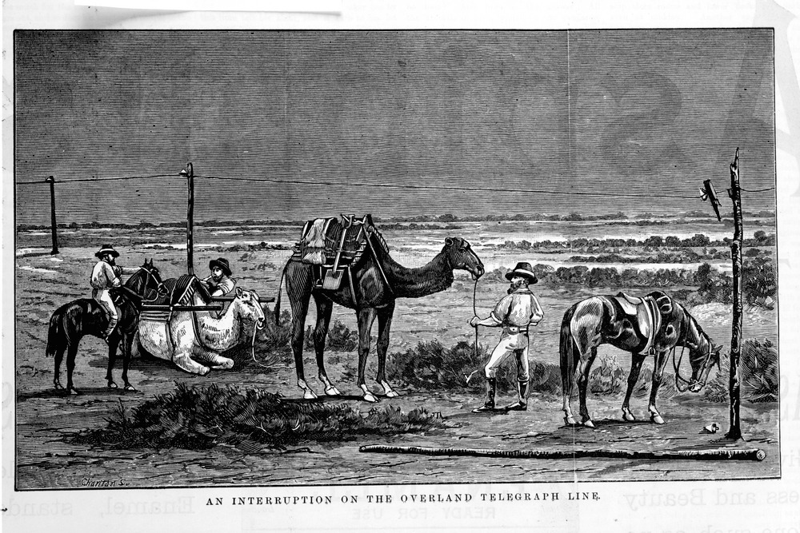
Engraving by Charlton, published by David Syme and Co, Melbourne, State Library of Victoria. Out of copyright
Spatial technologies and historical maps – Spatial Genie (optional)
Source 12 – SpatialGenie, Education Services Australia
Students use the SpatialGenie online mapping tools in source 12 to examine historical maps of Australia, overlaid on each other and on a contemporary base map. Historic maps are accessible through the ‘spatial data search’ icon. Note – SpatialGenie requires registration and a login.
Independent research task (optional)
Note – This research task can address the syllabus content covered in the teaching and learning framework: Notable colonials. The syllabus states: The role that a significant individual or group played in shaping the colony (ACHHK097).
Students select one internal colonial explorer or expedition group. They formulate a set of inquiry questions guided by the sample questions listed in this inquiry. Students draw information and evidence from at least one secondary source and three primary sources. They organise their information using a source analysis table, such as table 3.
Students analyse their information using a cause and effect table to show the impacts of the internal exploration expedition. They use a creative way to communicate their information, showing an understanding of the thinking of the time as well as empathy for negative impacts of the expedition on Aboriginal people and their land. Note: The focus is on impacts of the expedition as opposed the details of the journey.

Historical inquiry step 4 – evaluate
Guide the students in evaluating the reliability of the sources used. Whose views were presented in the sources? How reliable were the sources? Do the inquiry questions need to be redesigned as a result of analysing and evaluating sources?

Historical inquiry step 5 – communicate
Newspaper article – colonial reflections
Students write a letter to the editor, newspaper article, annotated illustration or cartoon, to accompany the 1891 map showing explorers’ routes in source 5, reflecting on the impacts of internal exploration.
Students write or sketch from the point of view of a person affected by inland exploration, such as a farmer who has benefitted from a land grant of prime grazing land, a town person providing support services such as a banker or publican, a displaced Aboriginal person, an Aboriginal stockman, a government official credited with expanding exports and wealth for the colony, an Afghan cameleer, or a labourer cutting through rail lines.
Reflection
Students reflect on the historical inquiry process, reflecting on what they learnt, how they learnt it and what else they would like to find out.

Inquiry 2b – impacts of one significant development or event
Inquiry 2b is an alternative option to inquiry 2a. Students should not undertake both. Inquiry 2b can operate as an independent inquiry or guided inquiry on one topic from the following list.
Note: If investigation into significant people or groups forms part of the inquiry, it can address the syllabus content covered in the framework: Notable colonials.
Topic selection
Select one significant development or event for an in-depth inquiry:
- internal exploration
- expansion of farming
- advent of rail
- frontier conflict
- gold rushes
- Eureka Stockade
- Federation drought of 1895 to 1903.

Stimulus
View the photograph in source 13. Use See-Think-Wonder prompts to analyse the image. Briefly discuss the potential consequences of the advent of rail as an introduction to the inquiry. Note: This image can be replaced with one more related to the topic to be investigated, for example an image from the goldfields or an image of timber-getting.
Source 13 – Bob, the railway dog, sitting on the roof of a locomotive in the railway yard at Port Augusta, circa 1887.
Bob travelled on the trains across the eastern half of Australia and was known throughout South Australia, Victoria, NSW and even Brisbane. It is said he attended the opening of the Hawkesbury Rail Bridge north of Sydney.
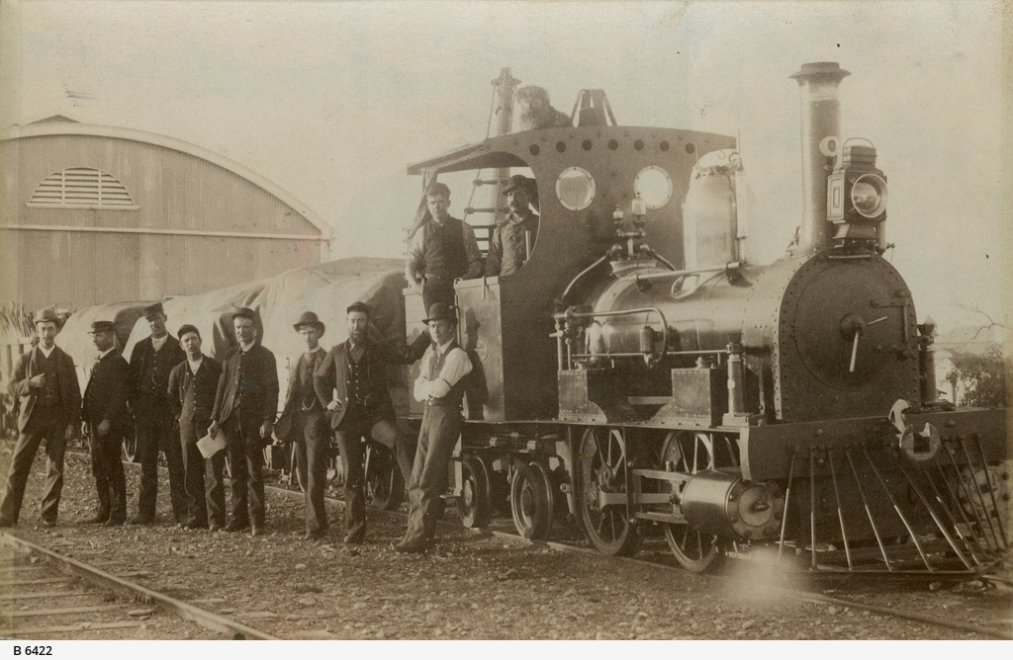
Bob, the railway dog at Port Augusta (B6422), State Library of South Australia. Public domain
See-Think-Wonder
See
- What is happening in the photograph?
- What is the physical setting?
- What people and animals are in the image and what are they doing?
- What structures and other objects are in the image?
- What other details do you notice?
Think
- Why do you think the various people are in the location?
- Who do you think the people are in the image?
- Where would the steam train travel to and what would it carry?
- What impact would the laying of rail have on settlement and development?
Wonder
- What do you wonder about when viewing the photograph?

Historical inquiry step 1 – question
Students formulate a set of inquiry questions they can answer through their research.
Sample questions:
- When and where did the significant event or development occur?
- What were the key features and sequence of events?
- Why did the event or development occur?
- Who were the key people related to the event?
- What were the impacts of the event (economic, social, and political)?
- What if one key part of the event had been different, what may have been the result?
- How can we find out about the event or development and its impacts?
Note – Inquiry questions may need to be redesigned through the historical inquiry process.

Historical inquiry step 2 – research
Introduction
Activate prior knowledge of the impacts of the arrival of the British and the spread of the colony on Aboriginal people and the environment. Recall the timeline of significant events that shaped Australia in inquiry 1. Provide background on the topic to be investigated.
Provide primary and secondary sources, or guide students in locating suitable sources, in order to answer the inquiry questions. Provide or encourage the use of scaffolds such as tables 6, 7 and 8 for students to organise their information.
Table 6 – Impacts of the event or development
Date | Event | Impacts
Table 7 – Key people in the event or development
Person or people | Position or role | Actions | Views | Effects | How I know
Table 8 – Source analysis table
Source number | Title and date | Who created it and why? | Key information | What it provides evidence of | Questions raised

Historical inquiry step 3 – analyse
Guide students to review the information organised in their charts and tables and analyse the impacts of the event. They classify the impacts into social, political and economic. Students construct a flow chart, or complete table 5, to show the consequences of the event.
Students use a strategy such as Think-Pair-Share to discuss a ‘what if’ question: What if one key part of the event had been different, what may have been the result?
Table 9 – Significance of the event or development
Social consequences | Environmental consequences | Economic consequences | Political consequences

Historical inquiry step 4 – evaluate
Students evaluate the reliability of their sources. Are there inconsistencies or contradictions between the sources? Do the inquiry questions need to be redesigned as a result of analysing and evaluating sources?

Historical inquiry step 5 – communicate
Explorer’s diary
Communication product
Students use a creative way to communicate the story of the impacts of the significant event or development.
Reflection
Students reflect on the historical inquiry process, reflecting on what they learnt, how they learnt it and what else they would like to find out.

Additional resources

Inquiry 1 and 3 – early sea explorers
Books
Bob the Railway Dog by Corinne Fenton and Andrew McLean (PRC 5-6)
Mustara by Rosanne Hawke and Robert Ingpen (PRC 3-4)
Eureka Stockade by Alan Boardman and Roland Harvey (PRC 3-4)
To the Goldfields by Rachel Tonkin (PRC 5-6)
The Legend of Lasseter's Reef by Mark Greenwood (PRC 5-6)
Waltzing Matilda by A.B. Paterson, John Williamson and Freya Blackwood (PRC 5-6)
One Small Island by Alison Lester and Coral Tulloch (PRC 5-6)
Jandamarra by Mark Greenwood and Terry Denton (PRC 5-6) Note: Some stage 3 students may find this text disturbing.
The Night We Made the Flag: A Eureka Story by Carole Wilkinson and Sebastian Ciaffaglione
The Whale's Song by Dyan Sheldon
Websites
Inquiry 1
Defining moments in Australian history, National Museum Australia
Inquiry 2
General
1878–before time, My Place for teachers
Indigenous terminology, University of NSW, Teaching
Inland exploration
Crossing the Blue Mountains, State Library of NSW
Advent of rail
Australia and the Industrial Revolution – Impact of the first railways, Margaret Simpson, 2014, Museum of Applied Arts and Sciences
SpatialGenie, Education Services Australia – has historic railway maps that can be overlaid on contemporary maps
Guide to using picture books in History K–10, NSW Department of Education, 2017
Frontier conflict
First encounters and frontier conflict, Aboriginal Institute of Aboriginal and Torres Strait Islander Studies (AIATIS)
AIATSIS map of Indigenous Australia, AIATSIS
Explainer: What are the Frontier Wars? NITV, 2016. Note – reference for teachers.
Gold and Eureka Stockade
Gold and civilisation education pack, National Museum of Australia
Eureka stories, Culture Victoria
Digital collections
Trove
State Library of NSW
State Records of NSW

