Depth study 3 – Australians at war (part 2) World War II (1939-1945)
This resource has been designed to support teachers by providing a range of tasks based on syllabus content. Tasks can be incorporated into context driven teaching and learning programs in full or can be used to supplement existing programs. All content is textbook non-specific.
Specifically targeted teaching activities to support critical and creative thinking in the history classroom have been embedded throughout – they are highlighted by the light blue cloud icon.
Outcomes and other elements of syllabus references in this document are from the History K-10 Syllabus © NSW Education Standards Authority (NESA) for and on behalf of the Crown in right of the State of New South Wales, 2020.

Table of contents
History depth study 3 – Australians at war (part 2) World War II (1939-1945) 1
About this resource 1
Table of contents 2
Key inquiry question 3
Outcomes 3
Historical concepts 3
Historical skills 3
Key terminology 4
Learning sequence 1 5
Content 5
Causes of World War 2 5
Australians in World War 2 6
Learning sequence 2 8
Content 8
Significant events and experiences of Australians at war 8
Learning sequence 3 10
Content 10
Experiences of Australians at war 10
Learning sequence 4 12
Content 12
Impact of the war on the home front 12
Historical inquiry process 13
Learning sequence 5 15
Content 15
Changing scope and nature of warfare 15
Learning sequence 7 18
Content 18
Impact of World War 2 on Australians 18
Commemoration of World War 2 19
Assessment task 20
Outcomes 20
Syllabus content 20
Task 20
Marking criteria 22

Key inquiry question
What was the significance of World Wars I and II?

Outcomes
A student:
- HT5-1 explains and assesses the historical forces and factors that shaped the modern world and Australia
- HT5-2 sequences and explains the significant patterns of continuity and change in the development of the modern world and Australia
- HT5-4 explains and analyses the causes and effects of events and developments in the modern world and Australia
- HT5-5 identifies and evaluates the usefulness of sources in the historical inquiry process
- HT5-7 explains different contexts, perspectives and interpretations of the modern world and Australia
- HT5-9 applies a range of relevant historical terms and concepts when communicating an understanding of the past

Historical concepts
- continuity and change - reasons for change and continuity in a particular context, for example rights and freedoms of groups in Australian society
- cause and effect - intended and unintended causes and consequences of a particular historical event or development, for example the Industrial Revolution
- perspectives - the reasons for different perspectives in a particular historical context, for example Turkish and Australian views of the Gallipoli campaign
- empathetic understanding - the actions, values, attitudes and motives of people in the context of the past
- significance - the reasons why the importance of an event, development or individual may change over time, for example commemoration of ANZAC Day
- contestability - historical sources, events or issues may be interpreted differently by historians depending on their perspectives and methods of inquiry

Historical skills
- Comprehension: chronology, terms and concepts:
  - read and understand historical texts
  - sequence historical events to demonstrate the relationship between different periods, people and places
  - use historical terms and concepts in appropriate contexts
- Analysis and use of sources:
  - identify different types of sources
  - identify the origin, content, context and purpose of primary and secondary sources
  - process and synthesise information from a range of sources as evidence in an historical argument
  - evaluate the reliability and usefulness of primary and secondary sources for a specific historical inquiry
- Perspectives and interpretations:
  - identify and analyse the reasons for the different perspectives in a particular historical context
  - recognise that historians may interpret events and developments differently
- Empathetic understanding:
  - interpret history through the actions, values, attitudes and motives of people in the context of the past
- Research:
  - ask and evaluate different kinds of questions about the past to inform an historical inquiry
  - plan historical research to suit the purpose of an investigation
  - identify, locate, select and organise information from a variety of sources, using ICT and other methods
- Explanation and communication:
  - develop historical texts, particularly explanations and historical arguments that use evidence from a range of sources
  - select and use a range of communication forms (oral, graphic, written and digital) to communicate effectively about the past for different audiences and for different purposes

Key terminology
ANZAC, campaign, cause, censorship, civilian, commemoration, conscription, enemy ‘aliens’, enlistment, government, Holocaust, home front, internment, inter-war, legacy, legislation, perspective, prisoners of war (POWs), propaganda, racism, rationing, technological innovation, warfare, wartime controls.

Learning sequence 1

Content
An overview of the causes of the wars, why men enlisted and where Australians fought (ACDSEH021, ACDSEH095, ACDSEH024)
Students:
- outline the main causes of both wars
- locate and sequence the places where Australians fought in both wars
- explain why Australians enlisted to fight in both wars

Causes of World War 2
Teacher note – there are a number of videos available online that students may wish to access to inform and begin their research into the causes of World War 2. You will need to guide them with any content they access to ensure it is accurate.
You have recently completed an investigation of World War I at school. Your teacher told you that at the time of World War I, the war was referred to as “the war to end all wars”. On a visit to your local park you notice that the war memorial located there refers to World War II and has the dates of 1939 to 1945.
Building on the knowledge you gained in your study of World War I, you are keen to find out how the world could have come to war again, just twenty-one years after the end of World War I. Your teacher has asked the class to create a series of pages (digital or paper) to explain the chronology of events or problems from the end of World War I in 1918 to the outbreak of World War II in 1939.
Each member of your class will choose one of the following events or problems:
- Treaty of Versailles
- The League of Nations
- The Great Depression
- Japanese Expansion
- Rise of Fascism
- Hitler and the Nazi party
- Nationalism
- Lebensraum
- Appeasement – Munich Agreement
- Ribbentrop- Molotov Pact
Your page should contain the following information:
- one or two pictorial primary sources
- an outline of each event or process that lead to the outbreak of war.
At the completion of the task, all your pages will be collated so that all students have an overall understanding of the events and processes that led to the outbreak of World War II.
Critical and creative thinking activity - present your pages as a series of cartoon strips to explain your chosen cause for the outbreak of World War II.

Australians in World War 2
Your pages have been printed and displayed in your school corridor near the history faculty. Your teacher is impressed with the sequencing and explanation you have provided as to the causes of the outbreak of World War II.
Your teacher asks you to create a short multimedia presentation to outline:
- the reasons why Australians enlisted in World War II
- when and where they were fought during this war.
Your teacher suggests that you start your research, by accessing the Australian War Memorial London website.
Your multimedia presentation should include the following:
- a map showing the locations Australians fought during World War II, including when Australians were involved in different locations (add the dates to your map)
- at least two enlistment posters showing a range of reasons why Australians enlisted in World War II and explanation of the posters.
Critical and creative thinking activity - for each poster you use in your presentation, complete a layers of inference activity.
Set your page out like the example below.

Figure 1 - Layers of inference scaffold
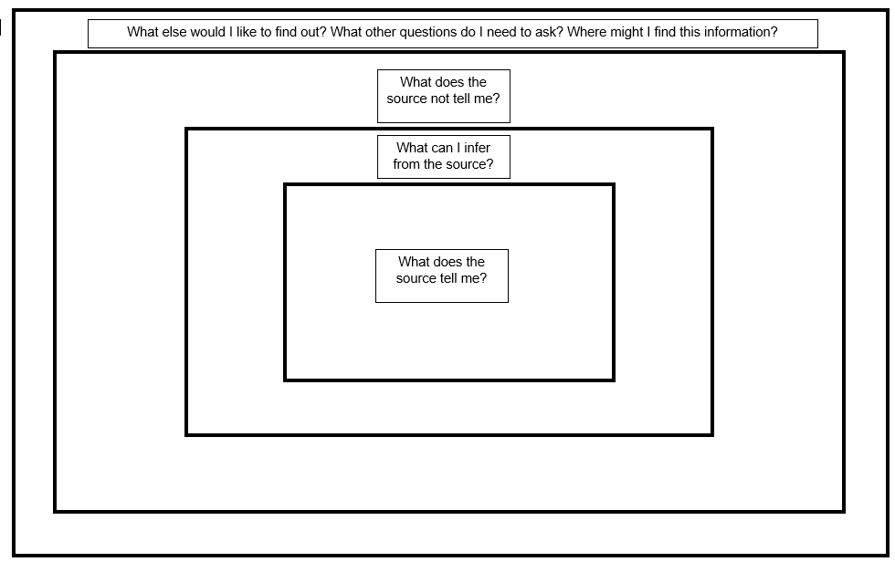
With reference to the posters you have located and analysed, write three paragraphs explaining why Australians enlisted to fight in World War II.

Learning sequence 2

Content
Significant events and the experiences of Australians at war (ACDSEH108)
- using sources, students investigate the following features of each war:
  - a specific campaign, for example the New Guinea campaign 1942
  - a specific event/incident, for example the Fall of Singapore 1942

Significant events and experiences of Australians at war
A parent, who is a travel agent, has contacted the school after one of your classmates discussed all the places that Australians fought in World War II. They are interested in putting together a series of virtual tours to some of the locations Australians fought during World War II.
They have asked that your class create a series of e-brochures for each location they might use to promote these tours.
The e-brochures should be two pages in total and should:
- identify the location of the event or incident
- explain the event or incident in detail
- describe the context of the destination in terms of the larger campaign.
The e-brochure should include:
- a map and diagram of the event
- four primary sources (both written and images)
Choose an event and campaign from the list below:
- New Guinea
  - Kokoda track
  - Milne Bay
- Pacific theatre
  - Battle of the Coral Sea
  - Battle of the Bismarck Sea
  - Borneo
  - Sinking of the Centaur
  - Bangka island massacre
- The Malayan campaign
  - Fall of Singapore
- North Africa
  - Tobruk
  - Bardia
  - El Alamein
- Syrian Campaign
  - Damascus
- The Mediterranean
  - Crete
  - Brallos Pass (Greece)
  - Battle for the Mediterranean (naval battles)
- The Atlantic
  - The Flying Porcupines
- Another campaign and event of incident as discussed with your teacher.
Critical and creative thinking activity - write a newspaper headline capturing and summarising the essence of each location.

Learning sequence 3

Content
Significant events and the experiences of Australians at war (ACDSEH108)
- using sources, students investigate the following features of each war:
  - prisoners of war
  - the role of women
  - participation of Aboriginal and Torres Strait Islander peoples

Experiences of Australians at war
Teacher note - you will need to ensure that all groups referenced in the syllabus content are covered. Students will need to present their scripts to the class, so all students are familiar with all groups.
A client of the travel agent is planning a trip to a location of a battle based on the information in your tourist e-brochure. Before they travel, however, they would like some more information on the experiences of different groups of Australians who were involved in World War II. The client will use this information to determine a final itinerary as they wish to visit some of the sites where these groups were involved in World War II. The travel agent has asked you to create a podcast they can direct clients to, that provides the client with details of the experiences of your group.
Your podcast should be three to four minutes long and include:
- details of the daily activities of members of your group
- one to two examples of specific incidents members of your group experienced
- a biography of a specific individual in your group, for example:
  - Vivienne Bullwinkle
  - Edward Weary Dunlop
Groups of Australians include:
- prisoners of war
  - Thai-Burma railway
  - Sandakan prison
  - Changi prison
  - another case study as discussed with your teacher
- women
  - experiences of nurses
  - another case study as discussed with your teacher
- Aboriginal and Torres Strait Islander peoples, such as
  - Leonard Waters
  - Reg Saunders
  - Kath Walker (Oodgeroo Noonuccal)
  - another case study as discussed with your teacher
Critical and creative thinking activity - create a digital photo album of each group of Australians. For each photo/poster, conduct a source analysis and provide a caption that captures the essence of that group’s involvement in the war.

Learning sequence 4

Content
Impact of the wars on Australia (ACDSEH096, ACDSEH109)
Students:
- outline the Australian governments' control on the home front in both wars for each of the following:
  - conscription
  - use of government propaganda
  - changing roles of women
  - enemy 'aliens'
  - wartime controls/censorship

Impact of the war on the home front
Teacher note - students will be undertaking an historical inquiry to investigate various aspects of the Australian home front during World War II. Students will need to develop a series of focus questions to guide their research in answering the inquiry question. Divide the class into groups. Each group will investigate each aspect of life on the home front in Australia during World War II. Students will need to produce short radio news broadcasts to share their findings and understanding.
Your teacher is impressed with the work you have done to provide information for the prospective tours and your ability to present information for a specific audience. Your teacher has asked you to undertake an historical inquiry into one aspect of the home front in Australia during World War II. Specifically, you need to explore the nature of government control on the home front. Your group will produce a series of short (2-3 minute) radio news broadcasts to demonstrate your findings and understanding. Additionally, you will assess two sources per aspect of the home front, for their usefulness and reliability. You will need to develop a series of focus questions to guide your research to answer the inquiry question below:
Inquiry question for this task:
Why was World War II significant to Australian society?
Investigate one of the following:
- the issue of conscription in Australia
  - Citizens military forces (CMF)
  - Defence (Citizen Military forces) Act 1943
- the Australian governments use of propaganda
  - Austerity campaigns
- changing roles of women
  - Australian Women’s Land Army
- enemy “aliens” and internment camps in Australia
  - National Security Act 1939
  - Dunera Boys
- government control and censorship during World War II
  - National Security Act 1939
  - Australian Broadcasting Act 1942

Historical inquiry process
Step one
- Develop three or four focus questions that you will need to research in order to answer the inquiry question. These may include:
  - What was the status of your group before World War II?
  - What happened to your group during World War II?
  - What was the result of this process or action for your group?
Step two
- Research – collect and organise relevant information from primary and secondary sources.
Step three
- Analyse – do the sources contain information relevant for your inquiry? If not, you may need to conduct more research or redesign your inquiry or focus questions.
- Process the sources you have found to begin to form an opinion of the significance of World War II to Australian society.
Step four
- Evaluate the reliability of the sources.
  - Can the information processed in the previous step be believed?
  - Are there limitations to the believability of the sources?
Step five
- Communicate – synthesise the information from your sources, formulate a perspective and develop an historical text to answer your inquiry question.
Critical and creative thinking activity - colour, symbol, image activity:
- What colour would you choose to represent the essence of the home front during World War II?
- What symbol would you choose to represent the essence of the home front during World War II?
- What image would you choose to represent the essence of the home front during World War II?

Learning sequence 5

Content
The scope and nature of warfare (ACDSEH095, ACDSEH107)
Students:
- outline and sequence the changing scope and nature of warfare from trenches in World War I to the Holocaust and the use of the atomic bombs to end World War II

Changing scope and nature of warfare
Teacher note - this is an annotated timeline task that students will develop in groups using the jigsaw method. Each group member will focus on one aspect of the changes to the nature of warfare from the beginning of World War I to the end of World War II. Students need to focus on explaining how these aspects of warfare reflect continuity and change in history.
Your teacher has told you that you will now be focusing on the changing features and characteristics of warfare from the beginning of World War I to the end of World War II.
To do this you are going to develop an annotated timeline, with sources, examining the changing features and characteristics of warfare from World War I to World War II.
Your timeline will focus on a specific aspect of the changes to the features and characteristics of warfare as listed below:
In your timeline, you will address one of the following major dot points listed below:
- the static defensive nature of warfare in World War I, featuring machine guns based in trenches
- mobile nature of warfare in World War II due to the widespread use of tanks, road vehicles and aircraft
- changing technologies
  - use of gas
  - tanks
  - development and use of aircraft
  - atomic weapons
Your annotated timeline should address the following:
- an outline of the features of the change from the beginning of this period to the end
- the influence this change had on the nature of warfare, for example, tanks changed warfare from static combat to mobile combat.
- how change affected the outcome of warfare
- the continuity and change of warfare reflected by this change.
Critical and creative thinking activity
Teacher note – this is an optional extension task.
Use the following ‘Assessing change’ template to make a judgment about the way technology changed the scope and nature of warfare.

Figure 2 - Assessing change template
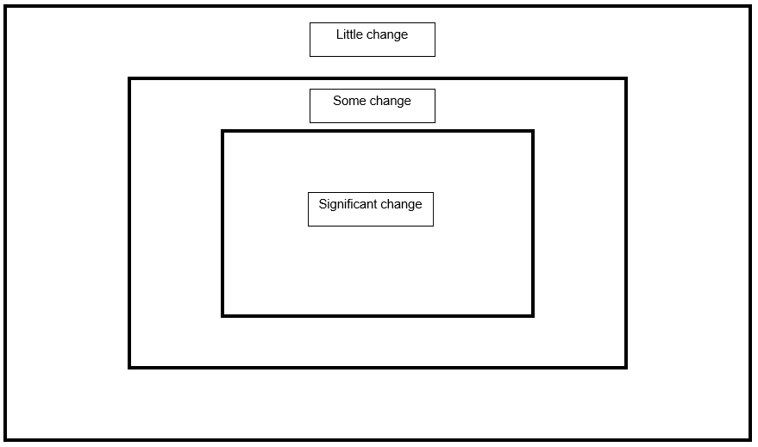

Learning sequence 7

Content
Significance of the wars to Australia (ACDSEH110)
Students:
- explain the impact of the wars on returned soldiers/civilians
- analyse the changing relationship of Australia with other countries after World War II
Commemorations and the nature of the ANZAC legend (ACDSEH097)
Students:
- explain how and why Australians have commemorated the wars
- explain different perspectives on the ANZAC legend

Impact of World War 2 on Australians
Teacher note – this activity has been expanded into an assessment task with marking criteria at the end of this document for those that wish to use it as part of a summative assessment process.
Your class cohort is beginning to consider their next course of study in history; investigating Australia in the post-war era. Prior to embarking on that study, a clear picture of where Australia was in terms of its social and political development at the end of the war is required. This will enhance your capacity to understand the changes in society that occurred post World War II.
To achieve this, your teacher has asked you to write a report on the impact of the war on Australia. Your report will be about two pages long and needs to convey your understanding of Australian society at the end of World War II.
Your report should include:
- A summary of the challenges soldiers faced returning to civilian life after the traumas of war including
  - difficulties soldiers had coping with their wounds both physical and emotional
  - the reaction of members of the community to the soldier's wounds
  - difficulties integrating into a society that had little to no understanding of the experiences soldiers had had during the war
  - a changed society; new gender roles and expectations
- Australia’s changing international relations as the nation began to move away from traditional ties with Great Britain and towards America as our main strategic ally.

Commemoration of World War 2
You have been asked by your school's executive to consider commemoration of wars. You need to conduct a series of interviews with people of different ages and backgrounds. You will also examine sources about the money governments spend on commemoration. Finally, you consider why the narrative around the commemoration of WWI and WWII is different. These activities will help you draw conclusions about the way Australia has commemorated wars over time.
Critical and creative thinking activity: the three Ys:
- Consider each of the following questions:
  - Why might commemoration matter to me?
  - Why might commemoration matter to people around me?
  - Why might commemoration matter to the world?
- Locate at least 10 people to conduct an interview about what commemoration means to them.
- Seek each interviewee’s permission to record their responses.
- Why do people feel differently about it? Why do you think things are changing about how people feel?
- How much does Australia spend in comparison to other countries?
- Read each of the following sources comparing government spending on commemoration of different countries. What do you notice? What conclusions can you draw?
  - 100 years of Anzac
  - Is Australia spending too much on the “Anzac centenary”? A comparison with France
  - Anzac Budget Review
  - Government powers
- WWII: what do you remember about commemoration from your study of WWI? Why is the narrative around WWI and WWII so different?

Assessment task
Teacher note - when using this task, ensure it is placed on the school template and follows all assessment requirements.

Outcomes
- HT5-5 identifies and evaluates the usefulness of sources in the historical inquiry process
- HT5-7 explains different contexts, perspectives and interpretations of the modern world and Australia
- HT5-10 selects and uses appropriate oral, written, visual and digital forms to communicate effectively about the past for different audiences

Syllabus content
Commemoration and the nature of the Anzac Legend
Students:
- explain different perspectives on the Anzac Legend

Task
Write a two-page response to the question:
Explain different perspectives on the Anzac Legend.
In your response, evaluate the usefulness of each source, using the following source analysis table
To answer this question well, you will need to undertake research into different perspectives on the Anzac Legend. To do this:
- access the Anzac Legend Great Debates sources
- read all eight sources. Use one source from each of the main sources, ensuring you use a variety of visual and written sources
- complete a source analysis sheet for each source
- plan and draft your response using the following scaffold:
Source details | Information from the source
Source
Who created the source?
What information does the source provide?
What argument does the information provide your character?
What questions are you left asking?
How useful is this source in a study of perspectives on the Anzac Legend?

Marking criteria
Criteria | Grade
Demonstrates outstanding knowledge of the content by explaining different contexts, perspectives and interpretations of the Anzac legend.  Demonstrates outstanding knowledge of the course content and concepts by effectively identifying and evaluating historical sources for usefulness.  Effectively communicates complex ideas and information by selecting and using appropriate oral, written, visual and digital forms to communicate about the past for different audiences. | A
Demonstrates thorough knowledge of the content by explaining different contexts, perspectives and interpretations of the Anzac legend.  Demonstrates thorough knowledge of the course content and concepts by identifying and evaluating historical sources for usefulness.  Clearly communicates complex ideas and information by selecting and using appropriate oral, written, visual and digital forms to communicate effectively about the past for different audiences. | B
Demonstrates sound knowledge of the content by explaining different contexts, perspectives and interpretations of the Anzac legend.  Demonstrates sound knowledge of the course content and concepts by identifying and attempting to evaluate historical sources for usefulness.  Communicates ideas and information in an appropriate way by selecting and using appropriate oral, written, visual and digital forms to communicate about the past for different audiences. | C
Demonstrates basic knowledge of the content by attempting to explain different contexts and perspectives in relation to the Anzac legend.  Demonstrates basic knowledge of the course content and concepts by attempting to identify and evaluate historical sources.  Communicates ideas in a descriptive manner by selecting and using appropriate oral, written, visual and digital forms to communicate about the past for different audiences | D
Demonstrates elementary knowledge of the content by identifying some different perspectives of the Anzac legend.  Demonstrates elementary knowledge of the course content and concepts by engaging with historical sources in a limited way.  Demonstrates elementary skills in communicating ideas and selecting information. | E

