Stage 5 geography – Changing places
This resource has been designed to support teachers by providing a range of tasks based on syllabus content for the changing places topic. Tasks can be incorporated into context driven teaching and learning programs in full or used to supplement existing programs. All content is textbook non-specific. Outcomes and other elements of syllabus references in this document are from Geography K-10 Syllabus © NSW Education Standards Authority (NESA) for and on behalf of the Crown in right of the State of New South Wales, 2015.

Table of contents
Stage 5 geography – Changing places 1
Table of contents 2
Outcomes 3
Learning sequence 1 – causes and consequences of urbanisation 4
Syllabus content 4
Activities 4
Learning sequence 2 – urban settlement patterns 7
Syllabus content 7
Activities 7
Learning sequence 3 – internal migration 11
Syllabus content 11
Activities 11
Learning sequence 4 – Australia’s urban future 14
Syllabus content 14
Activities 14
Implications for growth and sustainability 16
Case study – managing Australia’s urban heat islands 17
Case study, urban sprawl and biodiversity 20
Strategies to create economically, socially and environmentally sustainable urban places 21
Assessment task 24
Content 24
Outcomes 24
Task instructions 24
Part A – design your city 24
Part B – assess your best design feature 25
Marking criteria 26

Outcomes
A student:
- explains processes and influences that form and transform places and environments GE5-2
- analyses the effect of interactions and connections between people, places and environments GE5-3
- assesses management strategies for places and environments for their sustainability GE5-5
- acquires and processes geographical information by selecting and using appropriate and relevant geographical tools for inquiry GE5-7
- communicates geographical information to a range of audiences using a variety of strategies GE5-8

Learning sequence 1 – causes and consequences of urbanisation
Teacher note – in this topic, students will first explore what urbanisation is and what causes urban areas to grow. They will then explore the causes and consequences of increasing urbanisation in one Asian country. The syllabus requires a study of one Asian country. China has been chosen as a study in this lesson sequence. If other Asian countries are of greater relevance or interest to students in your school, this may be substituted.
As a ‘starter’ activity for this topic, teachers may play a quick game or quiz to get an understanding of what students know about the world, its countries and major cities. Examples may include a competition on how many cities of the world students can name in 5 minutes, or a Kahoot, or games like the World cities map quiz. A variety of resources are also available online for this topic and are free for non-commercial educational use, for example those developed by the Asia Education Foundation.
If time permits, the Urbanisation game may also be a fun way for students to learn about the history of urbanisation.

Syllabus content
Students:
- investigate the causes and consequences of urbanisation with reference to ONE Asian country, for example:
  - identification of spatial distribution patterns
  - description of the causes of urbanisation
  - examination of economic, social or environmental consequences of urbanisation

Activities
Teacher note – For the case study on China, students will need to be provided with maps illustrating population density, relief and precipitation. Resources for these may be found online at sites like Uneven population distribution: Case Study or in textbooks. Students will also need to be provided with a blank political map. Copyright free maps can be located at sites like creative commons, blank map political.
- In small groups, students submit their best guess on the exact world population on this day. Compare group estimates with the actual figure using the Worldometer.
- Use school resources, Urbanisation and the future of cities (duration 4:08 minutes) or National Geographic, urbanization, to complete the following:
  - define urbanisation
  - create a storyboard that identifies key factors that have led to urbanisation over time.
- Use Urbanisation push pull factors (duration 3:52), to complete the following:
  - identify examples of push and pull factors that lead to more people living in urban areas
  - explain, in 1 paragraph, the connection between economic opportunities, social opportunities and increasing urbanisation.
- In small groups, imagine a scenario where the number of students in school is increased 5 times overnight. Brainstorm as many impacts, challenges or changes that may result from this rapid change. Then, categorise these impacts into:
  - social impacts, that is, the impacts on people’s lives, entertainment, connections, peace and harmony
  - economic impacts, that is, impacts on people’s jobs and income
  - environmental impacts, that is, impacts on plants, animals, water, air quality and the natural environment.
- As a class, discuss how the challenges identified by the class could also apply in cases of rapid urbanisation.
- Watch BBC Megacities, ‘Living in the city,’ (duration 57:47) and use this to complete the following:
  - mark the location of each city mentioned in the documentary onto the blank world map provided by your teacher
  - identify benefits and challenges of rapidly increasing urban populations
  - choose the city from the video that you would most like to live in and the city that you would least like to live in. Write one paragraph justifying your choices.
Teacher note – this study of urbanisation in China is linked to internal migration study in lesson sequence 3. Further study of impacts of internal migration in China, for example the Hukou system, will be explored in this sequence.
- As a class, discuss what is meant by spatial distribution of a population.
- Use Statista, ‘Degree of urbanisation in China,’ to describe how the percentage of China’s population living in cities has changed over time.
- Watch and use this to complete a 3-2-1 summary task, that is, identify 3 things you found out, 2 interesting things and 1 question you still have.
- Use resources such as China in transition (duration 4:19); China’s left behind children (duration 5:54); internal migration in China; and Chinese Migrant workers suffer under Hukou (duration 3:44), to complete the following:
  - identify the push and/or pull factors that have led to mass rural-urban migration in China
  - outline how the Chinese Hukou system works
  - explain how the Hukou system impacts on rural-urban migrants
  - identify other challenges for individuals who move from rural to urban China and for the families that they leave behind.
- In small teams, research more social, economic and environmental consequences of rapid urbanisation in China. Summarise the information into the table below. A resource for this task may include: China’s Ballooning cities: the rise of the megacity (duration 43:34).
Table 1- Consequences of rapid urbanisation in China
Economic consequences | Social consequences | Environmental consequences
- Use the summary to complete a freehand, PowerPoint or Canva infographic on urbanisation in China, that answers the following question: ‘How have China’s cities changed and what are the impacts of this change?’

Learning sequence 2 – urban settlement patterns
Teacher note – In this lesson sequence, students will explain why Australians live where they do and compare this to settlement patterns in the USA. They will then consider impacts of urban concentrations on places.

Syllabus content
Students:
- investigate differences in urban settlement patterns between Australia and another country, for example:
  - examination of urban settlements to determine patterns of concentration
  - explanation of factors influencing urban concentration e.g. climate and topography, transportation networks, land use or perceptions of liveability
  - assessment of the consequences of urban concentrations on the characteristics, liveability and sustainability of places.

Activities
- View the image below and use this to consider the distribution of Australia’s population. Use this to complete a See -Think-Wonder thinking routine, that is:
  - What do you see?
  - What does it make you think?
  - What does it make you wonder?
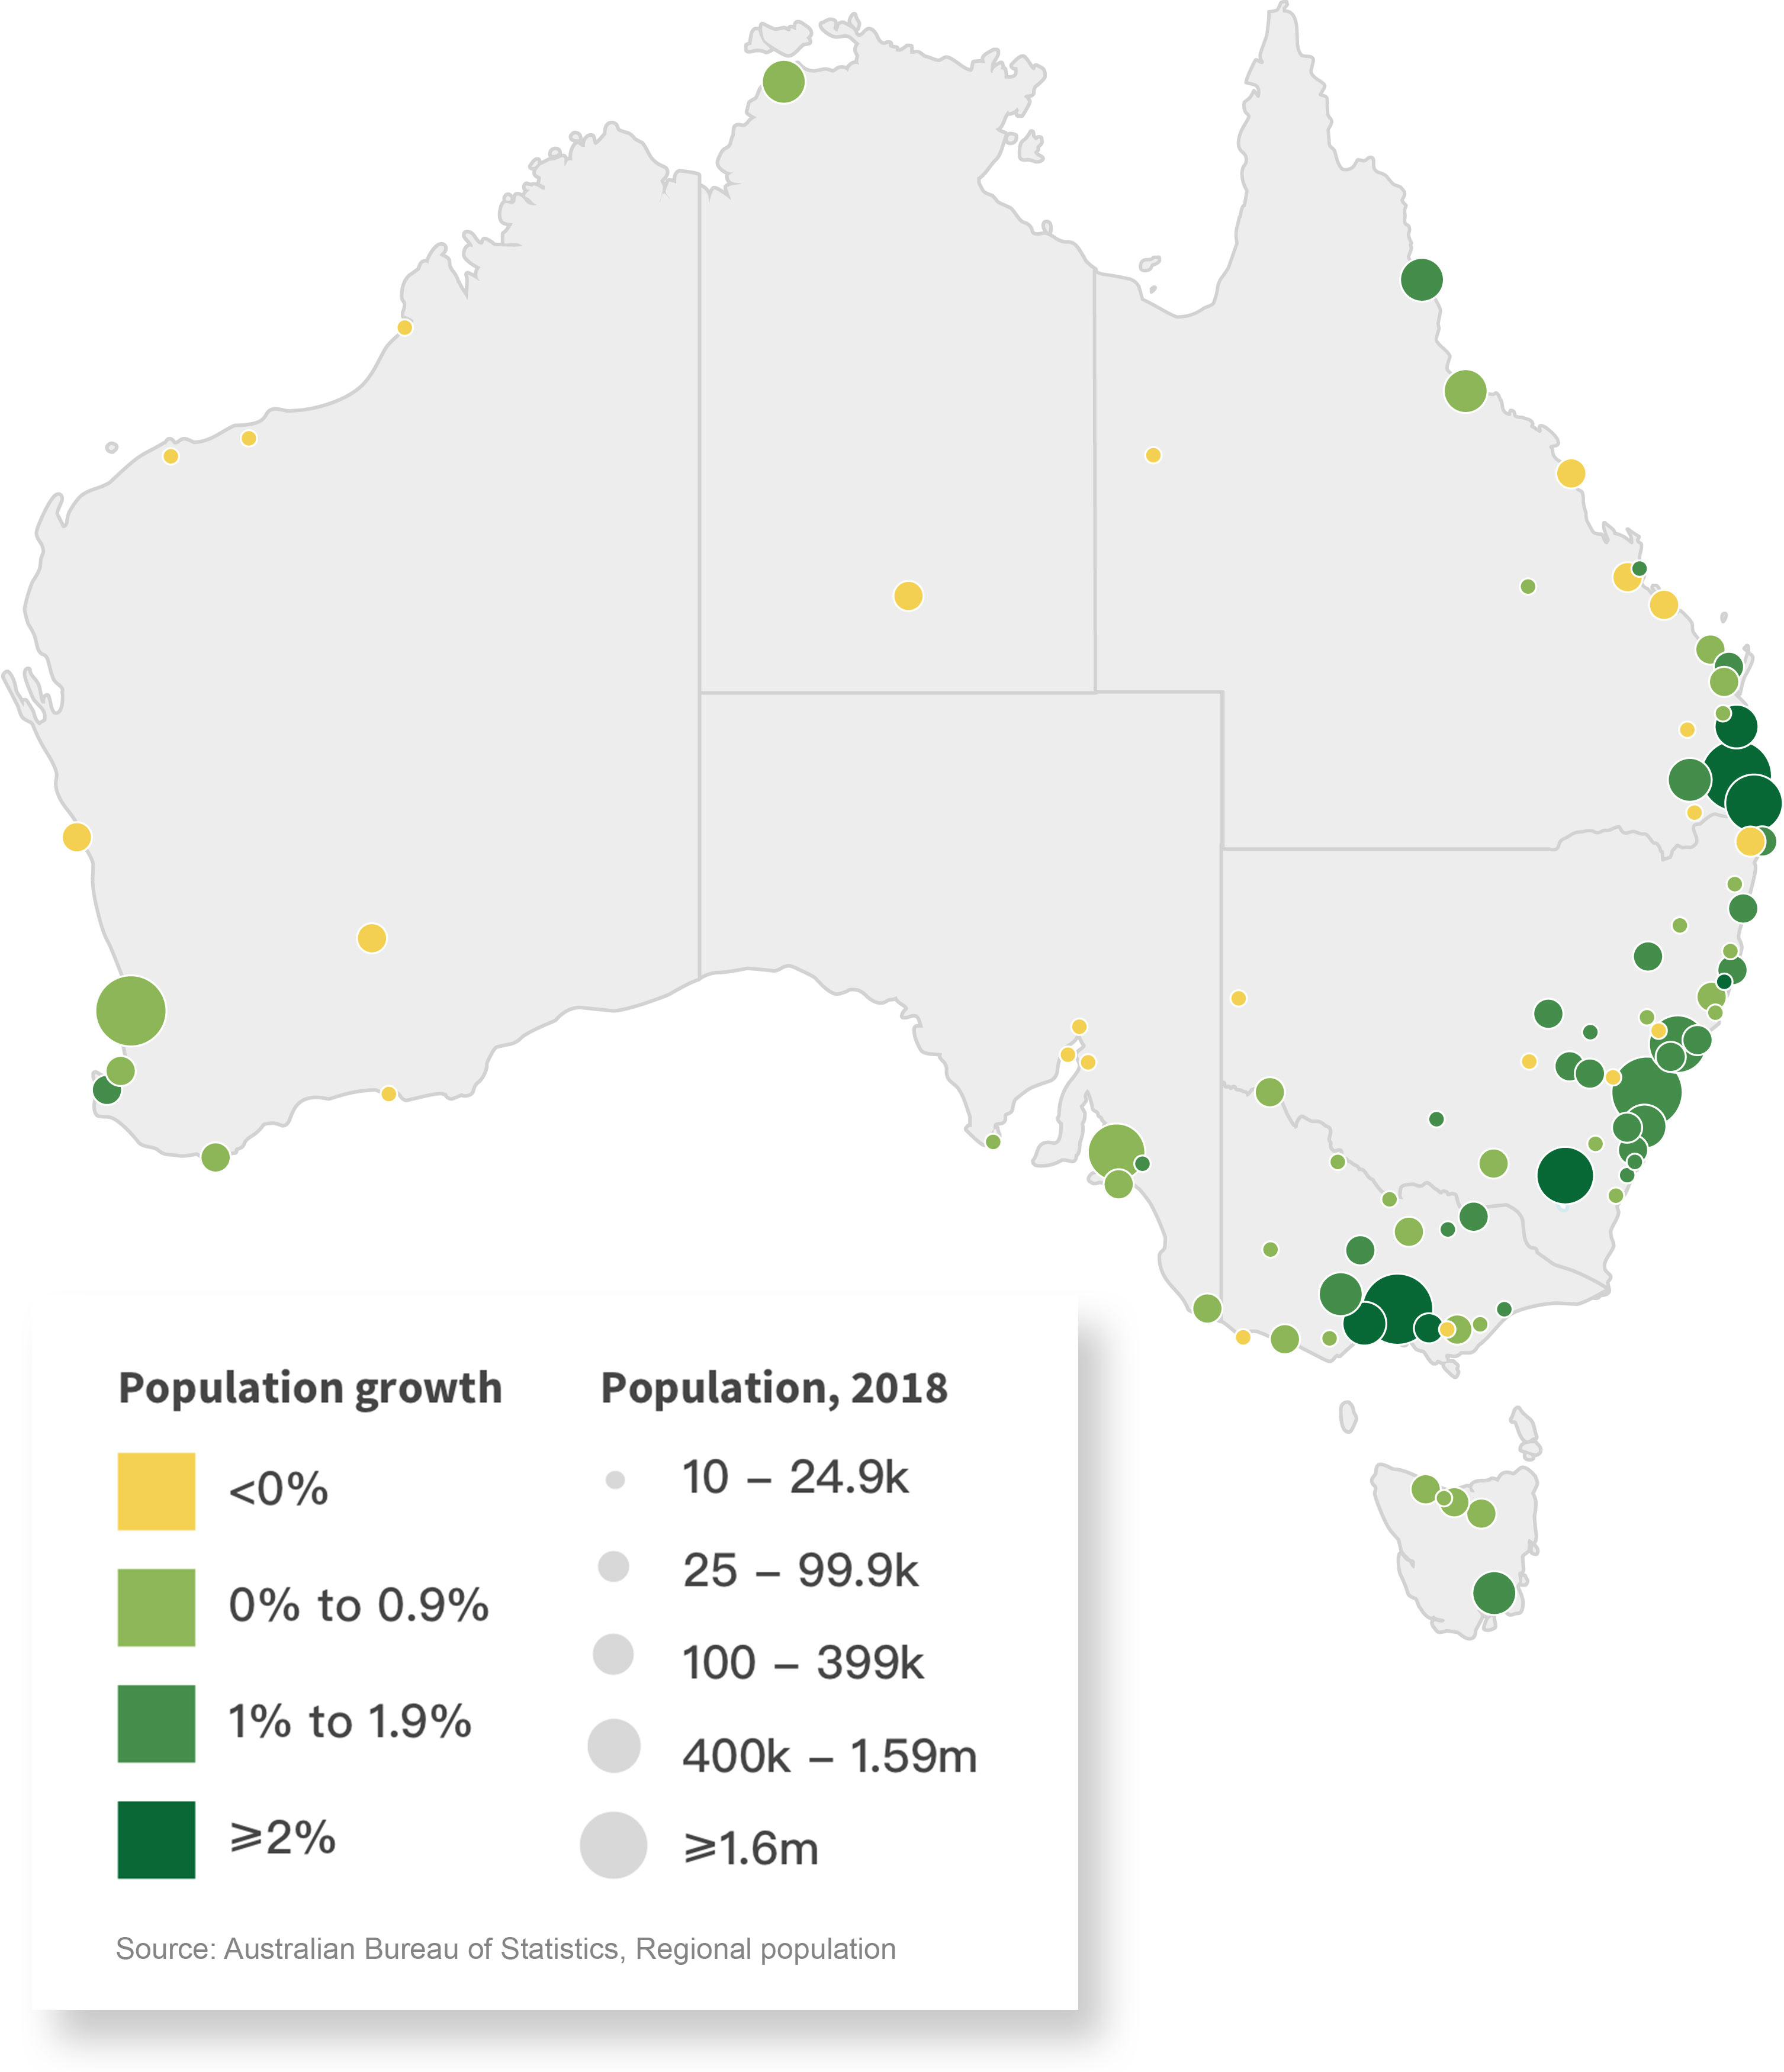
Source: Australia’s population – Australian government centre for population © Commonwealth of Australia used under Creative Commons 3.0 Australia.
- Use school resources and Australian Climate Zones; Australia, Shaded Relief to complete a concept map titled, ‘why do Australians live where they do?’ Factors to research and consider may include:
  - climatic zones, for example 35% of Australia is desert and 70% of Australia is arid or semi-arid
  - transport networks
  - access to infrastructure, for example hospitals and universities
  - topography, for example the Great Dividing Range
  - European settlement.
- Participate in a class discussion on the following question: ‘How would our lives change if Australia’s population was moved to the remote centre of Australia?’
- Research the spatial distribution of the USA population and, using images like 2020 Population Distribution in the United States; and US Population density by County; Maps for free; complete the following:
  - describe how the population of the USA is distributed, for example is it evenly distributed or concentrated in particular areas?
  - explain the significance of climate and landforms in this pattern of distribution
  - compare the spatial distribution of the USA population distribution with Australia.
- One impact of increasing urban concentrations in both Australia and USA is urban sprawl. Use the articles and videos provided below to complete a Plus-Minus-Interesting thinking routine on issues associated with urban sprawl:
  - The future of Sydney’s food bowl (duration 2:08)
  - What Australian home buyers can learn from Sydney's urban sprawl (duration 5:22)
  - Housing developments are putting Australia's native wildlife at risk. Here's how to be part of the solution
  - Urban Sprawl: A brief history of the causes and effects of the expansion of our cities.
- Using the impacts of urban sprawl that you have identified, draw a cartoon that captures:
  - what urban sprawl is
  - how it impacts on places around cities.
- Return to the news article, ABC, Housing developments are putting Australia's native wildlife at risk. Here's how to be part of the solution. With a partner, complete the following:
  - review the 2 housing developments in the article and complete a Venn diagram that highlights how they are the same and how are they different
  - discuss the benefits and limitations of changing future housing developments.
- Assume the government has just made a new law that: ‘Australian residents in cities can no longer build single dwellings and everyone must live in low to medium density apartment buildings that are surrounded by nature parks.’ Use your knowledge from the previous activity and consider the law from the perspective of each of the following groups. You may add your thoughts to the table below:
  - new home buyers who are excited about achieving the ‘great Australian dream’ of owning their own house’
  - developers of traditional housing estates who want to use every part of the land for profit
  - nature, for example plants, animals.
Table 2 - perspectives on housing development laws
Perspective | New home buyer | Developers of traditional housing estates | Nature (plants, animals)
My viewpoint is...
I think the new law is great/bad because...
What might convince me to change my mind is...

Learning sequence 3 – internal migration
Teacher note – in this learning sequence, students will investigate internal migration trends in Australia and China and analyse the impact of these trends on both the places of origin and destination. Some content related to internal immigration in China has been touched on in learning sequence 1. If following this entire sequence, discretion should be used to avoid repetition of content.
For the 2 minute ‘pitch,’ a more detailed explanation of what is required may be needed for some contexts. It should be explained to students that they are explaining the best features of the location in order to try and get people to move to the town.

Syllabus content
Students:
- investigate reasons for and effects of internal migration in Australia and another country, for example:
  - analysis of trends in temporary and permanent internal migration
  - discussion of economic, social or environmental consequences of internal migration on places of origin and destination

Activities
- Conduct a class survey of the reasons that students have moved to another location, or the reasons that might cause them to move.
- Categorise these reasons as either:
  - push factors, that is, negative conditions at the original locations that forces or encourages people to move
  - pull factors, that is, positive conditions at the new location that encourages migration.
- Use Net Internal Migration and Net migration to the regions highest on record to complete the following:
  - define internal migration
  - identify trends in internal migration in Australia in recent years
  - identify the drivers, push and pull factors in internal migration.
- In small groups, use resources such as Why do people move?; Anticipating the impact of COVID-19 on internal migration; and How locals are being priced out by the regional housing boom, to answer the following questions:
  - How and why has Covid-19 has changed internal migration within Australia?
  - How has this change impacted on destination locations, for example impacts on housing affordability or infrastructure?
  - Predict whether this change will be temporary or permanent.
- Use your research into migration caused by Covid-19 to write a collaborative team response in GoogleDocs to the following question: ‘Discuss whether internal migration during the Covid period has benefited regional areas.’
- Use ‘Millenials moving to regional areas’, to:
  - describe why many more young people are moving away from cities than they did in the past
  - suggest possible economic impacts of this move on the original and destination locations.
- Work in small groups to create a 2 minute ‘pitch’ to encourage the person in the scenario below to migrate to your town or city. You will need to research the possible locations and justify your selection of where Sam should move to, based on his income and needs:
Sam currently lives in Melbourne. He has just gained a position with NSW Police and has a choice of 5 locations to migrate to. Sam’s salary will be $73,609. He would like to buy a house with a big yard for his large dog, so average house prices will be a significant factor. He also likes to go to the theatre and entertain himself with social activities and sports when he has days off work.
- As each group presents their pitch to the class, make notes in the table provided
Town or city | Positives | Negatives | Rank
Sydney
Coffs Harbour
Menindee
Inverell
Orange
Wagga Wagga
- Groups vote on the location that is best suited to Sam overall.
Teacher note – For the first activity, students will need to be shown a flowline map with arrows indicating migration patterns in China. These maps can be accessed in text resources or online. Additional teacher resources for internal Chinese migration are available on ClickView and also through the Australian Geography Teachers Association, for example AGTA, ‘Internal migration within China’.
- Review the flowline map provided by your teacher that shows internal migration within China. With a partner, complete a See-Think-Wonder thinking routine, that is:
  - What do you see?
  - What does it make you think?
  - What does it make you wonder?
- Use resources such as China in transition (duration 4:19); China’s left behind children (duration 5:54); internal migration in China; and Chinese Migrant workers suffer under Hukou (duration 3:44) and your knowledge of urbanisation in China from learning sequence 1 to complete a story board representing the life of a fictional rural-urban migrant in China. Your storyboard should include reference to:
  - the person’s name, town of birth and the migration destination city
  - jobs undertaken and the wages for this work
  - the benefits of being in the city
  - challenges of being in the city, for example, the impact of the hukou system on daily life and other social impacts of being in the city.
- Hold a class discussion to compare the experience of internal migrants in Australia and China, referring to factors like:
  - levels of freedom for citizen to move between locations
  - availability of social security and housing support
  - cultural attitudes towards migrating from one location to another.

Learning sequence 4 – Australia’s urban future
Teacher note – in this lesson sequence, students will explore Australia’s projected population growth and discuss some implications of this, including positive economic impacts and negative aspects associated with housing affordability, traffic congestion and urban heat. Students will then propose and explain strategies for individuals and communities to plan for a sustainable urban future.

Syllabus content
Students:
- investigate the management and planning of Australia’s urban future, for example:
  - description of Australia’s projected population growth
  - discussion of the implication of population forecasts for the future growth and sustainability of urban places
  - explanation of strategies used to create economically, socially and environmentally sustainable urban places
  - proposal of ways for individuals and communities to contribute to a sustainable urban future

Activities
Teacher note – Because study of population growth can be a controversial issue, it is important that the teacher delivers the material in an objective and unbiased manner and provides students with balanced resources to allow them to form their own opinions on the economic, social and environmental impacts of population growth. For further information, see the Controversial issues in Schools Policy.
- Estimate the exact number of people in Australia.
- Review Australia’s current population at ABS, population clock and discuss with a partner how this figure compares with your estimate.
- Use the projected population graph at, ‘ABS population projections.’ to complete the following:
  - identify the medium range prediction for Australia’s population in 2027
  - identify the medium range prediction for Australia’s population in 2066
  - predict two challenges and two benefits this growth could bring.
- Watch the ABC 7.30 report ‘Australia 2050’ clips below. In small groups, use the clips to complete a Plus-Minus-Interesting chart on the question of whether our population should grow at a rapid rate.
Table 3- PMI chart on rapid population growth
Plus (benefits of increase in population) | Minus (challenges with population growth) | Interesting (facts or data)
- Resources:
  - Australia 2050, Australia's population: How big is too big?, part 1 (duration – 12:45 minutes)
  - Australia 2050, Will Australia cope with the rise of mega cities?, part 2 (duration 11.54 minutes)
  - Australia 2050, Can we encourage migrants out of crowded cities? part 3 (duration 11.53)
Teacher note – For students to analyse population growth, it is important that they understand both the negative and positive impacts of population growth. In this activity, students can change levels of migration, fertility and life expectancy to view how these impact population. They will also learn about the ageing population and economic and social benefits of ongoing overseas immigration.
- Open the interactive ABC site, ’You decide Australia’s population, we’ll show you how it looks.’ and use this to complete the following:
  - select your preferred level of migration, fertility and life expectancy and use the interactive predictions from the article to complete the table below
  - complete a concept map identifying ways an ageing population may impact on the economy of Australia?
  - explain how Australia’s future might be different with no more immigration.
Table 4 - Interactive population levels
Category | Results based on your selected levels of migration, life expectancy and fertility
Population in 2101
The year that elderly people will outnumber children
Percentage of the population made up by children in 2101
Ratio of dependents to working age.
- Write a 2-paragraph response to the following question: ‘Describe the current size and distribution of Australia’s population and predict how this may change in future.’
- Reflect on what you have learnt so far about changes to population and rapid urban growth in Australia. Choose one way in which your thinking has changed as a result of these lessons. Use this to complete the following sentences:
  - I used to think...
  - Now, I think...

Implications for growth and sustainability
- Use ‘What is sustainability?’ (duration 3:06 minutes) to explain, in 1-2 sentences, why sustainable urban development is important to the future of all Australians:
- Use ABS, ‘Where do migrants live?’ and ‘Migrants want to live in the big cities’, to identify the factors that may lead to almost half of overseas migrants settling in Sydney or Melbourne.
- As a class, use a collaborative tool like Jamboard to brainstorm all of the possible social, environmental and economic impacts of a larger population in Australia, that is concentrated in a few cities.
- Categorise the following effects of increasing urbanisation as social, environmental or economic impacts in the table provided:
  - loss of biodiversity on the urban outskirts
  - increased traffic congestion that causes a mum to be late home every night
  - business innovation and new ideas from skilled overseas workers
  - increased air pollution
  - increased land clearing for new houses
  - shortage of housing
  - more people working and contributing to taxes
  - more diversity and access to restaurants, arts and entertainment
  - more jobs
  - water shortages
  - overcrowded schools and hospitals
  - people waiting a long time to get into crowded hospitals and schools.
Table 5 - economic, social and environmental impacts of urbanisation
Social impacts (people, food, water supply) | Environmental impacts (nature, plants, anmals, rivers) | Economic impacts (jobs, income, productivity)

- Complete a jigsaw activity where each group member is assigned an impact of increasing population, for example:
  - urban sprawl into bushland or food production areas
  - traffic congestion
  - water access
  - air pollution
  - cost and availability of housing.
- Each group member joins an expert group allocated the same research topic and explores the consequences of urban concentrations on the characteristics, liveability and sustainability of places. Resources to get started may include:
  - Urban sprawl is threatening Sydney’s food bowl
  - Traffic congestion is getting worse in Australian cities
  - Sydney facing water shortage within 20 years if current growth continues, government predicts
  - Australian house prices rise for 14th month in a row
  - Group members then return and present to their home groups. The group summarises the research for each impact into the table below:
Table 6 - impacts of urban concentrations
Impact of urban concentrations on places | Effect on characteristics, sustainability or liveability of places
urban sprawl into bushland or food production areas
Traffic congestion
Water access
Air pollution
Cost and availability of housing

Case study – managing Australia’s urban heat islands
Teacher note – in this series of activities, students will explore strategies to create sustainable urban places through a detailed study of urban heat islands.
- Predict the differences in temperature between 3 different areas in your neighbourhood, home or school, such as:
  - a hard surface in the sun, for example a cement path or bitumen
  - grass on a lawn, playing field or nature strip
  - a shaded area, for example under a tree
- Use a thermometer to measure and record the temperature on the ground in the 3 different areas in your neighbourhood, home or school.
Table 7 - fieldwork records
Location | Description of the area e.g. colour, plants, shade | Predicted temperature | Actual temperature
Hard surface in the sun e.g. bitumen or cement
Grassed area in the sun
Shaded area, for example under a tree
- Analyse your results:
  - Which surface showed the highest temperature?
  - How did your results compare with your predictions?
  - Explain the relationship between the colour of the areas and the temperature recorded
  - Explain the relationship between the type of surface and the temperature recorded
  - Suggest reasons for the results that you obtained
  - Explain how this fieldwork might illustrate issues of heat in increasingly urbanised areas.
- Use a Think-Pair-Square thinking routine and the resources below to complete answers to the research questions:
  - explain the term ‘heat island’
  - predict how this will impact on people in cities like Sydney as they grow
  - explain causes of urban heat islands and summarise this into the table provided.
- Resources for this task:
  - US EPA, ‘Learn about heat islands’
  - Why It’s Usually Hotter in A City
  - NASA, ‘what is an urban heat island?’
  - ABC news 2021, ‘Australians face a hotter future if our cities don't do more to cool 'heat islands', report finds
  - ABC news 2021, 'Heatwaves may mean Sydney is too hot for people to live in 'within decades'

Table 8 - factors contributing to urban heat islands
Causes of heat islands | Explanation of how the factor contributes to heat
Dark surfaces, for example roofs, bitumen roads
Removal of vegetation, for example trees
Removal of water from the landscape
Buildings close together
Human activity, for example, industry and use of air conditioning
- Using the resources provided below, and your knowledge of the causes of heat islands, complete a concept map illustrating possible planning solutions to urban heat islands:
  - Heat island cooling strategies
  - ABC news 2018, How Western Sydney is tackling the mysterious 'heat island' effect behind rising temperatures
  - ABC news, 2021 ‘Australians face a hotter future if our cities don't do more to cool 'heat islands', report finds
  - ABC news, 2021, ‘Heatwaves may mean Sydney is too hot for people to live in 'within decades'
- Observe the urban image of Western Sydney below. Use your knowledge of heat islands to complete the following:
  - identify reasons why this suburb may become very hot
  - propose 3 solutions to this problem that could be implemented by individuals or communities
  - rank the solutions from 1 to 3, with 1 being the most effective and 3 being the least effective
  - for your preferred solution, explain in 1-2 paragraphs how the issue of heat islands would be improved if it was introduced in this area.
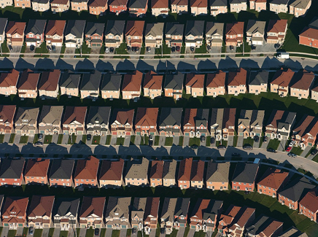
Source: An aerial view of housing developments near Markham, Ontario Photo by IDuke, at commons.wikimedia.org/wiki/File:Markham-suburbs_aerial-edit2.jpg#/media/File:Markham-suburbs_aerial-edit2.jpg. Licenced under CC BY-SA 2.5

Case study, urban sprawl and biodiversity
Teacher note - one impact of urban sprawl and increasing concentration of people in urban areas is a reduction in biodiversity. As part of exploring this issue, students will now undertake fieldwork on the biodiversity of bird species in their local area of school.
- Use your own knowledge and Birds in backyards, Find a bird and Birds in Sydney, to complete the following:
  - identify the type and number of birds that you see in your yard, local area or school in 1 day
  - use your observations to complete the table below.
Table 9 - Local bird biodiversity
Bird name | Description | Tally
- Investigate the reasons why these birds may be located in your area, for example access to water sources or specific plants (note, ‘Birds in Sydney’ and other websites will tell you what the birds eat).
- Predict what factors could cause the numbers of birds that you saw to increase or decline over time.
- Use your knowledge of the main food source of birds to write one paragraph explaining:
  - the importance of maintaining biodiversity in trees and plants
  - the benefits of avoiding pesticides and insecticides if possible.
- Draw a design for a backyard or balcony garden that will encourage biodiversity. Label the plants that you are including and note in your annotations why the plant has been included. Resource for this task:
  - Backyards for nature
  - Plant a green roof or wall for nature
  - Create small spaces for nature
  - Green roofs or walls for nature
  - Communities for nature
  - How to help native wildlife by installing a nest box in your garden
- Reflect on what you have learnt in this lesson and use this to complete an ‘I used to think-Now I think’ routine on urban sprawl and biodiversity. Use the sentence starters below as a guide:
  - I used to think …
  - Now I think …

Strategies to create economically, socially and environmentally sustainable urban places
Teacher note – in this series of activities, students will propose and explain strategies that may contribute to a sustainable urban future in Australian cities.
- Use the resources below to create a concept map of ideas to help make cities sustainable
- Resources for this task:
  - Megacity 2050: Future Green City Illustration
  - 7 innovative sustainable city projects to make cities more sustainable (duration 3:41)
  - Big Questions, Big Ideas: The Sustainable City with Steven Cohen (duration 2:19)
  - ABC, Self-sustainable zero waste productive home in Melbourne demonstrates future (duration 8:54)
  - Five innovative ideas to help build sustainable cities
  - Sustainable cities
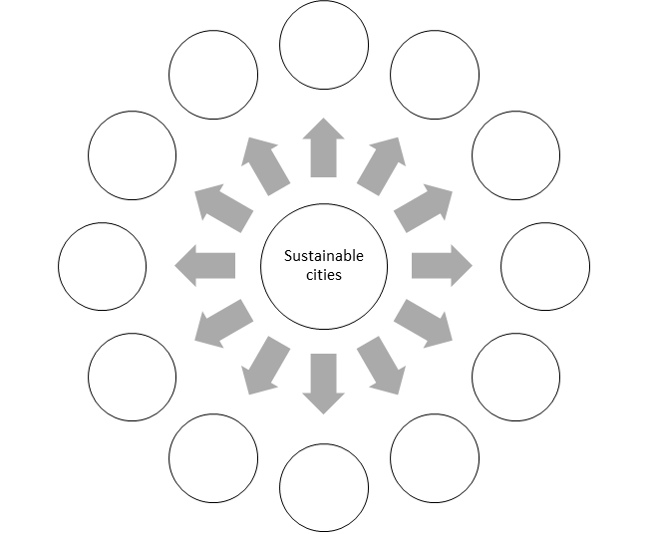
Figure 2 - concept map, sustainable strategies
- Consider all the ideas for sustainable cities that you have researched. Now choose your top 10 ideas to include in city design. For each design idea you should analyse the solution in the table below, that is:
  - what sustainability issue does it address?
  - How does it do this?
  - What are the possible advantages and disadvantages of this option?
Table - top 10 sustainable design ideas
Element of design that you will include | Identify the issue this design idea will address and explain how | Advantages and disadvantages of this solution
- Work in small teams to analyse each of the following scenarios, and complete the following:
  - identify all of the issues associated with increasing urbanisation
  - recommend changes that can be made by individuals and town planners to improve the sustainability of the particular city.
Scenario 1: Alex lives in an inland suburb of a crowded Australian city. Their backyard is too small for any plants and is covered in dark pavers that are too hot to walk on in summer. All the cars driving on the freeway near their house means that the air outside smells and tastes bad, so Alex doesn’t go out onto the hot pavers, they just stay inside. Lately their family have noticed that summers are so hot that no one can sleep at night. To make things worse, they can’t run their air conditioner most nights as the power cuts out when everyone in the suburb turns these on. Alex would love to go to the beach for a swim some hot afternoons, but their dad needs the car to drive 3 hours to his job in the city each day.
Scenario 2: In Ahmed’s suburb there are small farms where vegetables are grown. There are also birds everywhere. Now the council is about to approve the development of the farms for a very large new housing estate. The developers are hoping to get as many houses onto the estate as possible. This will mean that a wetland is drained, and all trees are removed. Ahmed is worried about the birds and that he will now have to buy vegetables that are transported from another state in a truck.
- Reflect on what you have learnt in this series of lessons on sustainable urban design. Use this to complete an ‘I used to think-Now I think’ routine, with the sentence starters below guiding your response:
  - I used to think …
  - Now I think …

Assessment task
Teacher note – if suitable for your context and students, Part A of this task can be completed in small teams, with students then completing Part B individually.

Content
Students:
- investigate the management and planning of Australia’s urban future, for example:
  - proposal of ways for individuals and communities to contribute to a sustainable urban future

Outcomes
A student:
- GE 5-5 - assesses management strategies for places and environments for their sustainability
- GE 5-8 - communicates geographical information to a range of audiences using a variety of strategies.

Task instructions
- As the world’s urban population increases, the need to build sustainable cities becomes even more important. According to the United Nations, “managing urban areas has become one of the most important development challenges of the 21st century”. In this task you will work on sustainable city design. You will complete both Part A and Part B.

Part A – design your city
- For this task, you will complete a design for your own sustainable city that includes:
  - a city plan with sustainable features
  - brief annotations, labelling the sustainable features
  - BOLTS (border, orientation, legend, title, scale)
  - a key with colours selected for different areas, for example, green spaces may be coloured green and high-rise buildings might be grey
- The design can be completed on paper, or made using technology of your choice, for example Canva, GoogleDoc, GoogleSites, or the Minecraft Education Edition.
- Questions to get you started may include:
  - How will you power your city? renewable energy?
  - How will you manage pollution?
  - How will you manage heat islands?
  - Where can local food be grown?
  - How will you recycle and reuse waste?
  - How are you integrating nature, for example gardens of native plants, trees, wildlife corridors?
  - How will you transport people around and avoid traffic congestion?

Part B – assess your best design feature
- Write 500-words about the best design feature in the city. For this part, you should:
  - identify and describe the 1 (one) best design feature of your city
  - explain why you have selected this as the best sustainable design feature
  - predict the challenges or barriers to implementing this design feature in cities.

Marking criteria
Criteria | Grade
- Demonstrates extensive knowledge of sustainability issues in urban areas  - Displays sophisticated skills in assessing strategies for managing sustainability challenges  - Communicates comprehensive geographical information in a sophisticated and engaging manner, using a variety of strategies. | A
- Demonstrates thorough knowledge of sustainability issues in urban areas  - Displays high level skills in assessing strategies for managing sustainability challenges  - Communicates detailed geographical information in an engaging manner, using a variety of strategies. | B
- Demonstrates sound knowledge of sustainability issues in urban areas  - Displays sound skills in assessing strategies for managing sustainability challenges  - Communicates a sound level of geographical information using a variety of strategies | C
- Demonstrates basic knowledge of sustainability issues in urban areas  - Displays basic skills in assessing strategies  - Communicates some geographical information in a basic manner | D
- Identifies some sustainability issues in urban areas  - Displays elementary skills in assessing strategies  - Communicates limited geographical information in an elementary manner. | E

