Geographical Toolkit K-10
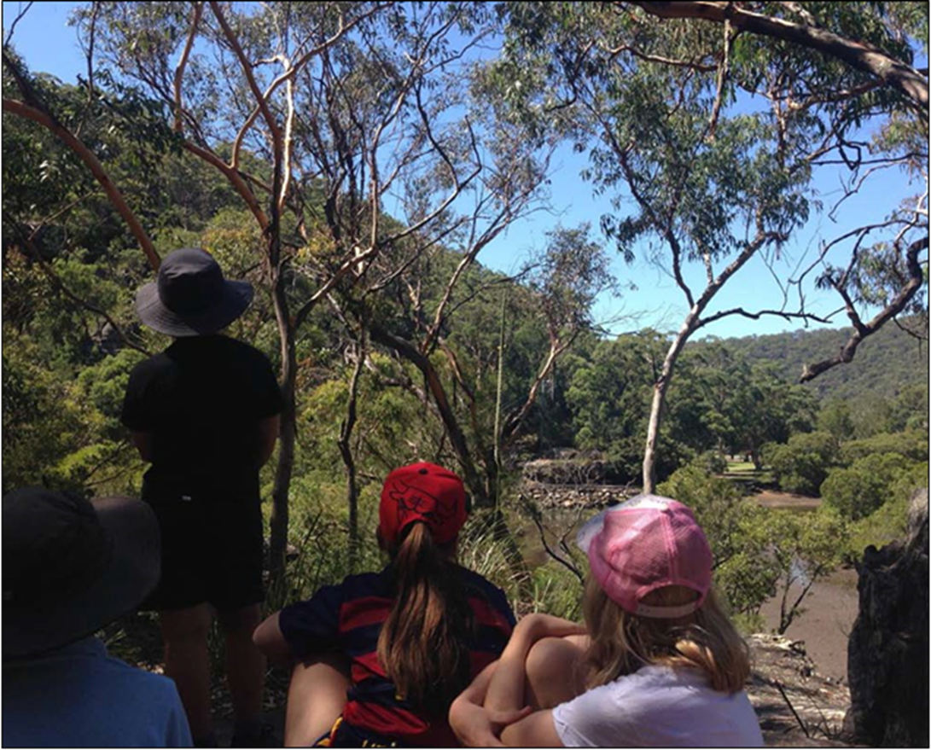
Geography fieldwork at Bobbin Head. Gibberagong Environmental Education Centre (EEC) © State of New South Wales (Department of Education), 2020

Table of contents
Geographical Toolkit K-10 1
Table of contents 2
Geographical tools 3
Geography K-10 syllabus elements 3
What are geographical tools? 3
Maps 4
Map types 4
Cadastral maps 5
Choropleth maps 5
Flow line maps 6
Isoline maps 6
Pictorial maps 7
Political maps 7
Précis maps 8
Relief maps 8
Sketch maps 9
Synoptic charts 10
Thematic maps 10
Topographic maps 11
Other types of maps 12
Mapping basics 16
Fieldwork 17
Purpose of fieldwork 17
Fieldwork sites 18
Environmental and zoo education centres 18
Aboriginal and/or Torres Strait Islander sites 19
Fieldwork activities 19
Interviews and survey questionnaires 28
Animal surveys 28
Plant surveys 29
Resources 30
Graphs and Statistics 31
Graphs 31
Statistics 36
Spatial Technologies 37
Introduction to spatial technologies 37
Virtual maps 37
Notes on specific virtual maps and tools 40
Visual Representations 46
Introduction to visual representations 46

Acknowledgement: This booklet has been developed as a resource for K-10 teachers as an extension of the K-6 Geographical toolkit. It is written by HSIE advisors and writers in the Learning and Teaching Directorate and teachers in DoE Environmental and Zoo Education Centres (EZEC).

Geographical tools

Geography K-10 syllabus elements
The interconnections between geographical concepts, inquiry skills and tools enables students to think and work geographically when investigating geographical knowledge and understandings.
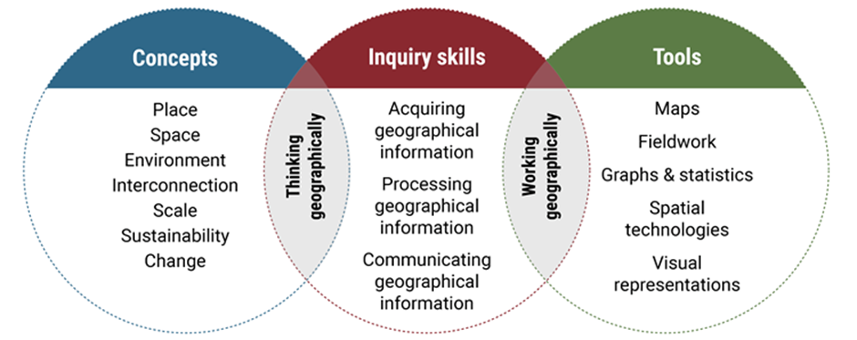
This model is an adaptation of a diagram in ‘Inquiry-based learning in geography’ by Dr Grant Kleeman, Macquarie University, presented at the Canberra Geography Roadshow, November 2015.

What are geographical tools?
Geographical tools are used by geographers during an inquiry to acquire, process and communicate geographical information (geography syllabus K-10, NESA, 2015).
The Geography K-10 Syllabus requires all students to use and integrate geographical tools throughout the geographical inquiry process. The Tools continuum in Geography K-10 provides examples of tools students may use in each stage of learning. This booklet provides examples of a variety of geographical tools and suggested stages where they can be applied.

Maps

Map types
Maps are one of the geographer’s main tools. They show the location of places and features, and show spatial patterns and distribution. Students should use a variety of types of maps to acquire, represent and communicate geographical information.
Refer to the Tools continuum for Geography K-10 for examples of map types appropriate to each stage of learning. The continuum is a guide for where tools can be used and integrated into Geography K-10.
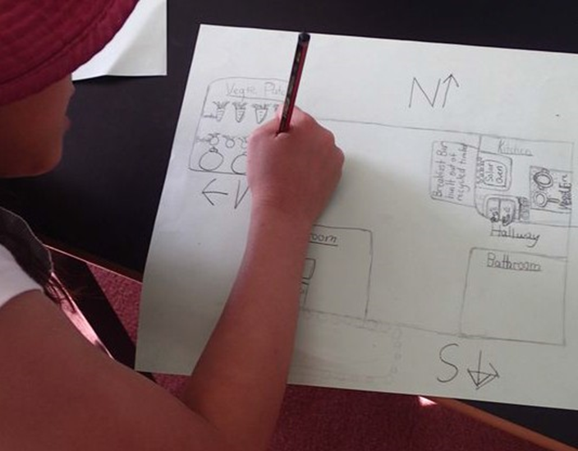
Student creating a large-scale map. Dorroughby EEC © State of New South Wales (Department of Education), 2020

Cadastral maps
Stage 5.
A cadastral map shows property boundaries. Cadastral maps from varying time periods can be analysed for changing land uses and settlement patterns.
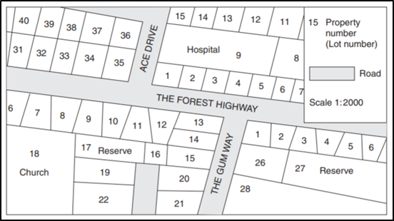
Geography 2018 HSC exam pack © NSW Education Standards Authority (NESA) for and on behalf of the Crown in right of the State of New South Wales, 2018.

Choropleth maps
Stage 4 and Stage 5.
A choropleth map is a thematic map that uses colours or shading to represent areas with the same characteristics, for example land use, vegetation types, climate zones, population density.
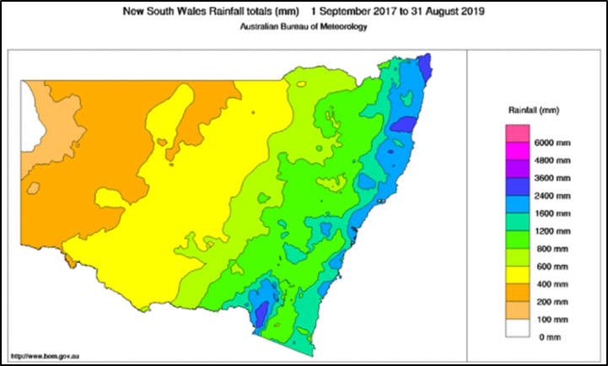
New South Wales Rainfall totals 2017-2019 by Australian Bureau of Meteorology is licensed under CC BY 3.0 AU

Flowline maps
Stage 3, Stage 4 and Stage 5.
A flowline map uses arrows to show the flows of people, goods, information or ideas between places. The thickness of the line represents the volume of flow.
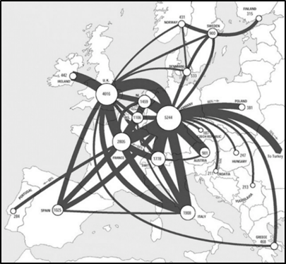
Telecommunications Traffic Flow Map by Amber Case available under a CC BY-NC 2.0

Isoline maps
Stage 4 and Stage 5.
An isoline map has continuous lines that join points of the same value, for example. rainfall, elevation. A synoptic chart is an isoline map used in meteorology. Contour lines on a topographic map are also called isolines.
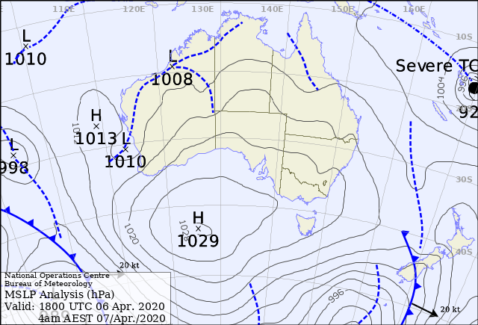
Latest Colour Mean Sea-Level Pressure Analysis by Australian Bureau of Meteorology is licensed under CC BY 3.0 AU

Pictorial maps
Early Stage 1 and Stage 1.
A pictorial map uses illustrations to represent information on the map. They are often used for tourist maps and presented either an oblique or birds eye view.
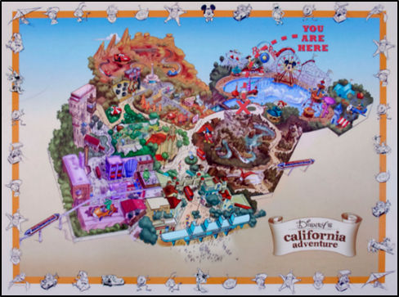
Disney’s California Adventure by Renatta R available under a CC-BY 2.0

Political maps
Stage 3, Stage 4 and Stage 5.
Political maps illustrate state and national boundaries, capital cities and major cities. Different colours are used to differentiate between countries.
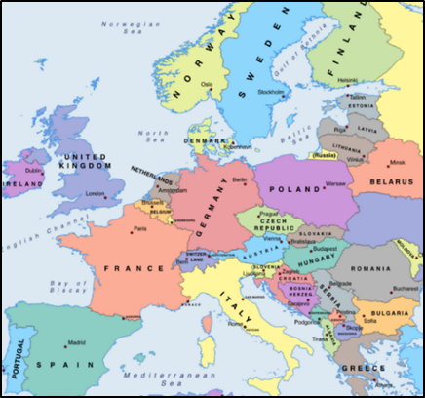
Political map of Europe by Mapswire is licensed under CC-BY 4.0

Précis maps
Stage 4 and Stage 5.
A précis map is a simple sketch map drawn from a photograph or topographic map. It usually focuses on one feature, for example vegetation cover.
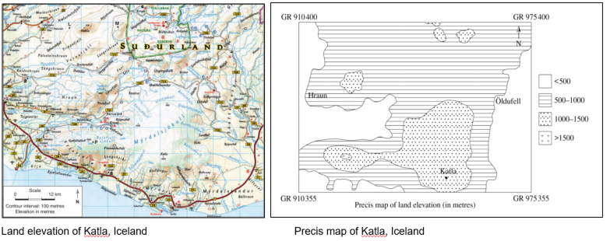
Geography 2017 HSC exam pack © NSW Education Standards Authority (NESA) for and on behalf of the Crown in right of the State of New South Wales, 2017.

Relief maps
Stage 4 and Stage 5.
A relief map is either a 2D or 3D map that represents terrain and landforms, that is, the shape of the land.
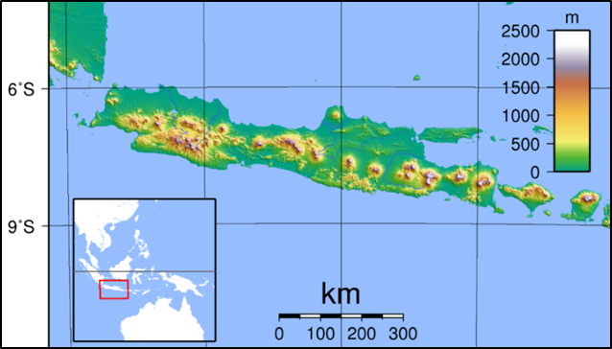
Java Topography by Sadalmelik licensing released under public domain

Sketch maps
Stage 2, Stage 3, Stage 4 and Stage 5.
A sketch map is a drawing of the study area from an aerial perspective. It can be either estimated or to scale. A sketch map provides a simple visual description of an area and maps the main natural and human features. It should include a border, title, orientation and a legend.
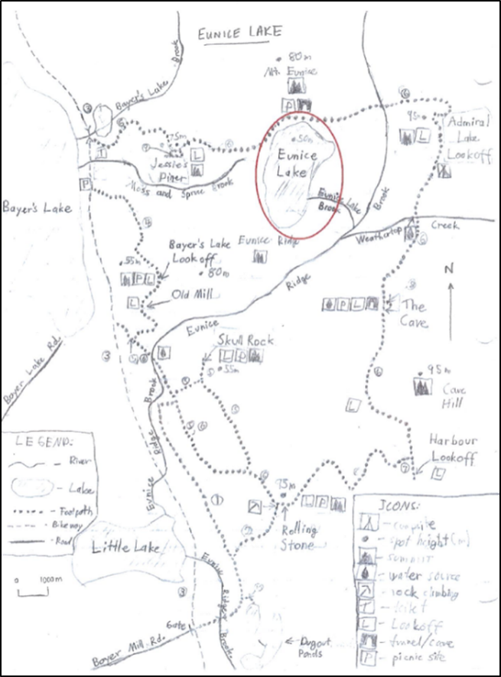
Admiral Lake Loop map with Eunice Lake highlighted by Denver & Rio Grande is licensed under CC-BY 3.0

Synoptic charts
Stage 4 and Stage 5.
Synoptic charts are weather maps. They are isoline maps that show the atmospheric conditions of a location on a particular day including rainfall, air pressure (atmospheric pressure), wind speed and wind direction. The Australian Bureau of Meteorology website has current four day forecast synoptic charts: Colour Forecast map for next 4 days
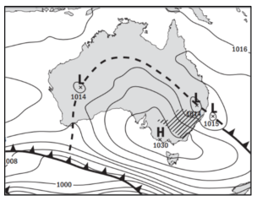
Mean Sea Level Pressure Prognosis by Australian Bureau of Meteorology is licensed under CC BY 3.0 AU

Thematic maps
Stage 5.
Thematic maps are based on a particular theme or topic, for example distribution of resources, weather, and vegetation type.
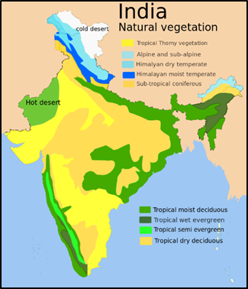
India Natural vegetation by Amog is licensed under CC BY-SA 3.0

Topographic maps
Stage 3, Stage 4 and Stage 5.
Topographic maps use contour lines to show the shape of the land as well as important natural and human features such as landforms, vegetation and roads. Topographic maps are large scale maps showing a small area in large detail.
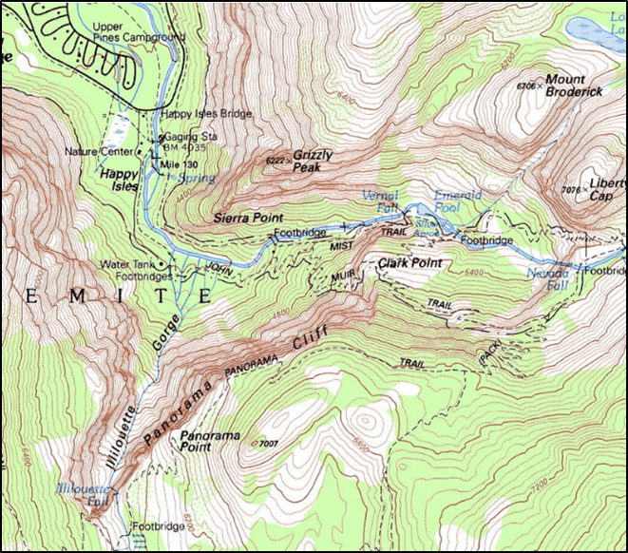
Happy Isles topo map Yosemite Valley by U.S. Geological Survey released under public domain

Other types of maps

Map scale
Maps show the earth’s surface in varying amounts of detail, depending on their scale. Maps can be large scale or small scale, showing varying levels of detail.
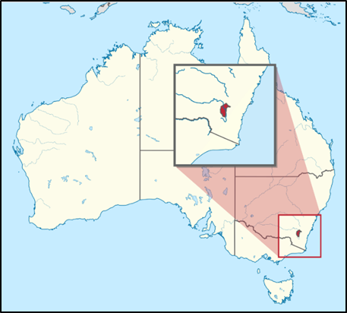
Australian Capital Territory in Australia at varying scales by TUBS is licensed under CC BY-SA 3.0

Large scale maps
Large scale maps show a small area in large detail. Examples of large scale maps include topographic maps, school site maps, national park maps and tourist information maps. On a large scale map, 1 centimetre might represent 500 metres (1:50 000). Large scale maps can be introduced in Stage 1.
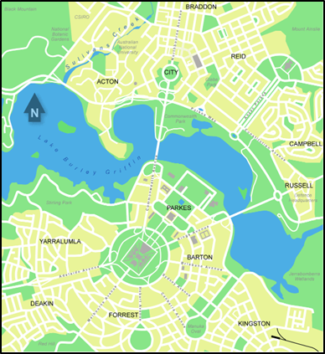
Inner Canberra by Martyman is licensed under CC BY-SA 3.0

Small scale maps
Small scale maps show a large area in small detail. Examples of small scale maps are maps of the world, maps of states and countries. On a small scale map, 1 centimetre might represent 1000 kilometres (1:100 000 000).
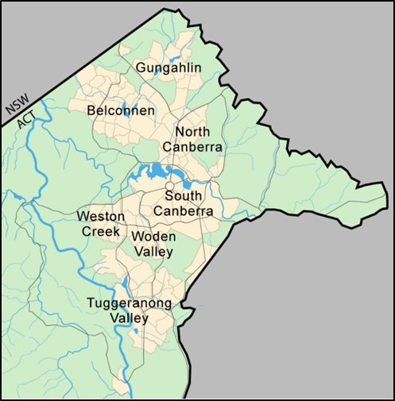
Canberra Map by Martyman is licensed under CC BY-SA 3.0

Physical maps
Physical maps illustrate the physical features and landforms of an area such as lakes, mountains, rivers and coasts.
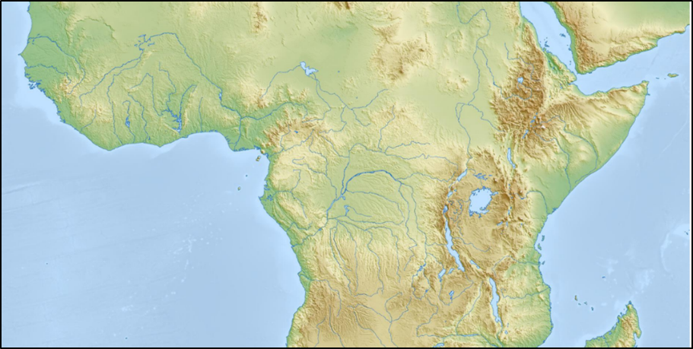
Physical map of Africa by Mapswire is licensed under CC-BY 4.0

Road maps
A road map shows roads and transport links at large scale (for example street directory) or small-scale (for example state highways).
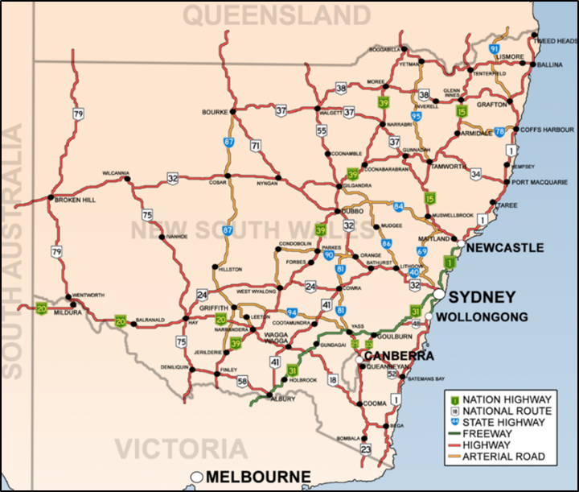
Road routes in NSW.by Bidgee is licensed under CC BY 3.0

Informal mapping

Mental maps
Mental maps are maps created from memory and can also be maps of the imagination. Mental maps can be drawn of familiar special places and journeys, such as the journey home or a grandparent’s backyard. An imaginary mental map could be a map of Little Red Riding Hood’s journey through the forest to her grandma’s house or a map. Refer to GeogSpace – Mental Maps for specific examples of mental maps.

Mud maps
Traditionally mud maps were drawn in the field in the dirt to explain how to get from one place to another. They usually accompany a story or yarn. Students and teachers can use mud maps during fieldwork activities to explain the location of features and show interconnections. Mud maps can also be used at the conclusion of fieldwork as a consolidating activity that demonstrates their understandings.

Nature maps
Similar to mud maps, nature maps are ephemeral point in time maps. Students use loose natural materials found on the ground to create a map of an area or to recreate the features of a place during fieldwork. Nature maps could be created in the school playground showing the features of a play area (Early Stage 1) and at a local park to show the varying uses and features of the park (Stage 1).
Natural and found materials can also be used to create diagrams of physical and human features of an area, for example, the vegetation layers in a forest (Stage 2). Ephemeral maps and diagrams can be photographed and used as the basis for drawn mapping activities following fieldwork.
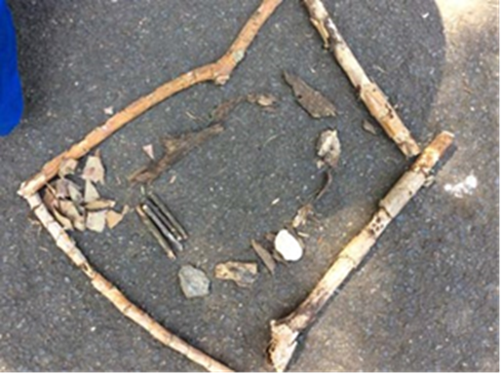
Nature created following a walk along a boardwalk and bushland loop. Field of Mars EEC © State of New South Wales (Department of Education), 2020
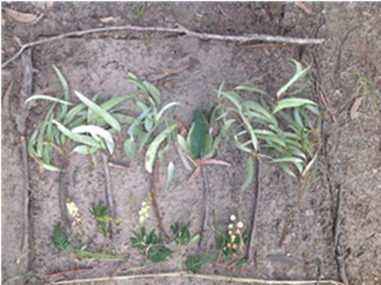
Vegetation profile showing layers of the forest. Rumbalara EEC © State of New South Wales (Department of Education), 2020

Mapping basics
In learning to use and construct maps, students should follow standard cartographic conventions.
B.O.L.T.S.
Every good map should have a:
- Border
- Orientation (north point)
- Legend (key)
- Title
- Scale
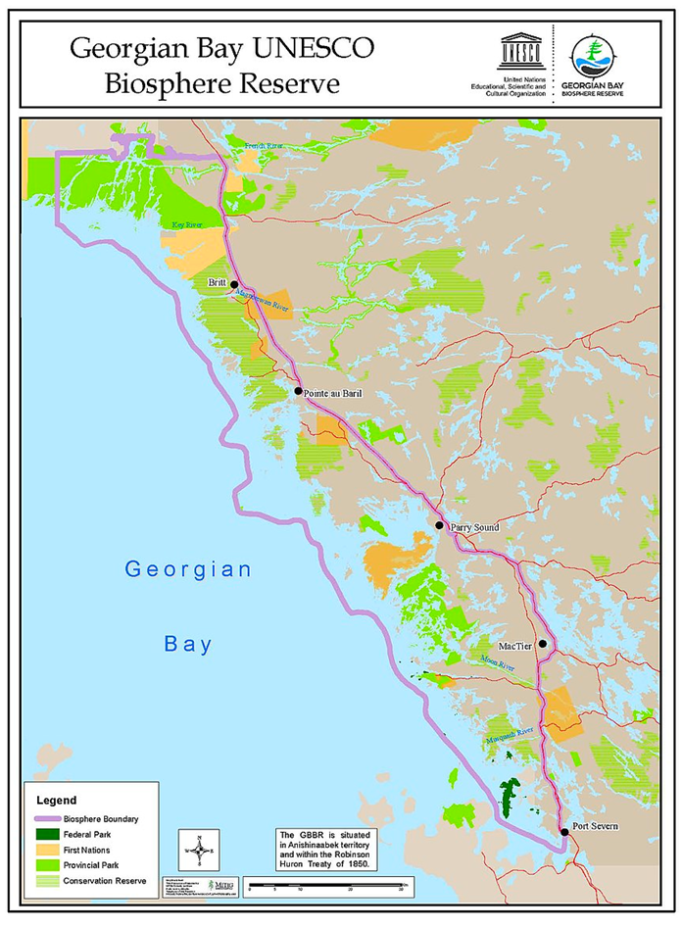
Georgian Bay map including BOLTS by Rebecca Pollock, Executive Director, Georgian Bay Biosphere Reserve is licensed under CC BY-SA 4.0

Fieldwork

Purpose of fieldwork
Fieldwork is essential to the study of geography and is mandatory for all students K-10. It involves taking students outside to observe, measure, collect and record geographical data and information that helps them answer their inquiry questions. The fieldwork experience should be fun, engaging and age appropriate.
Refer to the Tools continuum for Geography K-10 for examples of fieldwork tools appropriate to each stage of learning. The continuum is a guide for where tools can be used and integrated into Geography K-10.
Following fieldwork, students may process the data using tools such as maps, graphs and graphic organisers to identify connections and draw conclusions. Fieldwork findings can be used when communicating geographical information, for example in a map, story, presentation or report.
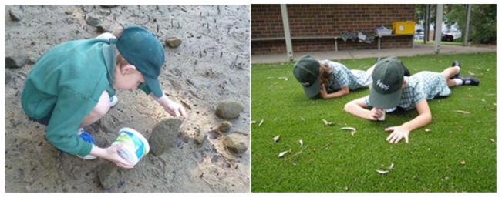
Examples of fieldwork on a river bank and in the school grounds. Images: Royal National Park EEC © State of New South Wales (Department of Education), 2020

Fieldwork enables students to:
- be immersed in a variety of real world environments
- be actively engaged in geographical inquiry
- investigate geographical phenomena in an authentic learning context
- learn through a variety of teaching and learning approaches
- use a wide range of geographical tools
- explore geographical processes within environments
- locate, collect and record primary data and information
- explore varying perspectives on geographical issues.

Fieldwork sites
Fieldwork can be undertaken at school, in the local area or at more distant places. Experiences can range from a part of a lesson, a full day excursion to an overnight camp. Fieldwork sites include:
- school grounds
- local neighbourhood
- natural areas, for example national parks, reserves
- beaches, estuaries, wetlands, agricultural areas
- towns and cities.

Environmental and zoo education centres
There are 25 DoE environmental and zoo education centres (EZEC) in NSW that provide geography fieldwork experiences. The centres have specialised measuring and recording equipment with teachers who have expertise in fieldwork skills, tools and techniques.

Aboriginal and/or Torres Strait Islander sites
When proposing fieldwork for Aboriginal or Torres Strait Islander sites, consult with local communities and your local Aboriginal Education Consultative Group (AECG). Students, teachers and accompanying parents and carers need to be familiar with protocols for visiting the site and working with Aboriginal communities. Refer to the Working with Aboriginal Communities: A Guide to Community Consultation and Protocols (PDF 37 pages).

Fieldwork activities
Fieldwork activities should be integrated into teaching and learning, be planned to meet syllabus outcomes, answer the inquiry questions and be appropriate for the age of the students. In addition to formal fieldwork, incidental opportunities enable students to make impromptu observations, for example when moving through the school.
Fieldwork becomes more comprehensive as students move through the stages. By stages 4 and 5, students use professional fieldwork equipment and techniques to collect complex data and information.
Fieldwork activities can include:
- plotting location, natural and human features on maps
- recording observations through sketches and photographs
- counting and plotting facilities for people
- surveying people to collect information
- counting plants using quadrats
- measuring distances, temperature, humidity
- collecting aquatic and terrestrial invertebrates
- testing water quality, turbidity
- recording change in features along a transect
- calculating direction and aspect using a compass.
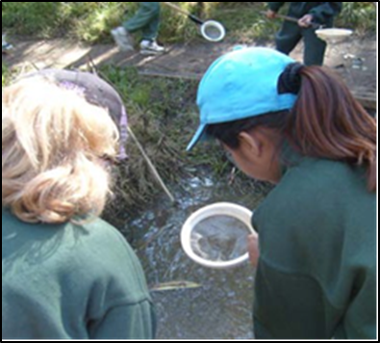
Dip netting for water bugs. Longneck Lagoon EEC © State of New South Wales (Department of Education), 2020

Early Stage 1
Focus: sensory and immersive experiences that enable Early Stage 1 students to explore the natural and human features of their school playground.
Refer to:
- Descriptions of suggested fieldwork tools and activities later in this section
- GeogSpace Selecting a fieldwork site – Foundation year (PDF 1 page)
- Early Stage 1 Geography learning and teaching framework – My school grounds (DOCX 79KB).
Early Stage 1 syllabus content | Potential fieldwork sites | Suggested fieldwork tools and activities
Important places | School grounds, classroom | Photography, sensory activities, tallies, informal mapping, pictorial maps
Aboriginal or Torres Strait Islander places | Local Aboriginal places | Sensory activities, interviews, photography

Stage 1
Focus: sensory and immersive experiences that enable students to explore places and spaces. Observations can be recorded using a variety of media.
Refer to:
- Descriptions of suggested fieldwork tools and activities later in this section
- GeogSpace Selecting a fieldwork site – Years 1 and 2 (PDF 2 pages)
- Stage 1 Geography learning and teaching frameworks.
Stage 1 syllabus content | Potential fieldwork sites | Suggested fieldwork tools and activities
Features of places | Local park, school grounds, natural area, for example bushland, beach, lake, wetland, river bank | Photography, sensory activities, invertebrate hunts, tallies, rubbings, sketching, informal mapping, large scale maps, for example school site map, pictorial maps
Weather and seasons | School grounds | Measuring rain, temperature, wind using formal and informal units; observations through senses
How places are organised | School hall, Covered Outdoor Learning Area (COLA), local recreation area | Pictorial maps, photography, sketching, interviewing, surveys, tallies, informal mapping
Australian places | Local neighbourhood | Photography, mapping, tallies, sketching, rubbings, sensory activities
People’s connections to places | School, local shops, park, library, sports facilities, natural areas | Interviewing, surveys, tallies (for example modes of transport to school), photography
Local and global connections | Natural areas, Aboriginal sites | Photography, interviews, sensory activities

Stage 2
Focus: recording in a variety of ways using a range of media, including verbal and non-verbal methods and sensory experiences.
Refer to:
- Descriptions of suggested fieldwork tools and activities later in this section
- GeogSpace Selecting a fieldwork site – Years 3 and 4 (PDF 2 pages)
- Stage 2 Geography learning and teaching frameworks.
Stage2 syllabus content | Potential fieldwork site | Suggested fieldwork tools and activities
Similarities and differences between places | Home town or city (for comparison with distant places) | Photography, sketching, line drawings, sketch maps, tallies, sound and video recordings
Different environments Significance of environments | Natural area, for example rainforest, woodland, eucalypt forest, wetland, state forest | Photography, sensory activities, animal surveys, invertebrate hunts, plant surveys, tallies, sketches, informal maps, large scale maps
Perception of environments  Protection of environments | Nature reserve, national or state park, cultural heritage site | Photography, mapping, sketching, surveys, sensory activities, waste audits, large scale maps

Stage 3
Focus: recording in a variety of ways using a variety of media, including sensory experiences. Recording quantitative data through formal measurements and qualitative data through surveys and interviews.
Refer to:
- Descriptions of suggested fieldwork tools and activities later in this section
- GeogSpace Selecting a fieldwork site – Years 5 and 6 (PDF 2 pages)
- Stage 3 Geography learning and teaching frameworks.
Stage 3 syllabus content | Potential fieldwork sites | Suggested fieldwork tools and activities
Factors that change environments (can be combined with Humans shape places) | Site with multiple uses, for example national park picnic ground, river bank development, recreational reserve | Photography, field sketches, plant and animal surveys, tallies, sketching, sketch maps, water quality testing, interviewing, surveys, tallies, compasses and GPS
Humans shape places | Site affected by a contemporary land use issue, for example waterway, bushland or recreational reserve, harbour foreshore | Photography, field sketches, plant and animal surveys, tallies, sketching, mapping, water quality testing, interviewing, surveys, tallies

Stage 4
Focus: students may observe, measure, collect and record data, develop and conduct surveys and interviews. Fieldwork activities may include using fieldwork instruments such as weather instruments, vegetation identification charts, compasses, GPS and GIS.
Refer to:
- Descriptions of suggested fieldwork tools and activities later in this section
- GeogSpace Selecting a fieldwork site – Years 7 and 8 (PDF 2 pages)
- Stage 4 Geography learning and teaching frameworks.
Stage 4 syllabus content | Potential fieldwork sites | Suggested fieldwork tools and activities
Landscapes and landforms  Value of landscapes and landforms  Changing landscapes | A landscape with distinct landforms such as a national park | Photography, field sketches, transects, compasses and GPS, develop and conduct interviews, surveys, water quality testing, mapping
Place and liveability  Influences and perceptions  Access to services and facilities  Environmental quality  Community  Enhancing liveability | Local suburb, town, city | Photography, field sketches, tallies, interviews, surveys, mapping
Water in the world  The water cycle  The value of water | School grounds, local suburb, lake, river wetlands, beach, local water waste treatment facility | Photography, field sketches, transects, compasses and GPS, develop and conduct interviews, surveys, water quality testing, mapping

Stage 5
Focus: students may observe, measure, collect and record data, develop and conduct surveys and interviews. Fieldwork activities may include using fieldwork instruments such as weather instruments, vegetation identification charts, compasses, clinometers GPS and GIS or remote sensing.
Refer to:
- Descriptions of suggested fieldwork tools and activities later in this section
- GeogSpace Selecting a fieldwork site – Years 9 and 10 (PDF 2 pages)
- Stage 5 Geography learning and teaching frameworks.
Stage 5 syllabus content | Potential fieldwork sites | Suggested fieldwork tools and activities
Sustainable biomes  Biomes  Biomes produce food  Challenges to food production  Food security | Zoo, local farm, national parks | Photography, field sketches, plant and animal surveys, sketching, sketch maps, soil testing, interviewing, water quality testing, compasses and GPS
Changing places  Urban settlement patterns | Local town, suburb or city | Photography, field sketches, plant and animal surveys, tallies, sketching, mapping, interviewing, surveys
Environmental change and management  Investigative study | Site affected by environmental change for example wetlands, beach, forest, waterways | Photography, field sketches, plant and animal surveys, sketching, sketch maps, soil testing, interviewing, water quality testing, compasses and GPS

Sensory fieldwork activities
Sensory fieldwork activities sharpen observations. When undertaking fieldwork provide time for students to:
- look – up, down and around. Notice details and changes
- listen – to natural and human sounds. Notice noise and quiet
- smell – the air, flowers and leaves. Notice the differences in smells of places
- touch – textures of natural and human features. Notice leaves, bark and surfaces underfoot.

Treasure hunts
- Instruct students to collect four items from the environment (from the ground) for example students may find seed pods/cones, leaves of different shape and colour, textures, rocks, sticks with galls, litter.
- Classify found items into natural and human and discuss interesting features.
- Discuss origins of litter and ways to care for places.

Colour chips
- Ask students what colours they can see in the immediate environment.
- Hand out colour chips to each student and ask them to match the colours to items in the environment.

Texture
- Ask students to find different textures in the environment, for example different leaves, bark, rocks, soil, pavements.
- Ask students to describe the textures, for example smooth, rough, prickly, soft, waxy, or furry.
- Use a crayon and paper to make rubbings to record the textures.

Sounds
- Students close their eyes and quietly listen to the sounds around them for several minutes.
- Students report on what they heard.

Leaf friends
- Students collect a leaf from the ground.
- Ask students to complete the following activities to get to know their leaf:
  - Touch – the leaf with different parts of your body (for example cheek, back of wrist) and use words to describe its texture.
  - Sight – Describe what you can see on your leaf. Colours? Are there parts missing? Are there lumps in it?
  - Smell –- What does your leaf smell like? Smell a friend’s leaf.
  - Tell – your leaf’s story. What’s been using your leaf and how? (For example caterpillar, leaf minor, gall wasp).

Shapes
- Provide students with cards, each cut to a different shape, for example square, circle, irregular.
- Ask them to match the shaped card to natural and human items in the environment.
- Back in the classroom draw the item from the environment next to the shape.
- Label and classify the items into natural and human features.

Sound maps
- Students mark an ‘X’ in the centre of a blank page to represent the location of themselves.
- Students sit separately and silently in their own space.
- They use symbols, words or other marks to represent the sounds they hear around them.

Scrunch and sniﬀ
- Before the fieldwork collect some leaves from the area being investigated, for example camphor laurel, bottle brush, tea tree. Crush up leaves and put them in separate containers.
- Students smell the crushed leaves in the container and then find the matching plant.
- Alternatively, give students a variety of leaves to scrunch and sniff in the area being investigated.

Hug a tree
- Organise students into pairs. One of the pair leads their blindfolded partner to a tree.
- The blindfolded student gets to know the tree without being able to see it.
- After being led back to a central position the blindfold is removed and the student finds that tree.
- Discuss the importance of trees, for example hollows provide habitat for birds, bats, possums; branches are habitat for spiders and nesting birds; leaves, seeds and flowers are food for many animals; provide oxygen, shade, wind breaks, mulch, timber, firewood and beauty.

Word clouds
- Students sit quietly and separately in a place.
- They write words that describe the place, their feelings there and how the place makes them feel.
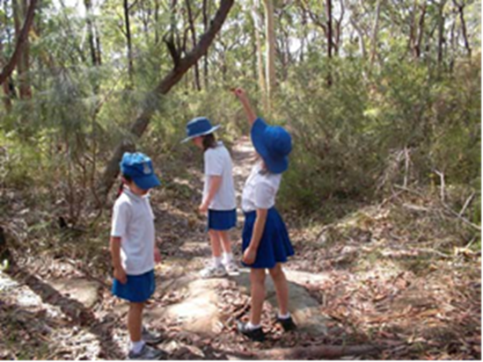
Leaf investigation. Field of Mars EEC © State of New South Wales (Department of Education), 2020
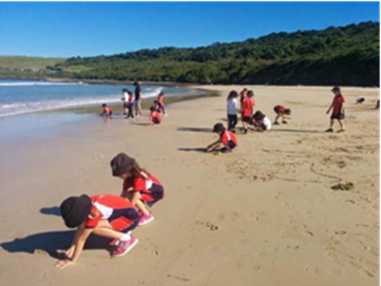
Beach exploration. Illawarra EEC © State of New South Wales (Department of Education), 2020

Interviews and survey questionnaires

Interviews
- Interviews are personal conversations between two people or a group of people.
- Interviews collect qualitative data that contain the interviewee’s perspective and biases.
- Prepare questions to elicit answers that are longer than ‘yes’ and ‘no’.
- Interview in pairs so that one student asks questions and the other records notes.
- Interviews are useful in collecting a variety of perceptions of places and uses of places.

Survey questionnaires
- Survey questionnaires are usually a written list of questions to gain quantitative data collected from a number of people.
- Examples of survey questionnaires include human uses of an area, land uses, modes of transport, ways people use areas and how people perceive places.
- Students should be aware that surveys are from a representative group only.

Counting surveys
- Counting surveys record human and physical characteristics of a place.
- Counting surveys can include modes of transport, visitor facilities in a recreation area and types of users of an area. Counting surveys usually include animal and plant surveys.

Animal surveys

Tree shake
- Working in groups students place a light-coloured sheet beneath a leafy tree or shrub.
- They shake the branches to cause invertebrates to fall onto the sheet.
- Place the invertebrates in plastic jars or bug magnifiers and record the number and types found.
- When finished return invertebrates to the collection point.

Leaf litter hunts
- Use a stick to gently lift apart the leaf litter to observe leaf litter invertebrates.
- To collect them, place a scoop of leaf litter into a tray or onto a ground sheet.
- Separate the leaf litter and place invertebrates in plastic jars or bug magnifiers and record the number and types found.
- When finished, return invertebrates to the collection point.

Animal evidence
- Look for animals or signs of animals. Make a list of animal evidence, for example scratch marks on trees, spider webs, chewed leaves, birds’ nests, possum dreys, wasp galls, scratchings in the ground, scats, tracks.
- Discuss animal habitats – How does a bird, possum, spider use plants for its habitat?

Dip netting
- Students use dip nets to gently scoop water from a pond or creek with the aim of collecting aquatic macro invertebrates.
- Students tip the net contents into a light coloured container of water, for example a tote tray or ice cream container.
- Students examine and identify collected invertebrates.
- When finished, return the invertebrates to the pond.

Plant surveys

Tree matching
- Locate five to ten common species of trees or shrubs in an area.
- Mark one of each species with a name tag, for example coastal banksia, cedar wattle, blackbutt.
- Students attempt to identify the plants in the area using the reference species.
- Record the number of each species using tally marks.

Plant bingo
- Print and laminate plant identification guides, or create into a plant bingo card. Plant identification charts may be available from local council websites.
- Students identify and record plants using the guides.
- Record the number of each species in a defined area, for example 5m x 5m.

Hoop studies
- Place hoops on the ground.
- Students examine the plants in the hoop.
- They count the number of different types of plants in the hoop.
- Repeat in several locations and calculate the average number of each type of plant.

Resources
- A checklist for undertaking fieldwork, Geogspace Australia
- Fieldwork ideas and resources, Geographical Association UK

Graphs and Statistics

Graphs
Graphs are used by geographers to visualise and summarise quantitative data about places. They include tally charts, pictographs, column graphs, line graphs, pie graphs and climate graphs. Graphs should always include the unit of measurement when reading data from graphs, for example temperature in degrees Celsius, rainfall in millilitres.
Refer to the Tools continuum for Geography K-10 for examples of the types of graphs and statistics appropriate to each stage of learning. The continuum is a guide for where tools can be used and integrated into Geography K-10.

Tally charts
Early Stage 1, Stage 1 and Stage 2.
Tally charts are used during fieldwork to record the numbers of specific natural and/or human features in a place, for example picnic tables in a park, lunch seats in an area of the school playground, animal evidence in a bushland area, types of management strategies in a catchment. Tally charts are also used in collating survey data.

Climate graphs
Stage 3, Stage 4 and Stage 5.
For a particular location, a climate graph combines:
- a line graph showing the average monthly temperature (Stages 3, 4, 5), and
- a column graph showing the average monthly precipitation (rainfall) (Stages 2, 3, 4, 5).
Refer to GeogSpace Climate graphs (PDF 5 pages) for information on using and analysing climate graphs and statistics.
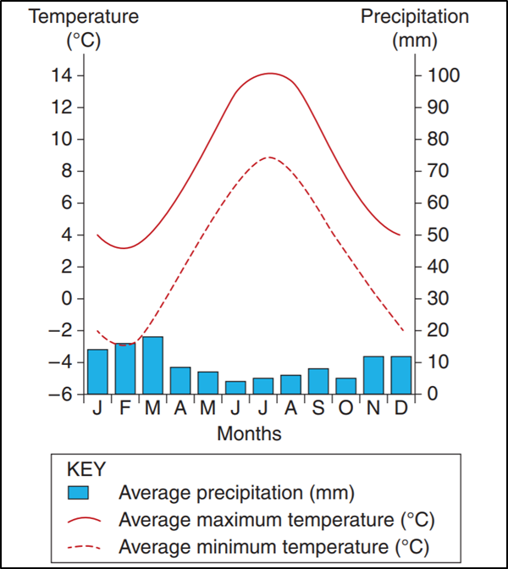
Geography 2017 HSC exam pack © NSW Education Standards Authority (NESA) for and on behalf of the Crown in right of the State of New South Wales, 2017.

Pictographs
Early Stage 1, Stage 1 and Stage 2.
A pictograph uses pictures and symbols to represent statistical information.
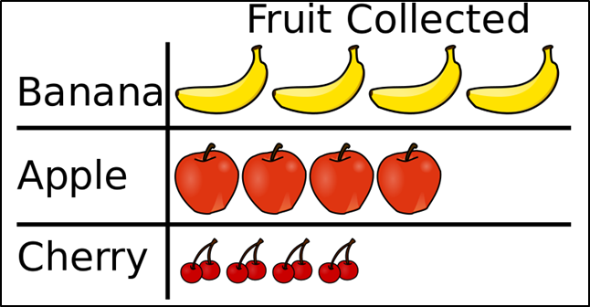
Pictograph by Smallman12q is licensed under CC BY-SA 3.0

Scatter graphs
Stage 5.
A graph which plots the relationship between two variables. For example, education and income:
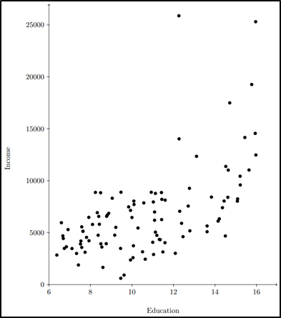
Scatterplot by Ista Zahn is licensed under CC BY 2.5

Pie graphs
Stage 3, Stage 4 and Stage 5.
A pie graph is circular and is divided into sectors. The sectors show the relative size of each value and are usually illustrated by different colours.
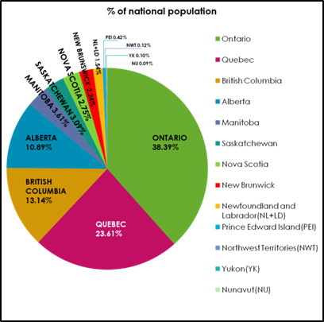
Population of Provinces and Territories of Canada Pie Chart by is licensed under CC BY-SA 3.0

Line graphs
Stage 3, Stage 4 and Stage 5.
A line graph shows data in linear form that is connected in some way. For example, change over time.
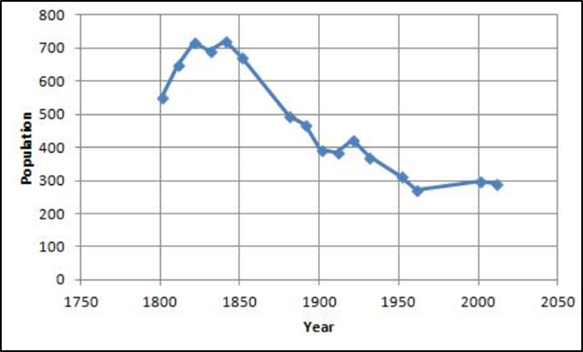
Cratfield population line graph by Scanlon J is licensed under CC BY-SA 4.0

Column graphs
Stage 1, Stage 2, Stage 3, Stage 4 and Stage 5.
A column graph is a type of bar graph using vertical bars to display data.
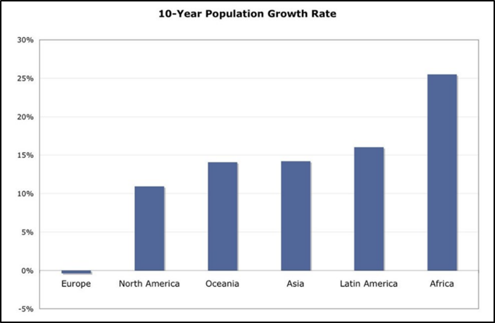
10 year population growth rate by Matt Lemmon is licensed under CC BY-SA 2.0

Compound column graphs
Stage 4 and Stage 5.
A compound column graph contains two or more types of information in one graph. Columns are split into sections to show the breakdown of data.
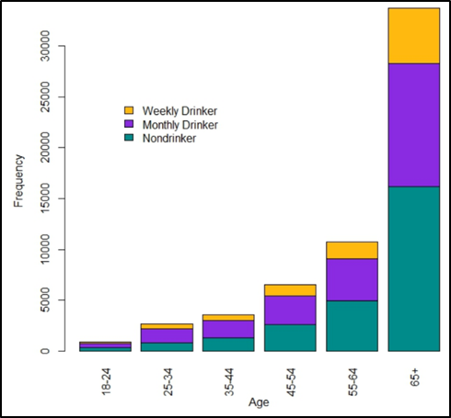
Age by Alcohol Status by Monika Wahi is licensed under CC BY-SA 4.0

Statistics
Statistics are used by geographers to collate, organise and summarise geographical data and information. In particular, climate and demographic statistics are useful data. Geographers analyse statistics for patterns, relationships and trends.
Useful sources of statistical data include:
- Australian Bureau of Statistics (ABS) website
- World Health Organisation (WHO) – Countries webpage

Data tables
Stage 1, Stage 2, Stage 3, Stage 4 and Stage 5.
Geographers represent and organise data collected through fieldwork and research in data tables for evaluation and analysis. Refer to GeogSpace Comparative data (PDF 1 page) for an example of a comparative data table.

Spatial Technologies

Introduction to spatial technologies
Spatial technologies are used by geographers to visualise, manipulate, analyse, display and record spatial data. Examples include virtual maps, satellite imagery, remote sensing, Global Positioning Systems (GPS), Geographic Information Systems (GIS) and augmented reality.
Refer to the Tools continuum for Geography K-10 for examples of the types of spatial technologies appropriate to each stage of learning. The continuum is a guide for where tools can be used and integrated into Geography K-10. Refer to the video GeogSpace: Introduction to geospatial technologies (duration 2:08).

Virtual maps
Early Stage 1, Stage 1, Stage 2, Stage 3, Stage 4 and Stage 5.
Virtual maps are online maps. Interactive virtual maps usually contain a map view and a satellite view. Virtual maps provide large scale and small scale maps for acquiring geographical information for students in all stages. Annotations can be made to virtual maps using inbuilt tools or by using a screenshot as the base map.
Examples of virtual maps and tools:
- Google Maps
- Google Earth
- Google My Maps
- Maps (Apple)
- Bing Maps
- Whereis
- Google Tour Builder
- Google Street View
- MapMyWalk app for Android
- SIX Maps
- Scribble Maps
- National Geographic MapMaker Interactive
- Eyes on the Forest (Sumatra’s forests, wildlife and climate 1985 to the present)

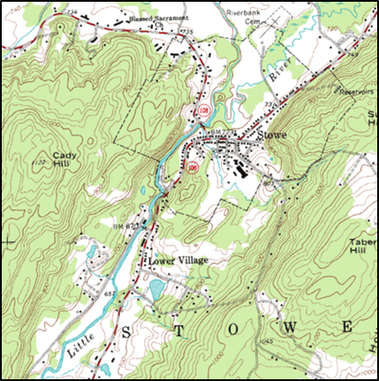
Example of a virtual map. Topographic map example by U.S. Geological Survey licensing released under public domain
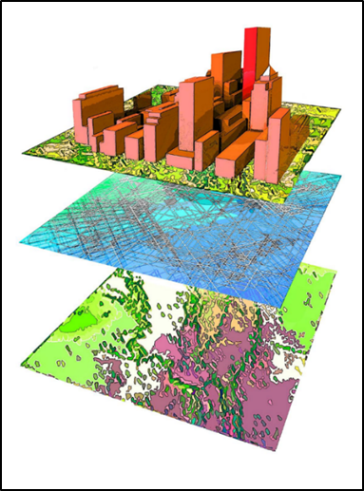
Example of a GIS map. Layers of information lolly by Diane Quick is licensed under CC BY-SA 3.0
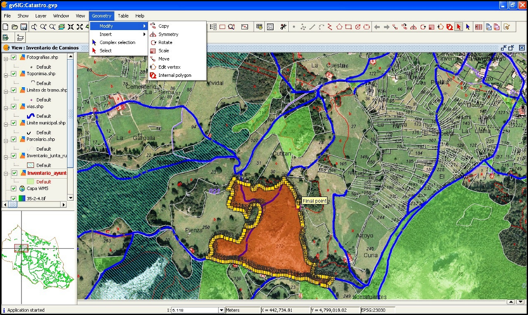
Example of editing a map using GIS tools. GvSIG – GIS by Emilio Gómez Fernández is licensed under CC BY 2.5

Notes on specific virtual maps and tools
(Due to copyright restrictions images of each mapping tool have not been included).

Google Maps and Google Earth
The video GeogSpace: Google Maps and Google Earth (duration 2:15) explains their capabilities.

Google My Maps
Google My Maps enables the creation of custom-built maps. It is freely available for all teachers and students as part of Google Apps (G Suite). To access Google My Maps:
- login to the DoE portal
- select Google Apps for Education
- select ‘Maps’
- click on ‘Menu’ (small button to left of search bar with 3 lines)
- select 'Your places’
- select ‘Maps’
- open existing maps or select 'Create map' at bottom to make a new one.
Google My Maps enables users to:
- Select different base maps (for example topographic, satellite, street)
- Save and share easily
- Pin photos (URL only, can Google search) and other details easily to a marker
- Add directions to a map
- Zoom in to create large-scale maps
- Measure distance, perimeter and area.

Google Tour Builder
Google Tour Builder enables users to create a tour of places visited. Users can select locations on the map and add photographs, text and video. The completed tour can be shared. The tool can be used for recounting a fieldwork experience, with students providing photographs and text for specific sites investigated.
Points to note when using Google Tour Builder:
- requires Google Earth Plugin
- browsers which supports Google Earth 3D plugin include Firefox, Safari and Explorer. Google Tour Builder defaults to a 2D version in other browsers
- only use a laptop or desktop to create and or view tours (not a mobile device)
- sign in using your DoE Gmail account – for example robert.teacher@nsw.gov.edu.au and your password is the same as you use to access DoE portal.

SIX Maps
SIX Maps has been developed by the NSW Department of Land and Property. It provides access to cadastral and topographic information, satellite data and aerial photography. SIX Maps does not have an annotation feature but a screenshot can be annotated in an app such as Skitch.
Users can:
- measure area, distance
- enter or identify longitude and latitude
- search for an address, lot, suburb, POI (point of interest)
- add layers, for example flood imagery
- move between types of map using a sliding bar, for example 1943 to the present.

School Asset Map
A basic map of your school can be downloaded from DoE Asset Management. Steps to access your school map:
- login to your portal
- select ‘My applications’ button
- select ‘AMS on the Web’
- click on your school name, then ‘Fetch’
- click on ‘PDF Plans’
- click on ‘Site and Building Plans File’ and download pdf of site plan.
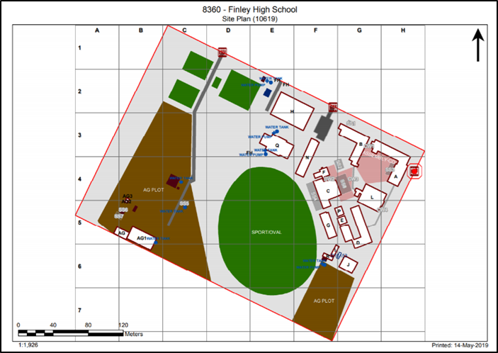
School asset map of Finley High School © State of New South Wales (Department of Education), 2020

National Geographic MapMaker Interactive
MapMaker Interactive is an educational map making tool that uses small-scale maps. It has many positive features but there are limitations on zooming and editing is complicated.
MapMaker Interactive enables users to:
- use different base maps (for example topographic, satellite, street)
- use a variety of markers and shapes. Turn on latitude and longitude lines
- add interesting layers (for example climate data, population data)
- measure distance (but not area).

Global Positioning System and Geographic Information System
Basic Global Positioning Systems (GPS) and Geographic Information Systems (GIS) are now a familiar part of life, for example using a phone or car navigation device, tracking a pizza delivery or locating a lost mobile phone.

Global Positioning System – GPS
Stage 2, Stage 3, Stage 4 and Stage 5.
GPS is a navigational system that relies on satellite signals to provide location and time information. GPS technology is integrated into mobile phones, car navigation and hand-held GPS devices. Each GPS device collects spatial data and plots it onto a base map. The digital plotting of spatial data to create visual images is a Geographic Information System (GIS).
Geocaching is an outdoor treasure hunt that requires a GPS enabled device to locate hidden items. Geocaching can provide an engaging method for undertaking geographical fieldwork, for example each geocache could contain geographical questions to answer and data to collect.
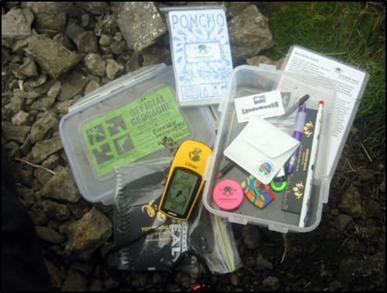
Geocache opened by Michalowic is licensed under CC BY-SA 3.0

Geographic Information System – GIS
Stage 4 and Stage 5.
A GIS stores, manages, analyses and portrays spatial data. Sophisticated GIS maps have multiple layers of information generated by computer programs.
GIS maps are a valuable tool for geographers as they:
- are a source of geographical information, for example landforms, vegetation, land use
- can be used for analysing spatial data, for example transposing mapping layers, measuring distances
- can communicate spatial data, for example plotting fieldwork data, creating a tour. The majority of virtual mapping tools listed previously have embedded GIS tools.

Remote sensing data
Stage 5.
Remote sensing includes the use of satellites, drones, aircraft and radars to collect geographical data and information remotely, for example satellite images.

Augmented reality
Stage 5.
Augmented reality (AR) is a computer-generated virtual view superimposed on a physical real world environment. Sound, video, graphics or GPS data are added to augment (supplement) the experience. Augmented reality in geography includes virtual reality videos that provide a 360 degrees viewing experience.

Virtual reality and 360 videos
Virtual reality is an immersive computer generated experience. Reasonably priced virtual reality goggles are also available, for example Google Cardboard.
The 360 videos are filmed using a 360-degree camera and provide an immersive experience for the viewer, for example Growing a World Wonder (Virtual Reality film) (duration 4:30) by Great Green Wall.

Visual Representations

Introduction to visual representations
What are visual representations?
Visual representations include picture books, diagrams, images, photographs, paintings, illustrations, symbols, models, posters, collages, cartoons, multimedia, infographics and mind maps. They are used in all steps of the geographical inquiry process.
Refer to the Tools continuum for Geography K-10 for examples of visual representations appropriate to each stage of learning. The continuum is a guide for where tools can be used and integrated into Geography K-10. There may be occasions where types of visual representations will be used that are below the stages identified, (for example a line drawing, a simple version of a field sketch) which can be completed by Stage 2 and Stage 3 students.

Photographs
Early Stage 1, Stage 1, Stage 2, Stage 3, Stage 4 and Stage 5.
Photography is an essential geographical tool utilised during fieldwork. Photographs enable the recording and labelling of observations of features of places and are a valuable tool in describing geographical characteristics.
Photographs in geography:
- record observations during fieldwork
- enable virtual access to distant places
- provide information varying from ground details to land use patterns over large areas
- can be annotated with labels and descriptions
- can be categorised and collated into annotated collages
- add a visual element to tables, flowcharts and other graphic organisers
- can be sequenced into simple slideshows with narration
- can be embedded into multimodal texts and presentations.

Historical photographs
Historical photographs can be used by students to study changes in places over time. These can be sourced from digital collections such as Trove, State Library NSW, State Records and local libraries.
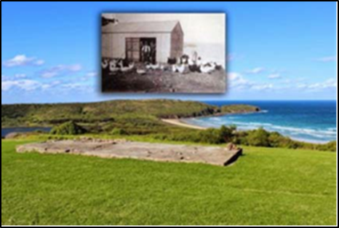
View north east over the piggery and chicken coup, Killalea State Park. Illawarra EEC (S3 Factors that change environments) © State of New South Wales (Department of Education), 2020
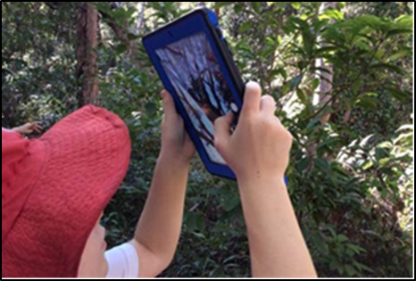
Photographs to record features of places. Botany Bay EEC © State of New South Wales (Department of Education), 2020

Illustrations
Early Stage 1, Stage 1, Stage 2, Stage 3, Stage 4 and Stage 5.
Sketches, field sketches, line drawings and photo sketches enable careful observation and interpretation of the features of places. Students record and label features and are valuable tools in describing geographical characteristics. Annotations comment on features, areas or processes. Whilst apps are available to add text to photographs taken in the field, completing a hand drawn field sketch sharpens the viewer’s observational skills.

Sketches and illustrations
Sketches are a useful tool for recording features during fieldwork. A variety of media can be used, for example 2B pencils, scratch art, watercolour pencils, collages with natural materials, sketch apps on iPads
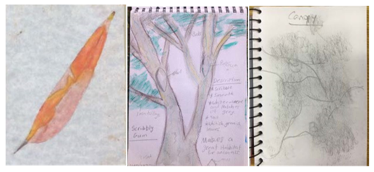
Examples of sketches and illustrations made during geography fieldwork. Field of Mars EEC and Rumbalara EEC © State of New South Wales (Department of Education), 2020

Field sketch
Stage 4 and Stage 5.
A field sketch is a labelled line drawing of an environment that records features observed during fieldwork activities. Prior to completing the field sketch, students need to be guided in identifying the purpose of the field sketch in terms of what they are aiming to show and ensuring these features are clearly depicted.
To create a field sketch, students:
- sit and study the view to be sketched
- determine landmarks that define the boundaries
- use a blank page and soft pencil to draw a frame and light guidelines that divide the page into a 3 x 3 grid. The horizontal spaces will represent the foreground, middle distance and background
- sketch in the main lines and features of their scene, starting with the horizon and main landforms
- add the other most obvious features such as rivers and roads
- add in details using simple lines
- label the main features
- add a title and date.
This field sketch procedure is adapted from GeogSpace Field sketching: Teacher notes (PDF 1 page)
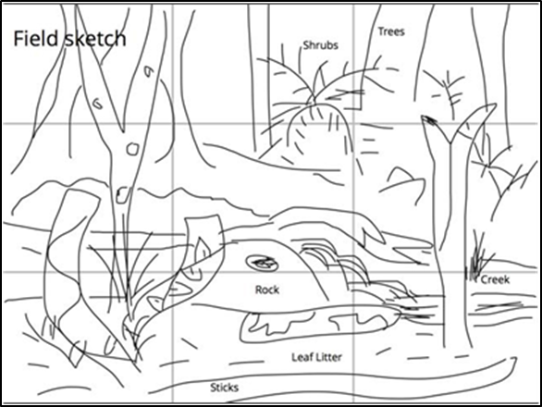
Labelled line drawing created by students on an iPad in Book Creator. Field of Mars EEC © State of New South Wales (Department of Education), 2020

Photo sketch
Stage 5.
A photo sketch is a sketch made from a photograph. The sketching process is the same as for a field sketch. Google Street View screenshots are useful for photo sketches when undertaking virtual fieldwork.
Refer to GeogSpace Photo sketching Teacher notes (PDF 1 page)
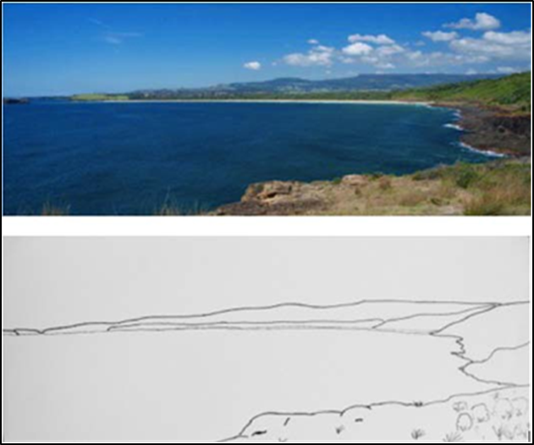
Photo sketches can highlight the features of places. View from Westringea Point, Killalea State Park looking towards Mystics Beach. Illawarra EEC © State of New South Wales (Department of Education), 2020

Graphic organisers
A graphic organiser is a visual tool that assists students to represent, organise, evaluate and analyse information in the processing step of a geographical inquiry. Stage appropriate graphic organisers are beneficial as scaffolds for students to process geographical information.
Graphic organiser templates are available on the Global Education Templates page.
Examples of graphic organisers:
- KWL charts (know, want to know/wonder, learnt)
- Consequences charts
- Development compass rose
- Diamond ranking
- Fishbone ranking
- Flow diagram
- Flow chart
- Futures wheel
- Placement proforma
- PMI chart (plus, minus, interesting)
- PNQ chart (positive, negative, question)
- T chart
- Venn diagram
- Web mat
- Y chart
- Mind map

Story books
Early Stage 1, Stage 1 and Stage 2.
Story books and picture books are a useful geographical tool for students from K-10. Story books:
- engage students in the learning
- introduce geographical concepts and contexts
- provide visual images of people and places
- use narrative to breathe life into places
- illustrate interconnections between people and places
- explore complex cultural issues
- provide a variety of perspectives.
Stage | Author | Title | Geography syllabus content
ES1 | Pat Hutchins | Rosie’s Walk | Locating places
ES1, 1 | Carson Ellis | Home | Important places, Local and global connections
ES1, 1 | Sara Fanelli | My Map Book | Locating places, How places are organised
1 | Bronwyn Bancroft and Katrina Germain | Big Rain Coming | Weather and seasons
1 | Penny Matthews and Andrew McLean | A Year on our Farm | Weather and seasons
1 | Diane Lucas and Ken Searle | Walking with Seasons in Kakadu | Weather and seasons (Aboriginal cultures)
1 | Joan Sweeney and  Annette Cable | Me on the Map | How places are organised (mapping)
1 | Mem Fox and Julie Vivas | Possum Magic | Australian places, People’s connections to places
1 | Alison Lester | Are We There Yet? | Australian places (scale), People’s connections to places
1, 2 | Lolla Stewart | Savannah Dreams | Australian places, Significance of environments
2 | Bronwyn Bancroft | Why I Love Australia | The Australian continent
2 | Glenda Millard | Mbobo Tree | Significance of environments, Perception of environments
2 | Jeannie Baker | Where the Forest Meets the Sea | Significance of environments, Perception of environments
2 | Gus Gordon` | Herman & Rosie | Similarities and differences between places (cities)
2 | Dr Seuss | The Lorax | Perception of environments
2 | Nadia Wheatley and Ken Searle | Papunya School Book of Country and History | Perception of environments (Aboriginal culture)
2 | Patricia Bernard and Tricia Oktober | The Lost Tail | Australia’s neighbours (PNG)
2, 3 | James Mollison | Where Children Sleep | Australia’s neighbours, World’s cultural diversity
2, 3 | James Mollison | Playground | Australia’s neighbours, World’s cultural diversity
2, 3 | Istan Banyai | Zoom | Concept of scale
2, 3 | Ted Lewin | Sacred River | Australia’s neighbours, World’s cultural diversity
2, 3 | Jeannie Baker | Mirror | Australia’s neighbours, World’s cultural diversity
3 | Rebecca Young and Matt Ottley | Teacup | Global connections (refugees, migration)
3 | Jeannie Baker | Window | Factors that change environments
3 | Alison Lester and Coral Tulloch | One Small Island | Humans shape places
3 | David J Smith and Shelagh Armstrong | If the World were a Village: a book about the World’s people | World’s cultural diversity

