English Standard – Staying Focused on the Module
Session 1 part three – resource booklet
Module C – The Craft of Writing

Table of contents
English Standard – Staying Focused on the Module 1
Table of contents 2
Required materials 3
Module statement – The Craft of Writing 3
Component 1 – 2019 HSC examination question 5
Resource 1 - right, let’s practise writing 5
Activity 1 – question 8 (a) let’s write 5
Activity 2 – question 8 (b) let’s write 7
Activity 3 – planning for feedback 8
Activity 4 – what makes you say that? 9
Resource 2 - stop and reflect 10
Activity 5 – types of text – personal reflection 10
Activity 6 – types of text – features 10
Activity 7 – discursive texts - similarities and differences 11
Activity 8 – goals for revision 11
Activity 9 – your turn 12
Component 2 – 2018 NESA sample examination question example a 13
Activity 10 – your turn 13
Activity 11 - need a different example? 15
Component 3 – 2018 NESA sample examination question example b 17
Creative option activity - making the figurative literal 17
Activity 12 – your turn 17
Activity 13 - need a different example? 19
Component 4 – 2018 NESA sample examination question example C 21
Activity 14 – your turn 21
Activity 15 – need a different example? 22

Required materials
Please ensure that you have:
- this resource in a soft or hard copy
- access to the 2019 examination paper and the specimen paper NESA website for English Standard Stage 6 syllabus

Module statement – The Craft of Writing
In this module, students strengthen and extend their knowledge, skills and confidence as writers. They write for a range of authentic audiences and purposes to convey ideas with power and increasing precision.
Students appreciate, examine and analyse at least two challenging short prescribed texts as well as texts from their own wide reading, as models and stimulus for the development of their own ideas and written expression. They examine how writers of complex texts use language creatively and imaginatively for a range of purposes, to describe the world around them, evoke emotion, shape a perspective or to share a vision.
Through the study of texts drawn from enduring, quality texts of the past as well as from recognised contemporary works, students appreciate, analyse and assess the importance and power of language. Through a considered appraisal of, and imaginative engagement with these texts, students reflect on the complex and recursive process of writing to further develop their ability to apply their knowledge of textual forms and features in their own sustained and cohesive compositions.
During the pre-writing stage, students generate and explore ideas through discussion and speculations. Throughout the stages of drafting and revising, students experiment with a range of language forms and features for example imagery, rhetoric, voice, characterisation, point of view, dialogue and tone. Students consider purpose and audience to carefully shape meaning. During the editing stages students apply the conventions of syntax, spelling, punctuation and grammar appropriately and effectively for publication.
Students have opportunities to work independently and collaboratively to reflect, refine and strengthen their own skills in producing crafted, imaginative, discursive, persuasive and informative texts.
Note: Students may revisit prescribed texts from other modules to enhance their experiences of quality writing.
English Standard Stage 6 Syllabus (2017) © NSW Education Standards Authority (NESA) for and on behalf of the Crown in right of the State of New South Wales, 2017.

Component 1 – 2019 HSC examination question
These activity relate to the video for English – Standard​ staying focused on the module - part 3 – component 1​.

Resource 1 - right, let’s practise writing
The following resources are designed to help you practise writing at home. Some may already be familiar to you while others might be brand new. The intention with these resources is that you are practising writing under examination conditions.

Activity 1 – question 8 (a) let’s write
Potential ideas:
- Imaginative – character reflecting on the changing nature of communication and the disconnect they feel with their peers… ends with a metaphorical reflection on the desire to show the messy, uneven, brightly coloured but far from perfect side of life free from the expectation of projecting airbrushed and filtered perfection…
- Discursive – a reflection about the unexpected role of place in shaping and reshaping identity/values/desires during a time of limited freedom, the piece ends with the valuing of the spaces that initially seemed insignificant and potentially avoided because of how they are perceived or portrayed…
- Imaginative – two characters find their way back, return, to an apartment building where they used to live and are transformed into the mural on the wall… as punishment… or a sign of eternal something … maybe love…
- Discursive – a character contemplates the presence and absence of youth voice in writing and uses the comparison of classical art and street art as a motif…
- Imaginative – dystopian piece that ends with the image as a portal, open ending…
- Discursive – exploring the notion of choice in life and the way this choice can lead to two very different outcomes… the art as a reflection on this at the end, same wall, same tools but very different outcomes…what was different for each artist?

2 minutes - my plan
In the space below identify the connection to your study of Module C, the type of text you will be writing, identify your form, audience, purpose and context. Then, begin drafting a response. Give yourself a couple of minutes to plan and 24 minutes to write.
Connection to Module C:
Type of text:
Form:
Audience:
Purpose:
Context:

24 minutes - my response
8 (a)
Create a piece of imaginative, discursive or persuasive writing that ENDS with the provided image.
12 marks
(Insert extra pages if you are using this as a hard copy)

Activity 2 – question 8 (b) let’s write
8 (b)
Explain how your study of the craft of writing has enabled you to create an engaging piece of writing. In your response, make detailed reference to your use of language in part (a).
8 marks

16 minutes – my response
(Insert extra pages if you are using this as a hard copy)

Activity 3 – planning for feedback
It’s important you give yourself a break between writing your response and engaging in self-reflection. This helps you see your response with objective eyes, you’re more likely to be able to identify its strengths and areas for improvement.
If you have not engaged in any reading about editing your own work it is worth completing some research. The article title ‘How to Self-Edit: 10 Tips for Editing Your Own Writing’ by MasterClass (search this title in a search engine and the article will come up), or copy and paste this link into the search engine: www.masterclass.com/articles/tips-for-editing-your-own-writing#10-tips-for-editing-your-own-writing.
You may find it useful to also complete the following:
- Re-read the HSC marker feedback and annotate your own work with this information in mind.
- Mark your own work using the NESA marking criteria. Make sure you use the criteria on pages 3 and 4.
- Discuss your response with a peer and talk through your plans and desired outcome, this may help you reflect on where you achieved these plans and where you could improve the next time round.
- Ask a peer to mark or grade your work and provide you feedback using the criteria. Reflect on their grade and comment and implement the feedback next time you write.
- Submit your response to your teacher for feedback, ensure you discuss with them the feedback you receive particularly if there is anything you do not understand. Implement the feedback they provide.
- Remember that this is a first draft, markers do not expect this piece to be flawless, come in prepared and do the best you can do but remember this is marked as a first draft.

Feedback plans
Outline the feedback you received and your implementation plans.
Feedback –

Implementation plans –

Activity 4 – what makes you say that?
Now that you have engaged in self, peer and or teacher feedback and reflection, it is a good idea to revisit your Module C assessment response and feedback. This is an opportunity to acknowledge your own improvement and continue refining your writing.
- What’s the key difference between your assessment and your latest response?

- What do you see that makes you say that?

- What would you like to improve upon or experiment with next and why?

Resource 2 - stop and reflect

Activity 5 – types of text – personal reflection
How confident are you when writing in each of the four types of texts? Tick the most appropriate column in this table for how you feel right now. Then, identify a writing goal.
Table 1 – levels of confidence about the four types of text
Type of text | Very confident | A little confident | So-so | A little worried | Very worried
Imaginative
Persuasive
Discursive
Reflective
Goal:

Activity 6 – types of text – features
In the table below, identify at least two key features for each type of text. Remember that these features can be flexible and that good writing often uses features from a range of types of text. It’s important to think about your purpose when you are deciding what type of text you’d like to utilise. Purpose has a direct impact on the form of your response and the features you are likely to utilise.
Table 2 – Notes on the types of texts
Type of text | Feature one | Feature two
Persuasive
Imaginative
Discursive
Reflective

Activity 7 – discursive texts - similarities and differences
Table 3 – similarities and differences between discursive and other types of text
Similar to the other types of text | Different from the other types
Structure
Purpose
Language

Activity 8 – goals for revision
Now you have self-reflected, outline 2-3 goals for a revision session. These should outline what types of texts you need to revise and how you will complete this task.
Sample goal: create a clear thesis statement at the start of my reflection that closely links to the purpose of my writing and the feature I used.
Goal 1:
Goal 2:
Goal 3:

Activity 9 – your turn
Set yourself up in a quiet space, examine the 2019 Standard Module C HSC examination question, one your teacher has provided you or one you have created yourself. Then, practise writing a response within timed (examination style) conditions. Give yourself a couple of minutes planning time and then write within the designated period.
Each time you complete this task you will get a little bit better and feel a little more confident.
(Insert extra pages if you are using this as a hard copy)

My plan
In the space below identify the connection to your study of Module C, the type of text you will be writing, identify your form, audience, purpose and context. Then, begin drafting a response. Give yourself a couple of minutes to plan and set yourself a specific time in which to write. Remember, you won’t have time to write this level of detail for your plan within the real examination, this is designed to help you practise focusing on these elements during this revision stage.
Connection to Module C:
Type of text:
Form:
Audience:
Purpose:
Context:

My response
Part a
(Insert extra pages if you are using this as a hard copy)

Part b
(Insert extra pages if you are using this as a hard copy)

Component 2 – 2018 NESA sample examination question example a
These activity relate to the video for English – Standard ​staying focused on the module - part 3 – component 2​.

Activity 10 – your turn
Set yourself up in a quiet space. Examine the NESA Standard Module C HSC specimen examination paper and Example A, one your teacher has provided you or one you have created yourself. Practise writing a response within timed (examination style) conditions. Give yourself a couple of minutes planning time and then write within the designated period.

My plan
In the space below identify the connection to your study of Module C, the type of text you will be writing, identify your form, audience, purpose and context. Then, begin drafting a response. Give yourself a couple of minutes to plan and set yourself a specific time in which to write. Remember, you won’t have time to write this level of detail for your plan within the real examination, this is designed to help you practise focusing on these elements during this revision stage.
Connection to Module C:
Type of text:
Form:
Changed mood or atmosphere:
Surprising or unexpected event:
Your focus language or stylistic device:
Audience:
Purpose:
Context:

My response
Part a
(Insert extra pages if you are using this as a hard copy)

Part b
(Insert extra pages if you are using this as a hard copy)

Activity 11 - need a different example?
To assist your writing we have provided you with three extra sample questions. They are similar in structure to the NESA example questions. This is the first sample question.

Sample 1
I am a collector of abandoned shopping carts.
Skyscrapers made of mirrors glare brilliant orange, a trick of blindness, and I creep to a stop at every intersection. I can only intuit the change in traffic lights. Thankfully, the city center lies still. The solitude bleeds into my body and instead of feeling lonely, a bubble of singleton glee swells inside my chest. My shopping carts cling, clang, clatter inside my van and the music of metal on metal is an urban orchestral production. I raise my right hand high to conduct a pothole crescendo.
This weekend is a long one, and the business shuffle turned into a mass exodus for the markets. Instead of bidding for pipes, steel cables, real estate, and crude oil, human suits are clamouring in long lineups…
Hiromi Goto
‘The Kappa Child’
(a) Describe how the writer creates a mood or atmosphere in this text. In your response make reference to at least one language device or stylistic feature.
5 marks
(b) Write the next part of the narrative where the mood or atmosphere in the text is changed because of a surprising or unexpected event.
15 marks

My plan
Connection to Module C:
Type of text:
Form:
Changed mood or atmosphere:
Surprising or unexpected event:
Your focus language or stylistic device:
Audience:
Purpose:
Context:

My response
Part a
(Insert extra pages if you are using this as a hard copy)

Part b
(Insert extra pages if you are using this as a hard copy)

Component 3 – 2018 NESA sample examination question example b
These activities relate to the video for English – Standard ​staying focused on the module - part 3 – component 3​.

Creative option activity - making the figurative literal
- Select a piece of writing you know contains a lot of figurative language.
- Turn all the figurative language into its literal counterpart.
- Share you’re the extract you chose and the re-write of the piece with a friend and discuss the figurative language you liked the most in the original and what the piece loses because this is removed.

You should begin to see many of the exciting, emotive and evocative aspects of the text stripped away.
That’s not to say literal language isn’t important, it most definitely is. Figurative language, those words or phrases that are used in a way that differs from the expected or everyday usage are used to create a specific effect and draw you into experiences and ideas of a text in a particular way.

Activity 12 – your turn
Set yourself up in a quiet space. Examine the NESA Standard Module C HSC specimen examination paper and Example B, one your teacher has provided you or one you have created yourself. Practise writing a response within timed (examination style) conditions. Give yourself a couple of minutes planning time and then write within the designated period.

Brainstorm:

My plan
Connection to what you have learnt about figurative language from texts in Module C:
Type of text:
Form:
Role of the stimulus in the opening of your piece:
Your figurative language focus:
Audience:
Purpose:
Context:

My response
Part a
(Insert extra pages if you are using this as a hard copy)

Part b
(Insert extra pages if you are using this as a hard copy)

Activity 13 - need a different example?
To assist your writing we have provided you with three extra sample questions. This is the second sample.

Sample 2
“There is a crack in everything. That’s how the light gets in.”
Leonard Cohen, 'Anthem'
or
“You can’t say it, but you know it’s true.”
Barack Obama
(a) Use one of the lines above as a stimulus for the opening of an imaginative, discursive or persuasive piece of writing. In your piece of writing incorporate at least one example of figurative language that you have learned about through your study of the prescribed texts for Module C.
12 marks
(b) Explain how your writing in part (a) was influenced by what you have learnt about figurative language through the study of your prescribed texts for Module C.
8 marks

My plan
Connection to what you have learnt about figurative language from texts in Module C:
Type of text:
Form:
Role of the stimulus in the opening of your piece:
Your figurative language focus:
Audience:
Purpose:
Context:

My response
Part a
(Insert extra pages if you are using this as a hard copy)

Part b
(Insert extra pages if you are using this as a hard copy)

Component 4 – 2018 NESA sample examination question example C
These activities relate to the video for English – Standard ​staying focused on the module – part 3 – component 4​.

Activity 14 – your turn
Set yourself up in a quiet space. Examine the NESA Standard Module C HSC specimen examination paper and Example C, one your teacher has provided you or one you have created yourself. Practise writing a response within timed (examination style) conditions. Give yourself a couple of minutes planning time and then write within the designated period.

My plan
Type of text:
Form:
Character’s response to entering this unfamiliar setting for the first time:
Your figurative language focus:
Focus devices to evoke character’s response:
Audience:
Purpose:
Context:

My response
Part a
(Insert extra pages if you are using this as a hard copy)

Part b
(Insert extra pages if you are using this as a hard copy)

Activity 15 – need a different example?
This is the final sample question.

Sample 3
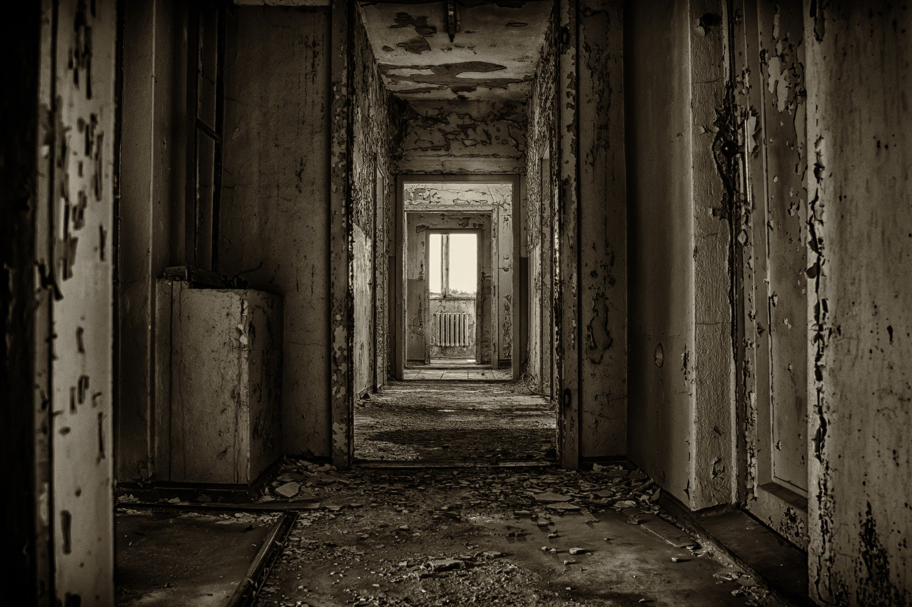
Figure 1 – Image by Peter H is licensed under CC0. The original version can be found on Pixabay
(a) Use the image to write creatively about a character’s response to entering this familiar setting for the last time.
10 marks
(b) Assess how effectively you evoked your character’s response to this experience, making detailed reference to your use of a range of language devices and stylistic features.
10 marks

My plan
Type of text:
Form:
Character’s response to entering this familiar setting for the last time:
Your figurative language focus:
Focus devices to evoke character’s response:
Audience:
Purpose:
Context:

My response
Part a
(Insert extra pages if you are using this as a hard copy)

Part b
(Insert extra pages if you are using this as a hard copy)

