HSC hub English Bites
Student resource to support preparation for the HSC – English Advanced, Standard and Studies – Common Module, Texts and Human Experiences. This graphic organiser activity will support students’ analysis of their prescribed text.

Common Module – human experience graphic organiser
On the first two pages you will find advice about why this resource will be useful to you and suggestions about how to use this resource.

Table of contents
HSC hub English Bites 1
Common Module – human experience graphic organiser 1
Table of contents 1
Instructions for students using this resource independently 2
How will the activities in this resource help you do well in this module? 2
Connecting to the examination 3
Analysing the prescribed text – graphic organiser 3
Activity unpacked 4
Practice examination response 5
Appendix 1 6

Instructions for students using this resource independently
- Revision is best done a little at a time and often; the activity below, for one human experience, is designed to be done in approximately 15-20 minutes. You can then do a different one, at a different time, for another human experience.
- This graphic organiser activity is an effective way to organise your ideas and information for each human experience you identify in your prescribed text. They can then be used as revision notes in preparation for writing practice responses, particularly in the lead up to the HSC examination.
- Revision also works well if it is collaborative; share your ideas with your teacher or a trusted friend and give positive, practical and encouraging feedback.

How will the activities in this resource help you do well in this module?
The activities in this resource are designed to support these points from the Common Module description in the English Advanced, Standard and Studies syllabus.
Students:
- deepen their understanding of how texts represent individual and collective human experiences
- examine how texts represent human qualities and emotions associated with, or arising from, these experiences
- explore how texts may give insight into the anomalies, paradoxes and inconsistencies in human behaviour and motivations, inviting the responder to see the world differently, to challenge assumptions, ignite new ideas or reflect personally
- further develop skills and confidence using various literary devices, language concepts, modes and media to formulate a considered response to texts
- make increasingly informed judgements about how aspects of these texts, for example context, purpose, structure, stylistic and grammatical features, and form shape meaning
- further develop a repertoire of skills in comprehending, interpreting and analysing complex texts
- communicate ideas using evaluative language to make informed judgements about texts.
NSW Syllabus for the Australian curriculum English Advanced Stage 6 Syllabus © NSW Education Standards Authority (NESA) for and on behalf of the Crown in right of the State of New South Wales, 2017. See the NESA website for additional copyright information.
It’s important to always visit the NESA website specific to your course even though this is a common section. See statements on the NESA website for your course:
- Advanced syllabus module
- Standard syllabus module
- Studies syllabus module

Connecting to the examination
The activities in this resource will help you develop the knowledge and understanding required to answer questions in the examination for the Common Module. A thorough and detailed bank of ideas, evidence and evaluation that can be adapted to suit questions such as this one from the NESA sample examination will help you become much better prepared.
Example C (20 marks)
Through the telling and receiving of stories, we become more aware of ourselves and our shared human experiences.
Explore this statement with close reference to your prescribed text.
Sample questions HSC Examination English Advanced Paper 1 © NSW Education Standards Authority (NESA) for and on behalf of the Crown in right of the State of New South Wales, 2019.
- Sample Questions New HSC English Advanced Paper 1 (PDF 1MB)
- Sample Questions New HSC English Standard Paper 1 (PDF 440KB)
- Sample Questions New HSC English Studies exam (PDF 731KB)

Analysing the prescribed text – graphic organiser
Utilise the graphic organiser to develop a bank of ideas, textual and contextual evidence and personal analysis of the text’s form, features, structures and devices. Engaging in a structured analysis of the composer’s representations within the text, their contextual basis and the impact on you as a responder will help you develop an informed personal response to your prescribed text.

Activity unpacked
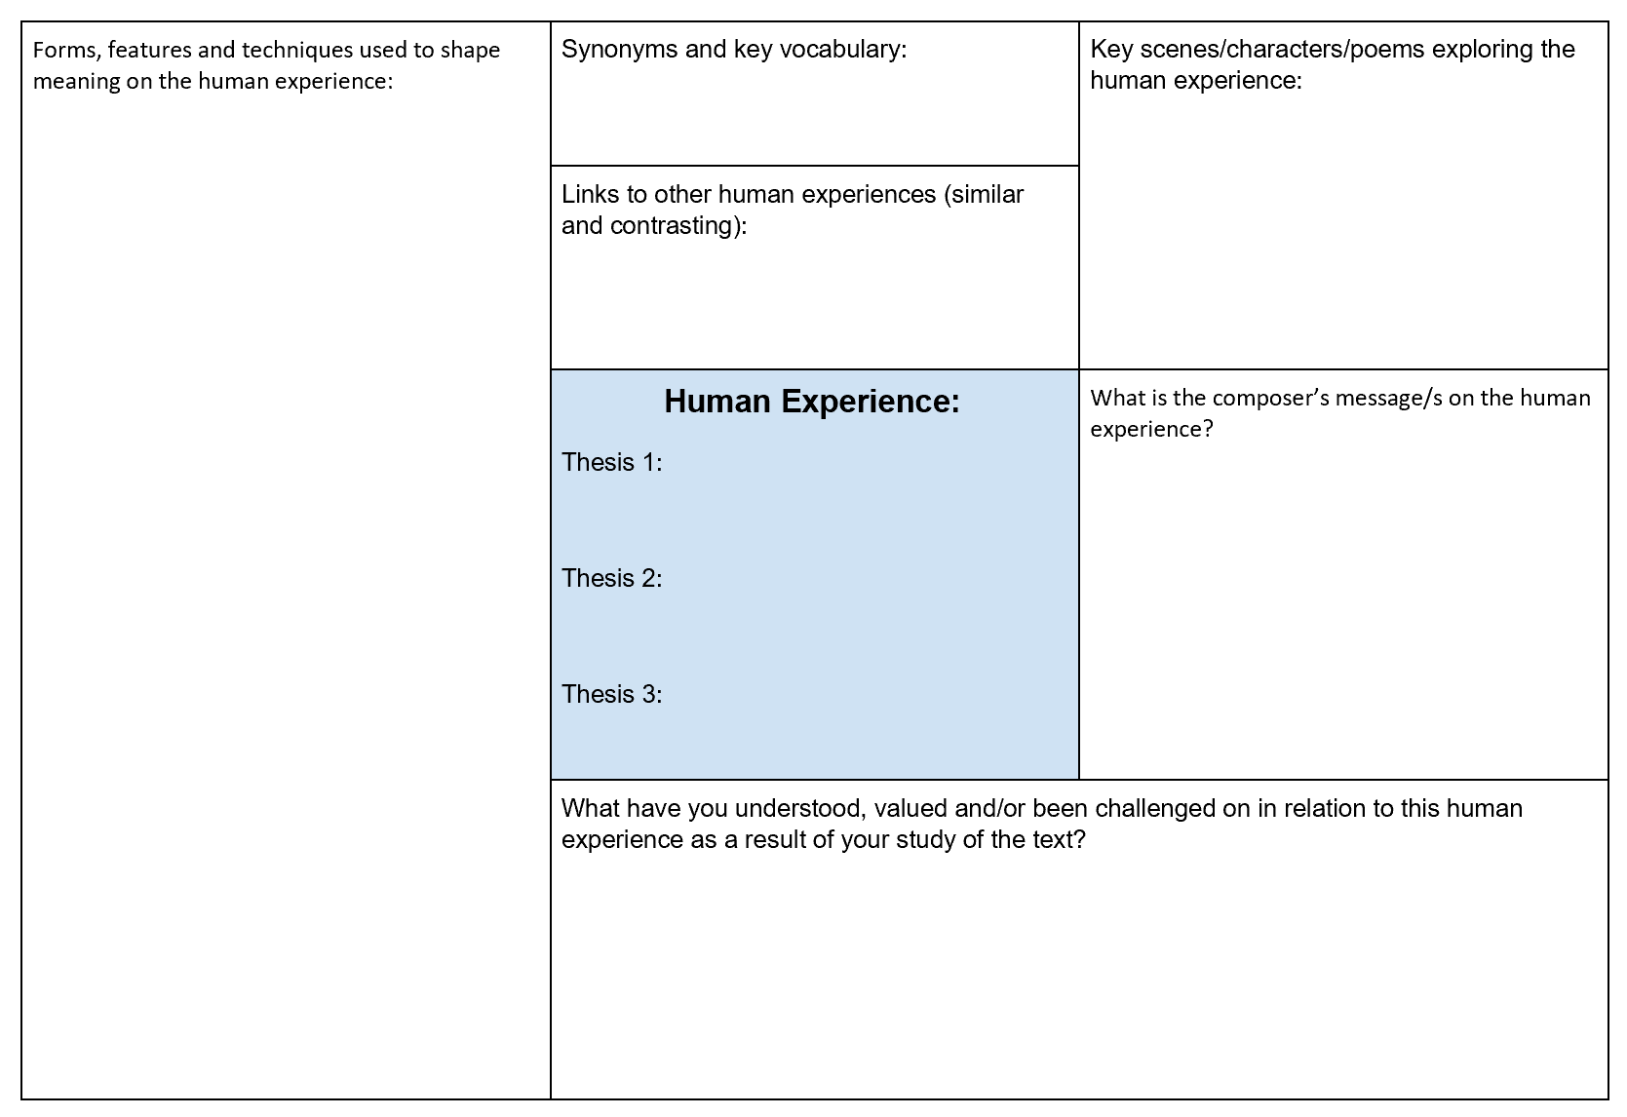

Identify key human experiences in your prescribed text. For example:
- guilt
- loneliness
- grief
- hope
- love.
For each human experience, use your classwork, notes and assessment task, to fill in the graphic organiser (shown above). You can use the Microsoft Word graphic organiser or the Google Docs graphic organiser version. This is also supplied in a table format in Appendix 1 below.
Suggested sequence:
- Identify the human experience in the centre square.
- Identify the key scenes, characters and/or poems (depending on your text’s form) that explore aspects of the human experience.
- What is the composer commenting on? What are they saying about the human experience through the text?
- Fill in the left-hand column with examples of how the human experience is explored through the text – language forms and features, techniques and give an example/s. Aim to have a range of features. These should be linked to the scenes, characters and/or poems identified in Step 2 and the ideas identified in Step 3.
- Add synonyms and related vocabulary in the upper middle section. It is important that you can identify and use a range of words when exploring the concept in your responses. For example, what other words link with grief: mourn, loss, sorrow and anguish?
- What are some of the related concepts/experiences? It is important that you can see the links between different experiences being explored. Those links can be for related experiences but also contradictory experiences.
- Fill in the bottom middle section – what the responder (you and others) learns from the author’s exploration of the concept in the text. This step is critical to developing your own critical personal response.
- Return to the centre square and write three thesis statements that reflect your valuing of the human experience in the prescribed text.

Practice examination response
Now you have practised developing a bank of ideas, evidence and evaluation use this information and write a response to NESA Example C above. You may wish to write under timed conditions. Or, create your own version of this sample examination question and write a response to that instead. Swap your response with a peer and provide each other feedback, pay particular attention to the connection between your thesis statement and the requirements of the question:
- Are they clearly connected?
- Do you link back to the question within your evaluation?

Appendix 1
Table 1 – thesis 1 – planning and unpacking the exploration of human experiences
Requirement | Idea, evidence, vocabulary, connection to other experiences
Human Experience:
Thesis 1:

What is the composer’s message/s on the human experience?

What have you understood, valued and/or been challenged in relation to this human experience as a result of your study of the text?

Key scenes/characters/poems exploring the human experience:

Synonyms and key vocabulary:

Forms, features and devices (techniques) used to shape meaning on the human experience:

Links to other human experiences (similar and contrasting):

Table 2 – thesis 2 – planning and unpacking the exploration of human experiences
Requirement | Idea, evidence, vocabulary, connection to other experiences
Human Experience:
Thesis 2:

What is the composer’s message/s on the human experience?

What have you understood, valued and/or been challenged in relation to this human experience as a result of your study of the text?

Key scenes/characters/poems exploring the human experience:

Synonyms and key vocabulary:

Forms, features and devices (techniques) used to shape meaning on the human experience:

Links to other human experiences (similar and contrasting):

Table 3 – thesis 3 – planning and unpacking the exploration of human experiences
Requirement | Idea, evidence, vocabulary, connection to other experiences
Human Experience:
Thesis 3:

What is the composer’s message/s on the human experience?

What have you understood, valued and/or been challenged in relation to this human experience as a result of your study of the text?

Key scenes/characters/poems exploring the human experience:

Synonyms and key vocabulary:

Forms, features and devices (techniques) used to shape meaning on the human experience:

Links to other human experiences (similar and contrasting):

