English Stage 4 – film study, ‘Finding Nemo’

Focus on character

Considerations for programming for learning from home
This sample learning sequence may function as either a unit starter or a sequence within a larger unit of work on genre or film. It can also be used within an entire unit of work exploring the English Textual Concept of character through a variety of texts. The learning sequence reflects the language of the MS Teams platform the focused learning management system (LMS), however this could easily be applied to other online learning management systems (LMS), or to an offline delivery (eg through resources and worksheets sent home with students). The activities use a blended approach and contain synchronous activities that could easily become asynchronous. Resources are provided at the end of the document or as live links within the teaching and learning activities. Submission of material at key checkpoints is via posts, collaboration in central documents, or submitting documents via assignments in MS Teams and sharing video and voice recordings via platforms such as Flipgrid (see below).
The teaching and learning activities provide a starting point and should be adjusted depending on the class context. All activities link to freely accessible web content or connect to specific free technology to help engage students in this new learning environment. Students can access the technologies listed either via links provided by the teacher (eg flipgrid and short films) or via free applications (such as Word, Powerpoint or Forms) within the Office 365 suite.
Table 1: Guiding questions for establishing learning expectations and communication processes
Guiding question | The structure of teaching and learning activities
What are your students going to learn?  Outcomes and concept | Content from outcomes EN4-3B and EN4-7D has guided this learning sequence:  EN4-3B Engage personally with texts.  - engage with the language and structures of texts in meaningful, contextualised and authentic ways.  - identify, discuss and reflect on the ideas and information in a range of texts.  EN4-7D Engage personally with texts.  - draw on experience to consider the ways the 'real world' is represented in the imaginary worlds of texts, including imaginative literature, film, media and multimedia texts.  Content linked to English textual concept: character.  Understand and apply knowledge of language forms and features:  - S408UA7: understand and explain how combinations of words and images in texts are used to represent particular groups in society, and how texts position readers in relation to those groups.  Respond to and compose texts:  - S401RC05: recognise and analyse the ways that characterisation, events and settings are combined in narratives, and discuss the purposes and appeal of different approaches.  - S405RC12: critically analyse the ways experience, knowledge, values and perspectives can be represented through characters, situations and concerns in texts and how these affect responses to texts.
How are they going to learn it?  Resources and strategies | This learning sequence involves:  - The viewing of a set film text (Finding Nemo).  - Visible thinking routines aimed at sparking and capturing student thinking.  - Visual representations of character.  - The ‘mapping’ of narrative structure with visuals from the set film.  - Writing an extended response which demonstrates learning about the purposes and effects of characterisation.
Lesson sequence timing | This resource contains approximately one week of work, equivalent to four learning blocks of approximately one hour each.
Collecting evidence of student learning  Verification | Student learning will be collected via:  - Online: student posts of worksheets, discussion posts and extended writing on the class learning management system.  - Offline: student work in notebooks which can be physically sent to teacher or handed when they are in the classroom at school with their teacher.
Feedback | The teacher will provide feedback:  - Formative: comments on visual representations, thinking routine posts and mapping activities.  - Summative: marking guidelines for extended written response.
Communication | Content and uploading of material for this learning sequence can be done via Google classroom or MS Teams classroom.  The learning management system will need to accommodate:  - Teacher sharing content documents and live links to external content.  - Students uploading set work.  - Students giving feedback and teacher providing formative assessment.

Lesson sequence – Film study: Finding Nemo
Student guided inquiry into characterisation in a Stage 4 film text
Table 2: Learning and teaching sequence
Lesson sequence and syllabus outcomes | Learning and teaching activities | Evidence of learning – synchronous, asynchronous and workbook
What are your students going to learn? | Learning intention and success criteria  Students will:  - Describe the key aspects of the director’s characterisation.  - Apply their understanding to the ways in which the director has constructed the characters and organised the narrative.  This will be demonstrated through:  - Evaluation of the relationships between characterization, setting and narrative/events.
How are they going to learn it? (Resources and Strategies) | Resources:  Links are embedded within the teaching sequence.  Strategies utilised in learning sequence below:  - Harvard thinking routines posted to class learning management system.  - Hard copy or digital visual representations.  - Extended written response.
Lesson sequence 1:  Development of a character mind-map  engage with the language and structures of texts in meaningful, contextualised and authentic ways EN4-3B  identify, discuss and reflect on the ideas and information in a range of texts EN4-3B | Engaging personally and experimenting: students respond to the set film then create a visual representation.  Students have seen the film and perhaps completed initial post-viewing activities such as journaling their personal responses or class discussions on initial responses such as their ‘favourite character’ or ‘favourite scene’.  In this lesson  - The teacher initiates a Teams call. The teacher starts with a version of the Harvard thinking routine ; “I used to think… Now I think…” specifically focused on the students’ conceptions of the main characters. Students should be encouraged to think about how their first impressions of a character changed either DURING the film or during the post-viewing activities above.  - Students use OneNote to develop a visual representation of one main character. They must include:  - appearance  - personality  - key line of dialogue  - key scene  - a phrase to describe relationship to each of the other main characters  - a statement about how the director wants the audience to feel about this character (with supporting textual detail).  Various free online tools have the capability for students to create visual representations:  Google slides – teacher help centre here  Microsoft PowerPoint  Bubbl.us help here  Sign in to padlet using DoE username and password.  - Visual representations are shared digitally. | Online: use ‘chat’ function to record personal responses  Students post routine charts. Live online discussion focused on students’ reasons for choices.  For offline workbooks students paste in routine chart  Encourage personal responses to visual representations using comments or digital post-it notes. Students should post one piece of positive feedback and one piece of additional information to each visual representation.
Lesson sequence 2:  Exploration of director’s intent with characterisation and narrative/setting  S408UA7: understand and explain how combinations of words and images in texts are used to represent particular groups in society, and how texts position readers in relation to those groups (ACELT1628)  S401RC05: recognise and analyse the ways that characterisation, events and settings are combined in narratives, and discuss the purposes and appeal of different approaches (ACELT1622) | Engaging critically: higher order thinking activities to stretch student thinking – check in point.  - Students are given a set of stills (see Resource 1) via the learning management system or hard copies from school. They then:  - Cut out and order the stills chronologically on a larger sheet of paper or paste into a PowerPoint template.  - Write a caption for each which describes what is happening to the characters, where it is taking place and how it relates to the developing narrative.  - Students post ONE complete slide and caption to the learning management system where the teacher (explicit instruction) checks key terminology: setting and narrative structure including orientation, complication and so on.  - The teacher then sets up a Harvard Visible Thinking routine such as ‘Think, Puzzle, Explore’ to encourage deeper inquiry: (see Resource 2) What happens to characters during a story? Why are different settings important (to different characters)? What is the relationship between character and ‘event’?  - Students will then complete the thinking routine sheets, which should be posted to the Learning management system on sharepoint.  - Using a chat function in teams, students then work in pairs to:  - ‘Map’ the narrative structure under their stuck-on stills: orientation, complication and resolution.  - Label what is happening to each character at the different stages of the story.  - Include a caption about why the setting might be important at that moment.  - Perhaps create a ‘tension chart’ under the narrative structure - this plots (similarly to a temperature chart) the tension at each point in the narrative. | Students create a PowerPoint slideshow of images and post the first slide to the learning management system.  Students upload their Think/Puzzle/Explore charts to the learning management system.  The teacher may use a platform such as zoom which allows for multiple break-out rooms so that students can complete this online.  Students can also complete this individually using PowerPoint or MS Stream and then post or upload or email to the teacher.
Lesson sequence 3  Evaluation and development of personal response  S405RC12: critically analyse the ways experience, knowledge, values and perspectives can be represented through characters, situations and concerns in texts and how these affect responses to texts  draw on experience to consider the ways the 'real world' is represented in the imaginary worlds of texts, including imaginative literature, film, media and multimedia texts EN4-7D | Understanding, connecting or engaging personally: students examine set material and connect new learning to prior learning.  While there is an existing sequel to this film, this final task requires students to imagine/ re-imagine a sequel (or perhaps a sequel to the sequel!). To apply learning from this sequence students might:  - Write a pitch for a sequel. They must discuss how they – as the director – will show the development of the characters through the next stage of their lives.  - As part of the above (or as planning) develop an ‘Impacts Table’. What effect do you as the director want to have on the audience? How will you use character and ‘event’ to achieve this impact?  - As an alternative: write an extended response to a question such as ‘Finding Nemo successfully shows us that parents need to let their children experience more freedom’.  - A hypothetical, either as class debate or written response: how could you make a film with the same effect and intention as a live action film? | Students complete extended response and upload to learning management system.  For differentiation, the teacher might send out/provide online a scaffold for this writing task.
Where to next? | Subsequent lessons or sequences may explore:  - Other aspects of the film such as theme.  - The craft of the director: the use of close ups and long shots throughout to heighten tension or reflect on character emotions, for example.  - A comparison of this text to one chosen by students, especially a more recent film text which could be used to explore changing representations of character.

Resource 1: film stills from Finding Nemo
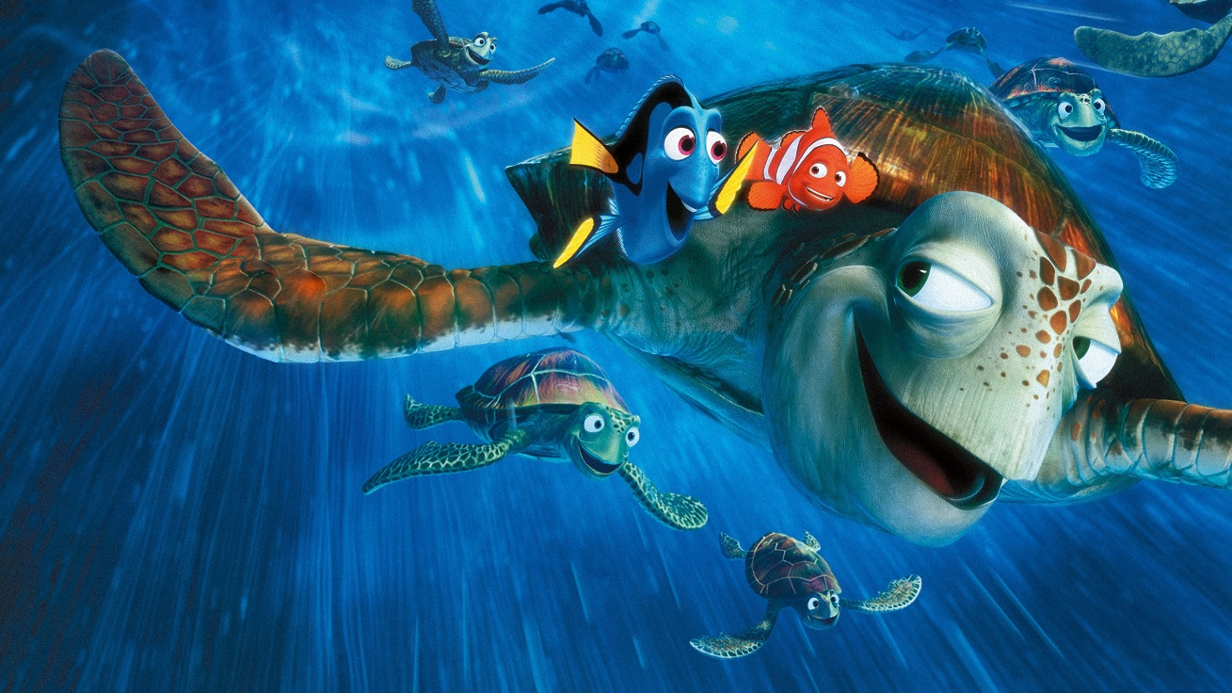
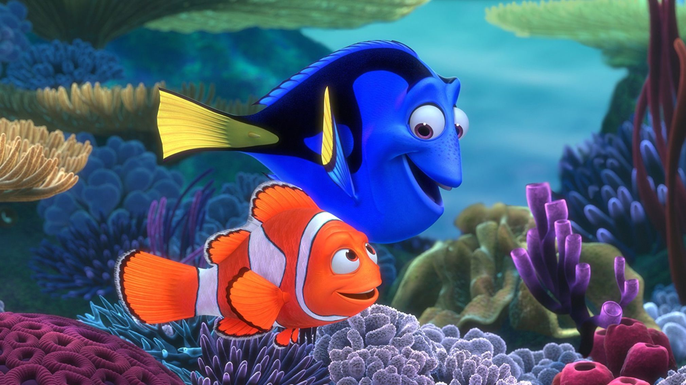
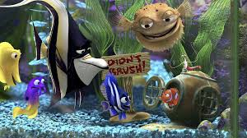
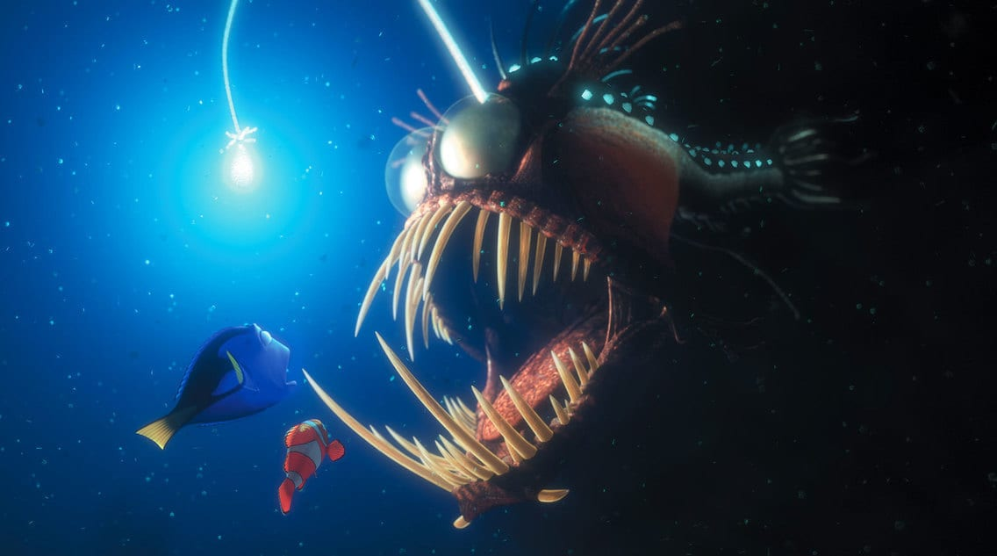
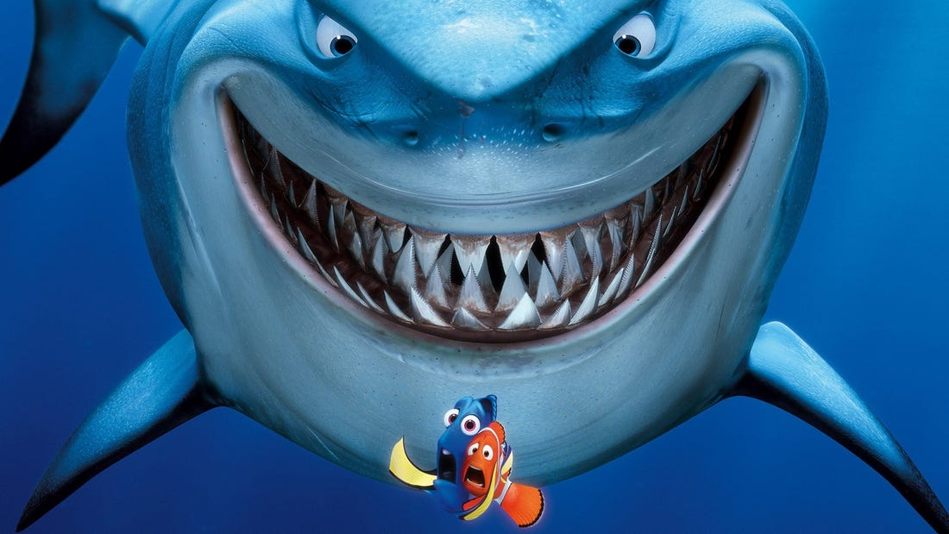
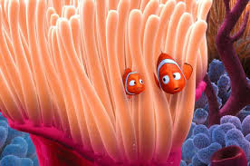
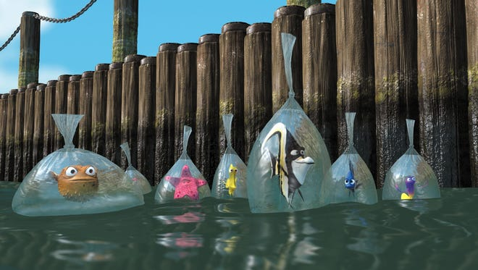

Resource 2 – Think, puzzle, explore

Mapping characters in this film
Characters in the film | What happens to characters during this film | Why are different settings important (to these characters? | What is the relationship between character and ‘event’?
Nemo
Dory
Marlin
Bruce
Crush
Add more rows if you’d like to include more characters

