On the Road – resource 9

Section 1 – plan your overseas trip
- Using a laptop, pick your destination:

- New York, USA
- Cairo, Egypt
- Rio de Janeiro, Brazil
- Beijing, China
- Suva, Fiji
- Paris, France
- Cancun, Mexico
- Tokyo, Japan
- Nairobi, Kenya
- Lima, Peru
- London, England
- Rome, Italy
- Bangkok, Thailand
- Reykjavik, Iceland
- Somewhere else?

Destination:
- What is the cheapest deal you can find to lesson your expenses?

Airline:
Date/time of arrival:
Ticket price:
Departure:

Accommodation: Cost for 7 days:
How is this accommodation rated? (Use websites such as Hotels, Tripadvisor, Trivago, and so on.)

How far is it from the airport?
How will you get from one to the other? Cost?

Is there a tour/travel deal available? Cost?

- Create a fact sheet for your destination.
Feature | Information
Country
Capital city
Two other major cities
Population
Languages spoken
Main religions
Food
Main form of transport
Local customs (manners, rules, traditions)
Famous places of interests or festivals
Possible issues
- Safety
Check how safe your destination is on SmartTraveller.
How safe is it?
Why/why not?

Check the website’s insurance section and describe why you should get travel insurance.

What medical precautions do you need to take for your destination?

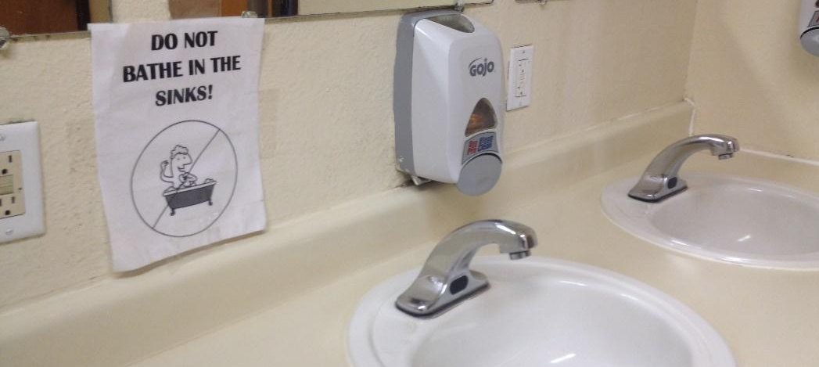
- Travel itinerary
What will you do in your 7 days of travelling? Research and plan out your trip, including tours, venues, times, monuments, events, and so on.
Days | Itinerary
Day 1 | Arrival time:
Day 2
Day 3
Day 4
Day 5
Day 6
Day 7 | Departure time:
- Keep your friends and family updated!
Using the example (Resource 4-2) as a guide, write three posts that you could put on Facebook about your travels. Tell your friends and family what you have been doing, be creative and descriptive, and link it to your itinerary.
Post 1

Post 2

Post 3

