On the Road – resource 29

Analysing shots from the film
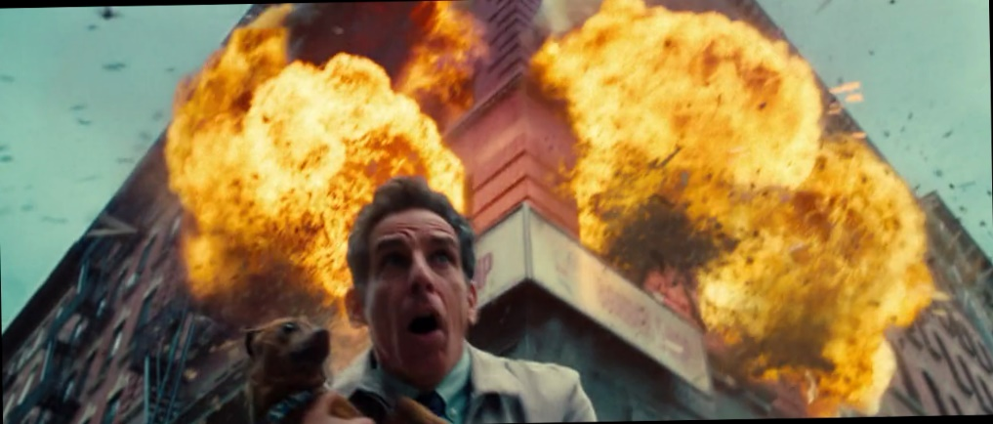
Think about:
- Angle of camera
- How realistic the shot is
- What the shot establishes about who Walter wants to be
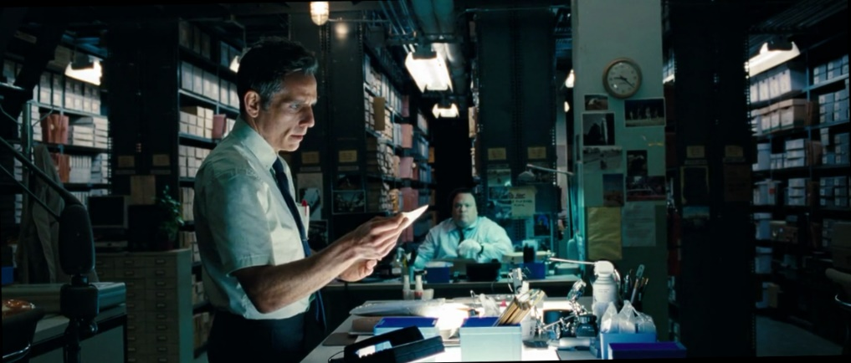
Think about:
- Background
- Foreground
- Setting
- Light and shadow
- What this shot says about Walter’s job
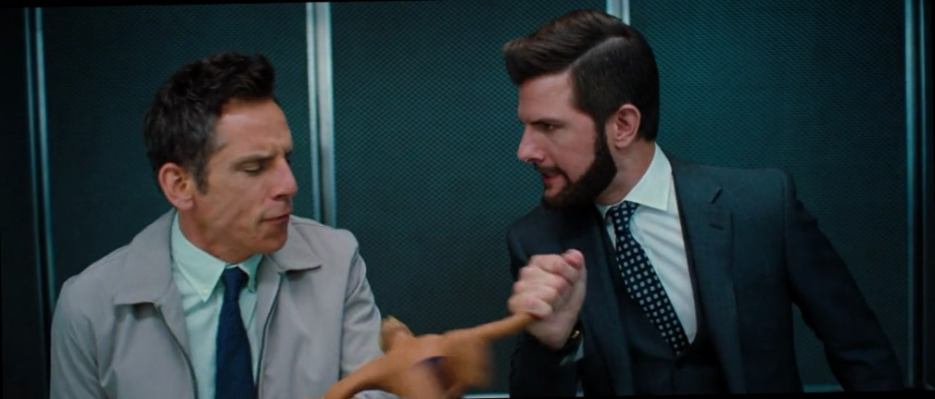
Think about:
- What this shot says about the relationship between Walter and Ted
- How emotion is shown
- Body language and costume
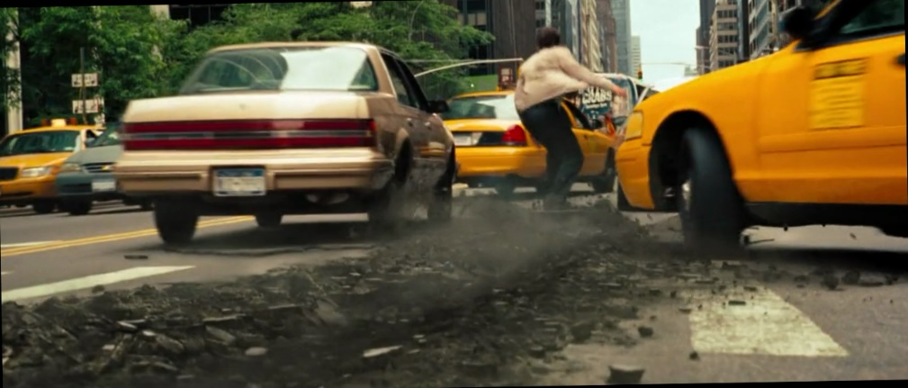
Think about:
- Why Walter is imagining this
- What the ‘board’ relates to in Walter’s life
- Why Walter would be in the centre of the shot
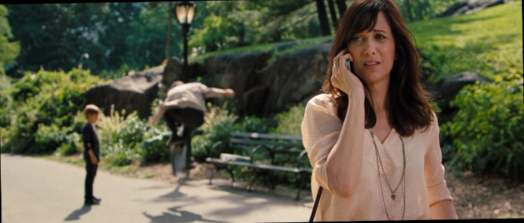
Think about:
- Background
- Foreground
- Placement of each character
- The direction Cheryl is facing
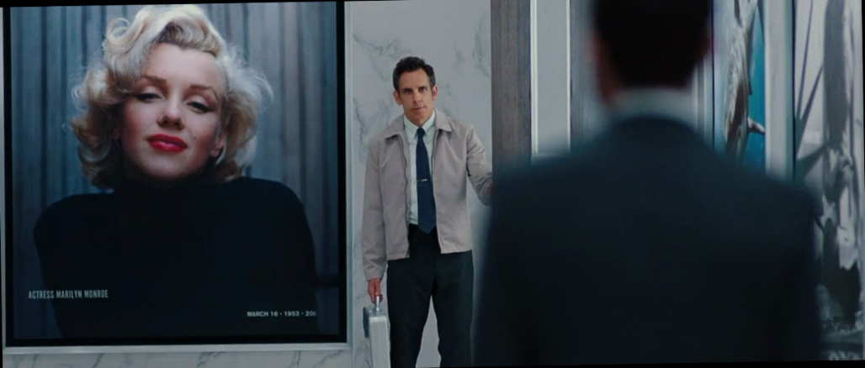
Think about:
- Background
- Foreground
- Where the camera is focused and why
- The size and placement of the magazine cover
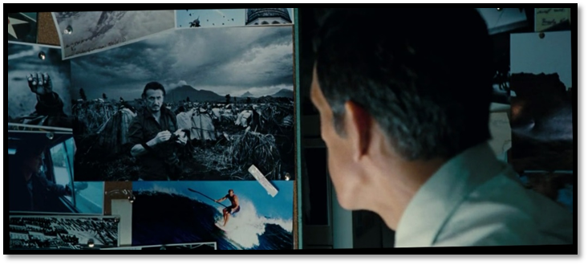
Think about:
- The direction Walter is looking in
- Where the camera has been placed and why
- The contrast between Walter and the photo
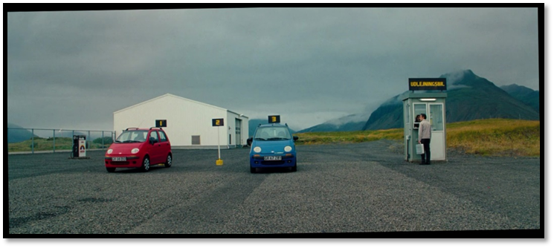
Think about:
- The size of the shot and why it is this size
- Walter’s placement in the shot
- Why and how is this shot funny?
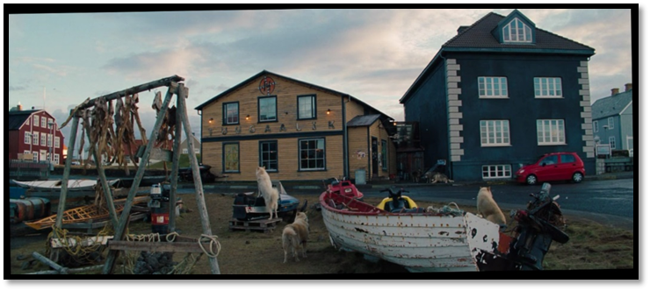
Think about:
- How this shot establishes where Walter is
- The difference between this environment and where Walter is from
- The size of the shot
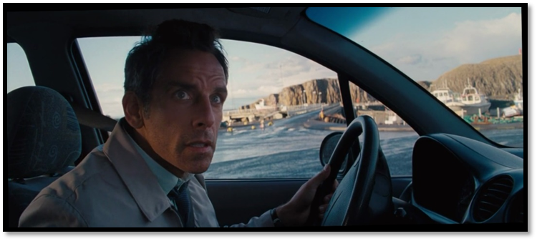
Think about:
- Background
- Foreground
- Facial expression
- The direction Walter is looking and how this affects the audience
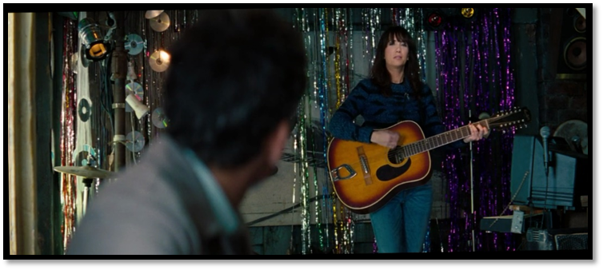
Think about:
- Where the camera is focused
- Where the camera is placed
- How a connection is established between these two characters
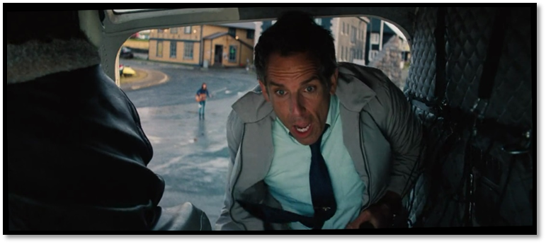
Think about:
- Camera angle
- Walter’s facial expression
- Movement and action
- Where the camera is placed
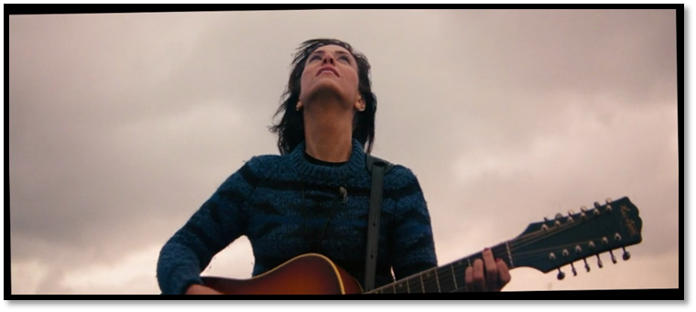
Think about:
- Camera angle
- Cheryl’s body language
- What can and can’t be seen in the background, and what this might symbolise
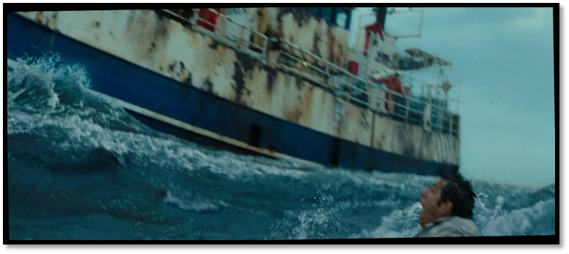
Think about:
- Camera angle
- Shot size
- Movement and action
- How danger has been visually depicted
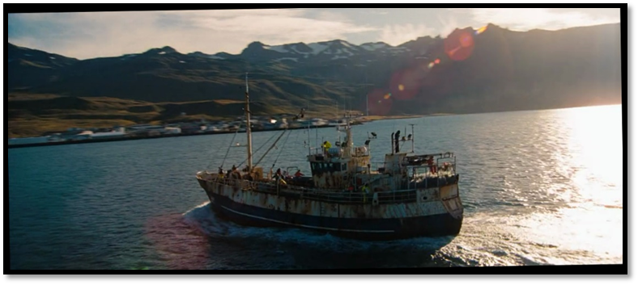
Think about:
- What does this shot establish about the new location
- What does the lens flare/light symbolise
- Shot size
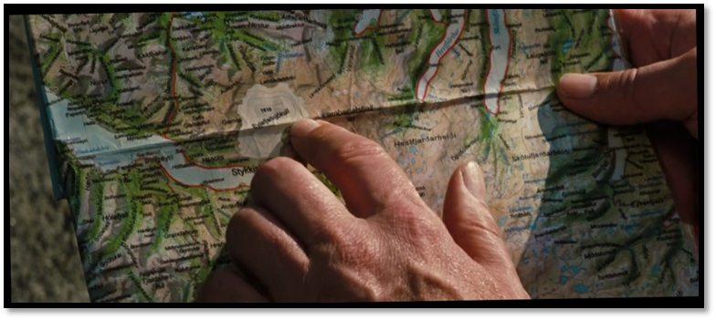
Think about:
- Shot size
- What is featured in this shot and why
- Symbolism of the map
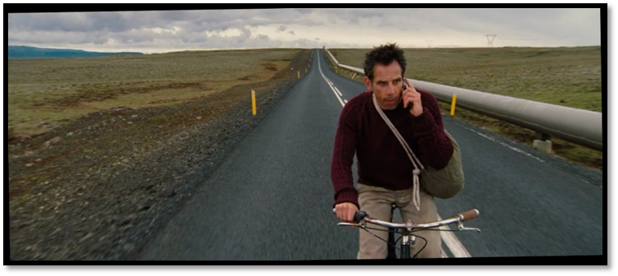
Think about:
- Where Walter has been placed in the shot and why
- Background
- What the road might symbolise or say about the themes
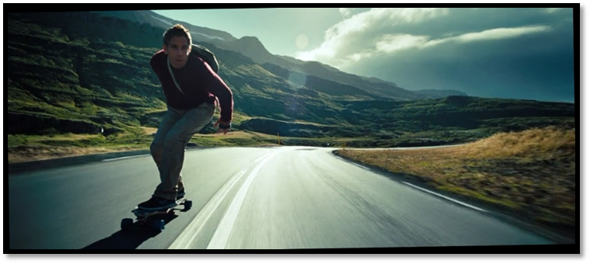
Think about:
- How the environment differs from Walter’s home
- Walter’s body language and placement in the shot
- How action is suggested
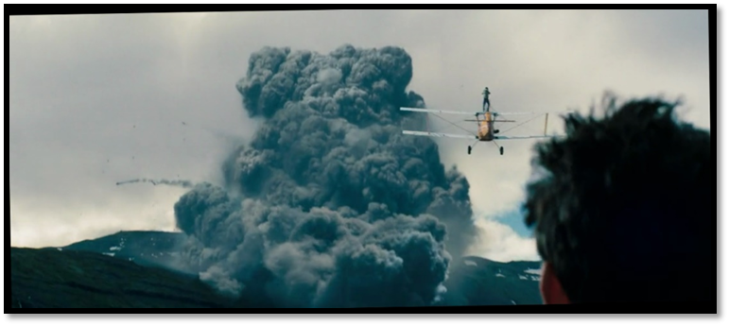
Think about:
- Foreground
- Background
- Where the camera has been placed – whose point of view is this?
- Midground
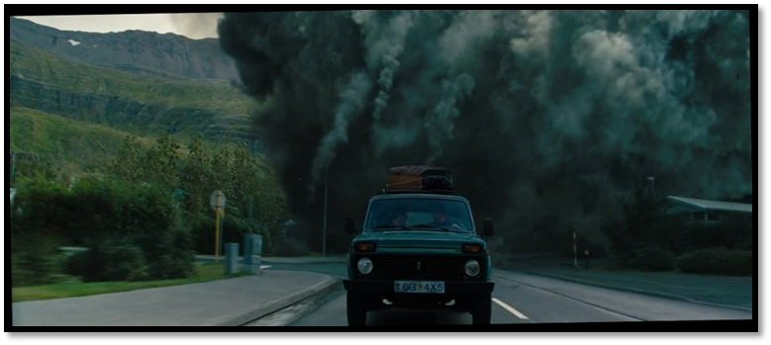
Think about:
- Foreground
- Background
- Where things have been placed in the shot
- How action is suggested
- Body language of those in the car
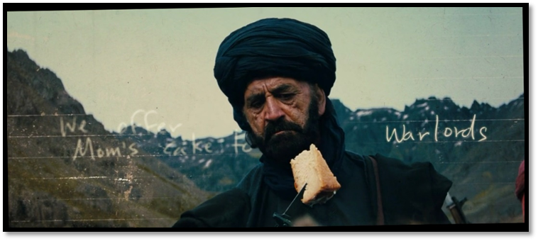
Think about:
- The use of writing on the screen
- Contrast between cake and weapon
- Facial expression
- Background
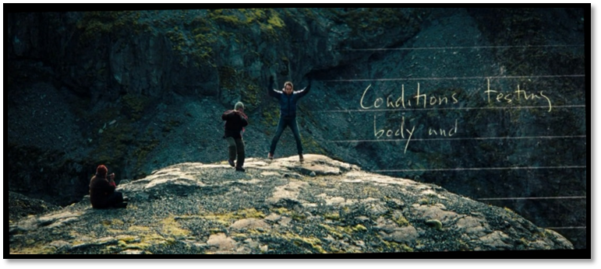
Think about:
- The use of writing on the screen
- Walter’s placement and actions
- Shot size
- The placement of the other characters
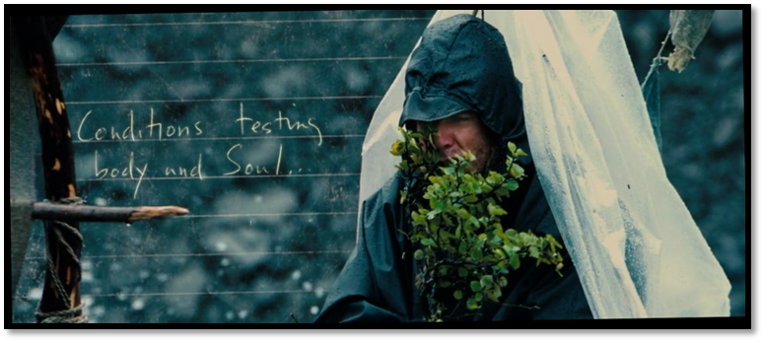
Think about:
- The use of writing on the screen
- Walter’s facial expression
- The use of props to establish weather conditions
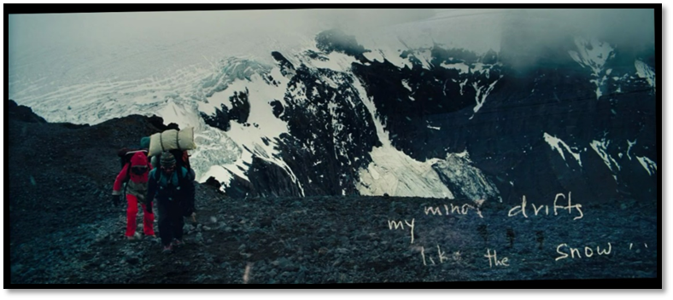
Think about:
- The use of writing on the screen – why have the words moved apart like this?
- Walter’s placement in the shot
- Background
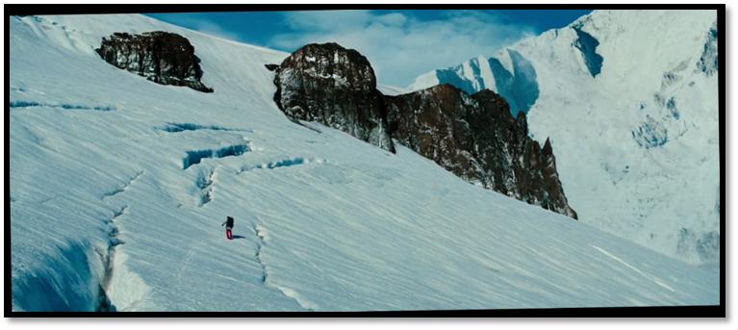
Think about:
- Shot size
- Camera angle
- Walter’s placement and size in the shot
- Environment
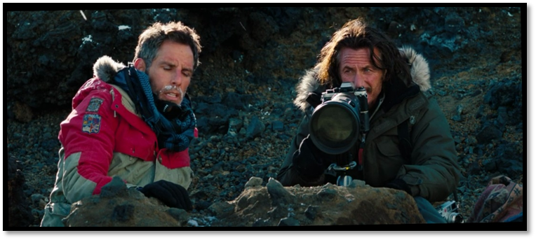
Think about:
- Comparison of Walter to Sean in costume and body language
- Props used to establish the sort of person Sean is
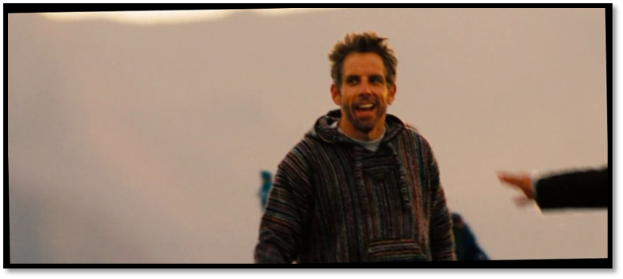
Think about:
- How costuming, body language and facial expression has been used to show Walter’s transformation
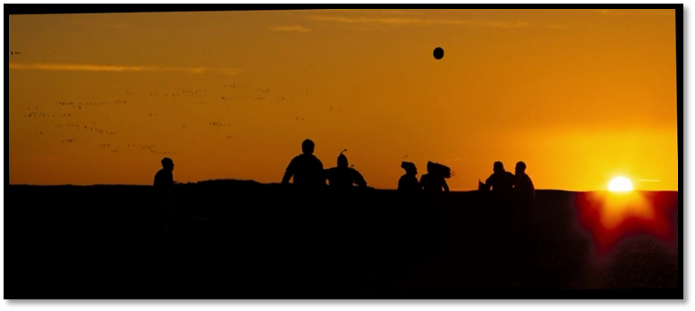
Think about:
- Shot size
- Light and shadow
- Symbolism of the setting sun
- How movement is shown
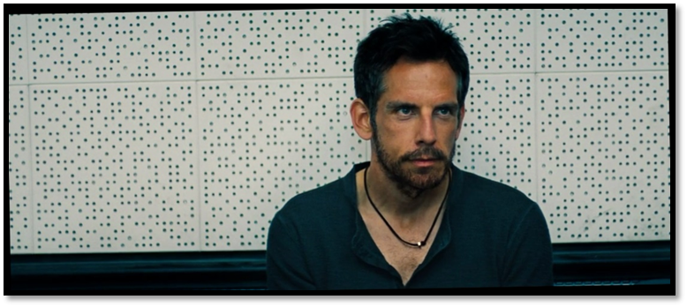
Think about:
- How costuming, body language and facial expression has been used to show Walter’s transformation
- Where Walter is looking and why
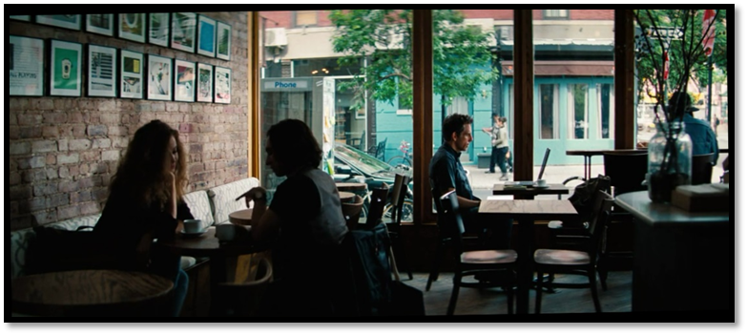
Think about:
- How this shot compares to the shot at the beginning that shows Walter on his computer in the apartment
- The presence of other people
- The different location
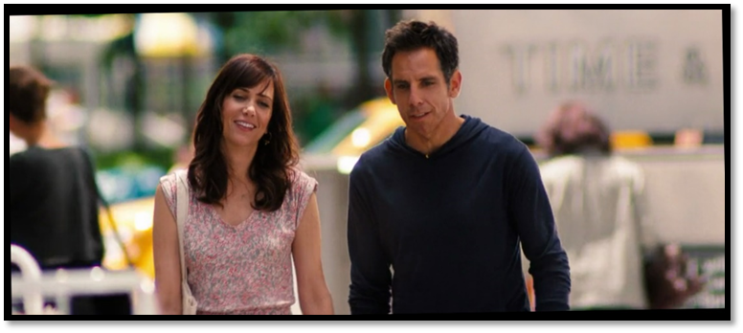
Think about:
- Facial expression and body language
- The way they lean in towards each other
- Shot size
- What’s in focus and what isn’t
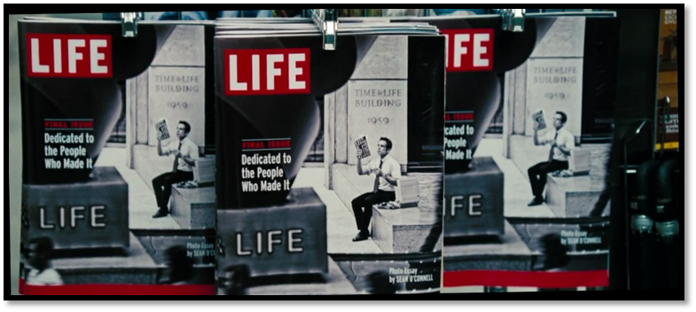
Think about:
- The symbolism of this cover
- What this shot says about Walter
- Shot size
- Camera angle
- Arrangement of the magazines

