On the Road – Resource 27

Explaining a shot in the film
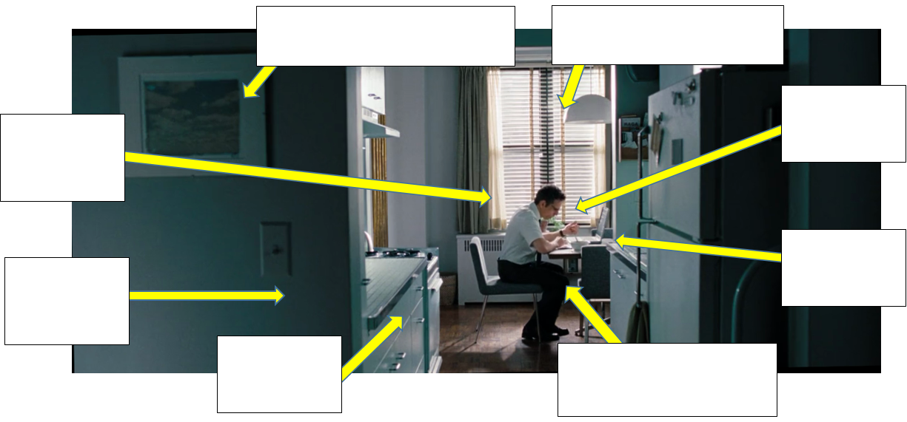

Questions
- Label each section of the shot above.
- What does each thing say about Walter as a person? (Use the boxes to explain.)
- If you wanted to make Walter into a completely different character, what would you change in this shot to achieve this?

