On the Road – resource 16

Travels in America – day 5 (Cedar City)
(Extract from Luke Bartolo’s blog.)
Day 5, South-West Utah.
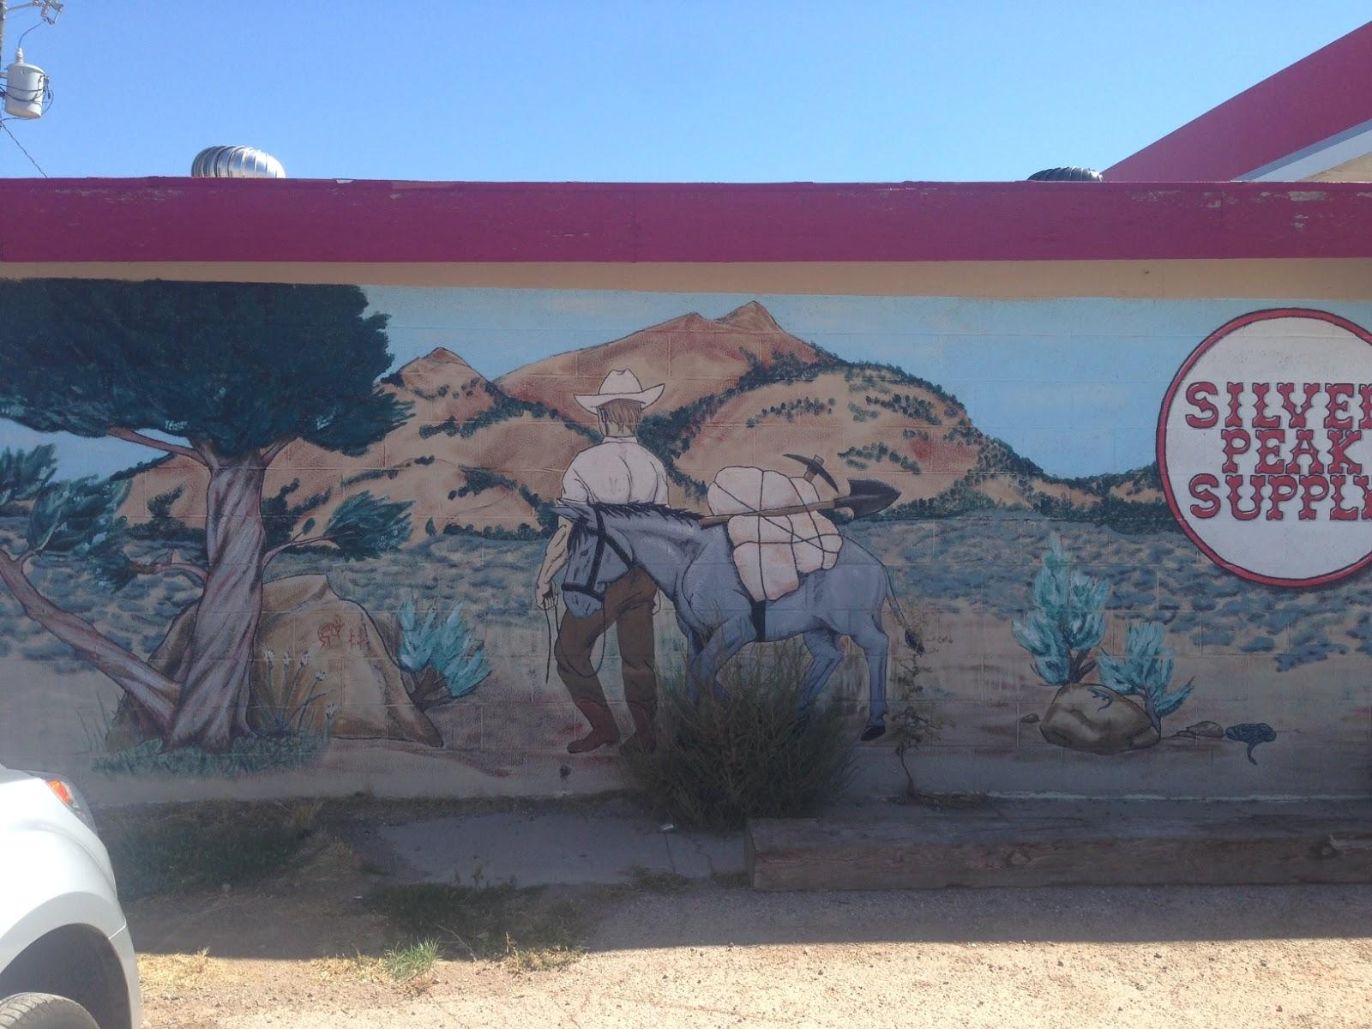
Picture 1 – Service station in Utah, USA. In the middle of the desert, they like to draw pictures of the desert on the side of their desert service stations.
After eating a service station breakfast and pre-preparing a service station lunch (a packet of chips), we strike out of Caliente and head for the Utah border. In the cold daylight it's suddenly apparent that Caliente is surrounded by mountains, and that it's also a bit of a tired and skint-looking town. But this is my second impression... my first impression was of the friendliness of the service station staff last night and the comfort of the Rainbow Canyon Motel, so I'll fondly remember Caliente as a place of rest and hospitality.

After our whirlwind, day-long tour of Nevada we find ourselves across state lines and in Utah. Driving for a couple of hours leads us to another gas station (near Newcastle), a small town where guns and shooting seem to be the predominant interest. The gas station features a lot of literature on shooting and advertisements for large hay purchases that come with a free rifle. We even get stuck behind a pick-up truck shortly afterwards, on the back of which is a large freshly-killed elk – its antlers as wide as the vehicle itself.
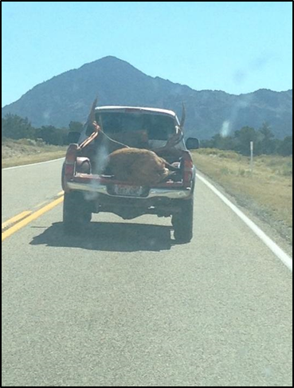
Picture 2 – Oh deer!
We pull into Cedar City around lunchtime and it turns out to be much larger than I expected. There are at least 20 fast food restaurants lining the main stretch, and the city (whilst small for America) is as big as any non-capital Australian city I've seen. After re-assessing our progress across this country so far, Nicole and I decide to base ourselves in Cedar City for the night so we can reach the two national parks on either side of it. Today we'll 'do' Bryce Canyon and Cedar Breaks, which are about an hour or so east of the city.
Cedar Breaks is quite a beautiful place, with a breathtaking view of the orange clifftops known as the 'Breaks'. The surrounding forest is firmly in the grip of autumn, many green-leaved trees are beginning to fade to yellow, and some have already bloomed into a deep russety orange. The drive between these multi-coloured corridors of pines, firs and aspens is peaceful and relaxing... a far cry from the tense journey taken yesterday.
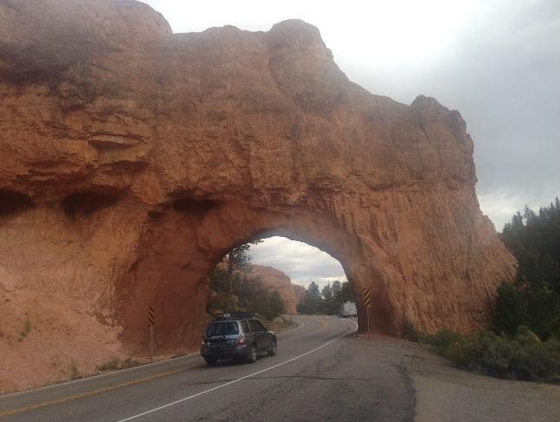
Picture 3 – The road to Bryce Canyon
Bryce Canyon is one of the main reasons we have come to this part of America, and we wind our way through the aptly-named Red Canyon to get there. Bryce is a fairly busy area, touristy but not overpopulated. We take a punt and look in a wildlife museum on our way. I have mixed feelings when I see the myriad of stuffed animals arranged in facsimiles of their natural habitats, and my amazement soon turns to sadness as we note the faint bullet holes that can't quite be hidden. Upon closer inspection, some of the large stuffed turkeys have painted, life-like plastic heads... which leads me to the realisation that they probably had their heads blown off. A quick meeting with the owner and perusal of newspaper clippings on the wall imply that he probably shot each and every one of these animals on his many travels throughout the world. He seems to be a genuine animal lover, which baffles me a little, but I don't dare ask him further questions because I don't want to know the answers. The museum is undoubtedly impressive but it also leaves me feeling a little horrified.
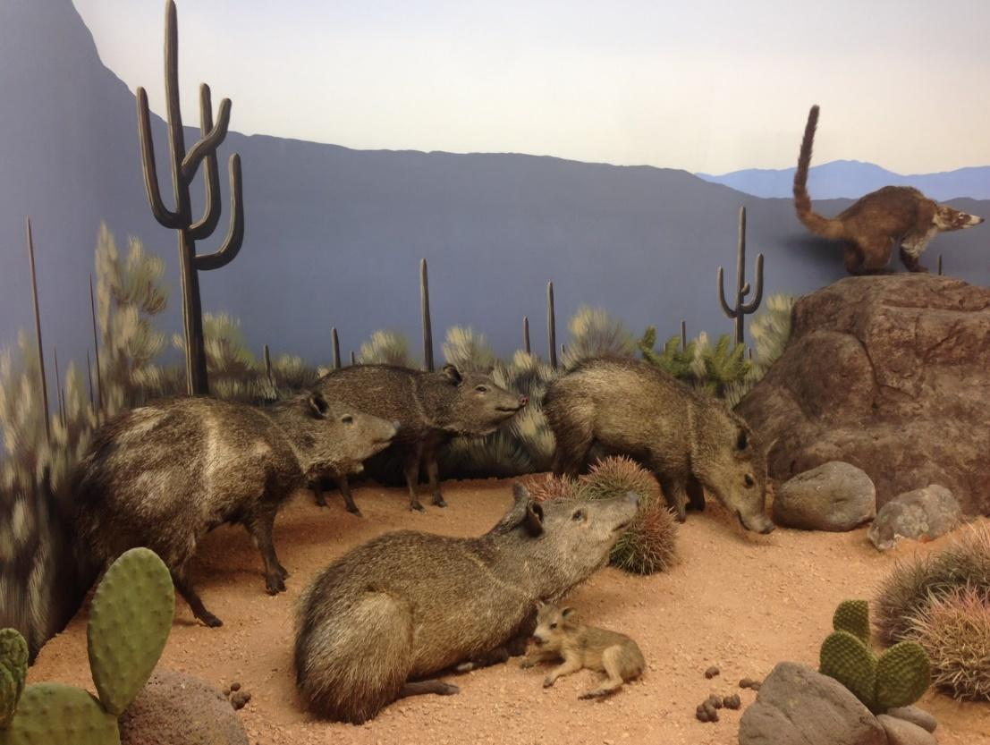
Picture 4 – Stuffed Javelinas (a Javelina is a little furry pig found in the American desert) and a Coati (the long-tailed raccoon-like animal on the rock)
The canyon we've come for is the complete opposite of the museum. If Cedar Breaks is beautiful, then Bryce Canyon is absolutely spectacular. Not actually a canyon at all, Bryce Canyon is a huge, cathedral-like, amphitheatre-shaped rock formation. We descend from the clifftop down a rather steep series of pathways called 'the Navajo Trail' and wind our way deep into the crimson valley of stone. The rocky walls range from white to pink and almost-red, their towering walls sculpted by wind and water into wave-like shapes. One solitary spire of rock is named 'Thor's Hammer' for its odd and square-shaped top, and many other spires (known as 'hoodoos') form a diverse and fanciful range of shapes. Trophies, sisters, soldiers and monks... all so high above and ready to topple should the years and weather continue to do their part.

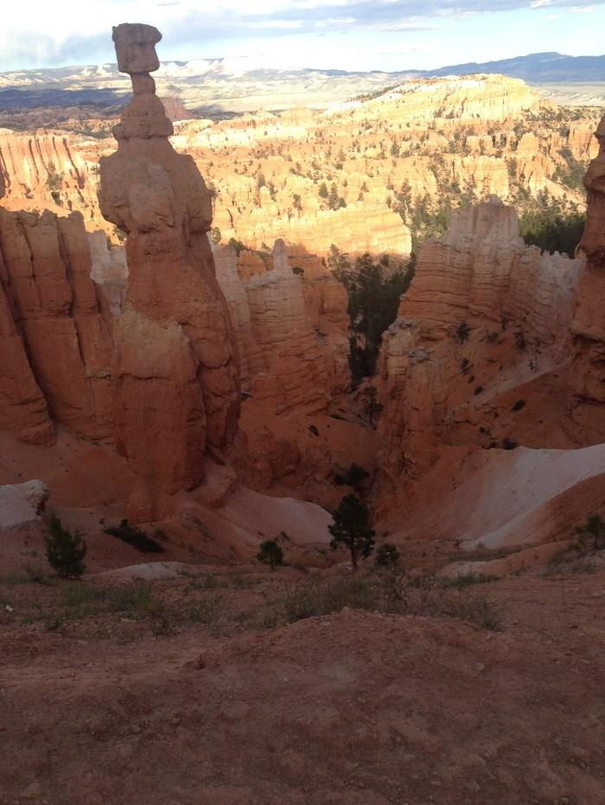
Picture 5 – Thor’s Hammer
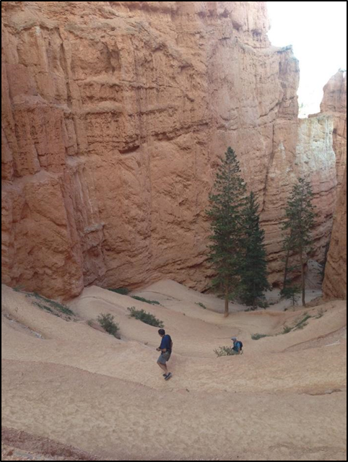
Picture 6 – The way down into the canyon

Coming back up out of the bottom of Bryce Canyon is no less majestic. That said, myself and Nicole tread a fine line between optimism and collapse as we slowly pick our way back to the top. What goes down must come up!
As we head back to Cedar City we see a couple more Mule Deer eating grass by the highway. They barely notice us, these deer pretty much own the place.
When we get back to town we book a room in a Quality Inn and eat a fairly late dinner at Arby's across the road. Arby's is one of the gazillion carb-loaded fast food chains that line the main stretch of Cedar City. Their angle is 'MeatCraft' (trademarked). It's passably edible but not something I'll seek out again, if given the choice.
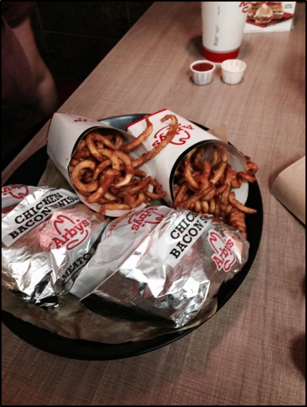
Picture 7 – Arby’s. Inside the alfoil is a whole lot of brown and yellow.

