On the Road – resource 15

Building a taxonomy.

What is a taxonomy?
A taxonomy is a way of organising information. Another word you might use is ‘categorisation’. By inventing systems to categorise things we can better understand how things relate to each other, or find better ways to describe things.
Here is an example applied to cups:
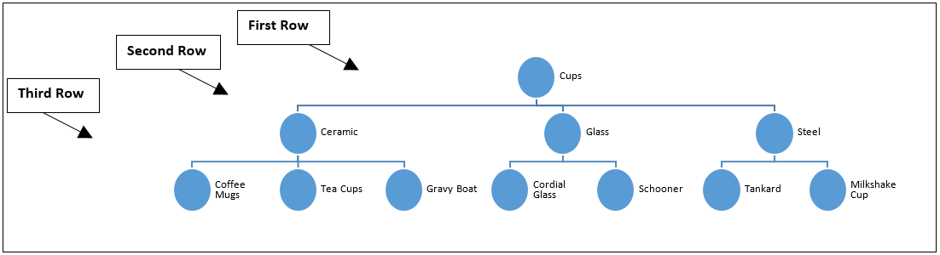
Think of a fourth way to classify two of the above items in the third row.
For example, cordial glass could be split into see-through, cloudy and coloured.
Third row item | Further categories

Questions
- What is a taxonomy?

- Why do you think it might be useful to create a taxonomy for an item?

- Using your Instagram pictures and the table below, create your own taxonomy. Separate your photographs into two categories first, and then find further ways to separate them for the next two rows.

