 Digital Worlds – Resource 1

LinkedIn

Resource from [au.pcmag.com](http://au.pcmag.com/linkedin/9175/review/linkedin) and written by Jill Duffy

LinkedIn is the number one online network for developing a professional network, finding new work opportunities, and building a career. Everyone over the age of 20 with career aspirations should have a LinkedIn account, even though the service falls well short of perfection. The service needs throttle back the volume of emails it sends, and it shouldn't send canned emails as invitations to connect. Still, the benefits of LinkedIn far outweigh its nuisances, making it a clear Editors' Choice.

This review looks at LinkedIn broadly and does not specifically consider the use case of hiring managers, recruiters, or businesses, although information regarding Premium accounts for those users is summarized below. There's no need for everyone to tend to their LinkedIn account everyday, though job seekers and recruiters may find that doing so brings them real value.

LinkedIn, which launched in 2003, is the place where professionals stay connected. LinkedIn is part professional networking site, part social networking site, and part job board. It's a place to go to find people, despite whether you know them personally. I use LinkedIn as a replacement for paper business cards, which are almost always out of date within a year. With LinkedIn, I can stay in touch with people from past jobs, volunteer work, schools, and professional groups, and I like that LinkedIn puts the onus on them to keep their contact information current. [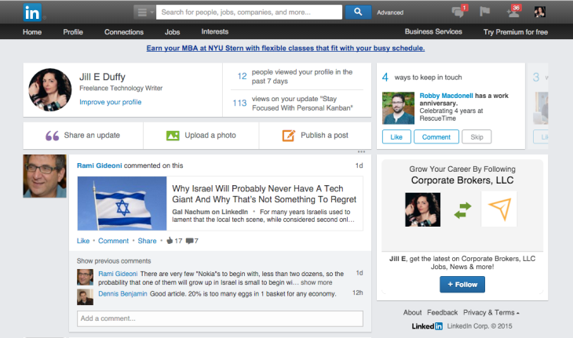](javascript:OpenImageWindow('http://www.pcmag.com/image_popup/0,1740,iid=476770,00.asp',%20'1063',%20'628'))

Similarly, people in my network can find me because I keep my LinkedIn profile up to date. LinkedIn facilitates communication between professionals while also leaving up some guards that give you privacy from people you don't know if you choose.

There are a lot of settings to customize in LinkedIn and features to learn. Likewise, the Premium membership options have changed a lot in recent years. Plans have become more expensive, but they're also more tailored to specific types of users.

If LinkedIn just seems like yet another online network that requires maintenance, I'd say quite the opposite is true. You can get a lot out of LinkedIn even if all you do is establish an account, customize a few settings, and leave it alone until your next career move. The vast majority of users won't need to tend to their LinkedIn account every day, though job seekers and recruiters may find that doing so is essential.

LinkedIn Basics

As with any other online networking site, new users set up a free LinkedIn account and draft an online profile. Here, however, profiles resemble resumes. Where general-interest social networking sites frame tiresome lists of movies, bands, and favorite quotes as evidence of one's persona, LinkedIn emphasizes professional affiliations, work experiences, skills, and job titles.

You can even add multimedia to your profile to showcase videos you've created, articles you've written or that have been written about you, and other spotlight moments. For advice on setting up these multimedia pieces, read my [tips for getting the most from LinkedIn](http://www.pcmag.com/article2/0,2817,2385576,00.asp).

Free to use, LinkedIn requires little more than an email address and password to get started, although you'll want to fill in your profile completely to get all that the site has to offer. As mentioned, the profile is similar to a resume, with a summary section and job history prominently displayed. LinkedIn prompts you to upload other information about yourself, including a photo. Until your profile is 100 percent filled in, the site will remind you periodically to complete the process, and it's mutually beneficial that it does. Users get more out of the site when their profiles are complete, and the more user data the site has, the better an experience it delivers.

The next step is to connect to people you know. You can find them by importing names and addresses from a variety of email programs. If one of your providers isn't supported, you can always upload a .csv, .txt, or .vcf file containing other contacts. To be connected on LinkedIn, both parties must agree to the relationship. Additionally, before you can request to connect with someone, you need to either note your relationship, such as colleague or former colleague, or know a piece of verified data about him or her, such as an email address or phone number that the person has provided to LinkedIn. If you don't know someone, you can still send them a LinkedIn private message, or InMail, though you need credits to do so. To get InMail credits, you need a Premium account, which you can read about below.

As you connect with coworkers, friends, and business partners, LinkedIn begins to suggest people you may know based on shared relationship and company affiliations. Sometimes I find these suggestions a little nagging.

People who use LinkedIn are usually looking to find a job or clients; hire or partner with new people and experts; keep tabs on their business acquaintances; and network, or more specifically, become visibly active in professional communities that matter to their long-term career goals. For all of these purposes, LinkedIn is pretty stellar.

When it comes to finding employment or employees, LinkedIn offers phenomenal search tools that let you drill down by multiple factors. You can search for people or companies by location, field of expertise, skill level, and even keep the search to people within your network or who are only one degree removed (in which case, you can request an introduction from the mutual contact).

In terms of design, the LinkedIn website has a busy, modular look. [LinkedIn's Android app](http://au.pcmag.com/linkedin-for-android) and [iPhone app](http://au.pcmag.com/linkedin-for-iphone), however, recently got a redesign that gives them a much more contemporary spin, among other improvements. If you were disappointed by them in the past, there are new [reasons to try LinkedIn's mobile apps](http://au.pcmag.com/feature/40351/5-reasons-to-check-out-linkedins-new-mobile-app). Here's to hoping some of those updates make their way to the main site soon.

[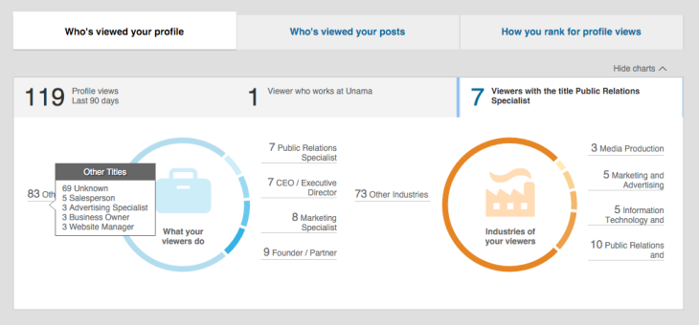](javascript:OpenImageWindow('http://www.pcmag.com/image_popup/0,1740,iid=476878,00.asp',%20'1015',%20'474'))

The Social Component

LinkedIn also functions as a social network that lets users post updates or read updates from others. These can be quite long (very similar to a blog post) or they can be as short as single link. You can follow the activity of users and businesses even if you are not directly connected to them.

Some of my friends and colleagues use Facebook in much the same way that I use LinkedIn. On Facebook, you can add your job history and professional skills to your profile, but I see too many gaps in Facebook that make it unsuitable for business. Its privacy settings aren't as well designed as LinkedIn's for professional use. Facebook requires too much vigilance for keeping your reputation squeaky clean and still publicly searchable. If you lock down your Facebook profile and enable all the privacy settings and approval requirements, no one but your friends will be able to find you, which limits your ability to network effectively in a business sense. Facebook doesn't have a job board, either, nor does it offer a way for employers to search widely for candidates that meet very specific criteria. I love the compartmentalization that I get from keeping my business and professional contacts on LinkedIn and not on Facebook.

Twitter, on the other hand, is a different story. I personally use Twitter to browse interesting ideas from people I follow whom I might not know personally or professionally. I also use it as a socialization mechanism with co-workers, where work and personal life often overlap. Twitter lacks the deep search functionality that LinkedIn provides for finding jobs, businesses, and people. At any rate, if you couldn't tell, I'm a fan of using different online networks for different purposes. The value of LinkedIn, in this context, is that it simply provides a huge array of business-networking services.

Premium Accounts

Like many online sites and services, LinkedIn is free to use but offers a Premium subscription upgrade with some added perks. There used to be just one Premium account that cost only $20 a month, but now there are four, which makes sense because people use LinkedIn in very different ways depending on their roles. The four Premium account types are:

Job Seeker ($29.99 per month)

Business Plus ($59.99 per month)

Sales Navigator ($79.99 per month or $700 per year)

Recruiter Lite ($119.99 per month).

A representative also explained to me that LinkedIn offers a full-strength package for recruiters sold separately by its Talent Solutions division. Contact the company for pricing if that sounds more like what you need.

I'll summarize a few of the benefits, but you can get the full details on [LinkedIn's Premium page](https://www.linkedin.com/premium/).

Job Seekers get three InMail credits per month, 90 days' worth of "who's viewed your profile" data including how they found you, featured applicant listing for job applications, and applicant insights that show you compare with other candidates for the same position. New, improved job listings with richer information about the listing company, among other improvements, are in the process of rolling out as of this writing.

Business Plus members get 15 InMail messages, 90 days' worth of "who's viewed your profile" data including how they found you, advanced search filters, and unlimited profile searches up to three degrees of separation.

Sales Navigators get 15 InMail messages per month, advanced search for creating custom lead lists, lead recommendations, and the ability to save leads.

Recruiter Lite members get 30 InMail messages with templates, enhanced information on who has viewed your profile, automatic candidate tracking, unlimited profile search results up to three degrees of separation, and more.

Settings and Customizations

If you're going to use LinkedIn, you need to set aside time for reading through all the settings and customizations, as many of them are very important and will make or break your experience with the site.

One huge gripe LinkedIn members have is that the service sends them excessive email. I absolutely feel that LinkedIn sends too much email by default (there are more than 20 different types of email notifications to customize or disable), but I also think the options it offers are excellent. It's just that going through those options is a mandatory exercise.

In some circumstances, the email summaries actually allow you to visit LinkedIn less often. They give you information you want, such as a listing of open jobs that might fit your experience, and if you read that email and decide that nothing tickles your fancy, you're done. You don't have to go to LinkedIn and investigate further. All the relevant information is in the email.

In LinkedIn's Settings are options for making your public profile visible to no one (outside your network that is) or everyone. If everyone can see your profile, you still have the option to turn off or on the visibility of certain sections, such as picture, headline, summary, skills, education, and additional information. All these customizations and others in the Settings and Privacy section are really important to review thoroughly.

LinkedIn for Everyone

If you're at all invested in your career, you really should be on LinkedIn. The site makes it easy to have an account that provides real value without asking much of you in return, although you can certainly explore the site's many features and services, too. Setting up an account takes some time, but it's worth doing. Have a resume handy when you do.

LinkedIn remains a great site that delivers real results for both networking gurus and people who are sometimes wallflowers in real life. For all it can do to help you get ahead, LinkedIn is a clear Editors' Choice for employment related social networking.