Common module: Reading to write
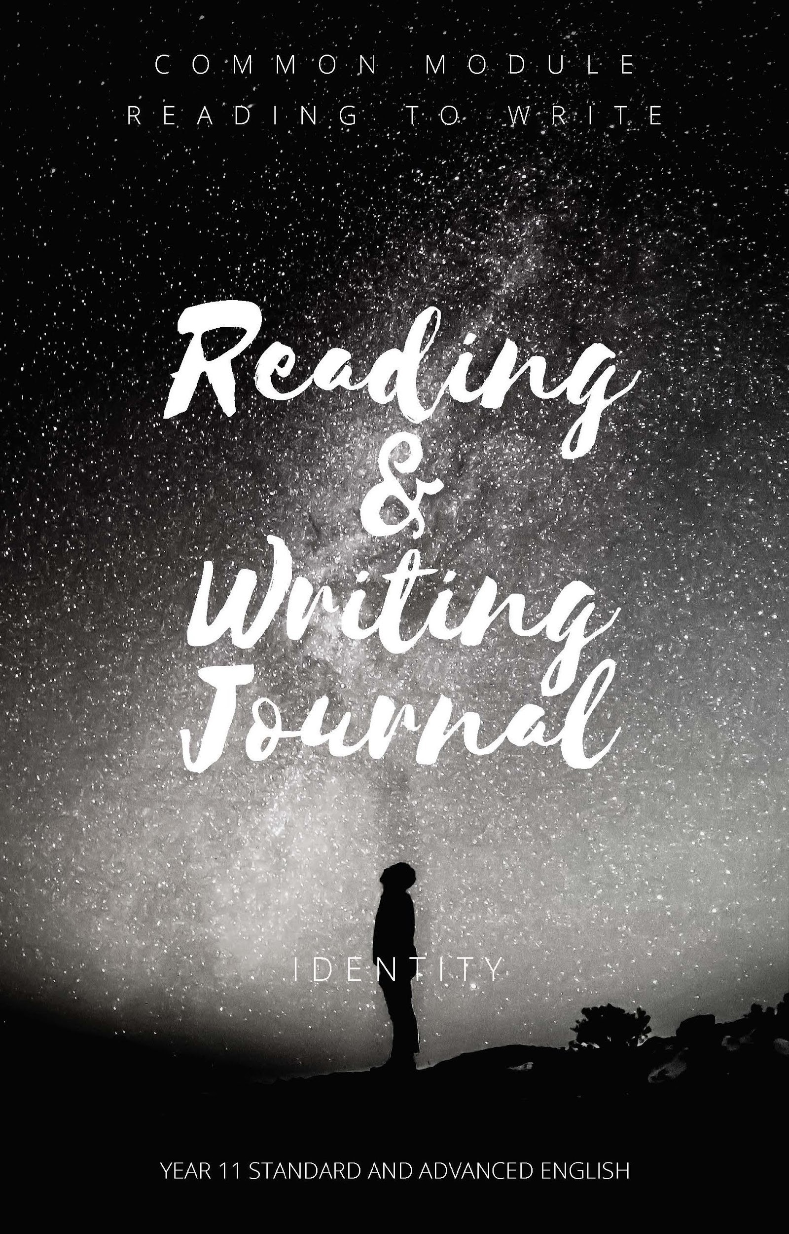
This reading journal forms an integral part of the Reading to Write Module. As you read, view or hear texts in class and outside of class, they need to be recorded in this journal. Our focus is on texts that explore ‘Identity’. There is also a writing component within this journal that will allow your teacher to see how well you understand and translate concepts from key texts into your writing. Your teacher will set you weekly journal tasks which should be recorded in the spaces provided.

Task 1: Who am I?
Name:

Age:

Birth Place

Cultural Background/ Ancestry

Family makeup

School history

Personal interests

Ambitions

Skills

Think about what has shaped your identity. Explain how your identity has been shaped by your context.

Week 1

Focus questions:

Reading journal
This week I read/saw/heard…
by…
It is about…
What is your initial reaction to the text?
After a second or closer read, what else has become clear about this text?
What aspects of identity are explored in this text?
What key questions has this text has raised for you?
How have your life experiences affected your reading or viewing of the text and your response to it?
How do you feel about events and characters – what has the author done to make you feel like this?
What connections are evident between this and other texts you have read (intertextuality)?

Language patterns, structures and features
How has the composer used forms and features of language in this text?
How has the medium of production affected the way we experience this text?
How has the composer conformed to or challenged structures of language in this text?

Writing task
(As set by my classroom teacher)
Due date:
The structure for the journal would remain the same for subsequent weeks, with pages for writing included between weeks or provided as an online scaffold students can add to.

