Writing about Writing Style
Highlight the quotes and link to the annotations on the right.

J D Salinger – The Catcher in the Rye (1951), Penguin: England
Chapter 6 – p 44
Some things are hard to remember. I’m thinking now of when Stradlater got back from his date with Jane. I mean I can’t remember exactly what I was doing when I heard his goddam footsteps coming down the corridor. I probably was still looking out the window, but I swear I can’t remember. I was so damn worried, that’s why. When I really worry about something, I don’t just fool around. I even have to go to the bathroom when I worry about something. Only, I don’t go. I’m too worried to go. I don’t want to interrupt my worrying to go. If you knew Stradlater, you’d have been worried, too. I’d double-dated with that bastard a couple of times, and I know what I’m talking about. He was unscrupulous. He really was.
Anyway, the corridor was all linoleum and all, and you could hear his goddam footsteps coming right towards the room. I don’t even remember where I was sitting when he came in – at the window, or in my chair or his. I swear I can’t remember.
He came in griping about how cold it was out. Then he said ‘Where the hell is everybody? It’s like a goddam morgue around here.’ I didn’t even bother to answer him. If he was so goddam stupid not to realise it was Saturday night and everybody was out or asleep or home for the week-end, I wasn’t going to break my neck telling him. He started getting undressed. He didn’t say one goddam word about Jane. Not one. Neither did I. I just watched him. All he did was thank me for letting him wear my hound’s tooth. He hung it up on a hanger and put it in the closet
- Stream of Consciousness (thoughts)
Designed to reveal a character's personality through the unique presentation of their thinking process, stream of consciousness encompasses two main techniques: Direct Interior Monologue (I) and Indirect Interior Monologue (she).
The use of direct interior monologue makes us feel intimate with the character, like a trusted best friend; or like a diary.
- References to negative descriptors such as “worried”, “bastard” reveal a level of stress and concern, creating a negative tone.
- Varied sentence lengths create natural, fluid rhythm.
- Reference to dialogue comes as an interjection in the stream of consciousness – so not break the thought process.
- The recurring reference to memory, “some things are hard to remember” and “I swear I can’t remember” tells us that the character’s version of events is subjective, based on perception and as such, potentially unreliable. Yet we
Chapter 7 – pp 50-51
A tiny bit of light came through from the shower curtains and all from our room, and I could see him lying in bed. I know damn well he was wide awake. ‘Ackley?’ I said. ‘Y’ awake?’
‘Yeah’
It was pretty dark, and I stepped on somebody’s shoe on the floor and damn near fell on my head. Ackley sort of sat up in bed and leaned on his arm. He had a lot of white stuff on his face, for his pimples. He looked sort of spooky in the dark.
‘What the hellya doing, anyway?’ I said.
‘Wuddaya mean what the hell am I doing? I was tryna sleep before you guys started making all that noise. What the hell was the fight about, anyhow?’
‘Where’s the light?’ I couldn’t find the light. I was sliding my hand all over the wall.
‘Wuddaya want the light for?.... Right next to your hand.’
If finally found the switch and turned it on. Old Ackley put his hand up so the light wouldn’t hurt his eyes.
‘Jesus!’ he said. ‘What the hell happened to you?’ He meant all the blood and all.
‘I had a little goddam tiff with Stradlater,’ I said. Then he sat down on the floor. They never had any chairs in their room. I don’t know what the hell they did with their chairs. ‘Listen,’ I said, ‘do you feel like playing a little Canasta? He was a Canasta fiend.
‘You’re still bleeding, for Chrissake. You better put something on it.’
‘It’ll stop. Listen. Ya wanna play a little Canasta or don’tcha?’
‘Canasta, for Chrissake. Do you know what time it is, by any chance?’
‘It isn’t late. It’s only around eleven, eleven-thirty.’
‘Only around!’ Ackley said. ‘Listen. I gotta get up and go to Mass in the morning, for Chrissake. You guys start hollering and fighting in the middle of the goddam – what the hell was the fight about, anyhow?’

are impelled to listen and believe, why?
- Use of cuss words or expletives “goddam” and “where the hell” emphasises the bitter frustration felt by the character
- Dialogue breaks the stream of consciousness – adding depth to our observation of the situation. The characters interjections guide our interpretation and emphasise that the situation is presented from his point of view, and we are on his side.
- Colloquialism “Wuddaya mean”, “Chrissake”, “Ya wanna” and “gotta” create a sense of relaxed informality but also reveals a lack of education connoting a lower or working class social status.
- The situation occurring at “eleven, eleven-thirty” at night, in the “dark” with reference to the “spooky” appearance of Ackley, along with fights and “all the blood and all” sets an unsettling hostile scene – yet when juxtaposed with the casual yet inappropriately timed conversation – evokes our sense of curiosity and intrigue. This is enhanced by the character’s casual reference to the bloody fight as a mere “tiff”.
- Salinger reveals the ironic distance between the characters with the statement “I never discussed my personal life with him” and by the Holden’s frustration when his prediction that his request to “sleep in Ely’s bed” will be denied holds true.

It’s a long story. I don’t wanna bore ya, Ackley. I’m thinking of your welfare,’ I told him. I never discussed my personal life with him. In the first place, he was even more stupid than Stradlater. Stradlater was a goddam genius next to Ackley. ‘Hey,’ I said, ‘is it okay if I sleep in Ely’s bed tonight? He won’t be back til tomorrow night, will he?’ I knew damn well he wouldn’t. Ely went home damn near every week-end.

Notice how the annotations are transferred to the ALARM Paragraph Scaffold. Is there anything you would add?
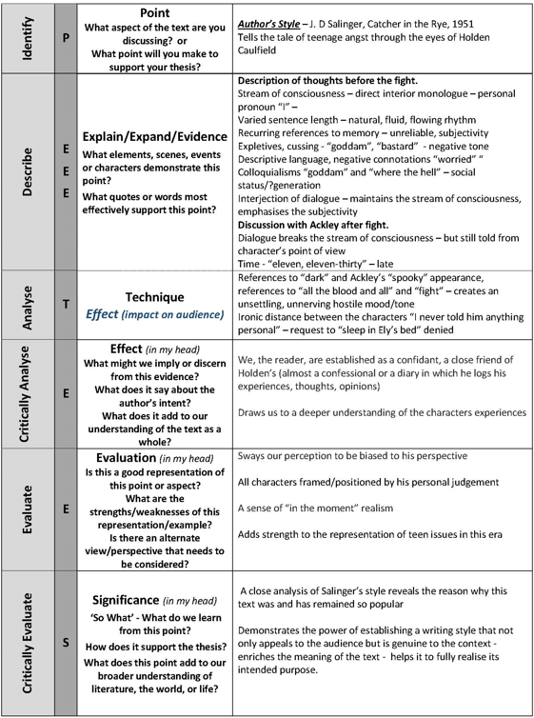

Transferring Ideas into a Cohesive Paragraph
Remember that the ALARM paragraph structure just ensures you have all the right ingredients for an analytic paragraph – you do not have to religiously follow the structure provided. A more sophisticated paragraph will not make paragraph structure evident. The ideas will be woven together in a patchwork format to create a cohesive whole. But first steps first; first you learn to play the notes then you learn to create music.

Your Turn
This paragraph is still not perfect. Edit it. Have a go a rewriting it in your own words. Try a look, cover, and write activity. Cull some of the information. Do we need it all? Could we be more concise, more cohesive?
Could it be more than one paragraph?
Colour code the paragraph below to see the structural patter created, for example:
- Identify: Topic Sentence or Point = Yellow
- Describe: Quotes = Green
- Describe: Discussion of text scenes examples = blue
- Analysis: or Techniques and effect = Pink
- Critical Analysis: or Impact on audience/meaning = Purple
- Evaluation: = Aqua
- Critical Evaluation: or Significance = Red

Putting it all Together
J. D Salinger, author of the iconic novel “Catcher in the Rye” (1951), reveals the world of 1950’s teen angst in America through the eyes of the central character, Holden Caulfield. Salinger’s sustained stream of consciousness style of storytelling is one of the key reasons the novel has earned and maintained its place as one of the best. Salinger draws us into the world of Holden by establishing the reader as a confidant, a trusted friend. Salinger’s sustained stream of consciousness description of Caulfield’s experiences, with its natural, fluid rhythm created by varied sentence lengths, allows us directly into his interior monologue creating a powerful level of intimacy. The tone of the scene is established through references to negative descriptors such as “worried”, “bastard” revealing a level of stress and concern. This tone is further established along with inference to age and social status with the use of cuss words or expletives such as “goddam” and “where the hell”; which also serve to emphasise the frustration felt by the character. Youth and social status are further exposed through the slang and colloquialisms in dialogue such as “Wuddaya mean”,“Chrissake”, “Ya wanna” and “gotta”. The recurring reference to memory, “some things are hard to remember” and “I swear I can’t remember” tell us that the characters version of events is subjective, based on perception and as such, potentially unreliable, yet our intimacy compels us to believe, or to want to believe, his version of events. Dialogue serves to break the stream of consciousness – adding depth to our observation of the situation. The character’s indirect interjections of dialogue guide our interpretation of characters and events and emphasises that situations are presented from his point of view, and we are on his side. Dialogue is also revealed indirectly as an interjection in the stream of consciousness prose – so not break the thought process. The atmosphere is set by the time of day, the situation occurring at “eleven, eleven-thirty” at night, in the “dark” with reference to the “spooky” appearance of Ackley, along with fights and “all the blood and all”. These references disclose an unsettling hostile scene, yet when juxtaposed with the casual yet inappropriately timed conversation, evoke our sense of curiosity and intrigue. This is enhanced by the character’s casual reference to the bloody fight as a mere “tiff”. Salinger reveals the ironic distance between the characters with the statement “I never discussed my personal life with him” and by the character’s frustration when his prediction that his request to “sleep in Ely’s bed” will be denied holds true. Salinger’s powerful first person stream of consciousness style draws us to a deeper understanding of the situation and the character’s experiences; we feel the same level of apprehension and uncertainly in not being able to determine the intentions or perceptions of the characters around him, in not being able to predict what might happen next. We are cleverly positioned to be guided by Caulfield’s personal judgment of events and people, adding a sense of ‘in the moment’ raw realism to the reading experience provided by Salinger, adding strength to his representation of teen issues in this era. Analysis of this excerpt demonstrates the power of establishing a writing style that not only appeals to the audience but is genuine to the context, enriches the meaning of the text and helps it to fully realise its intended purpose.

Guided
In pairs: identify, highlight the techniques in the excerpt below. Annotate the quotes you feel are most appropriate. Complete the ALARM paragraph scaffold.

Tim Winton – That Eye, the Sky (1986), Penguin: Australia (Chapter 9 – p 79 and pp 83-84)

Page 79
Pages 84-84
Voice (What is the age and gender – how can you tell?)
Perspective
Pronouns
Tone/word connotations: positive and negative
Dialogue
Contrast: memory of past with present
Reference to weather
Emotive language
Senses/hearing
How is distance between the adults and the child established?
Sentence length
Alliteration
Character actions
Description
Tone/word connotations
Sentence length
Contractions

Euphemism
Malapropism
Slang
Sarcasm
Simplistic description
Nostalgia
Colloquialism
Euphemisms
Questioning/listing
Dialogue
Simplistic description/word choice

‘

Answer the following questions to help you understand the excerpt:
- What do you think is the central issue in this excerpt? What do you think is happening and what draws you to this conclusion?
- How does Winton establish the voice of the central character? Who is he and how can we tell?
- How does Winton establish relationships in this excerpt?
- What effect does the use of word contractions, colloquialism, malapropisms and euphemisms have on our understanding of the characters and of the time and place?
- How are dialogue and character responses (actions) used to demonstrate the nature of the conflict in the house and impact on characters?
- How does Winton use the contrast between Ort’s memories of his father and his present situation to establish an image of the change that has taken place in his relationship with his father?
- What can we infer about the characters of Mr Cherry and Henry Warburton from this excerpt?

Independent
Annotate the excerpt below, then fill out an ALARM Scaffold for a paragraph and write and edit a cohesive paragraph defining the author’s style.
Charles Dickens – Oliver Twist (1837-39) Chapter 6 pp 32-33)

