Resource 21 - Run Lola Run film poster analysis

Film poster and DVD cover | Discussion
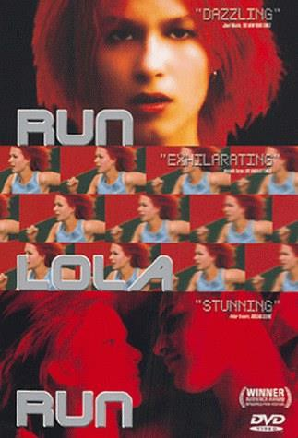 | Key visual features:  Aspects of text, themes and ideas communicated:
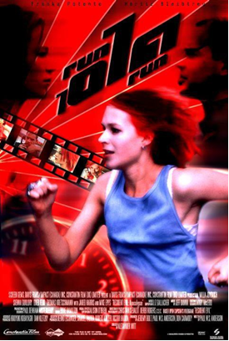 | Key visual features:  Aspects of text, themes and ideas communicated:
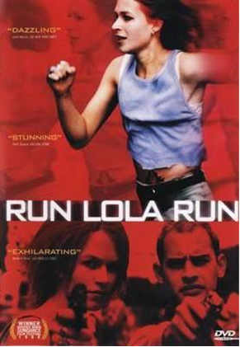 | Key visual features:  Aspects of text, themes and ideas communicated:
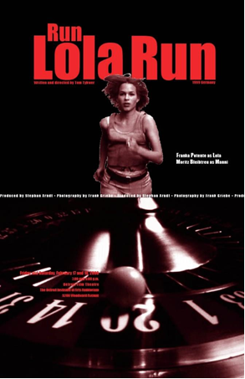 | Key visual features:  Aspects of text, themes and ideas communicated:

