Super Size Me

Analysing the validity of the message in a documentary
View the excerpt from the documentary 'Super Size Me', then respond to the following questions.
Video – Super Size Me: What is the purpose of this documentary?
- What conventions does the composer use to prove the validity of the message?
- How do film techniques guide the audience toward the composer's viewpoint?
- Consider the social media responses below. What impacts has the documentary had on the audience? What may account for these differing views?
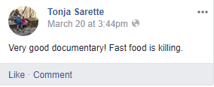
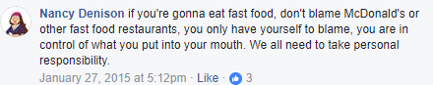
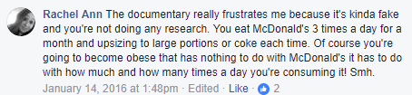
Discussion point – How might social media impact on documentary filmmakers?

Analyse oppositional text ‘Me and Mickey D’
Video – Me and Mickey D
- What is the message?
- What conventions does the composer use to prove the validity of the message?
- Compare and contrast scenes from each text using graphic organiser template.
Extension – Script an interview segment with both composers that asks them to defend their representation of the fast food industry. They need to refer to specific documentary conventions that assisted them to convey their experience.

