Resource 10
Plutchick’s Wheel of Emotions

Texts and Human Experience – Exploring Emotions
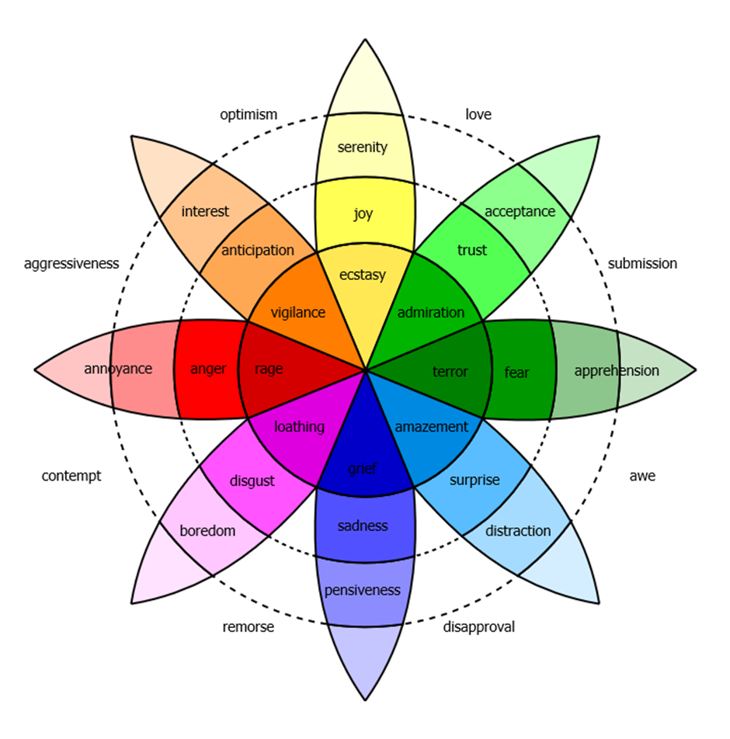
Read more about Plutchik's wheel of emotion.

Activities
- Using the chart, note each emotion you feel has been represented in the film.
- Chart the shifting emotions on a timeline for one key character.
- What are the emotions you felt as a responder to the narrative? Note when, during the course of the narrative, those emotions changed.
- What narrative devices or film techniques are used by the composer to emotionally manipulate the responder at key points in the story?
- How does this manipulation of emotion develop our overall response to the text?

