Resource 3 (1)

Teacher answers for handout 2
- Find a primary source of Abigail William’s testimony against George Jacob’s Jnr. and write the URL below:
  - Smithsonian- A brief History of the Salem Witch Trials
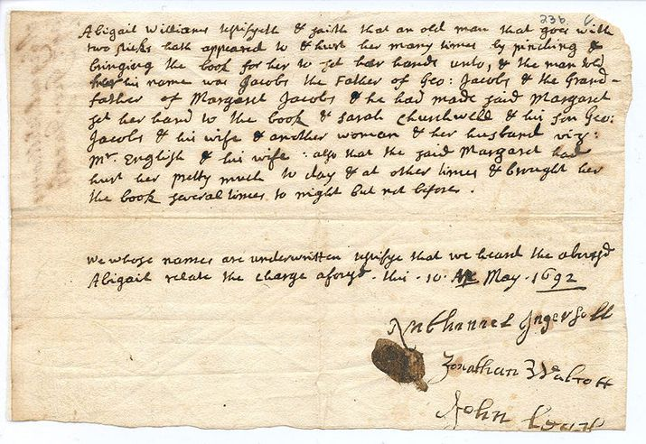
- Watch the following clip The Salem Witch Trials Cartoon and answer the questions below:
  - What two elements helped to fuel the hysteria in the Salem community?
- Threats of attack by the Native American Tribes
- The Smallpox Epidemic
  - What happened at Gallow’s Hill on June 10th 1692?
Bridget Bishop was the first accused witch to be hanged.
- Find the title/description/date/composer of the following lithograph:
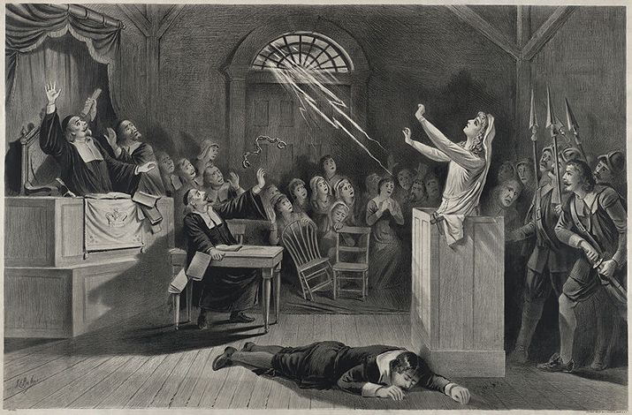
‘The Witch No.1’, 1892 Lithograph, by Joseph E. Baker, depicts lightening breaking the handcuffs of a woman accused of being a witch and strikes down her accuser.
- After viewing the above lithograph, identify 5 visual techniques that have been used by the composer to explore the supernatural elements of the scene:
  - The vector line created by the lightning bolts, leads the viewer’s eye to the raised arms of the accused, allowing them to see that nature has been willed to free her by supernatural means.
  - The salient image of the accused woman is foregrounded in this scene and the shading on her is lighter in contrast to the shadowy figures in the background, thus suggesting that she is a unique being within the courtroom.
  - The facial expressions of the figures in the background show a mix of shock and horror at this supernatural display, and also awe from a mere two figures, suggesting that some individuals are celebrating the accused’s newfound freedom.
  - By employing the Rule of Thirds in this lithograph, the audience distinctly interprets the first third of the lone lightning strike, the middle third which is a mass of huddled onlookers, and the lower third which is the body of the accuser. This juxtaposition suggests that the supernatural elements which are imposed upon the courtroom are unwelcome by most and unnatural.
  - The body language of the onlookers is predominantly defensive as they hold their weapons guardedly or hold their hands up to protect themselves, suggesting that they are fearful of this supernatural event.
- Who said, ‘I was taken very ill again all over & felt a great pricking in ye soles of my feet, and after a while I saw apparently the shape of Margret Scott, who, as I was sitting in a chair by ye fire pulled me with ye chair, down backward to ye ground, and tormented and pinched me very much, and I saw her go away at ye door, in which fit I was dumb and so continued till ye next morning, finding a great load and heaviness upon my tongue …’?
Mary Daniel, as can be found at: Sarah Pruitt- Document That Condemned a Woman to Death in the Salem Witch Trials
- List three of each of the following:
  - Women convicted as witches and executed
  - Accusers who were “afflicted”
  - Other accusers
  - Convicted and pardoned
  - Died in prison
List of these people can be found at: List of people of the Salem witch trials- Wikipedia

