Resource 2 (1)

Web quest worksheet
- Find a primary source of Abigail William’s testimony against George Jacob’s Jnr. and write the URL below:
- Watch the following clip The Salem Witch Trials Cartoon and answer the questions below:
  - What two elements helped to fuel the hysteria in the Salem community?
  - What happened at Gallow’s Hill on June 10th 1692?
- Find the title/description/date/composer of the following lithograph:
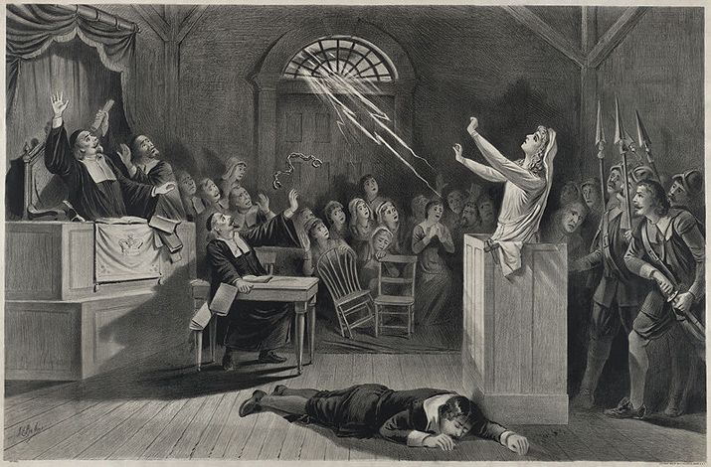
- After viewing the above lithograph, identify 5 visual techniques that have been used by the composer to explore the supernatural elements of the scene:
- Who said, ‘I was taken very ill again all over & felt a great pricking in ye soles of my feet, and after a while I saw apparently the shape of Margret Scott, who, as I was sitting in a chair by ye fire pulled me with ye chair, down backward to ye ground, and tormented and pinched me very much, and I saw her go away at ye door, in which fit I was dumb and so continued till ye next morning, finding a great load and heaviness upon my tongue …’?
- List three of each of the following:
  - Women convicted as witches and executed
  - Accusers who were “afflicted”
  - Other accusers
  - Convicted and pardoned
  - Died in prison

