Microwriting – getting practical in English
Planning and programming support for English Advanced and Standard, Module C: The Craft of Writing

Table of contents
Microwriting – getting practical in English 0
Rationale 3
Introduction 3
Purpose, audience and suggested timeframes 3
Learning intentions and success criteria 4
Microwriting in Stage 6 5
Comparing Year 11 to Year 12 5
Using the syllabus to design tasks 9
Activity 1 – Mapping writing content for outcome 9 11
Activity 2 – Connect, extend, challenge 14
The principles of microwriting 15
The English Textual Concepts 15
Microwriting activities and samples 19
Playing with punctuation 19
Creating characterisation 19
Experimenting with adaptation 20
Using a trope or motif 20
Mentor texts 21
Imitation writing 22
Additional microwriting activities 24
Reading for meaning 24
Activity 3 – teachers as writers 24
Collaboration space 27
Further reading 29
Share your experiences 29
English curriculum team’s resource evaluation 29
Further support 29
Quality assurance alignment 30
Evidence base 31
Curriculum 32
References 32
Links to third-party websites 32
Use of NESA resources 33
Updating the table of contents
Want to update the table? Have you added content to the document and noticed the page numbers have changed? As you add content to this booklet, you can update the table of contents to accurately reflect the page numbers within the resource. To update the table:
- Right click on the table and select ‘Update table of contents’ (in the browser version) or ‘Update field’ (in the desktop app). In the browser version, it will automatically update the entire table.
- In the desktop app, you will then need to select ‘Update entire table’. Your table numbers should then update to reflect your changes.

Rationale
This resource has been designed for use by teachers of Stage 6 English. The material is designed to support programming of Module C: The Craft of Writing in the HSC English Standard and English Advanced courses.
This booklet is not a standalone resource. It was created as a support for the English curriculum team 7-12 statewide staffroom meeting on 7 June 2022. It should be read in conjunction with the recording and/or transcript of the recording of this virtual meeting.
The content in this resource booklet has been prepared by the English curriculum team, unless otherwise credited. The English curriculum team have created a series of other HSC support resources for English Advanced and English Standard which could be used to complement this resource.

Introduction
This document is intended to support planning and programming for Module C: The Craft of Writing.

Purpose, audience and suggested timeframes
Integrating purposeful writing activities throughout the HSC course helps build student writing capacity. Examples of microwriting activities and samples of writing are provided. These could serve as models for teachers when they design microwriting tasks suitable for their school context. A showcase section is provided, and this demonstrates ways to use the syllabus outcomes and associated content points, as well as the English textual concepts, to guide the construction of microwriting tasks.
Ways to use this resource:
- use the section of outcomes and associated content points and the English textual concepts as professional learning during faculty meetings or planning days
- use the activity and sample with students
- adapt the activities to suit the specific writing needs of students
- use the examples of microwriting tasks as inspiration for designing student-specific microwriting tasks
- backward map the microwriting strategies and activities into Years 7 to 11.
Some of the information in this resource is collated from relevant NESA and DoE documentation. It is important that all users re-read and cross-reference the relevant syllabus, assessment and reporting information hyperlinked throughout. This ensures the content is an accurate reflection of the most up to date syllabus content. Links contained within this resource were correct as of 21 June 2022.

Learning intentions and success criteria
During this session, we aim to:
- deepen your understanding of the knowledge and skills required of students in Module C: The Craft of Writing
- demonstrate how microwriting activities can be embedded throughout Stage 6 to encourage and foster writing skills.
By the end of this session, you will:
- distinguish between the skills and knowledge required of students in Module C and identify how this knowledge and skill development can be supported in teaching and learning activities, informed by the syllabus requirements
- consider how microwriting tasks can be integrated into your HSC lessons throughout the year
- reflect on how you can use microwriting as a formative assessment tool to monitor and support student understanding and skill development in writing.

Microwriting in Stage 6
Where does Module C ‘fit’ in a Stage 6 scope and sequence?
Image 1 – Diagram representing backward mapping from Year 12 to Year 11

Comparing Year 11 to Year 12
It is useful to compare the knowledge and skills developed within the Year 11 module Reading to Write with Year 12 Module C: The Craft of Writing. The following tables provide a breakdown of each module description.
Table 1 provides a breakdown of the content students will understand through their study of the modules in Year 11 and Year 12. It is useful to compare these to identify the progression in content knowledge across Stage 6 English.
Table 1 – Comparison of module descriptions for 'students understand why'
Reading to Write  Students understand why: | The Craft of Writing  Students understand why:
a quality text is to be appreciated for its complexity of ideas, relationships, endeavours and scenarios | various language forms and features, for example structure, tone, imagery and syntax, are used for particular effect
developing a perceptive response to a text involves a thoughtful and considered critique | reading and writing complex texts broadens the repertoire of their vocabulary and extends control of spelling, punctuation and grammar to gain further understanding of how their own distinctive voice may be expressed for specific purposes
it is important to reflect on the reading and writing process | writers of complex texts use language creatively and imaginatively for a range of purposes, to describe the world around them, evoke emotion, shape a perspective or to share a vision
close study of texts develops insights into the world, the lives of others and themselves as composers and responders | texts drawn from enduring, quality texts of the past as well as from recognised contemporary works provide opportunities to appreciate, analyse and assess the importance and power of language
reflection is a core component of the reading and writing process | [they require] opportunities to work independently and collaboratively to reflect, refine and strengthen their own skills in producing crafted, imaginative, discursive, persuasive and informative texts.
audience, purpose and context directly impact choices in language form, features and structure | N/A
reflection on the distinctions between texts enhances understanding of how knowledge of language patterns, features and structures can be applied to other texts | N/A
purposeful crafting shapes meaning and influences responses. | N/A
Table 2 provides a breakdown of the content students will understand through their study of the modules in Year 11 and Year 12. It is useful to compare these to identify the progression in skills across Stage 6 English.
Table 2 – comparison of module descriptions for 'students know how to'
Reading to Write  Students know how to: | The Craft of Writing  Students know how to:
undertake intensive and close reading of critical and creative texts from various modes and media | respond and compose for a range of purposes and audiences to further develop skills in comprehension, analysis, interpretation and evaluation
express appreciation, comprehension, understanding, analysis and evaluation of quality texts | analyse and assess texts using appropriate terminology, register and modality
structure a perceptive response through judicious reflection of specific skills and knowledge | write for a range of authentic purposes to convey ideas with power and increasing precision
critique texts from a thematic, aesthetic, stylistic and/or conceptual lens | appreciate, examine and analyse at least two challenging short, prescribed texts as well as texts from their own wide reading, as models and stimulus for the development of their own ideas and written expression
compose complex imaginative and reflective texts | reflect on the complex and recursive process of writing to further develop their ability to apply knowledge of textual forms and features in their own sustained and cohesive compositions
employ language precisely and appropriately reflecting specific audience, purpose and context | throughout the stages of drafting and revising, experiment with a range of language forms and features, for example imagery, rhetoric, voice, characterisation, point of view, dialogue and tone
engage in imaginative re-creation in various modes and experiment with language patterns, features and structures of texts | consider purpose and audience to carefully shape meaning
experiment with tone, imagery, style, concept, representation, form, point of view, vocabulary, spelling, punctuation, grammar, syntax, genre, theme, register, modality, audience, purpose and context etcetera. | during the editing stages apply the conventions of syntax, spelling, punctuation and grammar appropriately and effectively for publication.

Using the syllabus to design tasks
Mapping content in the syllabus – outcome EN12-3.
When designing a task, teachers should select an outcome to guide their thinking. This outcome should be what students are expected to demonstrate at the completion of the task. The task should align with the outcome and the intent of the module. This approach is demonstrated in Image 2 for outcome 3 in English Standard.
Image 2 – Mapping content for English Standard outcome EN12-3
In Image 3, the planning approach is also modelled for outcome 4, English Advanced.
Image 3 – Mapping content for English Advanced outcome EA12-4

Activity 1 – Mapping writing content for outcome 9
Use column 2 of Tables 1 and 2, which provide the breakdown of Module C, to match the relevant parts of the module description to outcome 9 and its associated content points for the course you are currently teaching (EN12-9 or EA12-9). The outcome and associated content points for English Standard and English Advanced are provided below.

English Standard
Outcome EN12-9 – A student reflects on, assesses and monitors own learning and refines individual and collaborative processes as an independent learner.
Associated outcome content points:
- Students engage personally with texts:
- monitor and assess the effectiveness of their various learning strategies in English
- recognise that reading, viewing and listening are active and interactive processes in which personal experiences and expectations influence understanding and interpretation.
- Students develop and apply contextual knowledge
- assess their own strengths and needs as learners and apply strategies for ongoing improvement
- support the learning of others by objectively assessing their strengths and needs as learners and offering constructive feedback as appropriate
- assess individual and collaborative processes appropriate for particular learning contexts
- assess how technology can be used to enhance their learning.
- Students understand and apply knowledge of language forms and features
- understand and use appropriate metalanguage and textual forms to assess and reflect on their own learning and that of others.
- Students respond to and compose texts
- use writing as a tool to reflect on their own learning, assessing how processes can be adjusted to ensure better learning outcomes
- use critical and constructive feedback from others to improve learning, including their composing and responding
- assess the strengths and weaknesses of their own compositional style and improve compositions as a result of the process of reflection (NESA, 2017).

English Advanced
Outcome EA12-9 – A student reflects on, evaluates and monitors own learning and refines individual and collaborative processes as an independent learner (EA12-9).
Associated outcome content points:
- Students engage personally with texts
- reflect on and discuss personal preferences and insights gained from familiarity with a wide repertoire of complex texts.
- Students develop and apply contextual knowledge
- select, adapt and create individual and collaborative processes that are effective for a range of learning contexts
- express the pleasures and difficulties, successes and challenges experienced in independent and collaborative work in order to improve practices.
- Students understand and apply knowledge of language forms and features
- reflect on their development as skilful and confident composers, in particular how they have experimented with and refined language choices to establish a distinctive personal style
- use appropriate metalanguage and textual forms to assess and reflect on their own learning and that of others.
- Students respond to and compose texts
- critically evaluate feedback from others and make adjustments to improve responding and composing in a range of learning contexts
- independently reflect on and experiment with their own processes of responding to and composing texts (NESA, 2017).

Matching syllabus content
Use column 2 of Tables 1 and 2, which provide the breakdown of Module C, to match the relevant parts of the module description to the outcome 9 and/or the associated content points for the Year 12 course you are currently teaching.
Table 3 – Activity 1 working space
Activity 1 working space
Write your answer/record your thinking here

Activity 2 – Connect, extend, challenge
Use the skills and knowledge tables to reflect on your thinking about Module C through these focus questions:
- How does the breakdown of the module description connect to your current teaching of Module C?
- How did this section extend your understanding about ways to teach Module C?
- What challenges or puzzles emerge for you?
Table 4 – Activity 2 working space
Activity 2 working space
Write your answers/record your thinking here

The principles of microwriting
Timed writing drills in which there are:
- clear and explicit instructions
- focused writing strategies
- specified writing features/ focus (the English Textual Concepts).
Mentor texts such as:
- Module C prescribed texts
- prescribed texts from one of the other modules
- an additional text used to complement teaching and learning of the prescribed text.
The English Textual Concepts
To focalise a microwriting task, consider using the English Textual Concepts. At times, it might be beneficial to explicitly teach aspects of the concepts. This can be done by visiting the English Textual Concepts website or through reference to the concepts via posters displayed in your classroom. This will benefit students who can apply the metalanguage in their reflections or justifications.
Which English textual concepts?
- Code and convention
- Genre
- Style
The following posters are currently stored in the English Statewide Staffroom (SWS) in the Stage 4 and Stage 5 channels and will be uploaded to the webpage soon.
Image 4 – English textual concept poster for 'Code and Convention'
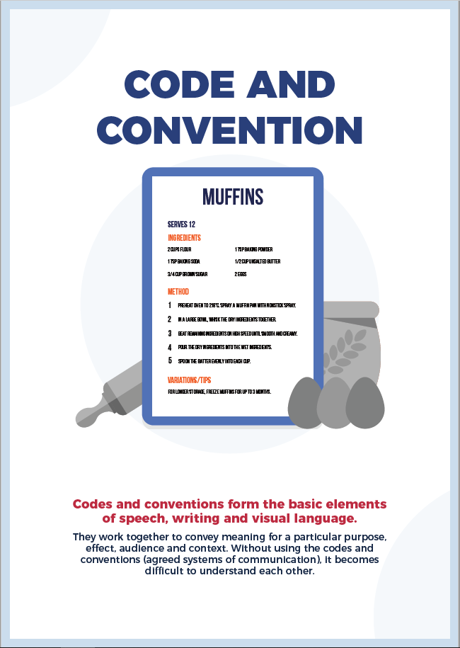
Image 5 – English textual concept poster for 'Genre'
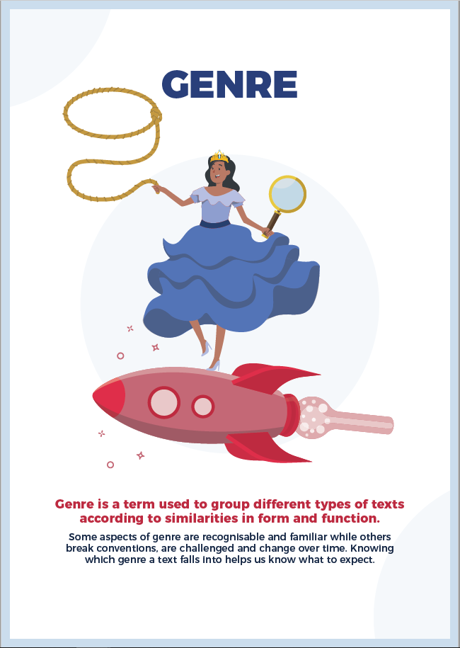
Image 6 – English textual concept poster for 'Style'

Microwriting activities and samples
The following activities are samples of microwriting tasks which fulfil the principles of microwriting. These can be completed as timed writing activities to build students’ capacity to respond to a stimulus quickly. Completing these with your students would also allow for discussion of the product and provide an opportunity for editing.

Playing with punctuation
Instructions to students:
- Write the opening of an imaginative response in which you play with punctuation. Follow these guidelines:
- start with the name of a place (in the first sentence)
- no (human) characters permitted
- use at least 5 types of punctuation (for example: full stop, exclamation, ellipsis, hyphen, bracket, question mark, inverted comma, caps lock, etcetera).
- Challenge: explain how these limitations impacted the flow of your creative thinking and the strategies you could use to overcome them.
Sample of writing
There's something enchanting about a cemetery after sunset in summer. Perhaps it is the stark contrast of the long days and short nights ... Or the quiet wind stirring the spirits? Whatever the reason, there's no doubt a graveyard after sunset in summer is far less haunting than after sunset in winter. Though – without doubt – the spirits prefer the winter nights ... (After all, they have longer to play and mingle!)

Creating characterisation
Instructions to students:
- Write the opening of an imaginative piece which introduces the character (and their context/attitude to life) through their reaction to a meal.
- Challenge: use imagery to capture the character’s sensory reaction to this meal in anticipation of devouring it.
Sample of writing
‘Simple but perfect,’ I tell myself. The perfect breakfast to wake up for ... The sound of the kettle boiling and the crunch of the block breaking in my hands sharpens my anticipation. My mouth waters as the perfect amount of pre-packaged spices are poured carefully into the bowl. The boiling water warms the whole kitchen, the steam caressing my face. The dryness in my throat eases as I imagine the first bite. I am preparing the meal of a lifetime – 2-Minute Noodles, fit for a king.

Experimenting with adaptation
Instructions to students:
- Spend 5 minutes reading your favourite fairy tale or fable. Note, you will be using this narrative as the basis of an adaptation.
- Retell part of the narrative from another character's perspective.
- Justify your choices and how this appropriation influences reader's values.
Sample of writing
Jack, the thief
Once upon a time, in a readership whose values were distorted by amplified emotional reactions for those who are poor, there was a pathetic child, JACK, who used his social status as an excuse to steal. And the antagonist in this story wasn't him! It was me! My name's Thunder. I'm a giant who (unfortunately) lives in the clouds directly above Jack's pathetic cottage. The last day Jack stole from me an entire pot of gold and my harp, I cut the beanstalk he'd been using for his break-and-enter shenanigans. I chopped it in half and Jack tumbled to earth, crashing through the straw roof of his home and breaking both his legs. Serves him right. Right? You'd think so BUT guess who ended up in Cloud Prison for reckless behaviour resulting in intentional bodily harm? Not Jack! I've served the five-year sentence and tomorrow I will be released. Fe, fi, fo, fum ... I smell the blood of an Englishman!

Using a trope or motif
Instructions to students:
- Use colour in a purposeful way to construct the setting of your narrative. Consider these guidelines:
- colour may be used metaphorically to represent emotions
- colour may be used as a motif
- colour may be used as a concept to create a trope
- colour may be removed from the setting of the text to create atmosphere (think Pleasantville)
Sample of writing
The grey walls of the city never changed. They did not fade. They did not rust. They had no shade – just grey. Times changed but the grey of the walls was constant. Slowly, the colour of the city's people matched the grey of the walls. No one knew if this happened by consequence or if it was due to eyesight ... most people no longer remembered colours other than grey. Only one person remembered! He had his late father’s water paints hidden in the bed mattress – sewn into it. Occasionally, when he was afraid he'd forget colour, then he'd unpick the stitching, look at them intently and then sew them in again, hours later.

Mentor texts
Instructions to students:
- Read the excerpt from Anne Bronte's The Tenant of Wildfell Hall to answer the following question: How does the writer use at least one language device or stylistic feature to create a sense of place?
- Use one of the features described to compose the opening of an imaginative piece in which you create a sense of place.
Excerpt from a mentor text:
Excerpt from Chapter II of The Tenant of Wildfell Hall
Near the top of this hill, about two miles from Linden-Car, stood Wildfell Hall, a superannuated mansion of the Elizabethan era, built of dark grey stone, venerable and picturesque to look at, but doubtless, cold and gloomy enough to inhabit, with its thick stone mullions and little latticed panes, its time-eaten air-holes, and it's too lonely, too unsheltered situation,—only ,shielded from the war of wind and weather by a group of Scotch firs, themselves half blighted with storms, and looking as stern and gloomy as the Hall itself. Behind it lay a few desolate fields, and then the brown heath-clad summit of the hill; before it (enclosed by stone walls, and entered by an iron gate, with large balls of grey granite—similar to those which decorated the roof and gables—surmounting the gate-posts) was a garden,—once stocked with such hard plants and flowers as could best brook the soil and climate, and such trees and shrubs as could best endure the gardener’s torturing shears, and most readily assume the shapes he chose to give them,—now, having been left so many years untilled and untrimmed, abandoned to the weeds and the grass, to the frost and the wind, the rain and the drought, it presented a very singular appearance indeed (Bronte, 1848).

Imitation writing
Instructions to students:
- Use the annotated excerpt from the Standard Module C prescribed text Crouch End by Stephen King to annotate another excerpt from this prose fiction text.
- Contribute to a class discussion about how the identified features create tension.
- Use this excerpt and the annotations as a model for writing your own paragraph in which tension is constructed. Note that it is not necessary to use the exact same features or to use them in the same order (however, if it helps to do this, that is fine).
Table 5 provides a sample of how a mentor text can be analysed using the forensic reading strategy which then leads to students using the features of language and form in their own writing.
Table 5 – Forensic reading of an excerpt from Crouch End
Sentences from the text | Forensic reading | Have a go
They were almost out – it was a very short underpass, she thought with ridiculous relief – when the hand grasped her upper arm. | Tension – the hope that Lonnie would be freed is built and then suddenly disrupted. | [student writing sample]
She didn’t scream. | Short sentences – included between longer sentences to jar the pace and make things seem more frantic. | [student writing sample]
Her lungs seemed to have collapsed like small crumpled paper sacks. | Simile – adds to the image of Doris’ immense distress. | [student writing sample]
Her mind wanted to leave her body behind and just… Fly. | Truncated sentence – abrupt and adds to the heightening fear in readers. | [student writing sample]
Lonnie’s hand parted from her own. | Personified body parts – they have no control of themselves. | [student writing sample]
He seemed unaware. | Another short sentence (followed by a significantly longer one). | [student writing sample]
He walked out on the other side – she saw him for just one moment silhouetted, tall and lanky, against the bloody, furious colors of the sunset, and then he was gone. | Imagery – creates an eerie description and creates an ominous atmosphere. | [student writing sample]
Sample of writing
John knew he only had to hold onto the metal bar for a few more minutes and then he would be able to drop to safety. Drop. The mere thought of this made his arms wobble like jelly and he wondered if he should just give up now and plummet into the red lava bubbling beneath him. But he couldn’t. Thinking of his parents, he couldn’t let go to meet death. His heart leapt into his throat, choking him. Weakening his grip. And this time, even if he didn’t want to give up, he had little choice. His fingers unfurled as his feet dragged him down.

Additional microwriting activities
Exploring Module C prescribed texts helps students read for meaning.

Reading for meaning
Suggested activities to ensure students understand the text:
- Write a condensed version of the plot line, using poignant quotes from the text itself.
- Complete a character profile on one of the characters in the text.
- Use a graphic organiser to compare the representation of characters in each text.
- Listen to the paragraphs in which the setting is described in a vivid way. Complete a sketch to stretch representing this setting.
- Write a feature article about a point of tension in the plot – this could be completed in a discursive style and would allow for explicit teaching of discursive writing.
- Write a review of the text, using features of persuasive writing, to showcase why the text is suitable for study in Module C.

Activity 3 – teachers as writers
Write a compressed version of this excerpt from Nam Le's text.
- “Very fancy,” he said as he led me through my own apartment. “You even have a piano.” He gave me an almost rueful smile. “I knew you’d never really quit.” Something almost moved behind his face and I found myself back on a heightened stool with my fingers chasing the metronome, ahead and behind, trying to shut out the tutor’s repeated sighing, his heavy brass ruler. I realised I was massaging my knuckles. My father patted the futon in my living room. “I’ll sleep here.”
- “You’ll sleep in my room, Ba.” I watched him warily as he surveyed our surroundings, messy with books, papers, dirty plates, teacups, clothes – I’d intended to tidy up before going to the airport. “I work in this room anyway, and I work at night.” As he moved into the kitchen, I grabbed the three-quarters-full bottle of Johnnie Walker from the second shelf of my bookcase and stashed it under the desk. I looked around. The desktop was gritty with cigarette ash. I threw some magazines over the roughest spots, then flipped one of them over because its cover bore a picture of Chairman Mao. I quickly gathered up the cigarette packs and sleeping pills and incense burners and dumped them all on a high shelf, behind my Kafka Vintage Classics.
- At the kitchen swing door I remembered the photo of Linda beside the printer. Her glamour shot, I called it: hair windswept and eyes squinty, smiling at something out of frame. One of her ex-boyfriends had taken it at Lake MacBride. She looked happy. I snatched it and turned it facedown, covering it with scrap paper.
Your purpose is to capture the mood in the scene and to showcase the personality of the character.
Guidelines:
- use no more than 8 quotes
- use whole clauses or quotes
- write 50 words.
Some samples from participants during the workshop on 7 June 2022
- He gave me an almost rueful smile. ‘You'll sleep in my room, Ba.’ I watched him warily as he scanned messy books, papers, dirty plates, teacups, clothes, whiskey, ash; Linda – her glamour shot. I snatched it and turned it facedown.
- ‘I knew you'd never quit,’ he gave me a rueful smile as I sat near the ebony and ivory board. Knuckles cracking, I glanced around at the mess and picked up the bottle of JW and hid it deep under the coffee table. With a quick sweep of my arm, the magazines and old newspapers now sat in front of Johnnie. Keeping him a secret.
- As my father moved through my apartment, his commentary conveyed his judgment on my perceived excesses. His ‘I'll sleep here,’ as he patted the futon in my living room was a jab, reminding me of his sacrifices. Our relationship re-established, I became my teenage self, cleaning and hiding my life.
- That was the moment. It had always been the moment, I just hadn’t seen it before. The moment that the glass cracked, stretched its tendrils until it shattered. That moment. That word. I snatched it and turned it face down.
- ‘You’ll sleep in my room, Ba.’ He gave me an almost rueful smile. ‘I work in this room anyway, and I work at night.’ I grabbed the three-quarters-full bottle of Johnnie Walker trying to shut out the tutor’s repeated sighing. The desktop was gritty with cigarette ash behind my Kafka Vintage Classics.
Use Table 6 to complete Activity 3.
Table 6 – Activity 3 working space
Activity 3 working space
Write your response here

Collaboration space
The suggestions in the table below are a compilation of tasks designed by the English curriculum team and responses from participants shared in the chat during the live meeting on 7 June 2022.
Add additional rows to the table to record your own ideas.
Table 7 – Statewide staffroom collaboration table
Craft of Writing tasks
Building a character
When reading a narrative, much of what we imagine of a character is inferred from the clues the writer creates. As Stephen King said 'description begins in the writer's imagination but should finish in the readers'.
Let’s get this started. Choose a character from one of the texts you have studied in Module A, B or C. Use this character as inspiration for crafting a new character. That is, take inspiration from this character to build your own. Use timed writing – no more than two minutes – to respond to each of these writing prompts. Keep in mind that these are intended as prompts for planning, to help you create this character.
- What event shaped your character emotionally, in the past?
- How has this manifested in the present?
- What impact will this have in the future?
- What big choices has your character had to make that have been impacted by this emotional experience?
Aim to answer these questions in an imaginative way. However, if it suits you better (for now) to simply retell or describe, that is appropriate at this stage.
Using the character you created in the previous activity, write a diary entry or internal monologue in which your character describes the moment when they met their idol (this does not mean someone famous) and the idol didn’t live up to their expectation. To accentuate your character’s disappointment, use contrast – what they anticipated and the reality.
Use a series of quotes from the collection of Gray’s poems studied in Standard Module B to employ intertextuality in an imaginative response about ones newfound connection with the landscape.
Write to a character from The Castle. In your email/letter, use emotive language in a measured way to explain why their values resonate with your own. Challenge: use a personal anecdote to exemplify your purpose in reaching out to this person.
Write an opinion piece about identity and culture in which you attempt to use humour to express your point about a topic which the majority think differently about.
Focusing on the composer’s use of imagery, use stretch to sketch to create an image of the main idea in each stanza of the poem you have read. Choose one of these images and recreate it as a prose paragraph. Aim to use imagery in the same style as the poet.
Take a pivotal moment in which two characters are represented and write about the scene from another character’s point of view or from the view of a third party onlooker.
Compose part of an imaginative response in which you explore the complexity of responsibility. Include at least one device used by Harwood in Father and Child. This device could be an extended metaphor, motif, the diptych structure, powerful symbolism (linked to nature, day, night), juxtaposition, visceral imagery, characterisation, or another language feature used by Harwood which stands out for you. You may want to create a character relationship where a child or young person takes responsibility, they are not yet ready for and must deal with the consequences. They may be forced to take responsibility by somebody who is elder/mentor to them.

Further reading
The content of this presentation was inspired by Creating Microstories: Small fiction with big impact by Erika Boas and Emma Jenkins. This AATE resource contains writing strategies that can be applied to students working across Stages 4 to 6. Some of the microwriting activities in this presentation can also be adapted for younger students.

Share your experiences
If you employ a microwriting strategy in your classroom, reach out to the English curriculum team. We would love to hear about your experience. You may also like to consider elaborating on a microwriting success for our ‘Voices from the Classroom’ section of our newsletter. All submissions can be sent to Englishcurriculum@det.nsw.edu.au

English curriculum team’s resource evaluation
Please complete the 2 minute online feedback form. This will help the English curriculum team improve the resources and support provided on the website and in the English SWS.

Further support
Need additional support? You can contact the English curriculum team by emailing English.curriculum@det.nsw.edu.au.

Quality assurance alignment
School Excellence Framework: This resource aligns to the School Excellence Framework elements of curriculum (curriculum provision and teaching and learning programs) and effective classroom practice (lesson planning). This resource booklet helps teachers plan and monitor student writing. It highlights opportunities to design teaching and learning programs that are dynamic, show evidence of revision based on feedback on teaching practices in relation to continuous tracking of progress and achievement. Teachers are also provided a syllabus aligned procedure for collaboratively planning for syllabus requirements and differentiation.
Australian Professional Standards for Teachers: It supports teachers to address Australian Professional Teaching Standards 1.5.2, 2.1.2, 2.3.2 and 3.2.2 as it helps teachers to plan their teaching and learning programs reflective of student need and curriculum requirements.
NSW Syllabus: NSW Syllabus for the Australian Curriculum English Advanced Stage 6 Syllabus and the NSW Syllabus for the Australian Curriculum English Standard Stage 6 Syllabus.
Syllabus elements: Module and examination requirements
Author: English 7-12 Curriculum Team
Reviewed by and/or trialled by: English Teachers Association State Conference participants and English teachers participating in the English SWS professional learning event
Publisher: NSW Department of Education
Resource: Microwriting professional learning participant resource
Related resources: further resources to support curriculum leadership and the implementation and evaluation of course requirements can be found on the Leading English K-12 curriculum web pages, English HSC hub and the English Standard and English Advanced curriculum web pages.
Professional Learning: Join the English statewide staffroom (7-12) and explore on demand professional sessions for ongoing professional learning opportunities
Universal Design for Learning Tool: Universal Design for Learning planning tool. Support the diverse learning needs of students using inclusive teaching and learning strategies
Creation date: 05 June 2022
Review date: 10 December 2022
Rights: © State of New South Wales, (Department of Education), 2022

Evidence base
This resource supports teachers to engage in explicit teaching practices as part of the teaching and learning cycle. Practical strategies for explicit teaching, as outlined in the What works best 2020 update, include providing opportunities for guided, and then independent practice, in conjunction with using high-quality exemplars which are supported by detailed annotations. The pedagogical practices modelled in this resource align with the development of intellectual quality, per the NSW quality teaching model, supporting teachers to demonstrate the elements of deep understanding and substantive communication. Other demonstrable elements of quality teaching supported by the approaches presented in this resource include engagement and student direction.
‘All students need to be challenged and engaged to develop their potential fully’ (CESE What works best update 2020 [PDF 1.11KB]). Differentiated learning can be enabled by differentiating the teaching approach to content, process, product and the learning environment. For more information on differentiation go to Differentiating learning (nsw.gov.au) and Differentiation (nsw.gov.au). In accordance with the Disability Standards of Education (2005), some students with disability are entitled to adjustments to ensure that they can access and participate in education on the same basis as students without disability. Adjustments must be consulted on with students/parents and recorded. Teachers may evidence adjustments in student plans or annotate on teaching and learning programs, depending on the individual student’s needs.
- CESE (Centre for Education Statistics and Evaluation) (2017) Cognitive load theory: research that teachers really need to understand, NSW Department of Education, cese.nsw.gov.au
- CESE (centre for Education Statistics and Evaluation) (2018) Cognitive load theory in practice, NSW Department of Education, cese.nsw.gov.au
- CESE (Centre for Education Statistics and Evaluation) (2020b) What works best 2020 update, NSW Department of Education, cese.nsw.gov.au
- Quality Teaching Framework, NSW Department of Education, Elements of Learning and Achievement

Curriculum
- NESA website. © 2017 NSW Education Standards Authority (NESA) for and on behalf of the Crown in right of the State of New South Wales.
- NSW syllabus for the Australian curriculum English Standard Stage 6 Syllabus outcomes © 2017 NSW Education Standards Authority (NESA) for and on behalf of the Crown in right of the State of New South Wales (accessed on 5 June 2022).
- NSW syllabus for the Australian curriculum English Advanced Stage 6 Syllabus outcomes © 2017 NSW Education Standards Authority (NESA) for and on behalf of the Crown in right of the State of New South Wales (accessed on 5 June 2022).

References
Boas E and Jenkins E (2019) Creating micro stories, AATE, Australia.
Bronte A (1848) The Tenant of Wildfell Hall, Penguin Classics, London.
King S (1980) ‘Crouch End’, in Campbell R (ed) New Tales of the Cthulhu Mythos, Arkham House Publishers, United States
Le N (2012) Love and Honour and Pity and Pride and Compassion and Sacrifice, Penguin eBooks, Australia

Links to third-party websites
Please note that the provided reading and viewing material and third-party hyperlinks are a suggestion only and implies no endorsement, by the New South Wales Department of Education, of any author, publisher or book title. School principals and teachers are best placed to assess the suitability of resources that would complement the curriculum and reflect the needs and interests of their students. All materials must be viewed in their entirety prior to use. If you use the links provided on this website to access a third party's website, you acknowledge that the terms of use, including licence terms set out on the third party's website apply to the use which may be made of the materials on that third party website or where permitted by the Copyright Act 1968 (Cth).
The department accepts no responsibility for content on third-party websites. If this resource contains links to your website and you have any objection to such link, please contact english.curriculum@det.nsw.edu.au. If you have any questions regarding use of material available in this digital platform, please contact the English curriculum team at english.curriculum@det.nsw.edu.au.

Use of NESA resources
Users of this content are reminded of the following advice from NESA:
‘The NESA website holds the only official and up-to-date versions of these documents available on the internet. Any other copies of these documents, or parts of these documents, that may be found elsewhere on the internet might not be current and are not authorised. You cannot rely on copies from any other source.
The documents on the NESA website contain material prepared by NESA for and on behalf of the Crown in right of the State of New South Wales. The material is protected by Crown copyright.
All rights reserved. No part of the material may be reproduced in Australia or in any other country by any process, electronic or otherwise, in any material form, or transmitted to any other person or stored electronically in any form without the prior written permission of NESA, except as permitted by the Copyright Act 1968.
When you access the material, you agree:
- to use the material for information purposes only
- to reproduce a single copy for personal bona fide study use only and not to reproduce any major extract or the entire material without the prior permission of NESA
- to acknowledge that the material is provided by NESA
- to include this copyright notice in any copy made
- not to modify the material or any part of the material without the express prior written permission of NESA.
The material may contain third-party copyright materials such as photos, diagrams, quotations, cartoons and artworks. These materials are protected by Australian and international copyright laws and may not be reproduced or transmitted in any format without the copyright owner’s specific permission. Unauthorised reproduction, transmission or commercial use of such copyright materials may result in prosecution.
NESA has made all reasonable attempts to locate owners of third-party copyright material and invites anyone from whom permission has not been sought to contact the Copyright Officer.
Phone: (02) 9367 8289, Fax: (02) 9279 1482, Email: copyright@nesa.nsw.edu.au, © 2017 NSW Education Standards Authority (NESA) for and on behalf of the Crown in right of the State of New South Wales.’

