Resource 3 – 3 way Venn diagram
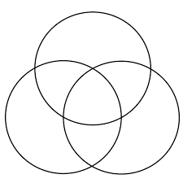
Figure 1 https://commons.wikimedia.org/wiki/File:Flower_of_Life_3-circles2.svg

