Student workbook: Character
Name:
Class:

Lesson 1
During this lesson you will learn to:
- identify how authors create characters to engage the reader
- identify a character’s goals and flaws in a text
- describe the emotional reactions characters can provoke in readers.

1.1 Speaking and listening
You will choose a familiar character from a text (movie or book). Without naming the character, describe that character to an adult, focusing on the character’s appearance, actions and behaviours.
The adult will try to guess the character, using the clues given.

1.2 Character video
After watching the character video, answer the following questions:
Do characters always have to be human? Explain.
________________________________________________________________________________________________________________________________________________________________________________________________________________________
Why are characters important in a story?
________________________________________________________________________________________________________________________________________________________________________________________________________________________
How do authors get their audience to connect with characters?
________________________________________________________________________________________________________________________________________________________________________________________________________________________
What are some examples of character goals? What was the goal of the volcano?
________________________________________________________________________________________________________________________________________________
What are some examples of character flaws?
________________________________________________________________________________________________________________________________________________

1.3 Character goals and flaws
A character flaw can be defined more fully as an undesirable quality in a person.
A character goal is what a character wants.
Think about the character that you described at the beginning of the lesson. You will identify one thing about the character’s appearance, goals and flaws.
You will write three sentences about the character, one on appearance, one on goal and one on flaws.
Example: Robin Hood is a tall, strong athlete man who usually wears green to blend in with the trees. Robin Hood has one goal, to steal from the rich and give to the poor. His flaws are that he was bossy and arrogant and stole a lot.
My character is _______________________________________________________________________
________________________________________________________________________________________________________________________________________________________________________________________________________________________________________________________________________________________________________________________________________________________________________________________________________________________________________________________________________________________________________________________

1.4 – Reflection
How can you connect with a character in a text?
Why do characters have goals and flaws?
Discuss with an adult.

Lesson 2
During this lesson you will learn to:
- read texts, including poems, using appropriate expression, e.g. pitch, pause, emphasis and attending to punctuation
- use adjectives in noun groups to create more accurate descriptions.

2.1 Speaking and listening
You will listen to the poem ‘Francesca Frog’ by Maura Finn found in The School Magazine. The print poem can also be found in the end of the student workbook.
You will discuss with an adult the way that the reader uses pausing, rhythm intonation and tone to engage the audience. What effect does this have on the poem? What is the author’s intention?
You will read part or all the poem aloud, attempting to use similar intonation.

2.2 Francesca’s appearance
After reading the poem Francesca the Frog, answer the following questions:
What does Francesca look like?
________________________________________________________________________________________________________________________________________________________________________________________________________________________
What do we know about her appearance and how does the author give us that information?
________________________________________________________________________________________________________________________________________________________________________________________________________________________
How tall is she? How do you know?
________________________________________________________________________________________________________________________________________________
What do her feet look like? Draw them.
________________________________________________________________________________________________________________________________________________

How does the author want us to feel about Francesca?
________________________________________________________________________________________________________________________________________________

2.3 Description of Francesca
You will use ‘Francesca’s appearance’ as a prompt to write a paragraph describing Francesca’s appearance.
Use any knowledge you have of frogs, and your understanding of Francesca’s appearance.
Remember to include adjectives and you may like to include similes.
Adjectives describe a noun (beautiful, radiant, large)
Similes compare one thing to another (as brave as a lion)
________________________________________________________________________________________________________________________________________________________________________________________________________________________________________________________________________________________________________________________________________________________________________________________________________________________________________________________________________________________________________________________________________________________________________________________________________________________________________________________________________________________________________________________________________________________________________________________________________________________________________________________________________________________________

2.4 Reflection
Why do authors use adjectives?
What does it provide the reader?
Discuss with an adult.

Lesson 3
During this lesson you will learn to:
- identify purposes for listening
- experiment with language choices to engage the reader
- identify that feelings and emotions are inferred in texts.

3.1 Speaking and listening
You will identify occasions when they learn new things or gain information from listening. Suggestions may include, listening to the weather on the radio, podcasts, discussions with adults and verbal instructions.
Identify the differences between learning new things through listening and learning new things through watching.
Identify the benefits and deficits of learning through listening.

3.2 Noun groups
Read or listen to the text ‘Darcy Does Things Differently’ from The School Magazine.
You will identify noun groups within the text that enhance the characters.
A noun group is a group of words relating to, or building on, a noun.
For example: A tall man with knobbly knees.
You will record the noun group and what the reader can infer about those characters from the noun groups.
Noun Groups
Noun Group | Infer
A decisive young lady, with security in mind. | She knows what she wants and she knew that Billy would make a great security dog. She was young and possibly lived on her own.

3.3 Darcy’s feelings and actions
You will read the following sentence from ‘Darcy Does Things Differently’.
Darcy Dawson Donnelly was a very distinguished dog who suddenly found himself solo in his senior years.
What do we know about Darcy that is explicitly stated?
________________________________________________________________________________________________________________________________________________________________________________________________________________________
What are we able to infer, and how do we infer this?
________________________________________________________________________________________________________________________________________________________________________________________________________________________
What feelings are created for the reader?
________________________________________________________________________________________________________________________________________________________________________________________________________________________
Author intent - how does the author want the reader to feel?
________________________________________________________________________________________________________________________________________________

3.4 Reflection
How can an author infer information about a character?
What did you enjoy about the text Darcy does Things Differently?
Discuss with an adult

Lesson 4
During this lesson you will learn to:
- retell or perform part of a story from a character's point of view
- recognise and use alliteration
- retell a text or event from a character’s point of view.

4.1 Speaking and listening
You are to imagine you are a character in a well-known fairy tale (e.g. wolf in The Three Little Pigs, the witch in Hansel and Gretel or Grandma in Little Red Riding Hood).
Retell a part of a story from a character's point of view.
Share with an adult.

4.2 Alliteration
Read or listen to ‘Darcy Does Things Differently’ from The School Magazine.
You will identify examples of alliteration used in the text. For example: Darcy Dawson Donnelly, distinguished dog, difficult dog, rough rubber
Alliteration used in Darcy Does Things Differently:

Why do authors use alliteration? What is the purpose?
________________________________________________________________________________________________________________________________________________________________________________________________________________________________________________________________________________________________

4.3 A day in the life of Darcy
You will write a diary entry, ‘A Day in the Life of Darcy’ from the perspective of Darcy the main character from ‘Darcy Does Things Differently’.
Think about the feelings and actions that Darcy has about his new home and write about his first day with his new owner.
You will need to convey to the reader how Darcy is feeling, what Darcy is thinking, Darcy’s goal and how his flaws may affect his feelings towards his new home.
________________________________________________________________________________________________________________________________________________________________________________________________________________________________________________________________________________________________________________________________________________________________________________________________________________________________________________________________________________________________________________________________________________________________________________________________________________________________________________________________________________________________________________________________________________________________________________________________________________________________________________________________________________________________________________________________________________________________________________________________________________________________________________

4.4 Reflection
Can you use alliteration to describe a family member?
How did the author show the reader what Darcy was feeling?
Discuss with an adult.

Lesson 5
During this lesson you will learn to:
- respond to and appreciate how Dreaming stories form part of an oral tradition for Aboriginal and Torres Strait Islander peoples
- justify interpretations of a text, including responses to characters.

5.1 Speaking and listening
Discuss with an adult:
- Have you seen traditional Aboriginal art before?
- Where have you seen traditional Aboriginal art? Why do Aboriginal people often use art to tell their stories?
You will look at the artwork ‘Wagilak sisters story’ by Dawidi Birritjama, from the Art Gallery of NSW. Your teacher will provide you with a copy of this artwork.
After looking at the artwork:
- describe the artwork and the story being shared to an adult
- discuss the use of symbols in the artwork
‘Wagilak sisters story’
This artwork is referred to with thanks to the Art Gallery of NSW. Please note that this artwork with need to be prepared for students in a non-digital environment for their student workbook.

5.2 Darcy and Dawn
Read ‘Darcy Does Things Differently’ from The School Magazine. You will focus on the character of Dawn to determine why Darcy was the perfect dog for Dawn.
What sort of companion did Dawn want? Why?
________________________________________________________________________________________________________________________________________________________________________________________________________________________
Why didn’t Dawn care for eagerness and energy?
________________________________________________________________________________________________________________________________________________________________________________________________________________________
What character traits in Dawn suited Darcy?
________________________________________________________________________________________________________________________________________________________________________________________________________________________
What lesson can we all learn from this story? What do you think might be the main message?
________________________________________________________________________________________________________________________________________________________________________________________________________________________

5.3 Character development - illustration
Think of a character that you relate to from a book or a movie. What are the characteristics or personality traits and actions that make this character appealing to you?
You will use this connection to create your own character, identifying behaviours, personality traits and characteristics that you would like your invented character to have.
Draw an illustration of your character.

What personality traits and characteristics does your invented character have?
________________________________________________________________________________________________________________________________________________________________________________________________________________________________________________________________________________________________5.4 Reflection
Why are Dreaming stories important for storytelling?
Darcy was the perfect pet for Dawn, though he wasn’t perfect for many other people. What would your perfect pet be and why?
Discuss with an adult.

Lesson 6
During this lesson you will learn to:
- identify and use similes to enhance character development
- write a detailed character description

6.1 Alphabet chain
With another adult or peers, you will play Alphabet chain.
To play, choose a category and take turns naming an item that fits the category following the sequence of letters of the alphabet.
The first person chooses a word starting with ‘a’, the second person a word beginning with ‘b’, the third person with ‘c’, etc. The category can be anything at all – animals, countries, names, superpowers, etc.

6.2 Similes
Identify the similes that are used in the text, ‘Mr Kessel’s Bush Tucker Garden’ to describe the characters.
For example: as tall as a giant.
Similes compare one thing to another.
Similes are used to give the reader a clear visual of the character.
Similes used in the text:

6.3 Character description
You will use your illustration from the previous (5.3) lesson.
Around your illustration, record adjectives, noun groups, similes and character traits of that character. You will identify your character’s goals and flaws.
Using your illustration, write a description of your character.
________________________________________________________________________________________________________________________________________________________________________________________________________________________________________________________________________________________________________________________________________________________________________________________________________________________________________________________________________________________________________________________________________________________________________________________________________________________________________________________________________________________________________________________________________________________________________________________________________________________________________________________________________________________________________________________________________________________________________________________________________________________________________________________________________________________________________________________________________________________________________________________________

6.4 Reflection
Similes allow the reader to create a visual in their mind. Describe a family member using a simile.
Share with an adult.

Lesson 7
During this lesson you will learn to:
- retell or perform part of a story from a character's point of view
- plan, compose and review imaginative.

7.1 Speaking and listening
You will select a significant event from a book you have read, or a movie you have viewed.
Recount the event, in as much detail as you can, as if you are one of the characters.
In the recount describe how you, as the character, are feeling and what you are thinking.

7.2 Synonyms and antonyms
You will read ‘Mr Kessel’s Bush Tucker Garden’ and identify the adjectives within the text.
You will identify synonyms and antonyms for selected adjectives.
Adjectives, synonyms and antonyms
Adjective | Synonyms | Antonyms
beautiful | pretty, attractive | unattractive, ugly

7.3 Narrative planning
You will be using this elephant as the main character in a narrative.
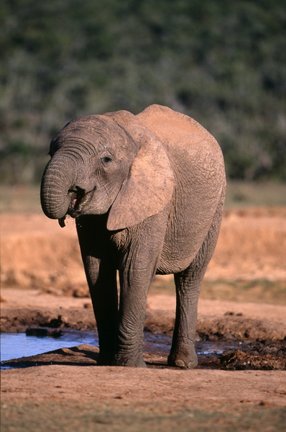
This photo by unknown photographer is licensed under CC BY-ND 3.0
Use the narrative planning below to plan your own character development.
Appearance _______________________________________________________________________
________________________________________________________________________
Personality traits _______________________________________________________________________
________________________________________________________________________
Goals __________________________________________________________________
Flaws __________________________________________________________________
Likes __________________________________________________________________
Dislikes ________________________________________________________________
You will use your planning to assist you to write an orientation to a narrative.
Your orientation will include a description of your character, the elephant.
________________________________________________________________________________________________________________________________________________________________________________________________________________________________________________________________________________________________________________________________________________________________________________________________________________________________________________________________________________________________________________________________________________________________________________________________________________________________________________________________________________________________________________________________________________________________________________________________________________________________________________________________________________________________________________________________________________________________________________________________________________________________________________________________________________________________________________________________________________________________________________________________________________________________________________________________________________________________________________________________________________________________________________________________________________________

7.4 Reflection
What adjectives would you use to describe Mr Kessel?
What adjectives would you use to describe Matty and Josh?
Discuss with an adult.

Lesson 8
During this lesson you will learn to:
- use persuasive language to compose simple persuasive texts appropriate to a range of contexts
- identify and use direct speech
- plan, compose and review imaginative texts

8.1 Speaking and listening
You will use persuasive language and 3 arguments to convince an adult of one of the following arguments:
Goldilocks should be charged with trespassing.
Jack should not have traded the cow for beans.
Cinderella should never have gone to the ball.

8.2 Direct speech
Read through the text Mr Kessel’s Bush Tucker Garden and identify some direct speech within the text.
When doing this, you will identify the speaker and the emotion/s the character is feeling as they are speaking.
Direct speech
Direct speech | The speaker | Feelings/emotions
Anyone care to tell me what happened?’ | mum | Disappointed and cross

8.4 Reflection
What did you find challenging today?
How did you overcome this challenge?
Share with an adult.

Lesson 9
During this lesson you will learn to:
- identify character traits for certain characters
- identify how opinions of characters can change
- plan, compose and review imaginative texts.

9.1 Speaking and listening
With another adult, you will play rhyming tennis.
Players will agree on a rhyming family – say ‘at’ as in hat – and take turns, back and forth, each saying a new word that fits the family.
You are encouraged to use a range of vocabulary.

9.2 Beginning and end
You will consider the characters Matty and Josh in Mr Kessel’s Bush Tucker Garden.
How did the boys view of Mr Kessler change from the beginning of the story, to the end?
Views in the beginning:
________________________________________________________________________________________________________________________________________________________________________________________________________________________________________________________________________________________________________________________________________________________________________
Views at the end:
________________________________________________________________________________________________________________________________________________________________________________________________________________________________________________________________________________________________________________________________________________________________________
Why did their views change?
________________________________________________________________________________________________________________________________________________________________________________________________________________________________________________________________________________________________

9.3 Narrative reflection
Read through the narrative you have been creating over the last 2 lessons and reflect on your character.
Watch the character video again and consider the following questions:
Does my character have a goal? Explain.
________________________________________________________________________________________________________________________________________________________________________________________________________________________
Does my character have a flaw? Explain
________________________________________________________________________________________________________________________________________________________________________________________________________________________
Has there been something that has hindered my character’s progress? What?
________________________________________________________________________________________________________________________________________________________________________________________________________________________
Has my character changed from the beginning of the narrative to the end of the narrative?
________________________________________________________________________________________________________________________________________________________________________________________________________________________

9.4 Reflection
Has your view of a character ever changed from the beginning of the text to the end? What caused the change?
Discuss with an adult.

Lesson 10
During this lesson you will learn to:
- use pace, tone and pitch to engage an audience
- use illustrations to enhance a text.

10.1 Speaking and listening
You will read your completed narrative to another person for recording.
Focus on reading in a manner that engages the audience and reflects the content.

10.2 Elephant poem
Using the poem Francesca the Frog from The School Magazine as a model, you will independently write your own poem around the character of the Elephant.
You can use Francesca the Frog as a model and adapt to suit the Elephant character.

10.3 Reflection
What went well when you read your narrative today? What parts of your narrative are you most proud of?
What would you like to include in your narratives next time?
Discuss with an adult.

My Record of Texts
‘Texts’ includes sound, print, film, digital and multimedia. It’s the way we communicate. So that means it can be a book, text message, podcast, play, website and even a movie. When we talk about text, it could be any of these communications.
Record the title of each text you engage with (or if it is a novel, you might like to record each chapter title).
Record of Texts
Date | Title | Type of text | Independent or shared | Notes
1 April | The Barber Shop Scissor Twister | comic | Shared with dad | I recommend this comic because it is funny. Dad did funny voices.

Francesca the Frog
poem by Maura Finn , illustrated by Christopher Nielsen
Francesca Frog stands metres tall
On flippers flat and wide.
With bulging eyes, the size of pies,
That roll from side to side.
The forest shakes, the cold earth quakes,
Whenever she’s about.
And when she hops into the pond,
The water all hops out.
Her tongue can stun two hundred flies,
She’s really like no other.
And yes, you’re right,
She’s quite a sight.
But you should see her mother.

Darcy Does Things Differently
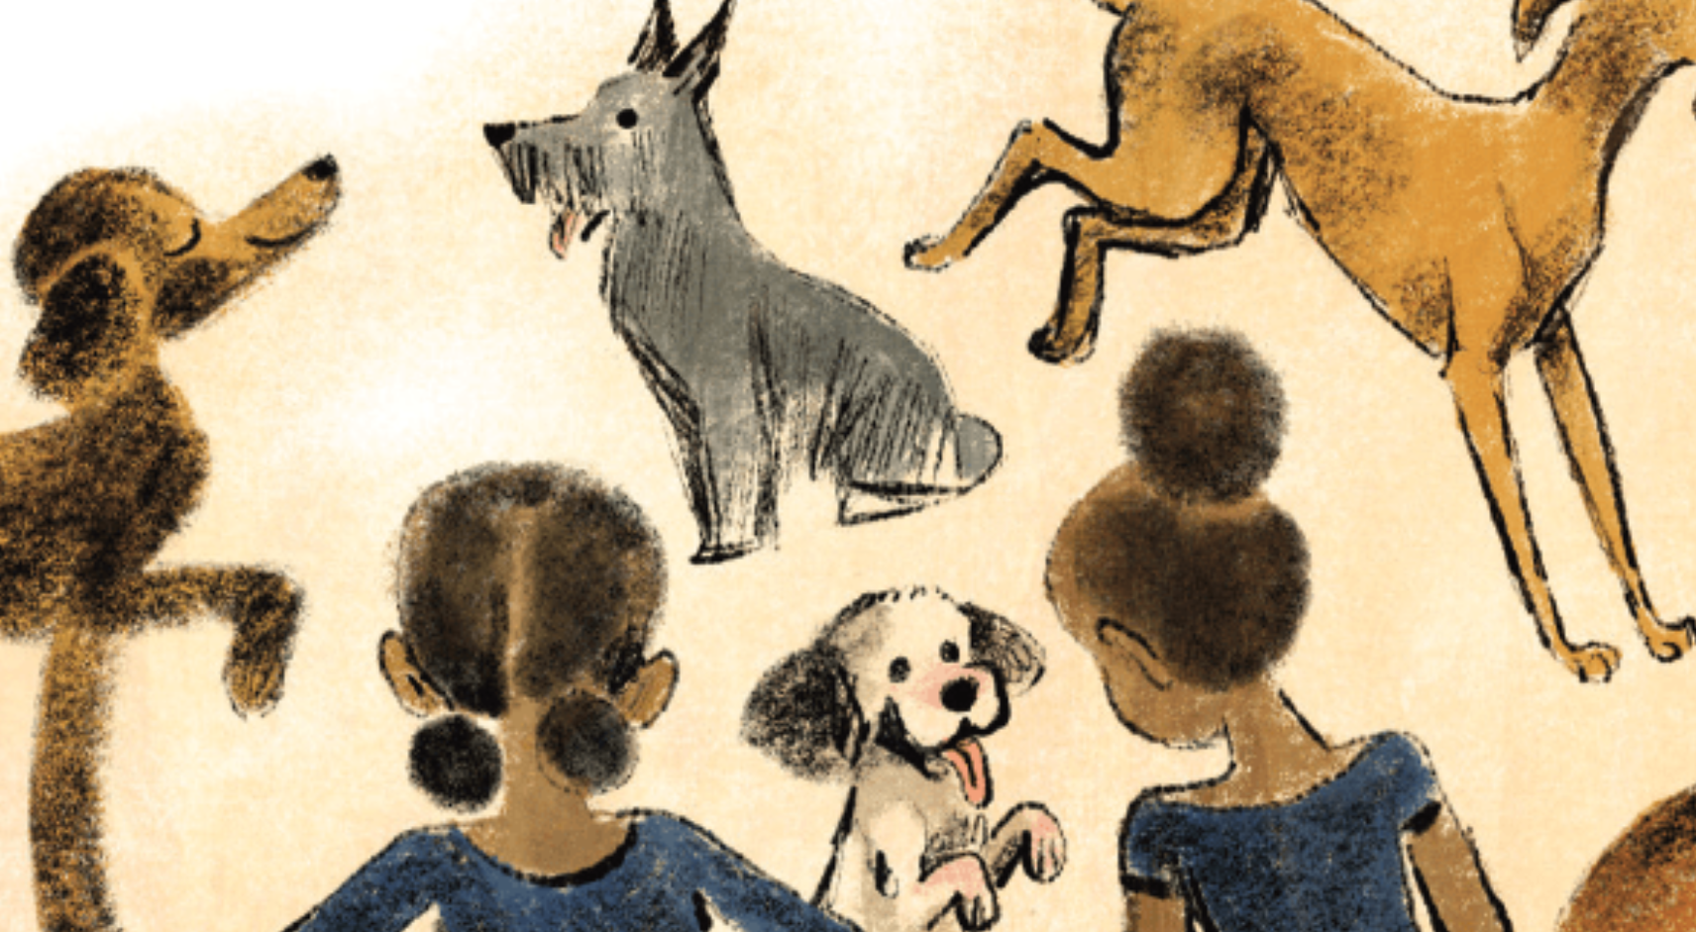
story by Lara Cain Gray , illustrated by Anna Bron
DARCY Dawson Donnelly was a very distinguished dog who suddenly found himself solo in his senior years.
One blustery morning, quite out of the blue, he was bundled up in blankets and delivered through a door. In a stuffy room that smelled like his food bowl on a hot summer’s day, he sat and wondered what on earth was going on.
Darcy was not a difficult dog. All he needed to live a happy life was:
1. Something nice to eat.
2. Somewhere soft to sleep.
3. Someone to sit with when his legs let him down, which happened with frustrating frequency as the years passed.
But suddenly everything had changed. Darcy snapped at a woman with rough hands as she tipped him into a cage and closed the door with a CLINK!
Soon a tall man with knobbly knees placed a bowl at Darcy’s feet. It wasn’t his favourite, roast beef with gravy. Darcy wasn’t happy.
‘Get some sleep, mate,’ said the man, placing a rough rubber mat into the cage. It instantly made Darcy’s tummy itch. He missed his usual cosy rug. He absolutely wasn’t happy.
As he snoozed, Darcy dreamed about his someone. He missed roast beef with gravy.
He missed his comfy basket. But it was the someone he missed the most. His someone had handed him over to someone else. It had been a curious and confusing kind of day.
The next morning, a woman in a white coat lifted Darcy off his mat. She poked him. She prodded him. She plonked him into a pen, where several other pooches begged for attention. Up on their back feet, eager and alert, the pooches watched the comings and goings.
Well, Darcy did things differently. He was not eager. He did not beg. He found a quiet corner and sat. Soon, a parade of people approached the pen, assessing each animal.
‘Look at this one! He has pretty brown patches!’
‘Oh, I prefer this one! She’s all white and fluffy!’
Darcy did not have pretty brown patches; nor was he white and fluffy. None of the visitors seemed to notice him at all, which suited Darcy just fine.
A poodle named Petal posed prettily as a family came near. A small boy, with an even smaller voice, watched Petal prance. ‘Hooray! This dog’s for me.’
Darcy did things differently. He didn’t prance and he wouldn’t pose. His legs wobbled when he stood for too long.
Petal was gently lifted out of the pen. It seemed she had a someone now.
Billy the bulldog wasn’t left for long either. Billy had a noble stance with a proud and purposeful bark. A decisive young lady, with security in mind, took note. ‘Hooray! This dog’s for me.’
Darcy did things differently. His bark was quiet. In fact, when he was particularly perturbed, he sneezed! Billy’s barking got on Darcy’s nerves. Good riddance! But Billy had a someone now too.
Day after day, Darcy watched the people parade. Each prancing, posing, purposeful pooch clambered out of the cage into the arms of a new someone.
Then Darcy met Dawn.
Dawn walked with a limp and came to visit at a quiet time of day. She wasn’t interested in prancing pooches. She didn’t care for eagerness and energy.
‘I’d like a different kind of dog,’ she declared.
So, Darcy still does things differently, but Dawn thinks that’s just fine. She gives him plenty of tasty treats, sometimes even roast beef with gravy. He has a soft, cosy rug. Dawn knitted it herself, just for him. At the end of each day, Darcy sits at Dawn’s feet and gives his tired legs a rest.
Darcy and Dawn have decided that differently is the nicest way for things to
be done.

Mr Kessel’s Bush Tucker Garden
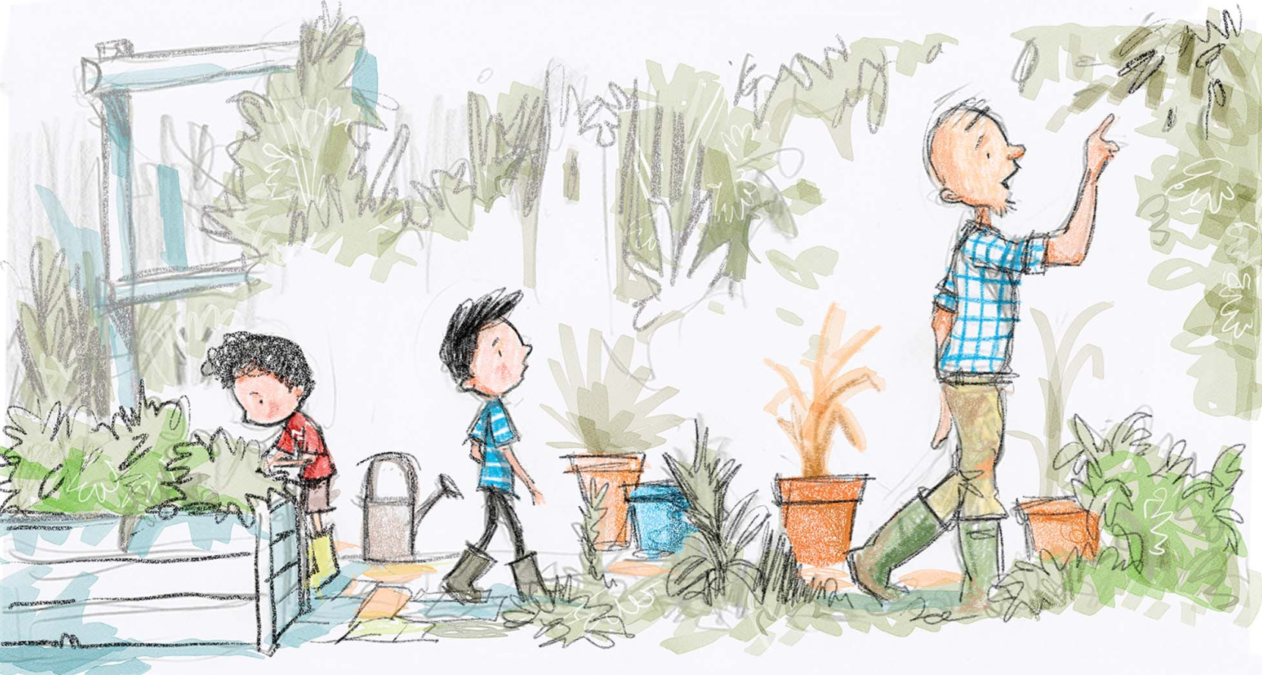
story by Sally Dixon , illustrated by Gabriel Evans
OLD MR KESSEL LIVED next door. He lived alone in a red brick house with a backyard that Josh thought must go on forever. Mr Kessel’s yard was filled with trees, and the trees were often filled with wrens, magpies, cockatoos or galahs. It reminded Josh of the Australian bush. One day last summer his family had left town and driven to the mountains where they’d embarked on a three-hour bushwalk. Josh remembered the grey-green leaves, the warbled voices of birds and the smell of lemony eucalyptus baking in hot sun.
Every day without fail Mr Kessel dug, raked or weeded his garden, and occasionally he just stood quietly underneath a scribbly gum with a tin cup of coffee in his hand. In those moments he stared at his garden with a gleam in his eye and a crooked smile on his face.
Mum sometimes made friendly chitchat with Mr Kessel over the fence. But Josh and his little brother, Matty, never did. They were fascinated, and also a little terrified, of the old man. He spoke with an unfamiliar accent—not an Australian one like their family did. He seemed as tall as a giant, and his skin looked as tanned and wrinkled as an old leather shoe.
But the most incredible thing about Mr Kessel was his right leg. It wasn’t real. Josh and Matty had discovered this fact by accident. There was a gap in the wooden fence between their backyard and Mr Kessel’s, which the boys sometimes peeked through. One day while peeping through the crack, they saw the old man hoist up his trouser leg. There should have been soft hairy skin underneath the fabric. But there wasn’t. Instead, the boys glimpsed some black and silver metal. Matty squealed, and Mr Kessel looked towards the fence with surprise. The brothers jumped up and ran as fast as they could back inside the house.
Josh wondered how a big man like Mr Kessel could lose a leg.
* * *
One Saturday afternoon Josh and Matty were playing cricket out in the backyard. Josh was batting; Matty was bowling, and Lola, their Silky Terrier, was fielding.
They played fast and hard. Matty was a reasonable bowler and Josh an exceptional batsman. Little Lola ran back and forth endlessly with her nose in the air and her eyes on the ball.
Matty rubbed the red cricket ball against his thigh, the way he’d seen players do on television. He looked his brother up and down and ran towards him. With a powerful overarm throw, he released the ball. It arched through the sky. Lola quivered with excitement, and Josh held his bat in position, never taking his gaze away from the oncoming ball.
SMACK! The bat whacked against the ball and sent it soaring high into the blue sky. Up, up, up it went, and then with an elegant curve began its descent. The boys held their breath, their eyes growing wider and wider with horror as they watched the ball fall. It wasn’t going to land in their backyard. It was headed straight for Mr Kessel’s garden!
Lola raced to and fro like a doggy ping-pong ball, but Josh and Matty stood like statues. They heard the tinkle of breaking glass. And then there was silence. Josh groaned. What should they do?
The boys raced towards the fence and peeped through. What had they broken?
They glanced towards Mr Kessel’s house, but the windows were all intact. They gazed the other way and noticed a small building half-hidden by trees; it was a greenhouse. See-through walls glistened in the sunshine—except in one spot where there was a jagged new hole.
Josh and Matty looked at each other with guilty faces. They realised it was only a matter of time until Mr Kessel came outside. They were too scared to retrieve their ball in case they bumped into the one-legged giant. Instead, the boys pulled up their stumps and disappeared inside the house. They thought it wise to lay low. They settled themselves in beanbags in front of the television and switched on a favourite movie.
About a half-hour later the doorbell sounded. Lola yapped her way down the hallway, but the boys looked at each other and didn’t say a word. Josh felt heavy inside, as if he’d swallowed ten cricket balls all at once.
They heard their mum’s voice, and in between her speaking, they heard the accented voice of Mr Kessel. Several minutes later, the front door clicked shut. Footsteps marched down the hallway and Mum appeared before them. She was holding their cricket ball. With a hand on one hip she asked, ‘Anyone care to tell me what happened?’
Josh looked down and kicked at a crumb on the carpet. ‘It was an accident,’ he muttered.
Matty remained mute.
‘I thought I’d raised two honest boys. I’m disappointed. You should’ve come and said something right away.’ Mum paused. ‘It’s going to cost Mr Kessel a lot of money to fix his greenhouse.’
‘Sorry, Mum,’ said Josh with a remorseful voice.
‘Sorry, Mum,’ echoed Matty.
‘It’s not me you need to apologise to. It’s Mr Kessel.’
The boys looked at each other with panic in their eyes. Were they going to have to speak directly to the old man?
‘Tomorrow afternoon both of you will go next door and apologise. Mr Kessel and I have talked and decided that you will help pay for the cost of fixing the greenhouse.’
Josh and Matty looked at each other again with even more panic in their eyes.
Mum continued. ‘Mr Kessel will have to get the greenhouse fixed straightaway, but every Sunday afternoon you’ll earn money by helping him in his garden. He won’t give you the money directly, but he’ll keep a tally of how much you earn. That money, plus pocket money from home, will go towards the cost of replacing the glass.’
Josh now felt like he’d swallowed twenty cricket balls.
* * *
The next day the boys walked over to the red brick house and timidly knocked on Mr Kessel’s front door. Floorboards creaked as heavy steps drew close. The door swung open and Mr Kessel himself towered over them.
The old man looked down at the boys and there seemed to be a twinkle in his eyes. ‘Welcome, Joshua. Welcome, Matthew,’ he greeted them. He used their full names, not their nicknames like everyone else did.
‘You can call me Benjamin,’ he said.
The inside of his home was simple and neat, and the air smelled like a mixture of musty books, sausages and sweet-scented flowers.
Benjamin Kessel led them through the house and into his backyard.
‘Welcome to my bush tucker garden,’ he said.
Josh and Matty looked around. They didn’t know what a bush tucker garden was, but felt too shy to ask. They stood beside a rectangular wooden trough where spinach-like leaves sprouted. Matty stroked one with his finger.
‘That plant’s called Warrigal greens,’ said Mr Kessel. ‘It’s delicious cooked in omelettes or stir-fried with other vegetables.’
Matty wrinkled his nose. It looked like spinach, and he hated spinach.
‘Don’t turn your nose up at food until you try it,’ said Benjamin, as the twinkle returned to his eyes.
Throughout the next hour, Benjamin gave the boys a guided tour of his garden. He showed them flowers, bushes and many varieties of trees: macadamia, lemon myrtle, Illawarra plum and pepper leaf.
He pointed to a wattle-tree. ‘Wattle seeds are delicious in cakes and desserts,’ he said. ‘One day I’ll make you pancakes with wattle seed ice cream.’
Matty forgot to be shy and responded with a loud ‘Yum!’ The old man smiled at him.
‘And you can try some of my lilly pilly jam with the pancakes,’ he said, pointing to a slender branch laden with unripe berries.
They came near the small greenhouse where they could see a big hole in a window. It was time. Josh pressed his lips together, took a deep breath and forced the words out of his mouth. ‘Sorry, Mr Kessel—I mean Benjamin—for breaking the glass,’ he said in an almost-whisper.
‘I’m sorry too,’ mumbled Matty.
Now the hole with its sharp, nasty edges was right before them, but Benjamin only smiled and said, ‘These things happen.’ Then he added, ‘It’ll be fixed this week, and all will be well.’ He said nothing more about it and led the boys inside the greenhouse.
Rows of tiny germinating seedlings surrounded them. Plastic markers identified the plants. Josh read some of the names: bush tomato, rosella flowers, hibiscus, saltbush … and there were many more.
‘Have you guessed yet what bush tucker is?’ asked Benjamin.
Josh had become so interested in the plants that for a moment he also forgot to be scared.
‘Is it … um … plants you get food from?’ he asked hesitantly.
‘Yes,’ said Benjamin. ‘And where do you think the plants come from?’
The boys looked blank, until Josh finally guessed: ‘Australia?’
‘You’re right. All these plants are native to Australia.’
Josh wondered why a man with a foreign accent would grow nothing but Australian plants. He felt so curious he asked with more confidence, ‘Are you from Australia?’
The old man looked at Josh with a thoughtful expression. ‘I was born in a country called the Netherlands, but twelve years ago my precious wife, Annika, died. It was a difficult time. My son had moved to Australia several years before and wanted me to come here. So I did.’ He paused. ‘At first I missed home …’
Josh thought Benjamin’s blue eyes looked a bit watery.
‘Gardening gave me something to do when I felt sad about Annika. And growing bush tucker plants helped me settle into my new home. Now, I’m thankful to live here, to be near my son and family. The garden reminds me of how lucky I am.’
Benjamin took them to a shaded garden bed where smooth green tips poked through the soil. ‘All my plants are Australian, except for these. They’re from the Netherlands. Like me, they’ve learnt to grow in foreign ground.’
‘What are they?’ asked Matty.
‘Tulips,’ said Benjamin. He said no more.
Throughout the next weeks, the boys lost all fear of their neighbour and looked forward to Sunday afternoons. Benjamin taught them to remove weeds to plant new seeds in little containers and to transplant seedlings into the outside garden. But Josh’s favourite job was picking berries, pods or leaves from the garden.
* * *
One Sunday, when colourful tulips bloomed in the bush tucker garden, Benjamin invited Josh’s whole family, including Lola, for afternoon tea. Fat pancakes were placed on each person’s plate, and on top of these Benjamin scooped wattle-seed ice cream and dolloped lilly pilly jam. Even Lola gobbled down a doggy-sized pancake on the ground.
Josh tucked into the creamy treat, and wondered why he’d ever been afraid of his neighbour. He took a spoonful of speckled ice cream, but before bringing it to his lips, he had a thought. He’d been thinking about gardens so much lately he’d forgotten something.
‘Can I ask you something, Benjamin?’ he said.
‘Of course,’ answered the old man.
‘How did you lose your leg?’
Mum looked at Josh with an I-can’t-believe-you-just-asked-that expression.
But Benjamin didn’t seem to mind. ‘It was a car accident,’ he said simply.
‘Oh,’ said Josh.
An awkward silence followed; no-one knew quite what to say next, but then Benjamin’s face crinkled with a crooked grin.
‘Want to have a look?’
The boys eagerly nodded their heads. They watched their neighbour lift his trouser leg, revealing the metal limb. He unstrapped it and held it in his hands for all to see.
‘You could use it like a cricket bat,’ shouted Matty with excitement. Everybody laughed.
Josh looked around Benjamin’s bush tucker garden and decided he was lucky. Even though Benjamin was old, Josh knew they were lucky to live next door to him
Between mouthfuls of ice cream and admiring glances at Benjamin’s leg, Josh felt a warm sensation growing inside his chest. It was the sort of feeling that comes when you know you’ve made a new friend. A friend does something kind for you.

