Attachment 2 – crossing enemy lines

Amended from the ABC net website
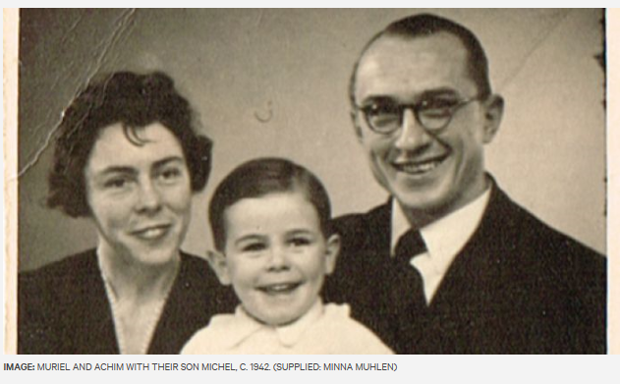
- In 1938 Achim Muhlen -Schulte returned to his native Berlin with his Australian wife, Muriel and their young son.
- Conscripted into the German Army in 1944, he wrote 52 letters to his wife while she continued to live in war-torn Germany.
- Over seventy years later his granddaughter Minna Muhlen-Schulte began to piece their story together.
- In this feature Achim’s letters, Muriel’s memoir and interviews with family are brought together to understand their war experience but also question what they witnessed and what they don’t talk about.

Teacher notes
- Minna describes her disconnect with the Australian experience of war when survivors question why a women of German heritage is researching World War Two? From the onset we are asked to consider this aspect of our national identity from a different perspective and in doing so challenge our assumptions of the overall impact of war. For many students this disconnect may also be felt as their families may be new to Australia or even placed on opposing sides to Australia in times of war.
- Minna is able to discredit her grandmother’s memoirs held in the Victorian State Library- through inconsistency of dates, changed locations etc. This leads her to question who Muriel was writing the memoirs for and why? Again as responders we are asked to consider texts in different ways, not as fact or fiction, but as representations of human experiences. We come to realise the value that exists in exploring the anomalies within these texts and the rich opportunities they provide in exploring how human experiences and emotions are represented within texts.
- Minna recalls that at various times later in life Muriel expressed anti-Semitic views and this along with a family photograph showing a swastika lead Minna to question the true reason as to why the young family had moved to Berlin near the outbreak of war. Unaware of the reasoning behind these choices Minna along with the respond continue along a story telling journey reflecting personally on the gaps in knowledge and how they ignite new ideas.
- Her grandmother only received official notification of Achim’s death 27 years later. This made it difficult for her to marry and in many ways move on. The cost of war for all sides is made clear here. Again the podcast explores aspects of war that at times go unrecognised in mainstream texts and Muriel’s personal struggle to move on is represented through Minna’s recollection of stories and references made to Achim which construct him almost as a myth rather than an individual.
- Muriel’s Australian background did make her a target at times when she lived in Germany during the World War Two. This was particularly true when Achim had been sent to fight. This section of the podcast draws our attention around who is represented as the enemy during times of war. The letters of Achim also present how he and Muriel see these incidents in very different ways. He almost chides her like a child for being so affected by these disagreements while Muriel clearly feels very isolated and afraid while caring for the children alone.
- Muriel accounts that Achim was imprisoned after being ‘informed on’ by a colleague for granting employees leave to return home at the height of fighting. Minna’s tone in describing this is sceptical as she is critical of much of Muriel’s accounts. As a responder we are left to consider the real uncertainty that existed in Nazi Germany where the line between ally and enemy to the state where one could be transgress without even realising. It also shows the national push and commitment to war when all men are conscripted and required to fight when the war turned in the Allies favour.
- Minna and Arthur describe how this element of their identity feels lost yet still remains with them through their memories of Muriel, their surname and the stories about Achim. The disconnect of culture is a recurring theme and draws out how those who were displaced to other corners of the world have not had the same opportunity to exorcise their confusion, guilty and uncertainty. This is further emphasised by Arthur’s remark that his former German girlfriend complained ‘You talk too much of the war’. In his way the family’s experience is expressed as an anomaly to the overall experience of Germans who remained in Europe after the war.

Aural features
- A combination of the composer’s introspection, her brother’s recollections and the effective use of a different Australian voice to recite Muriel’s memoirs present an engaging podcast that explores the ambiguity of the idea of ‘enemy’. The use of these different perspectives create a collective experience of the long lasting impact of war through a .
- Minna draws on her brother’s accounts of travelling through Poland in search of the area Achim went missing. Arthur’s emotions of lost, fear and uncertainty are all explored through his recount of this journey and the sibling’s discussion of his childhood nightmares of the lost Achim. Empathy is developed through Arthur’s recount, as responders we become strongly connected to his account through the use of colloquial language and emotive description of the impact of Achim’s death on the family.
- Minna’s personal explanation of processing the memoirs her grandmother left behind and her thoughts behind what she read and uncovered are relayed directly by her created an intimate link with the audience. Through her personal reasoning Minna presents her grandmother as an unreliable narrator and begins to question why Muriel felt this was necessary.
- The well-chosen voice of a young Australian female recites Muriel’s memoirs which is also non-diegetic music from the era to bring aspects of the recount to life.

Questions
- How does this related text link to the novel in relation to the use of multiple perspectives that create a collective exploration of the human experience of war?
- Individuals and family members struggle to make sense of World War 2. Identify key features of language and structure that shape this personal turmoil and confusion in the podcast?
- Much of what we read and explore in Australia is from the Allied perspective but this text explores those across enemy lines. Why is important to consider this aspect of war and its impact on the generations to follow? How does this broaden our perceptions and encourage us to see the world differently?
- How has Minna utilised language forms and features to present the ambiguity around her family’s past? Consider how these techniques work to engage the audience.

