Resource 7 - Human Experiences – What are they?
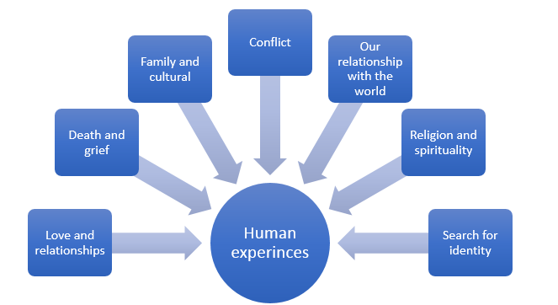
What effect do these experiences and events have on people?
View this response to a hate crime that occurred in Britain in 2016, the murder by an extremist of politician Jo Cox and discuss why the poet wrote the poem and why he would perform it to a public audience and share via social media. Speaking about the piece, George said:
During times like these it's important to hold on to the values of fairness and respect that distinguish us as humans.
George the Poet on hate crime
Humans reflect on and represent these experiences in different ways but ultimately in this module you need to consider
- What aspects of human experiences are represented in texts? What is the effect of context on a composer?
- How do texts represent these aspects of human experiences?
- How does the structure, form, and medium, effect its audiences understanding?
- What purpose do these texts have?

Examples of texts that represent different types of experiences

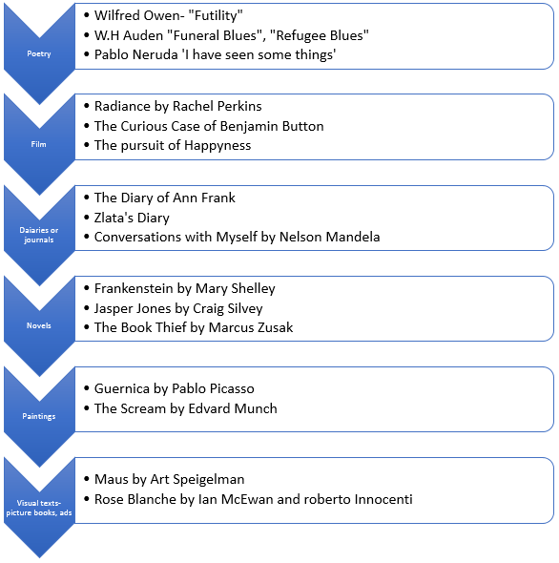

The Scream by Edward Munch
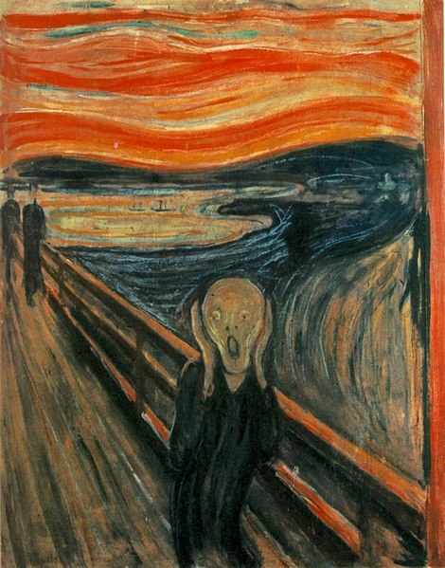
The Scream: https://commons.wikimedia.org/wiki/File:The_Scream.jpg
This painting is one of the most known in the world, commonly appropriated and copied most famously by Homer Simpson and Wes Craven’s slasher franchise Scream, with its ‘Ghostface’ mask, inspired by Munch’s painting, worn by the killers.
It holds such a fascination as it connects with its audience due to representation of raw human emotion, our anxieties are brought to life in this swirling landscape, our fears made real in burning reds and orange skies and dark and brooding lakes.
An entry in Munch’s diary, dated 22 January 1892, recorded the inspiration for The Scream:
I was walking along the road with two friends – the sun went down – I felt a gust of melancholy – suddenly the sky turned a bloody red. I stopped, leaned against the railing, tired to death – as the flaming skies hung like blood and sword over the blue-black fjord and the city – my friends went on – I stood there trembling with anxiety – and I felt a vast infinite scream through nature.
The Scream may have been influenced by events in Munch’s own life. In Munch’s childhood, he lost his mother and several siblings. In his adult life, Munch never married and was left by his only love. Munch also suffered from illness, and due to his life full of tragedy and depression, he became a recluse in his later years.
Art historian Jill Lloyd says:
It articulated an important shift that occurred within Western culture around the turn of the 20th Century. The Scream is one of those images that sums up a changing point in history, she explains. It presents man cut loose from all the certainties that had comforted him up until that point in the 19th Century: there is no God now, no tradition, no habits or customs – just poor man in a moment of existential crisis, facing a universe he doesn’t understand and can only relate to in a feeling of panic.
One may infer that Munch painted what he felt rather than exactly what he observed. The Scream conveys the feeling of despair along with a range of other powerful and unnerving emotions that an onlooker is forced to observe.
- With the intentional use of strong lines—both straight and curved—Munch’s brush strokes move the audiences’ eyes directly toward the distressed figure. The bold curved lines of the sky flow directly into the figure and continue to form the body of the individual. This element may represent feelings of chaos and madness. Not only do the chaotic lines form the body of the individual, but these curvy lines also shape the landscape that literally weighs down on the shoulders of the individual as if the force of the figure’s surroundings create immense pressure on the subject.
- Munch’s colour choices and placement of light and shadow appear to have significance and add to the emotional appeal of the scene. The scene appears dark and gloomy with the sky appearing as if it is in burning up in flames. The grey, black, and blue hues of the land and water are colours that are often closely associated with sadness and depression, perhaps Munch’s suggestion that nature had left him alone, depressed, and sick.
- The deep-orange and fire-red clouds in the sky intensify the agony that nature is releasing into the figure. In addition, the contrast between the light, pale face and the dark body contribute to drawing the audiences’ eyes to the focal point of the painting. Similarly, the figure seems to be surrounded by darkness with the landscape below blanketed in shadow.
- Neither the human figures nor the landscape appear overly detailed. By using simple forms, Munch is able to force his audience to focus on the emotions that the scene and subject emit rather than simply viewing an exact depiction of one particular scene.
- Likewise, the skull-like faced individual appears to be sexless, perhaps to appeal to both genders, illustrating the idea that depression and anxiety are feelings that relate to human nature. That is, sorrow, panic, fear, and other similar emotions are feelings that everyone has experienced at one time or another making the subject matter of The Scream relevant to all.
- The vast, somewhat-empty background space that represents the landscape intensifies the isolation and fear that the figure seems to be experiencing.
- Munch placed the frightful figure in the foreground and achieves a sense of balance by placing two smaller figures who are walking into the fiery sunset in the distance on the left side and by creating a powerful curve in the upper right hand corner.
- Munch seems to use contrasting elements to achieve a balanced composition. The straight lines seem to balance the curved lines, and, at the same time, the cold colours appear to balance the warm reds and yellows.
Analysis and information from:
What is the meaning of The Scream? http://www.bbc.com/culture/story/20160303-what-is-the-meaning-of-the-scream
The Scream: https://screamforcoke.wordpress.com/scream/
Why do you think The Scream spoke to so many about the human experiences and transcended art history to become such a touchstone for popular culture? What is its’ appeal?

