Year 12 English Standard

Ladder of change

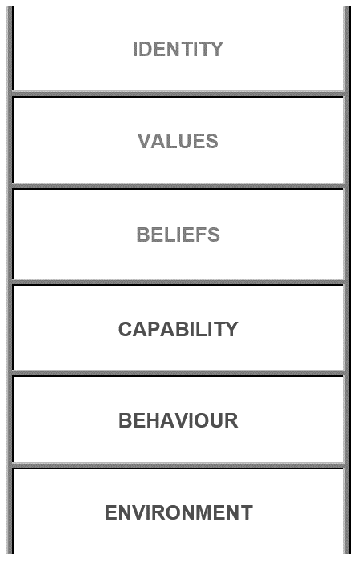

Understanding the ladder components (in descending order)
- Identity – Who am I?
- Values and beliefs – Why?
- Values are deep seated emotional responses
- Beliefs are the rules by which we live our life by
- Capability – How?
- Behaviour – What?
- My actions and decisions
- Environment – Where?

The process of identity – features
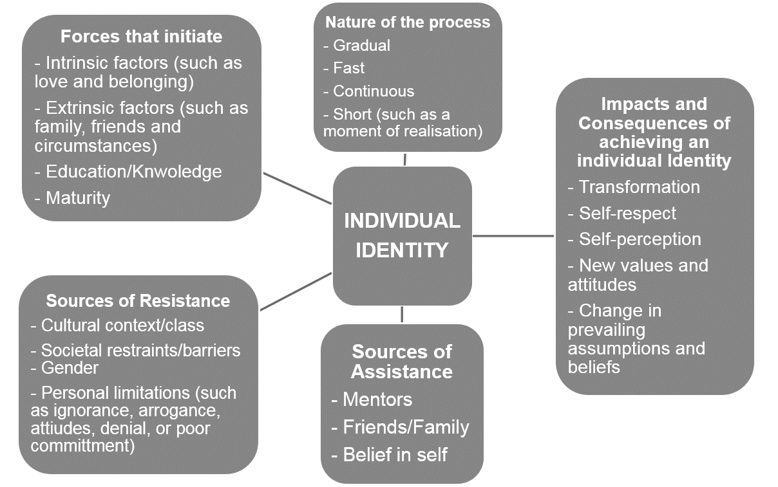
Task – Analyse the Mean Girls trailer and fill in the diagram below on how Kat’s individual identity is formed.
