Year 12 English Standard

Paragraph writing with PEEAL
PEEAL… What is it? Why do we use it?
A five step process to writing an essay paragraph in response to any question!
It’s a helpful structure to answer a complicated question

Introducing PEEAL
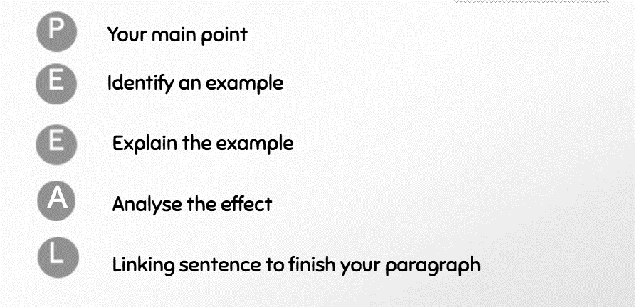

Un-PEEAL-ing the process
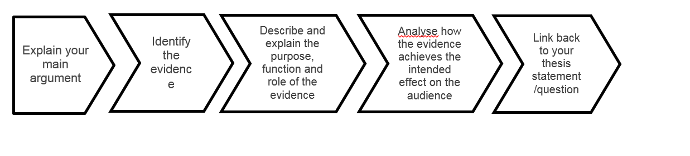

PEEAL in action
