Year 12 English Standard

Ladder of Change (Also evident in Resource 8- identity)
Task – Using your knowledge of the play, answer the questions below on how Eliza’s individual identity was shaped.

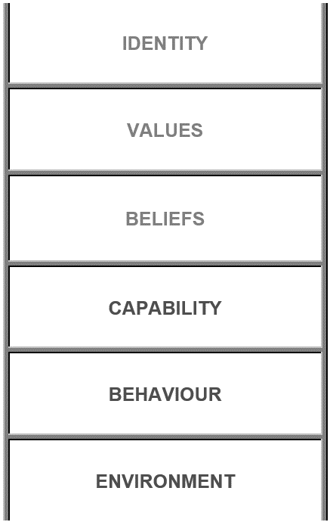
Identity – What was shaped?
Values – What was affirmed?
Beliefs – What was challenged?
Capability – How did she overcome obstacles?
Behaviour – What were her actions/decisions?
Environment – Where and when?

