Year 12 English Standard

The Phonetics Alphabet

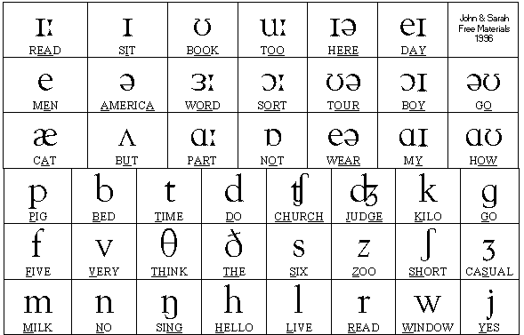
http://ciesenglishblog.blogspot.com/2013/10/ipa-international-phonetic-alphabet.html
Task – Using the phonetics alphabet, translate and transform the following words:
Phonetics | English
Your first name:
Your last name:
Your nationality:

Answers
Phonetics | English
 | Happy
 | Girl
 | Collective
 | Explain
 | Analyse
 | Change
 | Didactic

