Resource 16 – Pygmalion and British culture
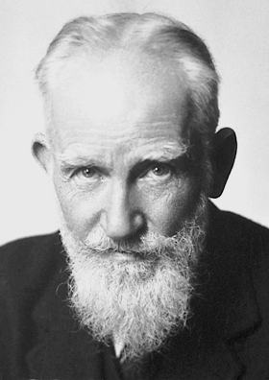
George Bernard Shaw
- Lived from 1856-1950
- Very outspoken about politics and often criticised for his “radical” views
- Won Nobel Prize for Literature in 1925
- Believed that the transformation of the individual could lead to the transformation of social values and beliefs

Activity one:
Complete the cloze passage
George Bernard Shaw was the third and youngest child (and only _________) of George Carr Shaw and Lucinda Elizabeth Gurly Shaw. His father was first a government employee and then an unsuccessful grain merchant, and George Bernard grew up in an atmosphere of ___________, which to him was more _______________ than being merely poor. At first Shaw was tutored by a clerical uncle, and he basically ___________________ the schools he then attended; by age 16 he was ___________________ in a land agent’s office.
Shaw developed a wide knowledge of music, art, and literature as a result of his _______________ influence and his visits to the National Gallery of Ireland. In 1872 his mother left her ______________________ and took her two daughters to London, following her music teacher, George John Vandeleur Lee.
In 1876 Shaw resolved to become a ____________________, and he joined his mother and elder sister (the younger one having died) in London. Shaw in his 20s suffered continuous frustration and poverty. He _____________________ upon his mother’s pound a week from her husband and her earnings as a music teacher. He spent his afternoons in the ___________ Museum reading room, writing novels and reading what he had missed at school, and his evenings in search of additional _____-__________________ in the lectures and debates that characterized contemporary middle-class London intellectual activities.

His fiction ______________ utterly. His next four novels were similarly refused, as were most of the articles he submitted to the press for a decade. Despite his failure as a novelist in the 1880s, Shaw found himself during this decade. He became a vegetarian, a socialist, a spellbinding orator, and tentatively a ______________________.
He became the force behind the newly founded (1884) Fabian Society, a ___________-___________ socialist group that aimed at the _____________________ of English society not through revolution but through “permeation” (growth from within) of the country’s intellectual and political life. Shaw involved himself in every aspect of its activities.

But Shaw truly began to make his mark when he began writing his own plays. Possibly Shaw’s __________________ masterpiece, and certainly his funniest and most popular play, is Pygmalion (performed 1913). It was claimed by Shaw to be a __________________ drama about phonetics, and its _________________________, Henry Higgins, is a phonetician, but the play is a humane comedy about __________________ and the English class system. The play is about the training Higgins gives to a _____________________ flower girl to enable her to pass as a lady and is also about the consequences of the experiment’s success.

Activity two:
Reread the Cloze passage and highlight events that may have influenced the formation of Shaw’s values and attitudes towards British culture, education and females.

Setting
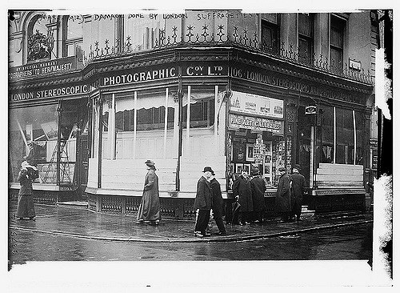

- London, 1912
- During this era, both in the play and in real life, there were huge differences between the rich and the poor.
- Social classes were clearly defined, and it was hard to move from one class to another.
- Women did not have the same rights as men and were often looked at as inferior.

How is class shown today?

Activity three:
- Brainstorm the ways your Social class can be reflected.
- Rank these features from most important to least important.

British class culture
The social structure of the United Kingdom has historically been highly influenced by the concept of social class, with the concept still affecting British society in the early-21st century. Although definitions of social class in the United Kingdom vary and are highly controversial, most are influenced by factors of wealth, occupation and education.
Given that Pygmalion is set in London, class culture and a desire to transform out of one’s class plays significant role in the play.

Upper
Class
Middle class
Working classes

Activity four
Rigid class culture comparison
Compare the way your class was reflected in 1912 versus the way it is reflected now. For the 1912 box, in one colour, highlight the features that exclusively apply to men and in another colour, those features that exclusively apply to women. What have you discovered about the way women were treated?

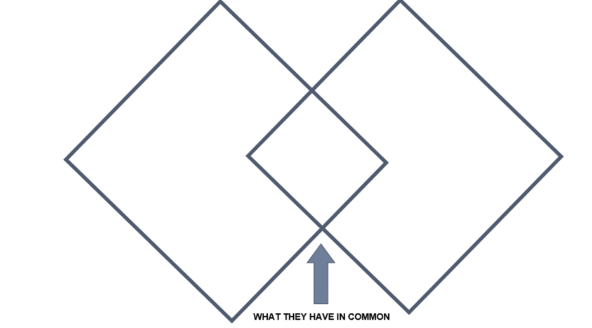

Wat’s UR SOCIAL CLASS?
Which social class do you think you belong to? (Hands up)
Your name: | Tick one box only
Upper class
Middle classes
Working class
Under class

Visit the ABC website to find out whether you are working class or affluent

Historical context

Class Culture
- Upper Class: didn’t work, noble men and women
  - In the play: Host and Hostess of the Embassy Ball
- Upper Middle Class: worked but were employed in safe, clean jobs (lawyers, doctors, professors)
  - In the play: Henry Higgins, Colonel Pickering
- Lower Middle Class: worked in dangerous jobs and unsanitary conditions
- Lower Class: did not work or worked little, had no financial freedom, were often servants
  - In the play: Eliza Doolittle

Activity five
Although a play, Shaw placed a significant amount of emphasis on the way he critiqued the way people spoke. He believe it reflected class, position and education.
The play Pygmalion focuses on Higgins teaching Eliza the proper way to speak.
- Why is voice and speech so important do you think?
- Do you think voice and speech still play a significant role in today’s society?

Activity six:
Watch My Fair Lady: English pronunciation (duration 4:43)
How does the video show the impact of conflicting cultural worlds on the individual?

