PYGMALION THROUGH THE AGES
READ THE OVID MYTH (SUMMARY) https://www.cummingsstudyguides.net/Guides3/pygmalion.html
Or https://en.wikipedia.org/wiki/Pygmalion_(mythology)
Source: Ovid – Metamorphoses
Excerpt: “He kisses her white lips, renews the bliss,
And looks, and thinks they redden at the kiss…”
Themes:
- Man shapes woman
- Man shapes himself in the process
- Love is the final transformation

PYGMALION PLOT – Summary
- Professor of phonetics Henry Higgins makes a bet with his friend Colonel Pickering that he can train a poor Cockney flower girl, Eliza Doolittle, to pass for a duchess at an ambassador's garden party by teaching her impeccable speech.
- During the course of Eliza’s education, Higgins uses his knowledge of the English language to shape Eliza’s individual identity as well as affirm her place in several different collective identities.
- Eliza’s identity evolves and transforms into a new form that provides her with independence and self-respect while simultaneously creating feelings of emotional isolation and cultural confusion.
- Shaw’s didactic purpose is both to critique and satirise the rigid British class system of the day as well as offer commentary on women’s emerging independence at the turn of the 20th Century.
TASK: Discover the definitions for the words in bold.

OVID’S PYGMALION IMAGES

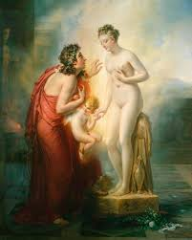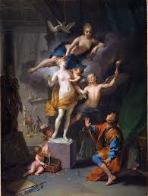

FILM APPROPRIATIONS
TRAILER #1: PRETTY WOMAN - From Prostitute to Princess
https://www.youtube.com/watch?v=T3Y16is7DNA

TRAILER #2: SHE’S ALL THAT –From Geeky to Gorgeous
https://www.youtube.com/watch?v=kI9fYsgduGE

TRAILER #3: DUFF – Confidence growth
https://www.youtube.com/watch?v=ci7eKlNRiuw

TRAILER #4: MY FAIR LADY – the film version of Pygmalion
https://www.youtube.com/watch?v=86JALxpEFEc

Consider:
WHAT ARE THE SHARED?
CHARACTERS
LANGUAGE
IDEAS
EXPERIENCES
CULTURES
TRANSFORMTAIONS
IDENTITIES
GENRE

