Year 12 English Standard

Analysing the Pygmalion myth: image 1
Task – Analyse the images on the page, identifying positioning, salience, size, facial expression and body language.
Consider how the power relationship changes between Pygmalion and Galatea through the four images.
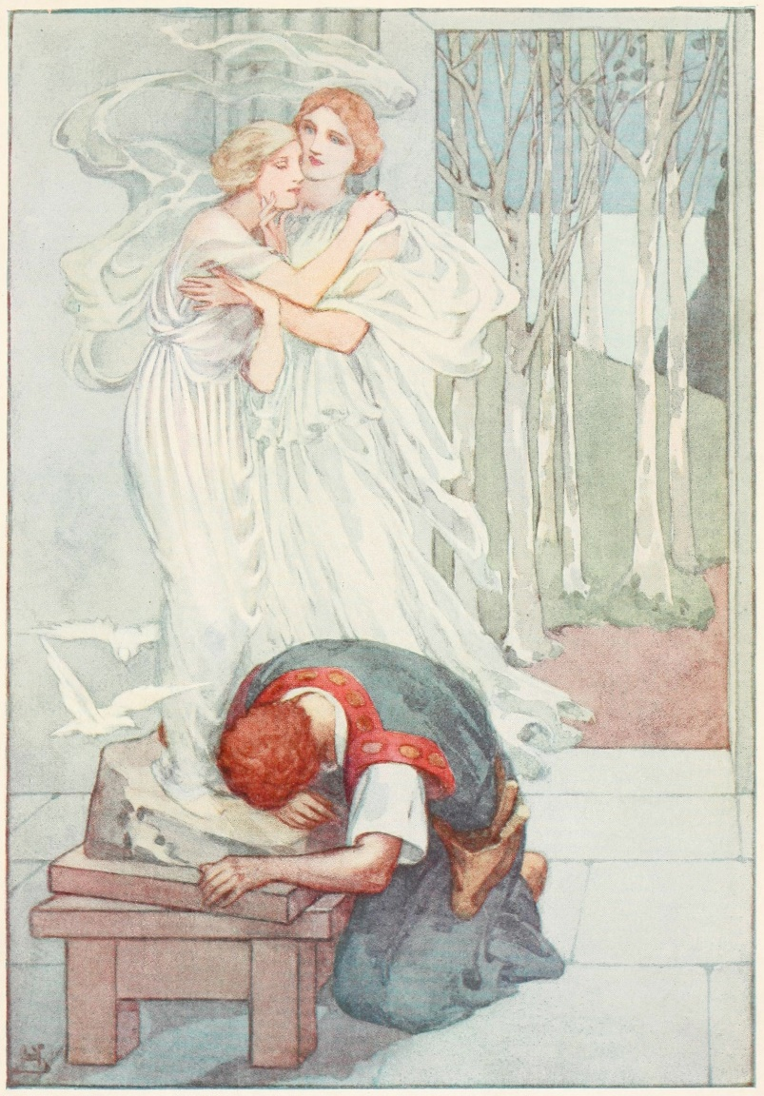

Analysing the Pygmalion myth: image 2
Task – Analyse the images on the page, identifying positioning, salience, size, facial expression and body language.
Consider how the power relationship changes between Pygmalion and Galatea through the four images.
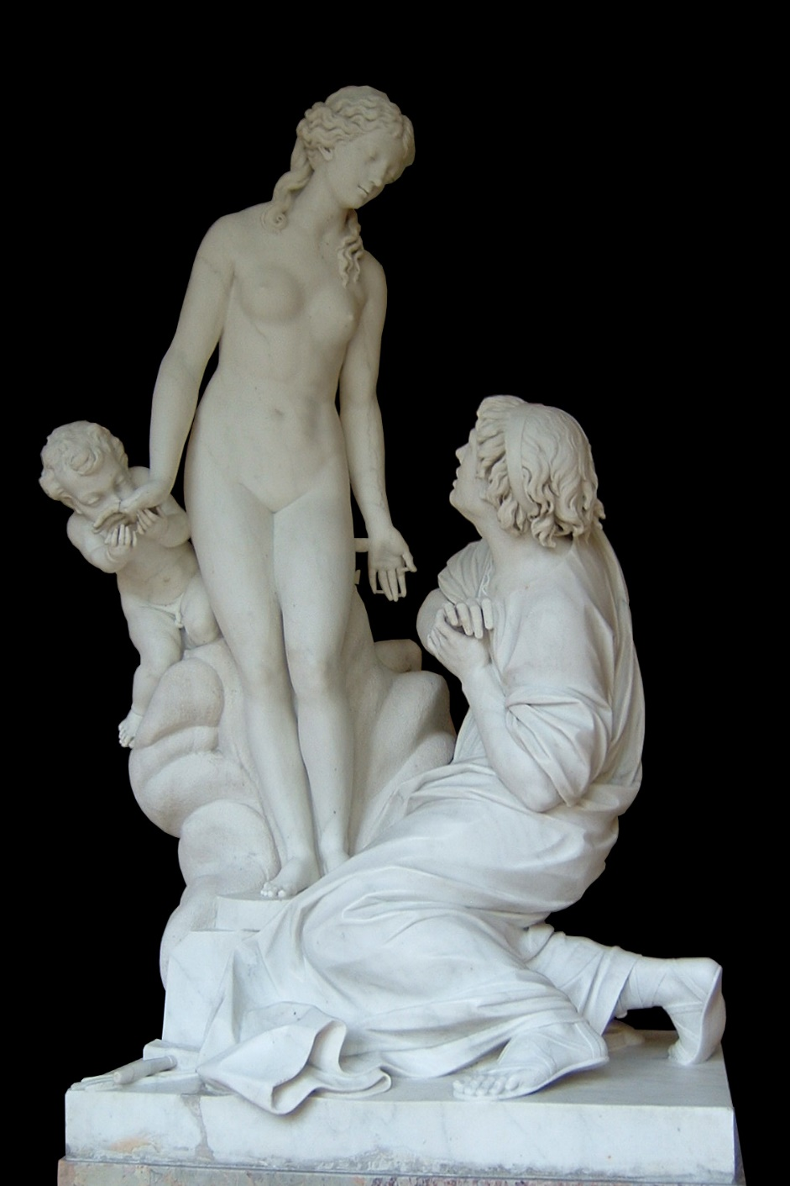

Analysing the Pygmalion myth: image 3
Task – Analyse the images on the page, identifying positioning, salience, size, facial expression and body language.
Consider how the power relationship changes between Pygmalion and Galatea through the four images.
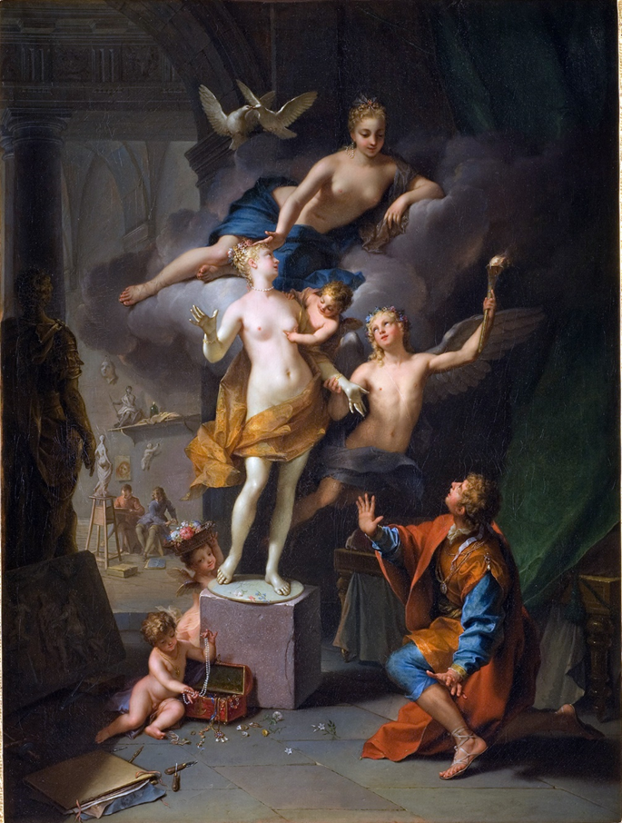

Analysing the Pygmalion myth: image 4
Task – Analyse the images on the page, identifying positioning, salience, size, facial expression and body language.
Consider how the power relationship changes between Pygmalion and Galatea through the four images.
