I Am…
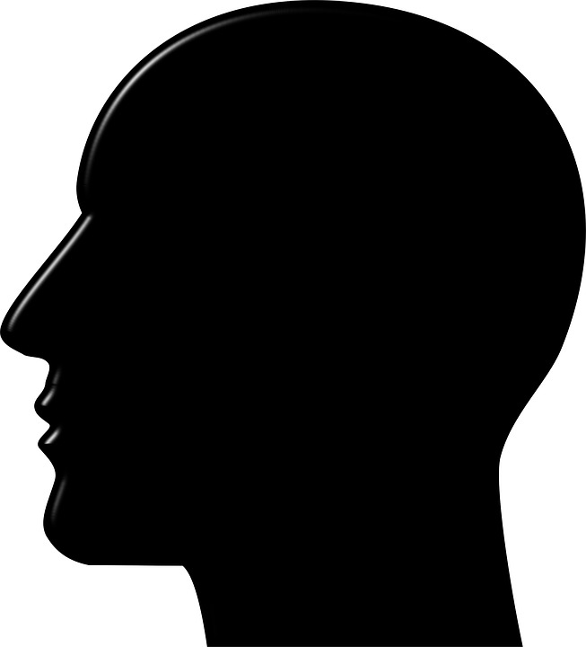

Use the table below to help you think a little more deeply about the aspects of your identity you have listed.

I Am | Because… | Which means I can/ do… | And also means I can’t/ don’t…

