Resource 6

Statement of Intent
A Statement of Intent is important to complete before undertaking writing in this course for a number of reasons:
- It allows you to outline your purpose for writing, for example, “to describe the world…, evoke emotion, shape a perspective or share a vision” (NESA, 2017);
- You can identify the target audience you’re writing for; and
- It makes you detail the key messages that you wish to convey.
This can help to keep you on track as you write. It can also allow you to see where and why you deviated from your original plan should your writing take you in new directions. By noting these ideas before you start, you will find that it is much easier to reflect on your writing process when it’s completed.
Brainstorm:
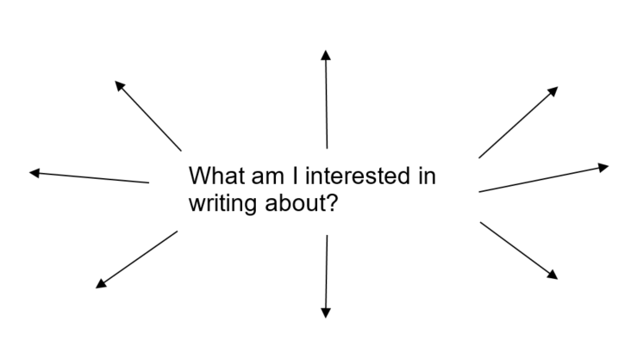

Suggestions | My planning
From
Purpose
Target audience
Strategies that I liked from prescribed text
Key ideas | - __________________________________________________________  - __________________________________________________________  - __________________________________________________________
Techniques that I want to try to include or experiment with
What do I want to achieve?
You can then turn these ideas into a brief paragraph in your journal before you start writing.

