Responding to the inquiry question
Use the scaffold below to help you write an extended response to the inquiry question posed at the beginning of your analysis of ‘A Comparison’.
How does Sylvia Plath craft her ideas in unique ways to convey her message with power and precision?
Step 1
Brainstorm the ‘unique ways’ Plath’s ideas are conveyed with ‘power and precision’:
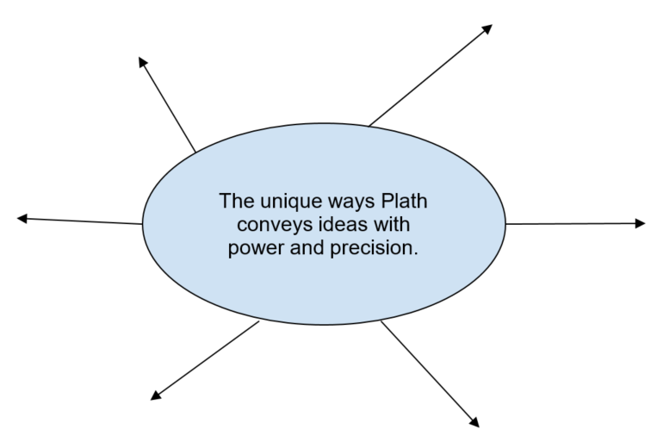
Step 2
Group these ideas into three common categories/themes/concepts. These will become your three body paragraphs in your response.
Step 3
Explain in detail HOW the ‘unique ways’ you have identified effectively convey ideas with power and precision. Think about how the language forms, features and structural elements make the reader think and/or feel about poets; novelists; the writing process.
The ‘unique’ aspect of the text you have identified: | What significant language forms/features/structures are used? How do these make us think and/or feel about the topic? | Why are these significant language forms/features/structures so effectively ‘powerful and precise’?
Step 4
Write your draft thesis in response to the question:
Step 5
Begin writing your draft response. Use the guide below to remind you what to include
Introduction:
- Thesis
- Title of the text, author, and date of publication you are discussing
- Brief outline of the supporting arguments you will use in your body paragraphs (in the order they will appear)
- An assertive concluding sentence which reiterates the significance/purpose of your response.
Body paragraphs (aim for three):
Each paragraph should contain:
- A clear and concise opening which explains the relevance of your supporting argument.
- Concrete evidence/quotes from the text
- Detailed analysis of the evidence (here, use what you’ve written during step 3). Remember to continually integrate references to the question.
- An assertive conclusion which reiterates the significance/purpose of the supporting argument to your thesis.
Conclusion:
- Write an engaging sentence which alerts the reader you are concluding your response.
- Briefly and assertively summarise your subpoints.
- Reiterate why your thesis is justified and finish with a powerful line that re-establishes your thesis.

